**Agon (Queen’s Guard)**

Agon, also known as Queen’s Guard was popular two-player game in the Victorian era. Agon comes from the ancient Greek word for contest or challenge. It is believed to have originated in France in the 18th century.

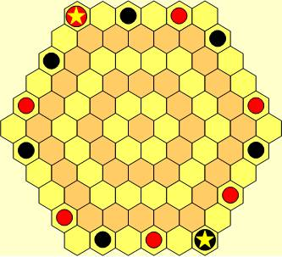

Figure 1: Agon board

**Rules**

Agon is played by two players on a hexagonal board made up of 91 hexagonal cells. Each player has one Queen (marked with a star) and six Guards which are placed on the outer ring of the board as shown in Figure 1. The goal of each player is to put the Queen on the center cell and surround her with her Guards. The players take turns, the first player being selected by the throw of a die. Pieces can only be moved one cell forwards or sideways; they cannot be moved back away from the center of the board. No piece can be moved between two opposing pieces. Only a Queen may move onto the center cell.

If a Guard is trapped between two opposing pieces, the owner of the captured Guard must move it on his next turn to any cell of his own choosing on the outermost ring. If a Queen is trapped between two opposing pieces, the owner of a captured Queen must move it on his next turn to any cell of his opponent’s choosing. If more than piece is captured in a single turn, the player owning the trapped pieces must continue to use his turns to move all his trapped pieces, one per turn, to the outermost ring. Guards may be moved in any order but if a Queen and a Guard are trapped, the Queen must be moved first.

If a piece is touched it must it possible be moved. If a player’s six Guards occupy the inner ring surrounding the center cell, the player loses the game. The winner is the player to first put the Queen on the center cell and surround her with her Guards.