KENDRIYA VIDYALAYA – IIT-M

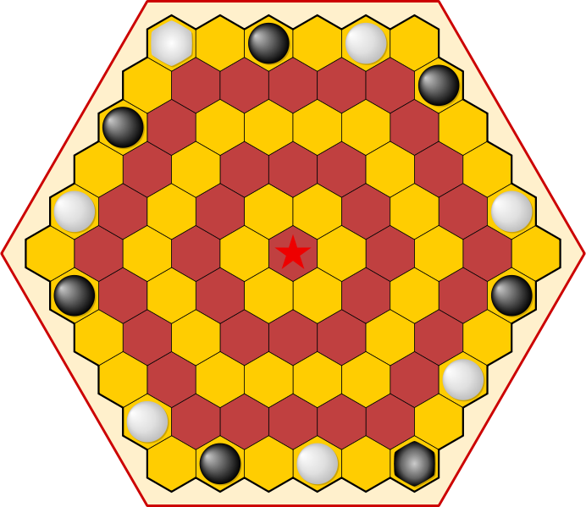

Class: XII – B
Subject: Computer Science
Game/Project name: “AGON”
Project done by: Mukesh A

BONAFIDE CERTIFICATE

This is to certify that Mr. / Miss. _____________________ of class XI ‘B’ with roll number __________________ of Kendriya Vidyalaya IIT-M is a Bonafide student and has completed the Computer Science Project entitled “Agon” as completed in the year 2012-2013 in the computer science laboratory.

__________________ ___________________
Examiner’s Signature Teachers’s signature

__________________
Principal’s Signature

ACKNOWELEDGEMENT

The preparation of this project would not have been possible without the valuable support, guidance and encouragement of our principal,
Mr. Cherian C. George and my teacher, Mr.Kamal Kishore Sharma, PGT Computer Science.

I consider myself privileged for having being given the opportunity to work under the guidance of my Computer Science teacher Mr. Kamal Kishore Sharma who helped me at every juncture and made this project successful.

I would like to thank my Parents as they encouraged me to put forward my project work. I would also like to extend my thanks to R.Ashwin and S.Shagesh who helped me with their brilliant ideas that inspired me to make my program code better.

TABLE OF CONTENTS

- Introduction

- Game rules

- Header files used

- Functions used

- User Documentation

- Game Coding

- Snapshots of the output

- Bibliography (Work Cited)
INTRODUCTION

“Agon” also known as “Queen’s Guard” is an abstract strategy game with perfect information (i.e. number random or unknown elements). “Agon” may be the two player oldest board game played on a hexagonally tiled board, first appearing as early as the late Eighteenth Century in “France”. The game reached the greatest popularity after hundred years later when the Victorians embraced it for its combination of simple moves and complex strategy.

The game starts with only queens, in opposite corners of the board. Players place their guards, one per time as move turns, on any vacant board cells (except the throne). After all twelve guards have been placed, the game proceeds under normal rules.
GAME RULES

- Each player has one Queen and six Guards. Which are placed on the outer ring of the board.

- The goal of each player is to put the Queen on the center and surround her with her Guards.

- The first player is selected by the throw of a die. Pieces can only be moved one cell forward or sideways, they cannot be moved back or away from the center of the board.

- Only a Queen may move onto the centre cell. Players cannot attempt to move their opponent’s pieces. This will make them lose.

- If a Guard is trapped between two opposing pieces, the owner of the captured Guard must move it to any cell of his own choice to one of the outermost ring.

- If a Queen is trapped between two opposing pieces the owner of a captured Queen must move it to any cell of his opponent's choice.

- If a player surrounds an empty throne with his guards, then neither player will be able to form the winning configuration, and that player forfeits the game.

- It is not allowed to move a piece between and adjacent to two enemy pieces, in a straight line.

- If a player touches one of his pieces he must move that piece, or forfeit his move turn.
HEADER FILES USED

- #include<graphics.h>

- #include<fstream.h>

- #include<process.h>

- #include<stdlib.h>

- #include<string.h>

- #include<stdio.h>

- #include<conio.h>

- #include<dos.h>
FUNCTIONS USED
And its description

- void dice();
//FUNCTION FOR ROLLING THE DICE

- void draw();
//FUNCTION TO DRAW THE HEXAGON

- void rules();
//FUNCTION TO DISPLAY RULES OF THE GAME

- void loadin();
//FUNCTION TO DISPALY LOADING

- void credits();
//FUNCTION TO DISPLAY CREDITS

- void file_del();
//FUNCTION TO DELETE FILE

- void file_list();
//FUNCTION TO SHOW SAVE FILES

- void file_save();
//FUNCTION TO SAVE THE GAME

- void clr_match();
//FUNCTION TO CHECK FOR SAME CLR

- void game_choose();
//FUNCTION TO CHOOSE THE GAME

- void modi(int);
//FUNCTION FOR POSTION MODIFICATION

- void clr_chs(int);
//FUNCTION TO CHOOSE COLOUR FOR COINS

- void hexagon(int,int);
//FUNCTION TO CHANGE THE COORDINATES

- void position(int*,int*);
//FUNCTION TO PRINT THE POSITIONS

- void graphics_screen();
//FUNCTION TO INITALISE GRA[HICS

- int moves();
//FUNCTION TO CHECK FOR CORRECT MOVES

- int lstrw();
//FUNCTION MOVE TO LAST ROW

- int capchk();
//FUNCTION TO CHECK FOR CAPTURE

- int game_cho();
//FUNCTION TO CHOOSE THE GAME IN START

- int file_read();
//FUNCTION TO READ THE SAVE FILE

- int winchk(int);
//FUNCTION TO CHECK FOR WIN

- int poschag(int);
//FUNCTION FOR POISTION CHANGING
User Documentation

Getting Started !!

Upon opening of the game the game starts with the game being loaded into to your system. Once the game is loaded your taken to the short menu of the game, where your asked to select from:
a. Starting a new game
b. Staring from a previously save game

Then the rules of the game are displayed, and then the First Player is selected, and the players get to choose their coins from the given 14 colours and they even get the opportunity to select the colour of the game board.

Now the 2 players are taken into the game !!

But if you want to play the game there are certain things which you much know before you start, like how to choose your coins and how to move them.

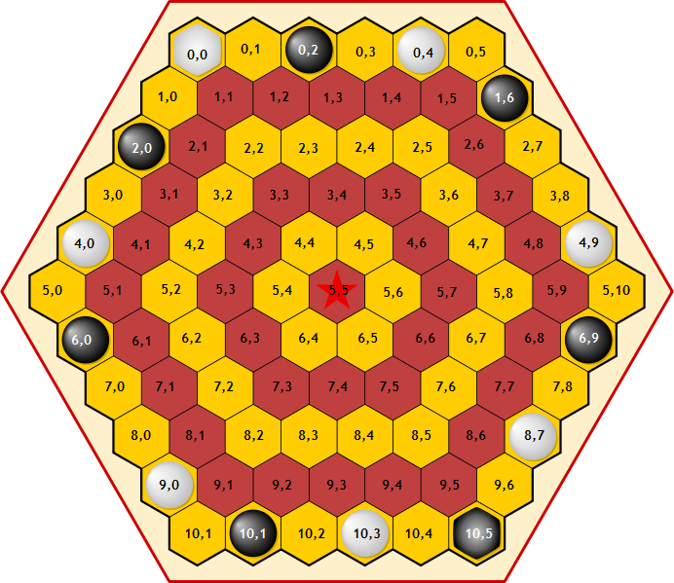

Player 1’s coins are at:-
Queen:- (0,0)
Guards:- (0,4) (4,0) (4,9) (8,7) (9,0) (10,3)

Player 2’s coins are at:-
Queen:- (0,2)
Guards:- (1,6) (2,0) (6,0) (6,9) (10,1) (10,5)

The above given BOARD represents the positions of all the possible coordinates used in this game by which the user gets to choose the coin which he/she wants to “move from” and “move to” and playing the game.

The Players must be careful and make sure that they move their coins from the correct coordinates and enter the new ones but making sure that they move their selected coin by one step at a time.

After completion of each turn the players are asked whether they want to continue or not. If the player wants to continue he has to press the “Y or y” key to do so, if any other key (except ‘s’ , ‘x’ )is pressed then the player is taken to the main menu where he can gets to choose from:-

- Staring a new game
- Continuing the current game
- Save the game
- See the existing games
- Load saved games
- Delete saved games
- See the rules
- Change coin color
- Change board color
- Or to EXIT

These options are chosen by entering the corresponding option number next to it, and if any other key is pressed the game is selected to exit and you are given an option of saving the current game or exiting the game without saving it.

There are two “HOT KEYS” in this game, after each player’s turn is over, they are asked to continue by pressing “y” or else they are taken to main menu, but instead if “x” is pressed the game is immediately exited without saving and if “s” is pressed the game is saved at that instant.

Game Coding

/*********************************************************************
HEADER FILES USED
*********************************************************************/

#include<graphics.h>
#include<fstream.h>
#include<process.h>
#include<stdlib.h>
#include<string.h>
#include<stdio.h>
#include<conio.h>
#include<dos.h>

/*********************************************************************
FUNCTIONS USED
*********************************************************************/

void dice(); //FUNCTION FOR ROLLING THE DICE
void draw(); //FUNCTION TO DRAW THE HEXAGON
void rules(); //FUNCTION TO DISPLAY RULES OF THE GAME
void loadin(); //FUNCTION TO DISPALY LOADING
void credits(); //FUNCTION TO DISPLAY CREDITS
void file_del(); //FUNCTION TO DELETE FILE
void file_list(); //FUNCTION TO SHOW SAVE FILES
void file_save(); //FUNCTION TO SAVE THE GAME
void clr_match(); //FUNCTION TO CHECK FOR SAME CLR
void game_choose(); //FUNCTION TO CHOOSE THE GAME
void modi(int); //FUNCTION FOR POSTION MODIFICATION
void clr_chs(int); //FUNCTION TO CHOOSE COLOUR FOR COINS
void hexagon(int,int); //FUNCTION TO CHANGE THE COORDINATES
void position(int*,int*); //FUNCTION TO PRINT THE POSITIONS

void graphics_screen(); //FUNCTION TO INITALISE GRA[HICS

int moves(); //FUNCTION TO CHECK FOR CORRECT MOVES
int lstrw(); //FUNCTION MOVE TO LAST ROW
int capchk(); //FUNCTION TO CHECK FOR CAPTURE
int game_cho(); //FUNCTION TO CHOOSE THE GAME IN START
int file_read(); //FUNCTION TO READ THE SAVE FILE
int winchk(int); //FUNCTION TO CHECK FOR WIN
int poschag(int); //FUNCTION FOR POISTION CHANGING
/*********************************************************************
GLOBAL VARIABLES
*********************************************************************/

const int plyr[2]={1,2};
char nm[2][30],fl_nm[30],grp[50]="c:\\turboc3\\bgi",ch;
int poly[14],rw1,cl1,rw2,cl2,ply=1,flag,cho,new_gm=0;
int clr1=4,clr2=2,bkclr=8,count=0;

fstream file;

int p1rw[7]={0,0,4,4,8,9,10},p1cl[7]={0,4,0,9,7,0,3};
int p2rw[7]={0,1,2,6,6,10,10},p2cl[7]={2,6,0,0,9,1,5};

/*********************************************************************
Representation of the initial board positions as a variable
*********************************************************************/

int pos[11][11]={
/* 0 */ { 11,0,2,0,1,0, -1,-1,-1,-1,-1},
/* 1 */ { 0,0,0,0,0,0,2, -1,-1,-1,-1},
/* 2 */ { 2,0,0,0,0,0,0,0, -1,-1,-1},
/* 3 */ { 0,0,0,0,0,0,0,0,0, -1,-1},
/* 4 */ { 1,0,0,0,0,0,0,0,0,1, -1},
/* 5 */ { 0,0,0,0,0,0,0,0,0,0,0 },
/* 6 */ { 2,0,0,0,0,0,0,0,0,2, -1},
/* 7 */ { 0,0,0,0,0,0,0,0,0, -1,-1},
/* 8 */ { 0,0,0,0,0,0,0,1, -1,-1,-1},
/* 9 */ { 1,0,0,0,0,0,0, -1,-1,-1,-1},
/* 10*/ { 0,2,0,1,0,22, -1,-1,-1,-1,-1}};

/*********************************************************************
CLASS DECLRATION
*********************************************************************/

class save
{
private:
char nm[2][30];
int count,ply;
int clr1,clr2,bkclr;
int p1rw[7],p1cl[7];
int p2rw[7],p2cl[7];
int pos[11][11];

public:
save(); //constuctor
void copy_to(); //to copy from global to class
void copy_4m(); //to copy from class to global
} s,nw_gme;

/*********************************************************************
CONSTRUCTOR OF CLASS
*********************************************************************/

save::save()
{
int i,j,k=5;

strcpy(nm[0],"Player 1");
strcpy(nm[1],"Player 2");
count=0;
ply=1;
clr1=4;
clr2=2;
bkclr=8;

for(i=0;i<7;i++)
p1rw[i]=p1cl[i]=p2rw[i]=p1cl[i]=0;

p1rw[2]=p1rw[3]=p1cl[1]=4;
p1rw[6]=p2rw[5]=p2rw[6]=10;
p1rw[5]=p1cl[3]=p2cl[4]=9;
p2rw[3]=p2rw[4]=p2cl[1]=6;
p2rw[2]=p2cl[0]=2;
p2rw[1]=p2cl[5]=1;
p1rw[4]=8;
p1cl[4]=7;
p1cl[6]=3;
p2cl[6]=5;
for(i=0;i<11;i++)
for(j=0;j<11;j++)
pos[i][j]=0;

pos[0][0]=11;
pos[10][5]=22;
pos[0][4]=pos[4][0]=pos[4][9]=pos[8][7]=pos[9][0]=pos[10][3]=1;
pos[0][2]=pos[1][6]=pos[2][0]=pos[6][0]=pos[6][9]=pos[10][1]=2;

for(i=0;i<5;i++)
for(j=6+i;j<11;j++)
pos[i][j]=-1;

for(j=10;j>5;j--)
{
for(i=10;i>k;i--)
pos[i][j]=-1;
cout<<endl;
k++;
}
}

/*********************************************************************
CLASS FUNTION COPY_TO
*********************************************************************/

void save::copy_to()
{
int i,j;

strcpy(nm[0],::nm[0]);
strcpy(nm[1],::nm[1]);
count=::count;
ply=::ply;
clr1=::clr1;
clr2=::clr2;
bkclr=::bkclr;

for(i=0;i<7;i++)
{
p1rw[i]=::p1rw[i];
p1cl[i]=::p1cl[i];
p2rw[i]=::p2rw[i];
p2cl[i]=::p2cl[i];
}

for(i=0;i<11;i++)
for(j=0;j<11;j++)
pos[i][j]=::pos[i][j];
}

/*********************************************************************
CLASS FUNTION COPY_4M
*********************************************************************/

void save::copy_4m()
{
int i,j;

strcpy(::nm[0],nm[0]);
strcpy(::nm[1],nm[1]);
::count=count;
::ply=ply;
::clr1=clr1;
::clr2=clr2;
::bkclr=bkclr;

for(i=0;i<7;i++)
{
::p1rw[i]=p1rw[i];
::p1cl[i]=p1cl[i];
::p2rw[i]=p2rw[i];
::p2cl[i]=p2cl[i];
}

for(i=0;i<11;i++)
for(j=0;j<11;j++)
::pos[i][j]=pos[i][j];
}

/*********************************************************************
FUNCTION TO INITALISE GRAPHICS
*********************************************************************/

void graphics_screen()
{
int gd=DETECT,gm,ec;
initgraph(&gd,&gm,grp);

ec=graphresult();

if(ec!=grOk) // an error occurred
{
cout<<"\"Graphics error:\" \n"<<grapherrormsg(ec)<<endl;
cout<<"Enter ur Graphics dir:-\n";
gets(grp);

graphics_screen();
}
}

/*********************************************************************
MAIN FUNCTION
*********************************************************************/

void main()
{
clrscr();

int run=1;

nw_gme.cpoy_to();

int chk,mov,cap,i,poschg,gm_ch;
char sav;
count=::count;

if(run)
loadin(); //calling of loadin

gm_ch=game_cho(); //calling of game choose
if(gm_ch==1)
goto cont;
else if(gm_ch==-1)
{
if(run)
credits(); //callin of credits
getch();
exit(0);
}

if(run)
{
rules(); //calling of rules function
clrscr();
dice(); //calling of dice function
clr_chs(0); //calling of colour function
clr_chs(1); //calling of colour function
clr_match(); //calling of clr_match
}
else
cout<<"MUKESH"<<endl; //will never get displayed

cont: //Graphics initialisation
graphics_screen();
if(gm_ch==1)
{
cout<<"\nplayer 1's coins are of the colour"<<endl;
setfillstyle(1,clr1);
fillellipse(300,25,10,10);

cout<<"\n\nplayer 2's coins are of the colour"<<endl;
setfillstyle(1,clr2);
fillellipse(300,70,10,10);

getch();

cleardevice();
}

draw(); //calling of draw function
modi(1); //calling of modi function

do
{
gotoxy(1,1);
for(i=0;i<28;++i)
cout<<"\t\t\t\t\t\t "<<endl;

if(count%2==0)
{
gotoxy(1,1);
cout<<"player 1"<<endl;
ply=1;
}
else
{
gotoxy(1,1);
cout<<"player 2"<<endl;
ply=2;
}

top: cout<<"enter r and c to \"move from\""<<endl;
cin>>rw1>>cl1;
//getting inputs of move from inital coordinates

if(pos[rw1][cl1]==0||pos[rw1][cl1]==(-1))
{
cout<<"entered coordinates are wrong"<<endl
<<"enter the coordinates again"<<endl;
goto top;
}

again: cout<<"enter r and c to \"move to\""<<endl;
cin>>rw2>>cl2;
//getting inputs of move to final coordinates

mov=moves(); //calling of moves function
if(mov==0)
{
cout<<"\"illegal move\" you can only move"<<endl
<<"one step at a time"<<endl;
goto again;
}

poschg=poschag(1); //calling of poschag function
if(poschg==1)
{
cout<<"illegal move"<<endl
<<"try again"<<endl;
goto top;
}

cap=capchk(); //calling of capchk function
if(cap==1||cap==3)
{
if(cap==1)
if(ply==2)
ply--;
else
ply++;
cout<<"your \"queen\" has been captured"<<endl
<<"your queen will be moved by"<<endl
<<"your \"opponent\""<<endl;
poschag(0);
}
else if(cap==2||cap==4)
{
if(cap==2)
if(ply==2)
ply--;
else
ply++;
cout<<"your \"guard\" has been captured"<<endl
<<"your guard will be moved "<<endl
<<"by \"you\""<<endl;
poschag(0);
}

chk=winchk(ply); //calling of winchk function

if(chk==1)
{
if(count%2==0)
cout<<nm[0]<<" has WON the game"<<endl;
else
cout<<nm[1]<<" has WON the game"<<endl;
getch();
delay(800);
exit(0);
}

cout<<"do u want to continue ('y')"<<endl;
cin>>ch;

if(ch=='x')
exit(0);
else if(ch=='s')
file_save(); //saving the game
else if(ch!='y'&&ch!='Y')
game_choose(); //main menu calling

count++;

}while(ch=='y'||ch=='Y'||ch=='s'||ch=='S');

getch();

cout<<"MUKESH"<<endl;

}
/*********************************************************************
FUNCTION TO DISPLAY LOADING
*********************************************************************/

void loadin()
{
clrscr();

graphics_screen(); //initialsing graphics

outtextxy(150,325,"please wait while the game is Loading......");
settextstyle(4,0,6);
outtextxy(225,100,"AGON");

bar(45,364,601,386);
setfillstyle(1,0);
bar(46,365,600,385);

gotoxy(7,24);
for(int i=0;i<69;i++)
{
cout<<(char)176;
if(i<32)
delay(500-15*i);
else
delay(50);
}
settextstyle(0,0,1);
outtextxy(200,425,"press any key to continue !!");
getch();

closegraph();
}
/*********************************************************************
FUNCTION TO DISPLAY RULES OF THE GAME
*********************************************************************/

void rules()
{

cout<<endl<<"\t\t\t\t\"RULES\""<<endl<<endl
<<"\tEach player has one Queen and six Guards"<<endl
<<"\twhich are placed on the outer ring of the board"<<endl<<endl
<<"\tThe goal of each player is to put the Queen on the center"<<endl
<<"\tand surround her with her Guards"<<endl<<endl
<<"\tThe first player being selected by the throw of a die"<<endl<<endl
<<"\tPieces can only be moved one cell forwards or sideways"<<endl
<<"\tthey cannot be moved back away from the center of the board"<<endl
<<"\tOnly a Queen may move onto the centre cell"<<endl<<endl
<<"\tIf you try to move your oppnents piece you wil loose your turn"<<endl<<endl
<<"\tIf a Guard is trapped between two opposing pieces,"<<endl
<<"\tthe owner of the captured Guard must move it"<<endl
<<"\tto any cell of his own choosing on the outermost ring"<<endl<<endl
<<"\tIf a Queen is trapped between two opposing pieces"<<endl
<<"\tthe owner of a captured Queen must move it to any cell"<<endl
<<"\tof his opponent's choosing"<<endl;

getch();

delay(800);

cout<<"MUKESH"<<endl;

}

/*********************************************************************
FUNCTION FOR ROLLING THE DICE
*********************************************************************/

void dice()
{
int i,ran[2];

randomize();

cout<<"enter the player 1's name:"<<endl;
gets(nm[0]);
cout<<"enter the player 2's name:"<<endl;
gets(nm[1]);

roll: for(i=0;i<2;++i)
{
cout<<endl<<nm[i]<<endl
<<"the dice is being rolled"<<endl
<<"and the no obtained is"<<endl;
delay(700);
ran[i]=(random(6)+1);
cout<<ran[i]<<endl;
delay(700);
}

if(ran[0]==ran[1])
{
cout<<"both players have got the \"same\""<<endl
<<"number on the dice, so \"rolling again\""<<endl;
delay(700);
goto roll; //to roll dice again
}

if(ran[0]>ran[1])
cout<<endl<<nm[0]<<" wins the \"first chance\""<<endl;
else
cout<<endl<<nm[1]<<" wins the \"first chance\""<<endl;

cout<<endl<<"You are the \"first Player\""<<endl;
getch();
}

/*********************************************************************
FUNCTION TO CHOOSE COLOUR FOR COINS & BOARD
*********************************************************************/
void clr_chs(int bk)
{
int i=0;
char cho='n';
char ch[14][3]={"1","2","3","4","5","6","7","8"
,"9","10","11","12","13","14"};

clrscr();
if(!bk) //coin's colour
{
cout<<"Do you want to choose colours for your coins"<<endl
<<"by Default"<<endl
<<"Player 1 gets \"RED\" coins"<<endl
<<"Player 2 gets \"GREEN\" coins"<<endl
<<"do you want to change ?? (y\\n)"<<endl;
cin>>cho;
}
else //board's colour
{
cout<<"Do you want to choose colours for the board"<<endl
<<"by Default"<<endl
<<"board has \"GRAY\" colour"<<endl
<<"do you want to change ?? (y\\n)"<<endl;
cin>>cho;
}
if(cho!='y')
return;

graphics_screen(); //intialise graphics
if(!bk) //colour of coins
{
cout<<"\t\t Enter the colours you want"
<<"for your coins"<<endl;
}
else //colour of board
{
cout<<"\t\tEnter the board colour you want"<<endl;
}

for(i=0;i<6;i++)
{
outtextxy(88+80*i,185,ch[i]);
outtextxy(88+80*i,285,ch[i+6]);
}

for(i=0;i<6;i++)
{
setcolor(i+1);
setfillstyle(1,i+1);
fillellipse(90+i*80,160,20,20);
}
for(i=8;i<14;i++)
{
setcolor(i+1);
setfillstyle(1,i+1);
fillellipse(90+(i-8)*80,260,20,20);
}

setcolor(15);
setfillstyle(1,15);
fillellipse(90+80*2,360,20,20);
outtextxy(85+80*2,385,ch[12]);

setcolor(15);
setfillstyle(1,16);
fillellipse(90+80*3,360,19,19);
outtextxy(85+80*3,385,ch[13]);

enter: gotoxy(1,5);

if(!bk) //colour of coins
{
cout<<nm[0]<<"-choose the colour :";
cin>>clr1;
cout<<nm[1]<<"-choose the colour :";
cin>>clr2;

if((clr1==clr2)||(clr1>14||clr2>14))
{
gotoxy(1,5);
for(i=0;i<4;i++)
cout<<"\t\t\t\t\t\t\t\t"<<endl;
gotoxy(1,4);
cout<<"enter again as chooses are wrong or same"<<endl;
goto enter;
}
if(clr1>6)
clr1+=2;
if(clr2>6)
clr2+=2;
}
else //colour of board
{
cout<<"enter the colour"<<endl;
cin>>bkclr;

if(bkclr>14)
{
gotoxy(1,5);
for(i=0;i<4;i++)
cout<<"\t\t\t\t\t\t\t\t"<<endl;
gotoxy(1,4);
cout<<"enter again as choose is wrong"<<endl;
goto enter;
}
if(bkclr>6)
bkclr+=2;
}
cout<<"MUKESH"<<endl;
closegraph();
}

/*********************************************************************
FUNCTION TO CHECK FOR SAME COLOUR OF COINS & BOARD
*********************************************************************/

void clr_match()
{

if((clr1!=bkclr)&&(clr2!=bkclr))
return;

cout<<"colour of the coin and board are same"<<endl
<<"enter them again and make sure dey are diff"<<endl;

getch();

clr_chs(0); //chosing colour of coins
clr_chs(1); //chosing colour of board

clr_match(); //colour match

}
/*********************************************************************
FUNCTION TO CHOOSE THE GAME IN START
*********************************************************************/

int game_cho()
{
int fr;
char ch;

gm: cho=0;
cout<<"Do you you want to :-"<<endl
<<"1.Play the new game"<<endl
<<"2.Play the saved game "<<endl
<<"3.Any other key to exit"<<endl
<<"enter ur choice:";
cin>>cho;
if(cho==1)
{
nw_gm: clrscr();
cout<<"\n\n\n\n\n\n\n\n\n\n\n\t\t\t";
cout<<" NEW GAME STARTED";
return(0);
}
else if(cho==2)
{
fr=file_read();
if(fr==0)
goto nw_gm;
else
return(1);
}
else
{
cout<<"are u sure u wanna exit this amazing game??"<<endl;
cin>>ch;
if(ch!='y')
{
clrscr();
goto gm;
}
}

return(-1);
}
/*********************************************************************
FUNCTION TO CHOOSE THE GAME
*********************************************************************/

void game_choose()
{
int fr;
char ch1,ch12='y',ch123,sav,cho12;

gm: cho=0;

if(ch12!='y')
cho=50;

closegraph();

cout<<"Do you you want to :-"<<endl
<<"1.Play the new game"<<endl
<<"2.Continue current game"<<endl
<<"3.Save the current game"<<endl
<<"4.See the saved games"<<endl
<<"5.Play the saved game "<<endl
<<"6.Delete a exirsting file"<<endl
<<"7.Read the instructions"<<endl
<<"8.Choose ur coin colour"<<endl
<<"9.Choose board colour"<<endl
<<"\nAny other key to exit"<<endl
<<"\nenter ur choice:";
cin>>cho12;
cho=(char)cho12;

if(cho==49)
{
cout<<"do u wanna exit this game and start a new one"<<endl;
cin>>ch1;
if(ch1=='y')
{
cout<<"do u wanna save the currnet game ??"<<endl;
cin>>ch123;
if(ch123=='y')
file_save();
else
cout<<"the current game is not saved"<<endl;

nw_gm: clrscr();

cout<<"\n\n\n\n\n\n\n\n\n\n\n\t\t\t";
cout<<" \"NEW GAME STARTED\"";

nw_gme.copy_4m();
new_gm=1;
count=-1;
ch='y';

getch();
}
else
goto gm;
}
else if(cho==50)
{
ch='y';
}
else if(cho==51)
{
file_save();
ch='y';
}
else if(cho==52)
{
file_list();
getch();
ch='y';
}
else if(cho==53)
{
fr=file_read();
if(fr==0)
goto nw_gm;
else
{
count--;
ch='y';
}
}
else if(cho==54)
{
file_del();
clrscr();
ch='y';
}
else if(cho==55)
{
rules();
ch='y';
}
else if(cho==56)
{
clr1=4;
clr2=2;
clr_chs(0);
clr_match();
graphics_screen();
draw(); //calling of draw function
modi(1); //calling of modi function
ch='y';
}
else if(cho==57)
{
bkclr=8;

clr_chs(1);
clr_match();

graphics_screen();

draw(); //calling of draw function
modi(1); //calling of modi function
ch='y';
}
else
{
cout<<"are u sure u wanna exit this amazing game??"<<endl;
cin>>ch12;

if(ch12!='y')
{
ch='y';
graphics_screen();
draw(); //calling of draw function
modi(1); //calling of modi function
return;
}

cout<<"do u want to save be4 exiting ??"<<endl;
cin>>sav;

if(sav=='y')
file_save();

getch();
credits();
getch();

exit(0);

}

graphics_screen();

draw(); //calling of draw function
modi(1); //calling of modi function

if(new_gm==1)
{
fillellipse(450,65,5,5);
fillellipse(430,145,5,5);
}

}

/*********************************************************************
FUNCTION TO SHOW SAVE FILES
*********************************************************************/

void file_list()
{

char file_nm[30];

file.open("txtfl_MK.txt",ios::in|ios::out);
if(!file)
{
cout<<"No Saved files found"<<endl
<<"Press any key to continue"<<endl;

getch();
return;
}

cout<<"the existing save files are:"<<endl;

while(!file.eof())
{
file.getline(file_nm,30,'\n');
cout<<file_nm<<endl;
}
file.close();
}

/*********************************************************************
FUNCTION TO SAVE THE GAME
*********************************************************************/

void file_save()
{

char names[30],ch;
int f_flag=0,rep=0;

file_list();

cout<<"enter file name to save as"<<endl;
gets(fl_nm);

strcpy(names,fl_nm);
strcat(fl_nm,".dat");

ofstream tochk(fl_nm,ios::nocreate);

if(tochk)
{
cout<<"file already exists"<<endl
<<"do u want to replace old file"<<endl;
cin>>ch;

if(ch=='y')
{
f_flag=1;
rep=1;
}

}
else
f_flag=1;

tochk.close();

if(!f_flag)
return;

count++;
s.copy_to();
count--;

file.open(fl_nm,ios::out|ios::binary);
if(!file)
{
cout<<"file not opened save"<<endl;
flag=0;
getch();
return;
}

file.write((char*)&s,sizeof(s));
file.close();

if(!rep)
{
file.open("txtfl_MK.txt",ios::app);

if(!file)
{
cout<<"text file not opened"<<endl;
getch();
return;
}

if(file)
{
file<<names<<"\n";
cout<<"save successful"<<endl;
}
file.close();

}
getch();
return;
}

/*********************************************************************
FUNCTION TO READ FROM SAVE FILE
*********************************************************************/

int file_read()
{

file_list();

cout<<"enter file name to read from"<<endl;
gets(fl_nm);

strcat(fl_nm,".dat");

file.open(fl_nm,ios::in|ios::binary);
if(!file)
{
cout<<"file does not exist read"<<endl;
getch();
return(0);
}
file.read((char*)&s,sizeof(s));
s.copy_4m();
cout<<"data retreaved successfully"<<endl;
file.close();
getch();
return(1);
}
/*********************************************************************
FUNCTION TO DELETE A FILE
*********************************************************************/

void file_del()
{
char name[30],buff[30];

file_list();
cout<<"enter the file name which u wanna delete"<<endl;
gets(name);
strcpy(fl_nm,name);
strcat(name,".dat");
file.open(name,ios::in);
if(!file)
{
cout<<"file does not exist delete"<<endl;
getch();
return;
}
file.close();
ofstream temp("temp.txt",ios::out);
if(!temp)
{
cout<<"temp file does not exist"<<endl;
getch();
return;
}
file.open("txtfl_MK.txt",ios::in);
if(!file)
{
cout<<"text file not opened"<<endl;
getch();
return;
}
while(!file.eof())
{
file.getline(buff,20,'\n');
if(strcmp(buff,fl_nm)!=0)
temp<<buff<<"\n";
}

remove(name);

file.close();
temp.close();

remove("txtfl_MK.txt");
rename("temp.txt","txtfl_MK.txt");
cout<<"delete succesful"<<endl;
getch();
}

/*********************************************************************
FUNCTION TO DRAW THE HEXAGON
*********************************************************************/
void draw()
{
int i,j,n=6,x=460,y=10;
setbkcolor(0);
setfillstyle(1,bkclr);
for(j=0,y;j<6;++j,++n)
{
for(i=0;i<n;x+=20,++i)
{
hexagon(x,y); //calling of hexagon function
fillpoly(7,poly);
}
x=x-10-20*n;
y+=20;
}
x+=20;
n=n-2;
for(j=0;j<5;++j,--n)
{
for(i=0;i<n;x+=20,++i)
{
hexagon(x,y); //calling of hexagon function
fillpoly(7,poly);
}
x=x+10-20*n;
y+=20;
}
}
/*********************************************************************
FUNCTION TO CHANGE THE COORDINATES
*********************************************************************/
void hexagon (int x, int y)
{
poly[0]=x+10;
poly[1]=y;
poly[2]=x+20;
poly[3]=y+10;
poly[4]=x+20;
poly[5]=y+20;
poly[6]=x+10;
poly[7]=y+30;
poly[8]=x;
poly[9]=y+20;
poly[10]=x;
poly[11]=y+10;
poly[12]=x+10;
poly[13]=y;
}
/*********************************************************************
FUNCTION TO CHECK FOR CORRECT MOVES
*********************************************************************/

int moves()
{
int x=rw1,y=cl1,i,j,k;

if(x==y) //diagonal (0,0) to (4,4)
{
if(x<5)
if((rw2==(x+1)&&cl2==(y+1))||(rw2==x&&
cl2==(y+1))||(rw2==(x+1)&&cl2==y))
return(1);
}

for(i=0;i<5;i++)
{
if(rw1==5&&cl1==i) //diagonal (5,0) to (5,4)
if((rw2==4&&cl2==i)||(rw2==5&&
cl2==(i+1))||(rw2==6&&cl2==i))
return(1);

if(rw1==i&&cl1==5) //diagonal (0,5) to (4,5)
if((rw2==i&&cl2==4)||(rw2==(i+1)&&
cl2==5)||(rw2==(i+1)&&cl2==6))
return(1);
}

for(i=10,j=0;i>j;--i,++j)
{
if(rw1==i&&cl1==j) //diagonal (10,0) to (6,0)
if((rw2==(i-1)&&cl2==j)||(rw2==(i-1)&&
cl2==(j+1))||(rw2==i&&cl2==(j+1)))
return(1);
}

for(i=10;i>5;--i)
{
if(rw1==i&&cl1==5) //diagoanl (10,5) to (6,5)
if((rw2==i&&cl2==4)||(rw2==(i-1)&&
cl2==5)||(rw2==(i-1)&&cl2==6))
return(1);

if(rw1==5&&cl1==i) //diagonal (5,10) to (5,6)
if((rw2==4&&cl2==(i-1))||(rw2==5&&
cl2==i)||(rw2==6&&cl2==(i-1)))
return(1);
}
for(i=0;i<4;++i) //Triangle 1
for(j=4;j>0;--j)
{
if(rw1==j&&cl1==i)
if((rw2==(j-1)&&cl2==i)||
(rw2==j&&cl2==(i+1))||(rw2==(j+1)&&
cl2==(i+1))||rw2==(j+1)&&cl2==i)
return(1);
}

for(i=6;i<10;++i) //Triangle 2
for(k=9,j=0;k>=i;++j,--k)
{
if(rw1==i&&cl1==j)
if((rw2==(i-1)&&cl2==j)||(rw2==(i-1)&&
cl2==(j+1))||(rw2==i&&cl2==(j+1))||
(rw2==(i+1)&&cl2==j))
return(1);
}

for(i=10;i>6;--i) //Triangle 3
for(j=4,k=6;k<i;++k,--j)
{
if(rw1==i&&cl1==j)
if((rw2==i&&cl2==(j-1))||(rw2==(i-1)&&
cl2==j)||(rw2==(i-1)&&cl2==(j+1))||
(rw2==i&&cl2==(j+1)))
return(1);
}

for(i=6;i<10;++i) //Triangle 4
for(j=6,k=9;k>=i;--k,++j)
{
if(rw1==i&&cl1==j)
if((rw2==(i+1)&&cl2==(j-1))||(rw2==i&&
cl2==(j-1))||(rw2==(i-1)&&cl2==j)||
(rw2==(i-1)&&cl2==(j+1)))
return(1);
}

for(i=4;i>0;--i) //Triangle 5
for(k=0,j=6;k<i;++j,++k)
{
if(rw1==i&&cl1==j)
if((rw2==(i+1)&&cl2==(j+1))||(rw2==(i+1)&&
cl2==j)||(rw2==i&&cl2==(j-1))||
(rw2==(i-1)&&cl2==(j-1)))
return(1);
}

for(i=0;i<4;++i) //Triangle 6
for(k=4,j=4;k>i;--k,--j)
{
if(rw1==i&&cl1==j)
if((rw2==i&&cl2==(j+1))||(rw2==(i+1)&&
cl2==(j+1))||(rw2==(i+1)&&cl2==j)||
(rw2==i&&cl2==(j-1)))
return(1);
}

return(0);
}
/*********************************************************************
FUNCTION FOR POSTION MODIFICATION
*********************************************************************/
void modi(int z)
{
int prw[7],pcl[7];

for(int j=0;j<2;++j)
{
for(int k=0;k<7;++k)
if(plyr[j]==1)
{
setfillstyle(1,clr1);
prw[k]=p1rw[k];
pcl[k]=p1cl[k];
}
else
{
setfillstyle(1,clr2);
prw[k]=p2rw[k];
pcl[k]=p2cl[k];
}

if(z==1)
position(prw,pcl);//calling of position function

for(int a=0;a<=rw1;++a)
if(prw[a]==rw1&&pcl[a]==cl1)
if(j==0&&ply==1)
{
p1rw[a]=rw2;
p1cl[a]=cl2;
}
else if(j==1&&ply==2)
{
p2rw[a]=rw2;
p2cl[a]=cl2;
}
}
}
/*********************************************************************
FUNCTION TO PRINT THE POSITIONS
*********************************************************************/

void position(int*prw,int*pcl)
{
int x=460,y=10,r=5,X,Y;

for(int i=0;i<7;++i)
if(prw[i]<=5)
{
X=x+10*(2*pcl[i]+1)-10*prw[i];
Y=y+15+20*prw[i];
fillellipse(X,Y,r,r);
}
else if(prw[i]>5)
{
int re;
re=prw[i]-6;
X=x+10*(2*pcl[i]+1)-10*prw[i]+20*(re+1);
Y=y+135+20*re;
fillellipse(X,Y,r,r);
}
}

/*********************************************************************
FUNCTION FOR POISTION CHANGING
*********************************************************************/

int poschag(int z)
{
int a,b,i,j,x=460,y=10,r=5,X,Y,coin=0,lst;

if(ply==1)
{
a=11;
b=1;
}
else
{
a=22;
b=2;
}

if(z==0)
{
agn: lst=lstrw();
if(lst==0)
goto agn;
}

if((pos[rw1][cl1]==a||pos[rw1][cl1]==b)&&pos[rw2][cl2]==0)
{
if(pos[rw1][cl1]==a)
{
if(ply==1)
coin=11;
else
coin=22;
}

if(pos[rw1][cl1]==b)
{
if(ply==1)
coin=1;
else
coin=2;
}

//To errase the circle

setcolor(bkclr);
setfillstyle(1,bkclr);

if(rw1<=5)
{
X=x+10*(2*cl1+1)-10*rw1;
Y=y+15+20*rw1;
fillellipse(X,Y,r,r);
}

if(rw1>5)
{
int re;
re=rw1-6;
X=x+10*(2*cl1+1)-10*rw1+20*(re+1);
Y=y+135+20*re;
fillellipse(X,Y,r,r);
}

//To make the new circle
setcolor(15);
if(ply==1)
setfillstyle(1,clr1);
else
setfillstyle(1,clr2);

if(rw2<=5)
{
X=x+10*(2*cl2+1)-10*rw2;
Y=y+15+20*rw2;
fillellipse(X,Y,r,r);
}

if(rw2>5)
{
int re;
re=rw2-6;
X=x+10*(2*cl2+1)-10*rw2+20*(re+1);
Y=y+135+(20*re);
fillellipse(X,Y,r,r);
}

pos[rw1][cl1]=0;
pos[rw2][cl2]=coin;
modi(0); //calling of modi function
}
else
return(1);

return(0);
}

/*********************************************************************
FUNCTION TO CHECK FOR CAPTURE
*********************************************************************/

int capchk()
{
int a1,a2,b1,b2,x=rw2,y=cl2,flag,flag_cap;

if(ply==2)
{
a1=11;
b1=1;
b2=2;

}
else
{
a1=22;
b1=2;
b2=1;

}

if(x<=5)
{

if(x-1!=-1&&y-1!=-1&&y!=x+6)
/*Centre up*/ if((pos[x][y]==a1||pos[x][y]==b1)&&
((pos[x-1][y]==b2&&pos[x+1][y]==b2)||
(pos[x][y+1]==b2&&pos[x][y-1]==b2)||
(pos[x+1][y+1]==b2&&pos[x-1][y-1]==b2)))
{
rw1=x;
cl1=y;
if(pos[x][y]==a1)
return(1);
else if(pos[x][y]==b1)
return(2);
}
if(x-1!=-1&&x-2!=-1)
/*Corner up 1*/ if((pos[x][y]==b2)&&(pos[x-2][y]==b2)&&
(pos[x-1][y]==a1||pos[x-1][y]==b1))
{
rw1=x-1;
cl1=y;
if(pos[x-1][y]==a1)
return(1);
else if(pos[x-1][y]==b1)
return(2);
}
if(x-1!=-1&&y-1!=-1&&x-2!=-1&&y-2!=-1)
/*Corner up 2*/ if((pos[x-1][y-1]==a1||pos[x-1][y-1]==b1)&&
(pos[x][y]==b2)&&(pos[x-2][y-2]==b2))
{
rw1=x-1;
cl1=y-1;
if(pos[x-1][y-1]==a1)
return(1);
else if(pos[x-1][y-1]==b1)
return(2);
}
if(y-1!=-1&&y-2!=-1)
/*Corner up 3*/ if((pos[x][y-1]==a1||pos[x][y-1]==b1)&&
(pos[x][y]==b2)&&(pos[x][y-2]==b2))
{
rw1=x;
cl1=y-1;
if(pos[x][y-1]==a1)
return(1);
else if(pos[x][y-1]==b1)
return(2);
}

/*Corner up 4*/ if((pos[x+1][y]==a1||pos[x+1][y]==b1)&&
(pos[x][y]==b2)&&(pos[x+2][y]==b2))
{
rw1=x+1;
cl1=y;
if(pos[x+1][y]==a1)
return(1);
else if(pos[x+1][y]==b1)
return(2);
}
if(y!=x+6)
/*Corner up 5*/ if((pos[x+1][y+1]==a1||pos[x+1][y+1]==b1)&&
(pos[x+2][y+2]==b2)&&(pos[x][y]==b2))
{
rw1=x+1;
cl1=y+1;
if(pos[x+1][y+1]==a1)
return(1);
else if(pos[x+1][y+1]==b1)
return(2);
}
if(y!=x+6)
/*Corner up 6*/ if((pos[x][y+1]==a1||pos[x][y+1]==b1)&&
(pos[x][y+2]==b2)&&(pos[x][y]==b2))
{
rw1=x;
cl1=y+1;
if(pos[x][y+1]==a1)
return(1);
else if(pos[x][y+1]==b1)
return(2);
}
}
else
{

/*Center down*/
if((pos[x][y]==a1||pos[x][y]==b1)&&
((pos[x-1][y+1]==b2&&pos[x+1][y-1]==b2)||
(pos[x][y+1]==b2&&pos[x][y-1]==b2)||
(pos[x+1][y]==b2&&pos[x-1][y]==b2)))
{
rw1=x;
cl1=y;
if(pos[x][y]==a1)
return(1);
else if(pos[x][y]==b1)
return(2);
}
if(x-1!=-1&&x-2!=-1&&x+y!=16)
/*Corner down1*/if((pos[x-1][y+1]==a1||pos[x-1][y+1]==b1)&&
(pos[x-2][y+2]==b2)&&(pos[x][y]==b2))
{
rw1=x-1;
cl1=y+1;
if(pos[x-1][y+1]==a1)
return(1);
else if(pos[x-1][y+1]==b1)
return(2);
}
if(x+y!=16)
/*Corner down2*/if((pos[x][y+1]==a1||pos[x][y+1]==b1)&&
(pos[x][y+2]==b2)&&(pos[x][y]==b2))
{
rw1=x;
cl1=y+1;
if(pos[x][y+1]==a1)
return(1);
else if(pos[x][y+1]==b1)
return(2);
}
if(x+1!=11&&x+2!=11)
/*Corner down3*/if((pos[x+1][y]==a1||pos[x+1][y]==b1)&&
(pos[x+2][y]==b2)&&(pos[x][y]==b2))
{
rw1=x+1;
cl1=y;
if(pos[x+1][y]==a1)
return(1);
else if(pos[x+1][y]==b1)
return(2);
}
if(x+1!=11&&y-1!=-1&&x+2!=11&&y-2!=-1)
/*Corner down4*/if((pos[x+1][y-1]==a1||pos[x+1][y-1]==b1)&&
(pos[x][y]==b2)&&(pos[x+2][y-2]==b2))
{
rw1=x+1;
cl1=y-1;
if(pos[x+1][y-1]==a1)
return(1);
else if(pos[x+1][y-1]==b1)
return(2);
}
if(y-1!=-1&&y-2!=-1)
/*Corner down5*/if((pos[x][y-1]==a1||pos[x][y-1]==b1)&&
(pos[x][y]==b2)&&(pos[x][y-2]==b2))
{ rw1=x;
cl1=y-1;
if(pos[x][y-1]==a1)
return(1);
else if(pos[x][y-1]==b1)
return(2);
}
if(x-2!=-1&&x-1!=-1)
/*Corner down6*/if((pos[x-1][y]==a1||pos[x-1][y]==b1)&&
(pos[x][y]==b2)&&(pos[x-2][y]==b2))
{
rw1=x-1;
cl1=y;
if(pos[x-1][y]==a1)
return(1);
else if(pos[x-1][y]==b1)
return(1);
}
}

/*Center up */
a1=11;
b1=1;
b2=2;

if(pos[x][y]==a1||pos[x][y]==b1)
{
if(x-1!=-1&&y-1!=-1)
{
if(pos[x-1][y]==b2&&pos[x+1][y]==b2)
flag_cap=1;
if(pos[x+1][y+1]==b2&&pos[x-1][y-1]==b2)
flag_cap=1;
if(pos[x][y+1]==b2&&pos[x][y-1]==b2)
flag_cap=1;
}
if(flag_cap==1)
{ cout<<"";
rw1=x;
cl1=y;
if(pos[x][y]==a1)
return(1);
else if(pos[x][y]==b1)
return(2);
}
}

/*Center down*/
a1=22;
b1=2;
b2=1;

if((pos[x][y]==a1||pos[x][y]==b1)&&
((pos[x-1][y+1]==b2&&pos[x+1][y-1]==b2)||
(pos[x][y+1]==b2&&pos[x][y-1]==b2)||
(pos[x+1][y]==b2&&pos[x-1][y]==b2)))
{
rw1=x;
cl1=y;
if(pos[x][y]==a1)
return(3);
else if(pos[x][y]==b1)
return(4);
}

return(0);
}

/*********************************************************************
FUNCTION MOVE TO LAST ROW
*********************************************************************/
int lstrw()
{
int i,j;
cout<<"enter r and c to move the \"captured peice\" too"<<endl
<<"make sure that the piece is "<<endl
<<"movied to the \"last ring\""<<endl;
cin>>rw2>>cl2;
if(pos[rw2][cl2]==0)
{
for(i=0;i<11;++i)
if(rw2==i&&cl2==0)//left up & dwn
return(1);
for(i=0;i<6;++i)
{
if(rw2==10&&cl2==i)//dwn
return(1);
if(rw2==0&&cl2==i)//up
return(1);
}
for(i=0,j=5;i<6;++i,++j)
if(rw2==i&&cl2==j)//right up
return(1);
for(i=5,j=10;i<11;++i,--j)
if(rw2==i&&cl2==j)//right down
return(1);
}

return(0);
}
/*********************************************************************
FUNCTION TO CHECK FOR WIN
*********************************************************************/

int winchk(int ply)
{
int x,y;

if(ply==1)
{
x=11;
y=1;
}
else
{
x=22;
y=2;
}

if(pos[5][5]==x&&pos[4][4]==y&&pos[4][5]==y&&
pos[5][4]==y&&pos[5][6]==y&&pos[6][4]==y&&pos[6][5]==y)
return(1);
else
return(0);
}

/*********************************************************************
FUNCTION TO DISPLAY CREDITS
*********************************************************************/

void credits()
{
cout<<"\t\t\t \"THANKS FOR PLAYING\""<<endl
<<"\n\t\t\t\t \"AGON\"\n"<<endl
<<"\t\t\t\ta C++ Project"<<endl
<<"\t\t\tDone by:-"<<endl
<<"\t\t\t (Lead Programer)"<<endl
<<"\t\t\t\tA.Mukesh"<<endl
<<"\t\t\t (Programers)"<<endl
<<"\t\t\t\tP.Pravin Kumar"<<endl
<<"\t\t\t\tR.Madhumitha"<<endl
<<"\t\t\t\tV.Prabha"<<endl
<<"\n\n\t\tOur Sincere thanks to your Computer Teacher"<<endl
<<"\t\t\t \"Mr.Kamal Kishore Sharma\""<<endl
<<"\t\tfor being a spectacular support and guide"<<endl
<<"\t\tthroughout the period of our project."<<endl
<<"\t\tHe has been motivating and inspiring us."<<endl
<<"\t\tAlso, he has given great opportunities to explore"<<endl
<<"\t\t\tand instill programming skills."<<endl

<<"\t\tI also thank my friends R.Ashwin and Shagesh"<<endl
<<"\t\tfor helping us in making this project"<<endl
<<"\t\t\t\ta succesful one"<<endl
<<"\t\t\t\t thank you ALL"<<endl;

}

/* we thank our computer teacher for being a spectacular support and guide throughout the period of our project making. He has been motivating and inspirin us. Also, he has given great opportunities to explore and instill programming skills. */

Snapshots of the Output
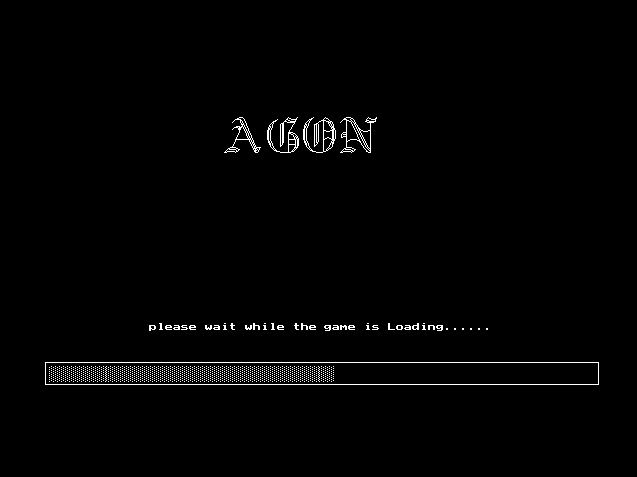
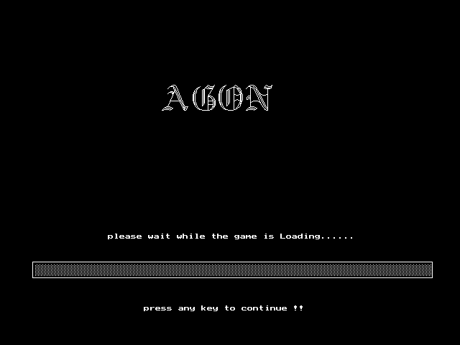
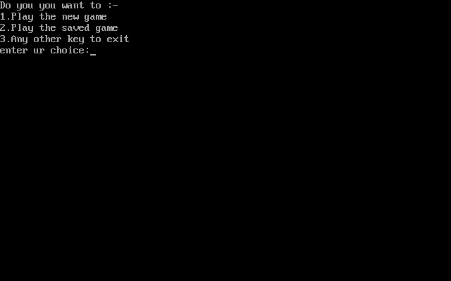
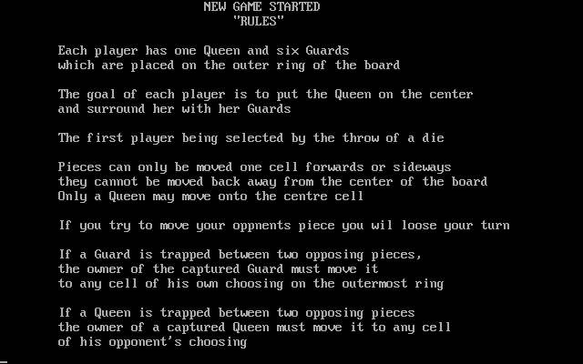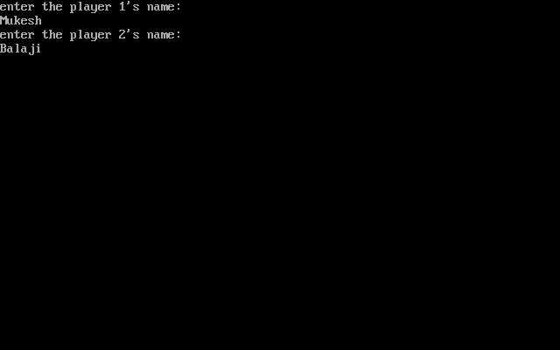
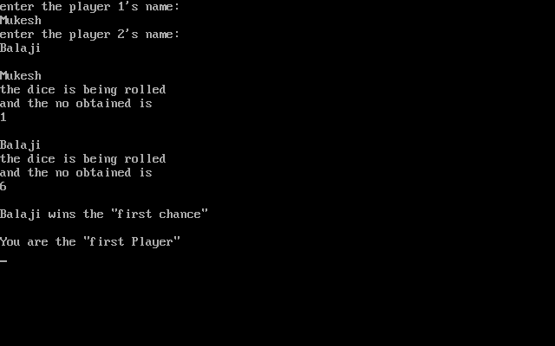
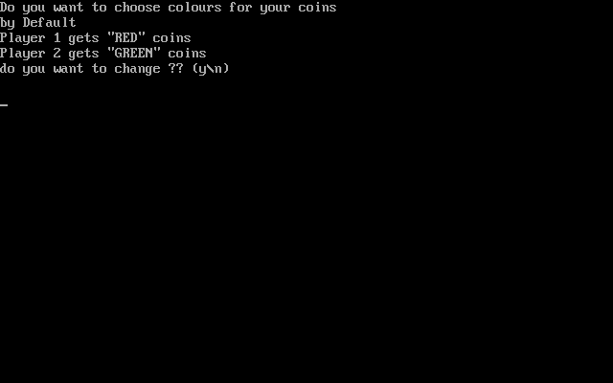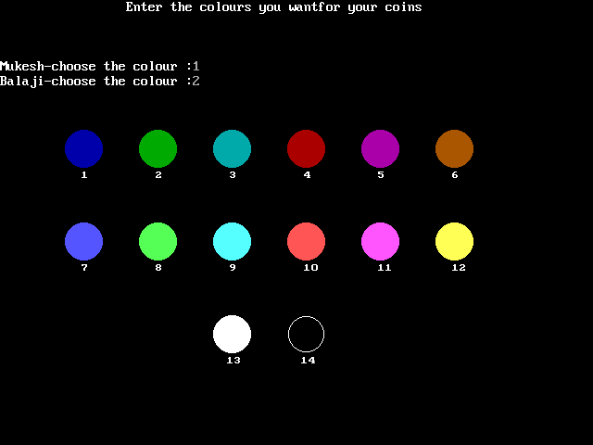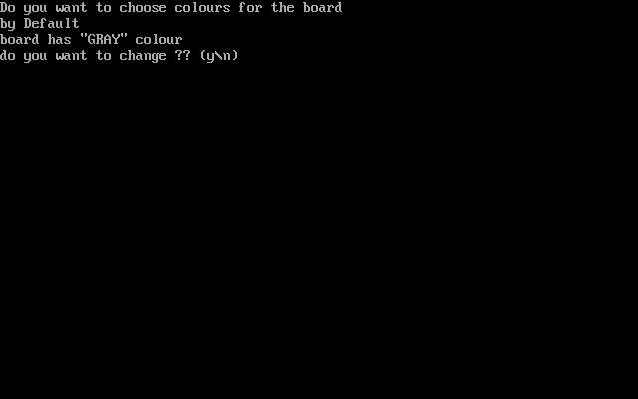
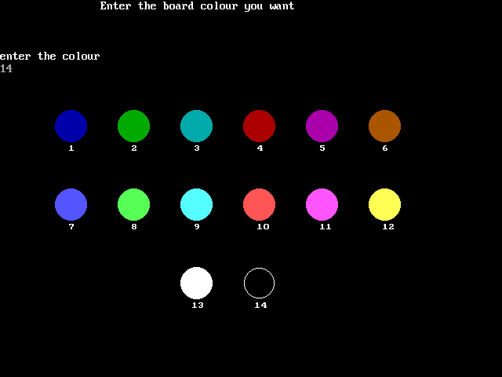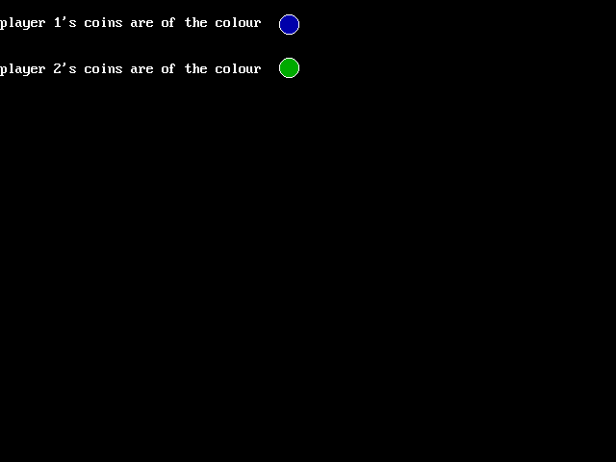
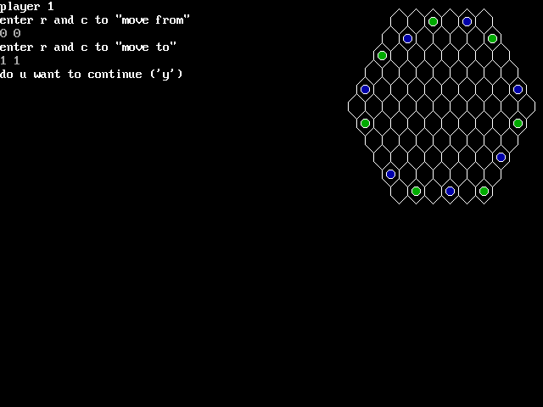
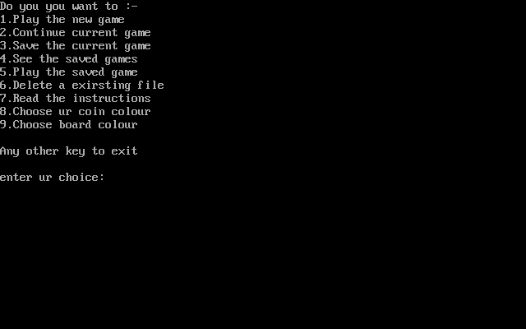
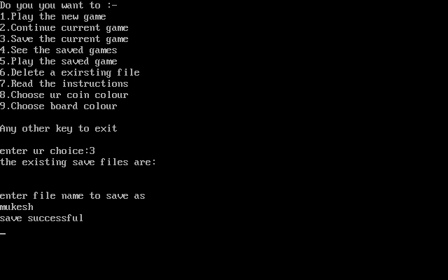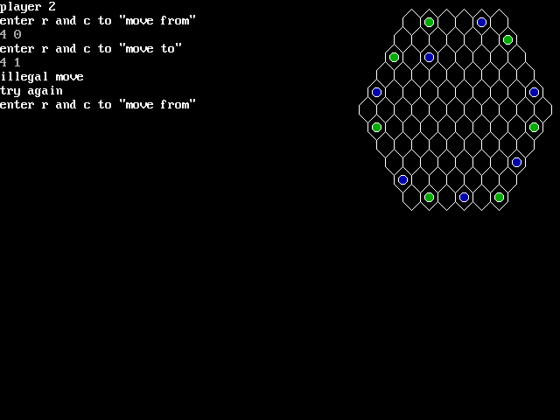
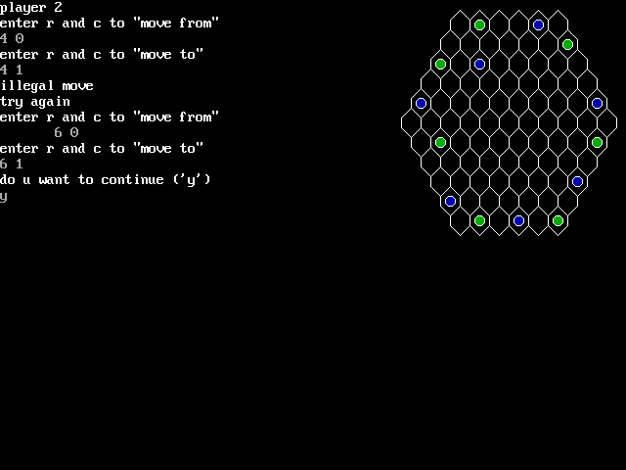
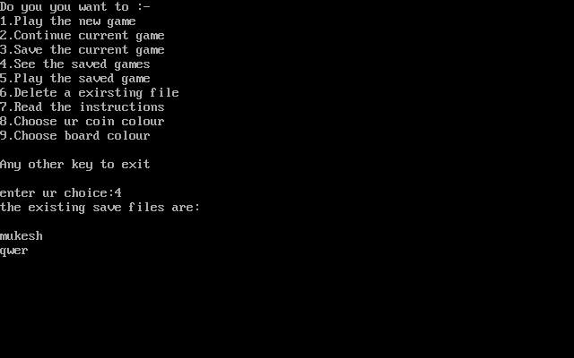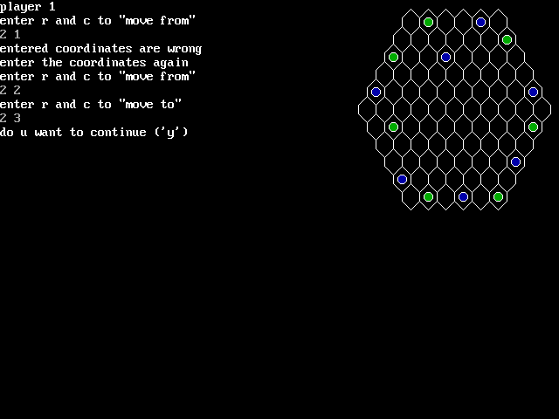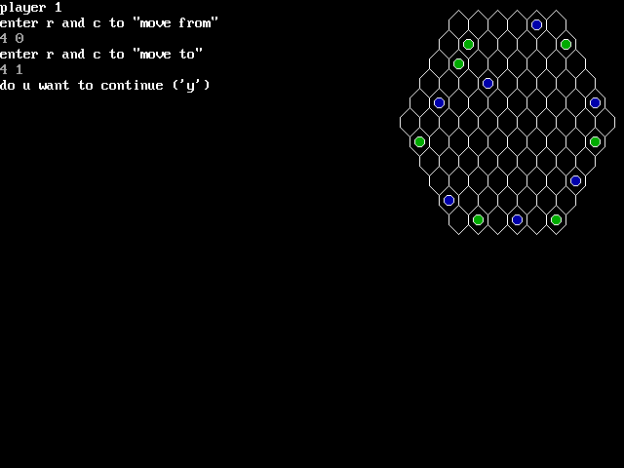
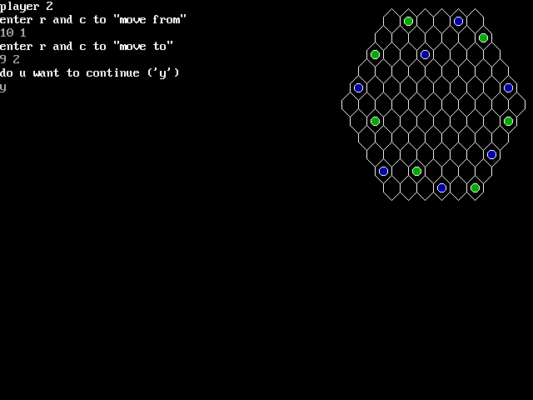

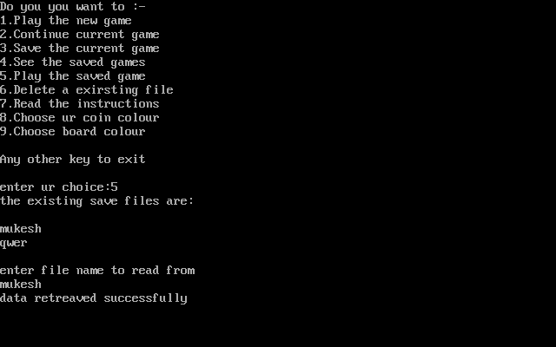
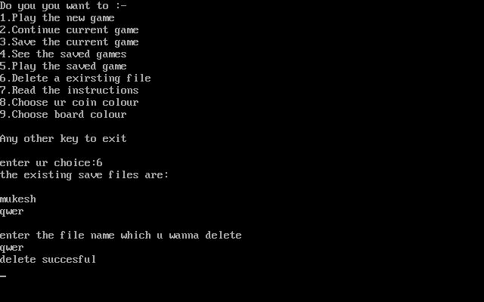
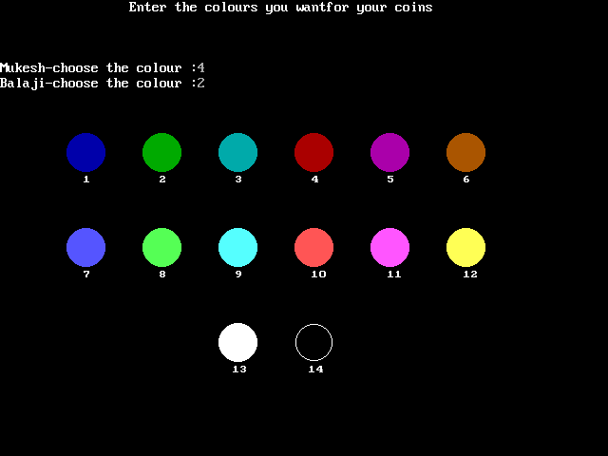

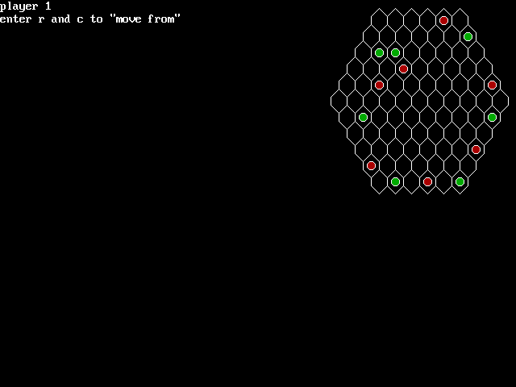
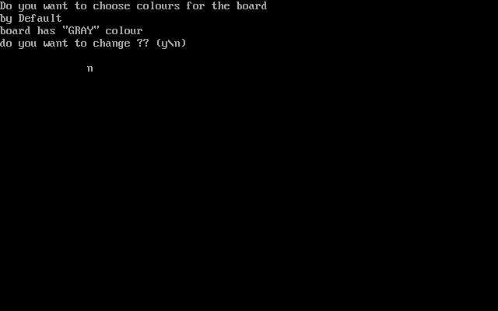
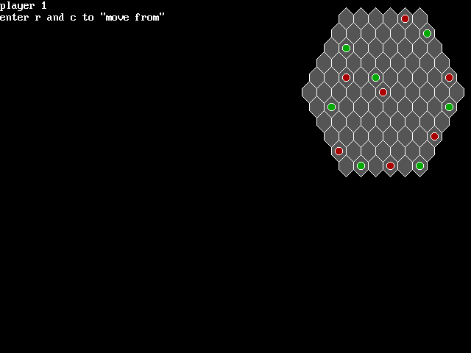
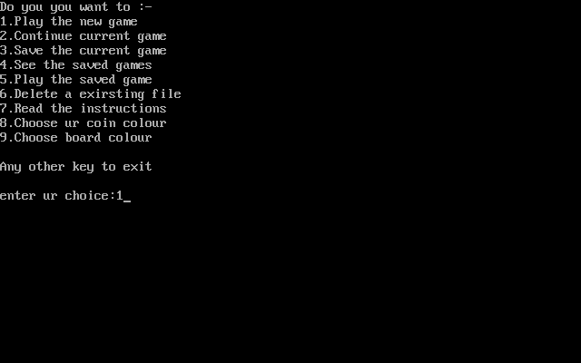
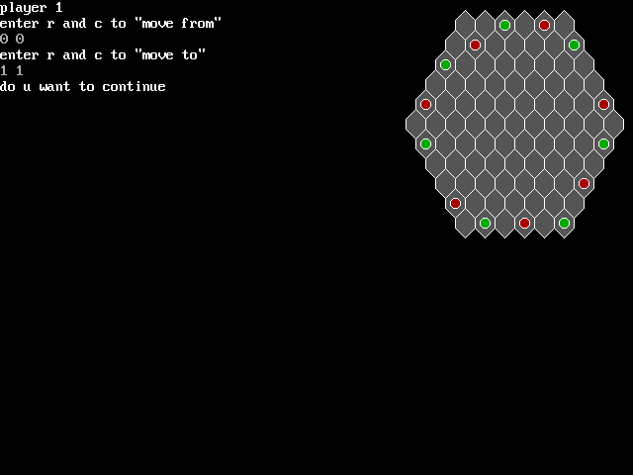
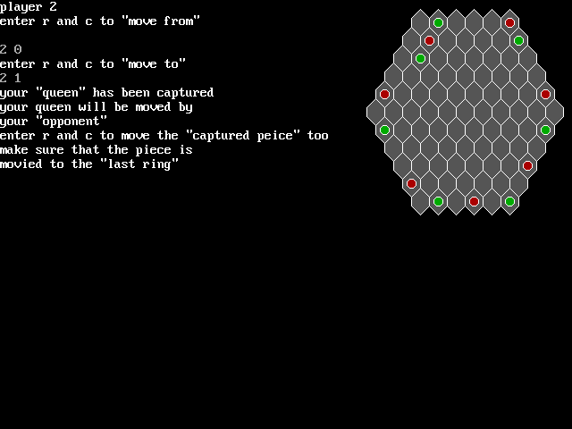
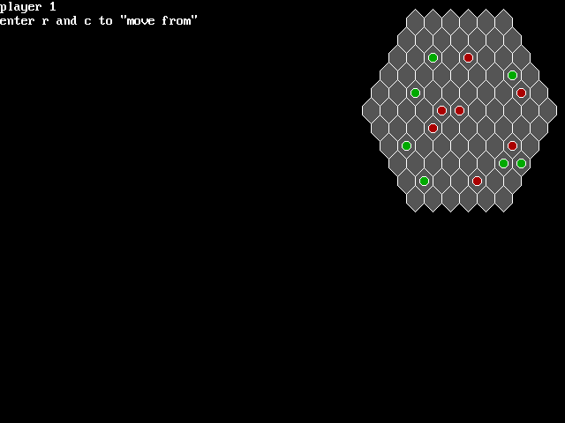
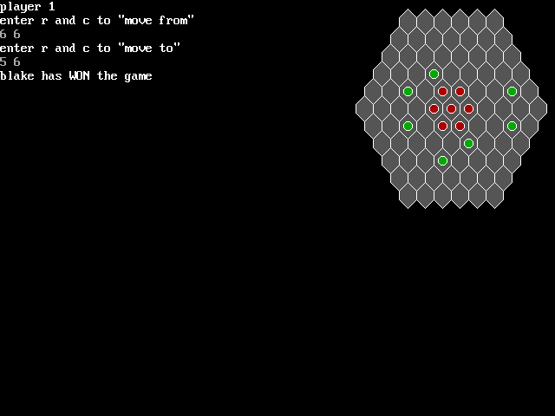
Bibliography (Work Cited)

- www.wikipedia.com
- www.google.com
- www.gmail.com
- Dos BOX v.O74
- Turbo c++ v 3.0
- C++ by Sumita Arora
- Our most respected Teacher Kamal Kishore Sharma

THANK YOU
ALL

