**Active MQ**

Apache ActiveMQ Server is the most popular and powerful open source messaging and Integration Patterns server form Apache Foundation Software.

ActiveMQ Server website: <http://activemq.apache.org/>

**Install Apache ActiveMQ Server**

Please use the followings steps to download and install Apache ActiveMQ Server into local system.

1. Download Active MQ server latest version from website as zip file.

<http://activemq.apache.org/download.html>

1. Extract apache-activemq-5.9.0-bin.zip file into local file system.

Apache ActiveMQ Server Home folder looks like below image:

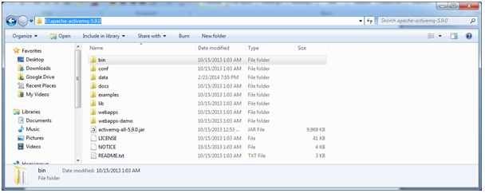

1. Start Apache ActiveMQ server.

Open Command Prompt (CMD) at Apache Active MQ bin folder:

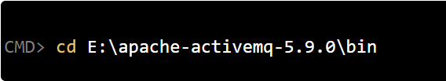

1. Start server by using “**activemq.bat start**” as shown below:



1. Apache ActiveMQ server console looks like as shown below:

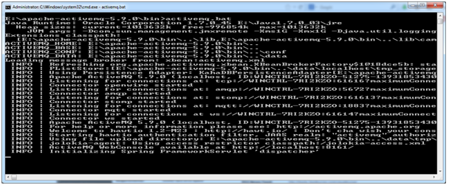

1. We have successfully installed Apache ActiveMQ Server. It’s time to setup required Queues or Topics to start development.

**Apache ActiveMQ Server Setup:**

In this section, we will access Apache ActiveMQ Server admin console and create Queues or Topics.

1. Access ActiveMQ admin console

ActiveMQ admin console URL: http://localhost:8161/admin/

Login details: admin/admin

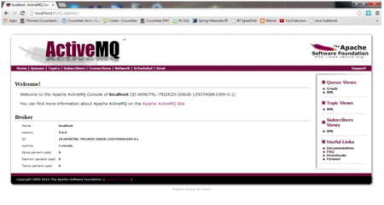

1. To view existing Queues, click on “Queues” Link.

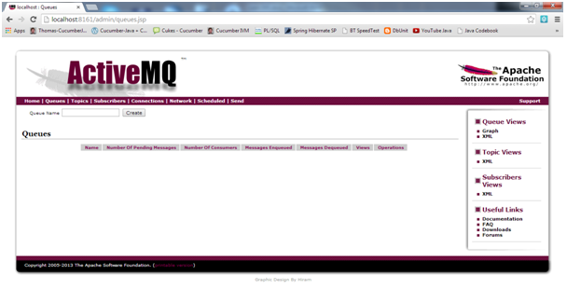

Similarly, Click on “Topics” link to view existing Topics, “Subscribers” to view existing subscribers and “Connections” to view existing connections.

1. Create new Queue or Topic

Queue Name : jms/TPQueue

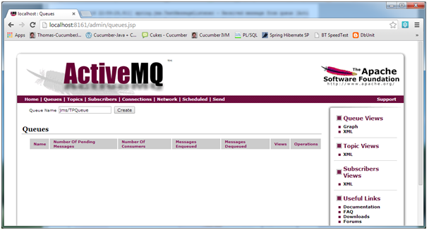

Click on “Create” button.

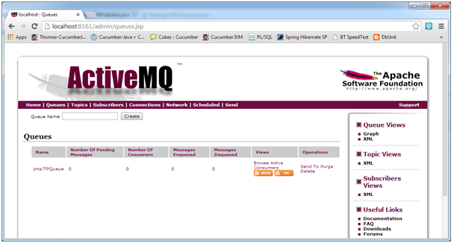

1. Topic Name: jms/TPTopic

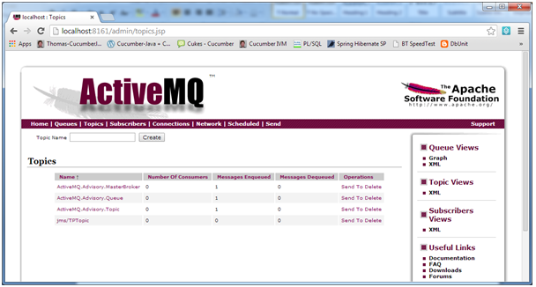

We have successfully installed and setup ActiveMQ Server with Topic or Queue.