**Deploying Mule application to Cloud hub:**

You can deploy a Mule application to CloudHub from:

* **Anypoint Studio** - Right-click your project and click Deploy to Anypoint Platform → Cloud.
* **Anypoint Runtime Manager** - In the cloud-based version of Anypoint Platform. Go to the Runtime Manager section, then from the Applications tab click Deploy application.

You can also deploy to CloudHub through:

* The CloudHub API
* CloudHub CLI
* Mule-Maven Plugin

**Deployment through Anypoint Runtime Manager:**

1. Sign in to the [Anypoint Platform](https://anypoint.mulesoft.com/) or click **Sign up** on the sign on page.
2. Hover your mouse over the **Runtime Manager** icon and click on it, or click **Open**.

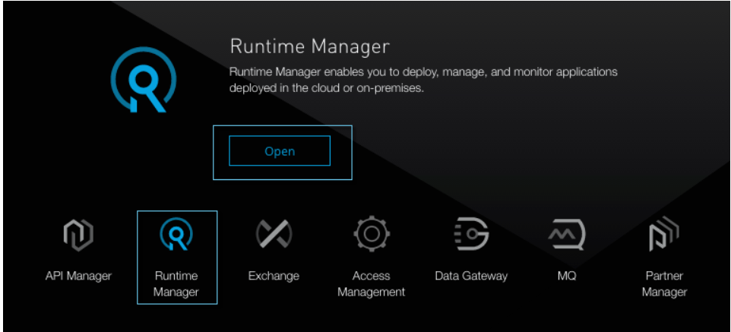

1. In the Applications tab, click Deploy application.

The Deploy Application page opens:

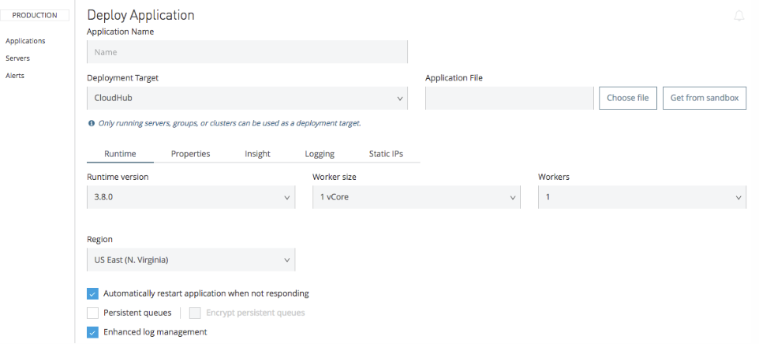

**Deployment through Anypoint Runtime Manager (SandBox)**:

If you created an application in a sandbox environment and tested it, when you are ready to deploy the application to production, you must first move the application.

To move an application from a sandbox environment to production:

1. Log into your Anypoint Platform account, and go to your production environment.
2. In the Applications tab, click the Deploy Application button.
3. When choosing the application file, click Get from sandbox.

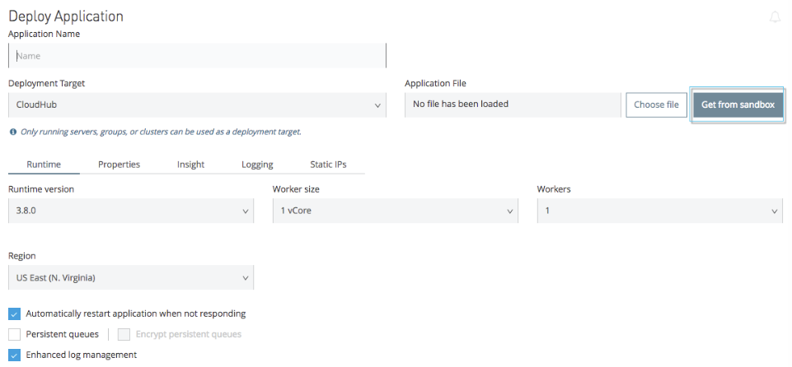

1. In the Get from sandbox dialog, select your sandbox environment, then select an application to deploy in production, and click Apply.
2. Continue setting up your deployment as you would with any other deployment.

**Limitations:**

1. Only a CloudHub Administrator can move applications between environments.
2. To avoid domain name conflict, an application with the same name cannot be deployed in two environments at the same time. Modify the application’s name slightly to deploy it to another environment.
3. Runtime Manager prevents you from duplicating applications in a single environment, so you cannot move an application into the environment it’s already in. To have the same, or similar, applications in a single environment, modify one application’s file to distinguish it from the original.