**Weblogic SSL, Keystore & Certificate**

**Agenda:**

* SSL and Keystores Overview
* SSL & Its Capabilities

SSL is an industry standard for securing communications between client and server (In most cases it will be between your browser and the webserver)

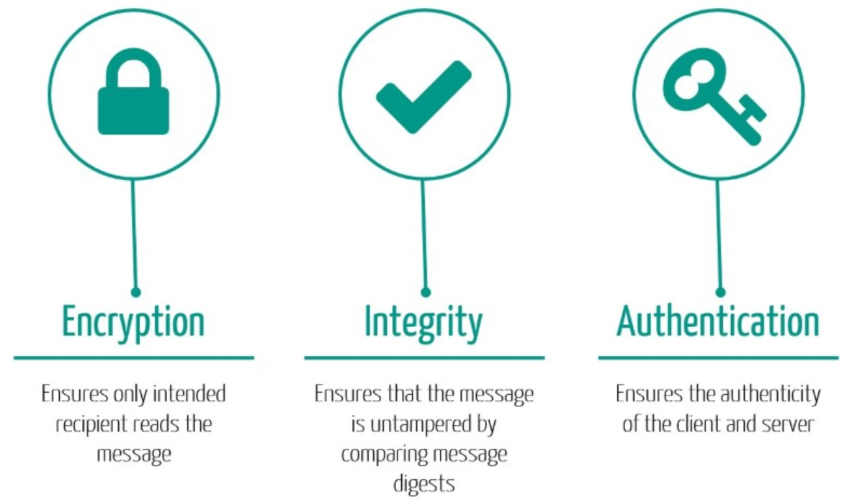

* Public & Private Key Cryptography

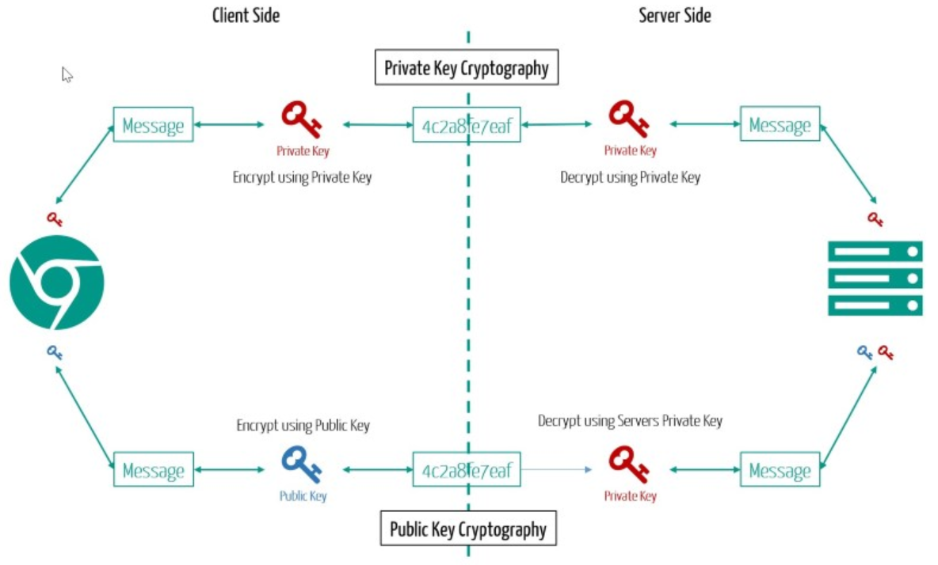

* SSL Handshake Request Flow

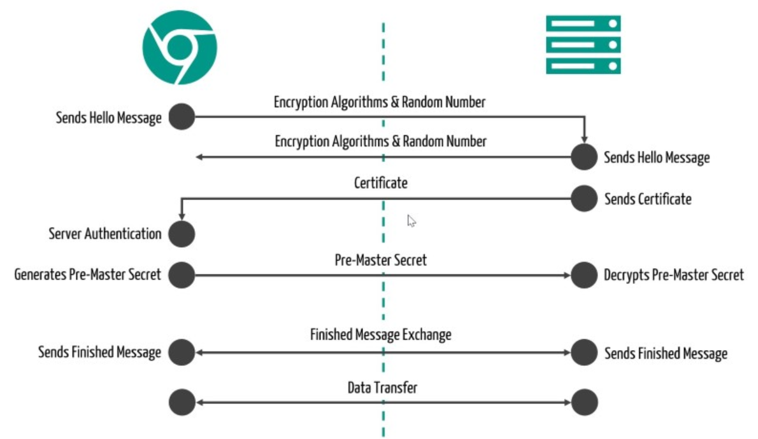

* Keystore Providers

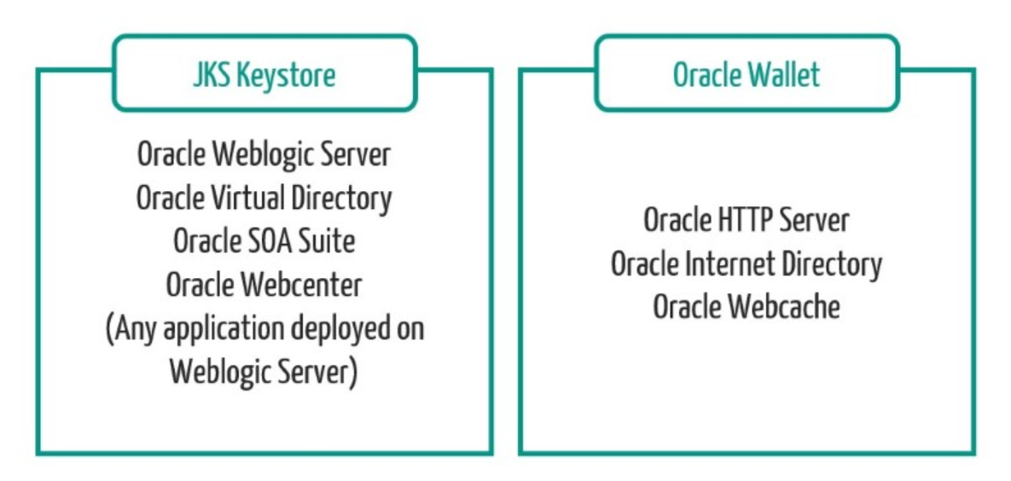

* Keystore Types

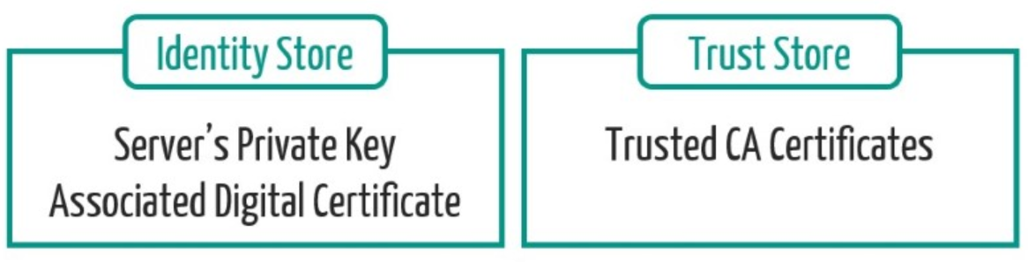

**Keystore Creation Using EM Console**

1. Login to Fusion Middleware EM Console using below URL and Weblogic administrator credentials
2. Navigate to Weblogic Domain -> Security -> Keystore:

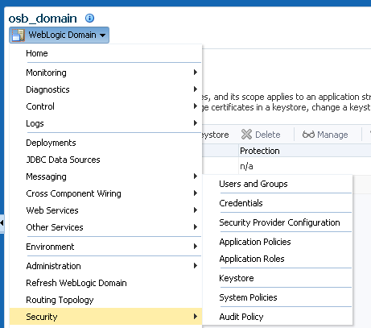

1. Click Create Keystore button

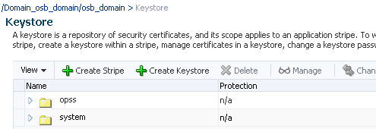

1. Provide new Keystore details and click OK

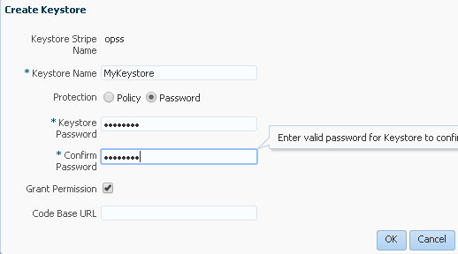

1. Verify new Keystore under your stripe:

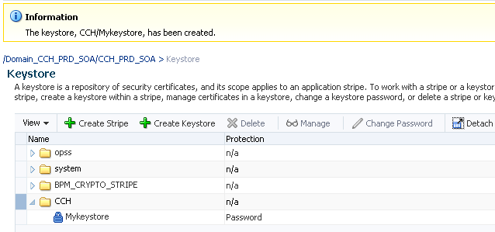

**Keypair & CSR Creation Using EM Console**

1. Select the new Keystore and click Manage:

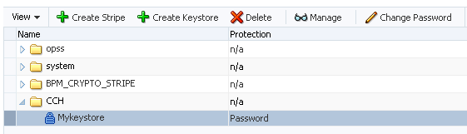

1. Click Generate Keypair which creates a public-private keypair



1. Provide details for your new keypair and click OK. Verify the new keypair details. Select it and click Generate CSR to generate a Certificate Signing Request



1. Provide password when prompted

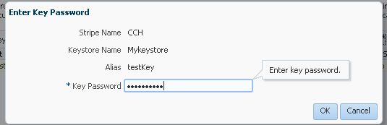

1. Copy the CSR content or export it to local machine to send it to third party Certificate Authority who will provide with a digitally signed certificate and trust certificates

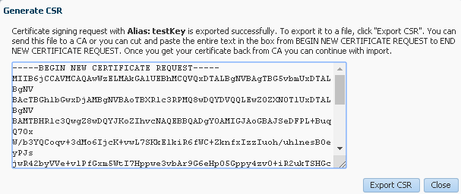

**Import Certificates Using EM Console**

1. Select alias on click Import on EM Console. Provide Keystore password when prompted

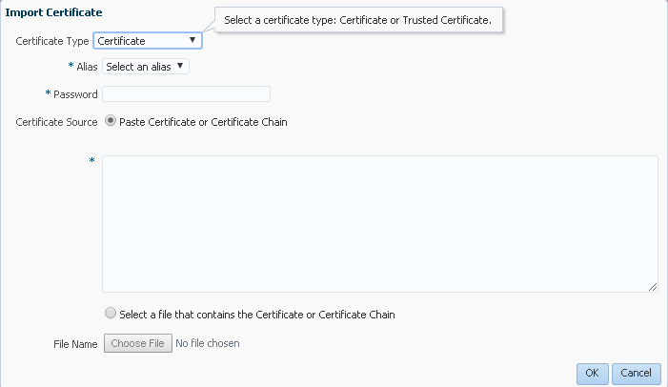

1. Provide details of the received certificates and click OK:

* Select either Trusted Certificate or Certificate depending on the type of certificate you are importing
* Select the alias from the drop down. Please select the same alias used while generating the CSR
* Provide the password for your Keystore
* For Certificate Source, you can either paste the certificate content directly or select the file received from the CA

