**(6428317 Mukesh P)**

***WEEK 2***

**Logging using SLF4J**

**MANDATORY HANDDS-ON:**

**Exercise 1: Logging Error Messages and Warning Levels:**

package com.example.logging;

import org.slf4j.Logger;

import org.slf4j.LoggerFactory;

public class LoggingExample {

private static final Logger *logger* = LoggerFactory.*getLogger*(LoggingExample.class);

public static void main(String[] args) {

*logger*.error("This is an error message");

*logger*.warn("This is a warning message");

}

}

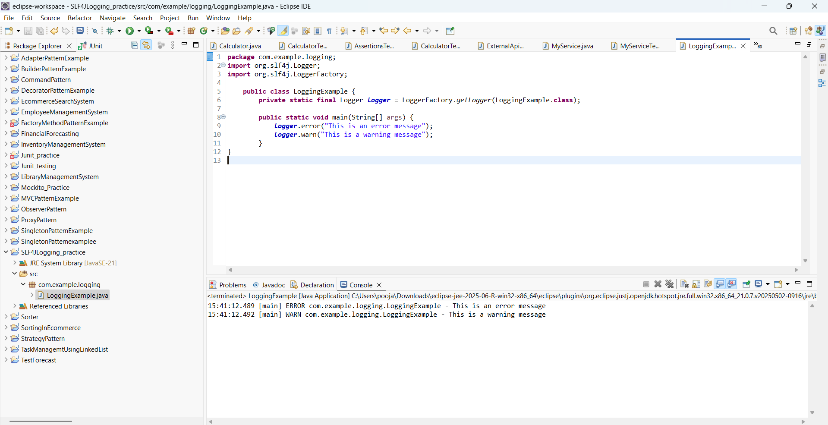

**---------------------------------------------------------------------------------------------------------**

**ADDITIONAL HANDS-ON:**

**Exercise 2: Parameterized Logging  
  
ParameterizedLogging.java:**

package com.example.logging;

import org.slf4j.Logger;

import org.slf4j.LoggerFactory;

public class ParameterizedLogging {

private static final Logger *logger* = LoggerFactory.*getLogger*(ParameterizedLogging.class);

public static void main(String[] args) {

String user = "Mukesh";

int age = 20;

*logger*.info("User {} has age {}", user, age);

*logger*.debug("Debug info for user: {}", user);

}

}

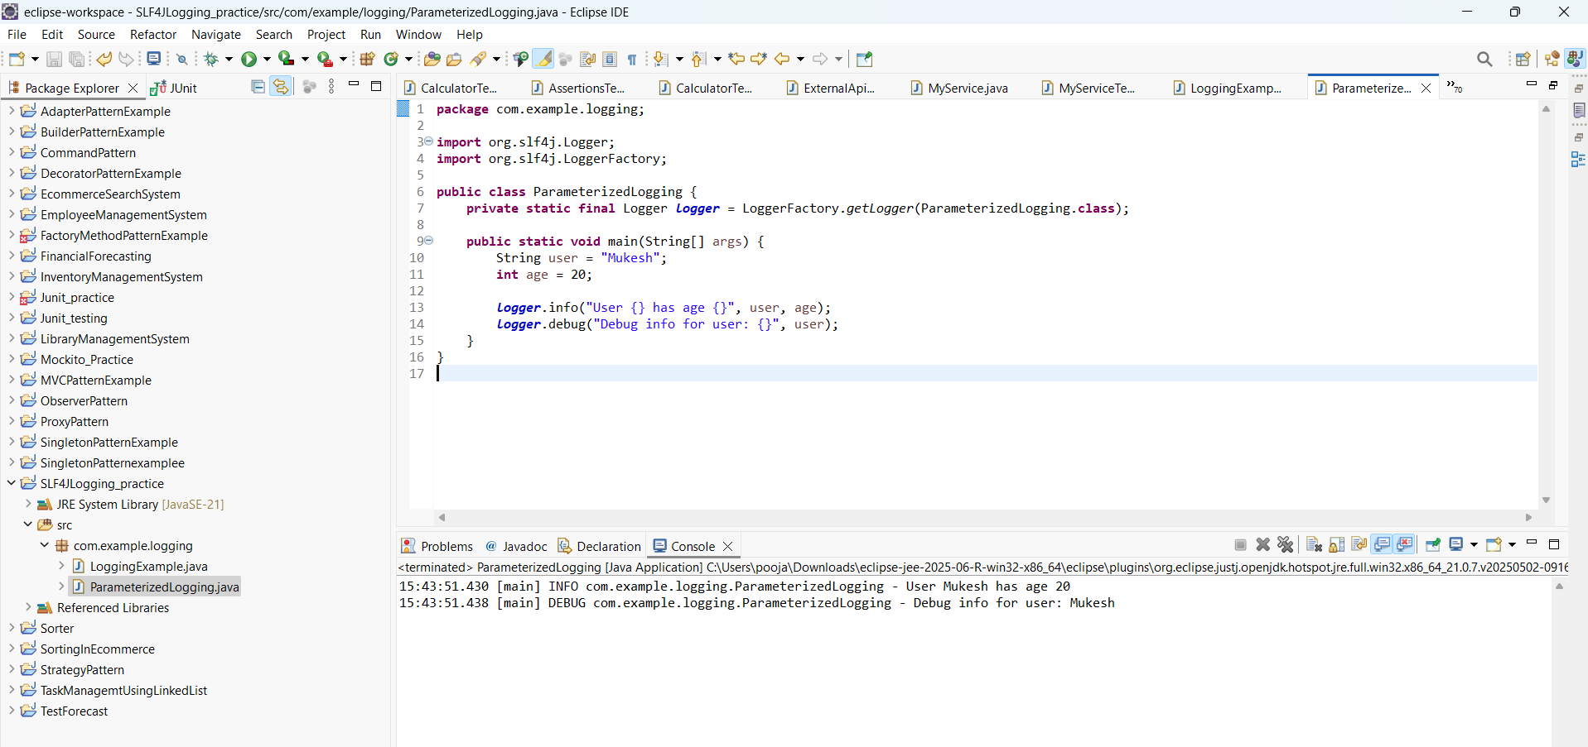

**Exercise 3: Using Different Appenders:**

package com.example.logging;

import org.slf4j.Logger;

import org.slf4j.LoggerFactory;

public class LoggingExample {

private static final Logger *logger* = LoggerFactory.*getLogger*(LoggingExample.class);

public static void main(String[] args) {

*logger*.error("This is an error message");

*logger*.warn("This is a warning message");

}

}

