**(6428317 Mukesh P)**

**WEEK 4 SPRING REST**

**Hands on 1**

**Create a Spring Web Project using Maven** 

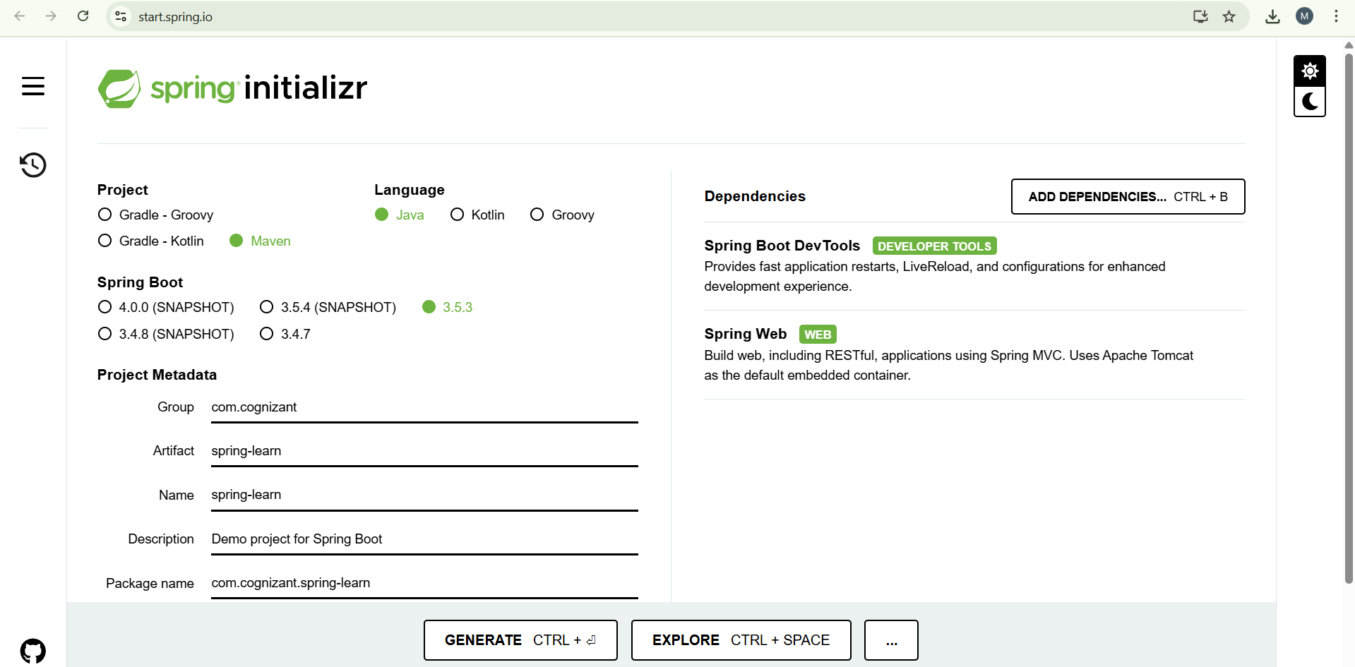

Build the project:

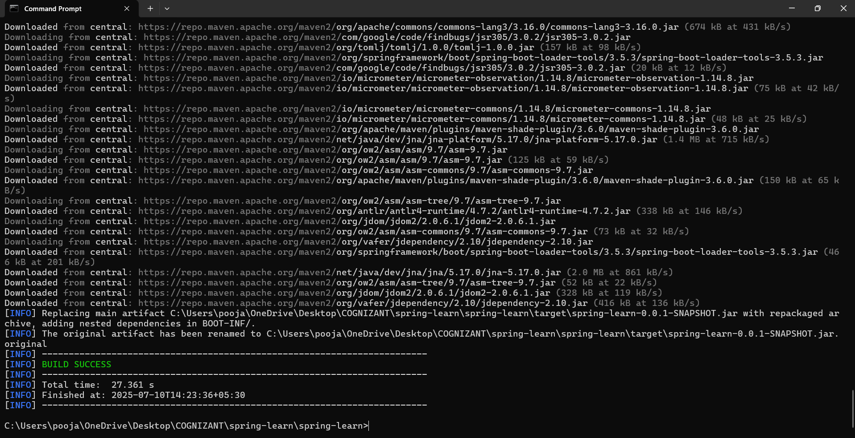

Included Logs:

**package** com.cognizant.spring_learn;

**import** org.slf4j.Logger;

**import** org.slf4j.LoggerFactory;

**import** org.springframework.boot.SpringApplication;

**import** org.springframework.boot.autoconfigure.SpringBootApplication;

@SpringBootApplication

**public** **class** SpringLearnApplication {

**private** **static** **final** Logger ***LOGGER*** = LoggerFactory.*getLogger*(SpringLearnApplication.**class**);

**public** **static** **void** main(String[] args) {

SpringApplication.*run*(SpringLearnApplication.**class**, args);

***LOGGER***.info("Inside main()");

}

}

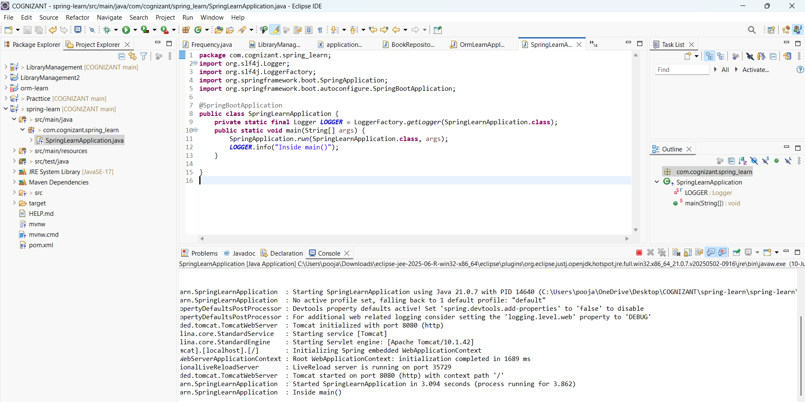

**Hands on 2**

**Spring Core – Load Country from Spring Configuration XML** 

**Country.java:**

**package** com.cognizant.spring_learn;

**import** org.slf4j.Logger;

**import** org.slf4j.LoggerFactory;

**public** **class** Country {

**private** **static** **final** Logger ***LOGGER***=LoggerFactory.*getLogger*(Country.**class**);

**private** String code;

**private** String name;

**public** Country() {

***LOGGER***.debug("Inside Country Constructor");

}

**public** String getCode(){

***LOGGER***.debug("Inside getCode()",code);

**return** code;

}

**public** **void** setCode(String code) {

***LOGGER***.debug("Inside setCode()",code);

**this**.code = code;

}

**public** String getName() {

***LOGGER***.debug("Inside getName()",name);

**return** name;

}

**public** **void** setName(String name) {

***LOGGER***.debug("Inside setName()",name);

**this**.name = name;

}

@Override

**public** String toString() {

**return** "Country [code=" + code + ", name=" + name + "]";

}

}

SpringLearnApplication.java:

**package** com.cognizant.spring_learn;

**import** org.slf4j.Logger;

**import** org.slf4j.LoggerFactory;

**import** org.springframework.boot.SpringApplication;

**import** org.springframework.boot.autoconfigure.SpringBootApplication;

**import** org.springframework.context.ApplicationContext;

**import** org.springframework.context.support.ClassPathXmlApplicationContext;

@SpringBootApplication

**public** **class** SpringLearnApplication {

**private** **static** **final** Logger ***LOGGER*** = LoggerFactory.*getLogger*(SpringLearnApplication.**class**);

**public** **static** **void** main(String[] args) {

SpringApplication.*run*(SpringLearnApplication.**class**, args);

*displayCountry*();

}

**public** **static** **void** displayCountry() {

ApplicationContext context = **new** ClassPathXmlApplicationContext("country.xml");

Country country = context.getBean("country", Country.**class**);

***LOGGER***.debug("Country : {}", country.toString());

}

}

**Country.xml:**

<?xml version=*"1.0"* encoding=*"UTF-8"*?>

<beans xmlns=*"http://www.springframework.org/schema/beans"*

xmlns:xsi=*"http://www.w3.org/2001/XMLSchema-instance"*

xsi:schemaLocation=*"http://www.springframework.org/schema/beans*

*http://www.springframework.org/schema/beans/spring-beans.xsd"*>

<bean id=*"country"* class=*"com.cognizant.spring_learn.Country"*>

<property name=*"code"* value=*"IN"* />

<property name=*"name"* value=*"India"* />

</bean>

</beans>

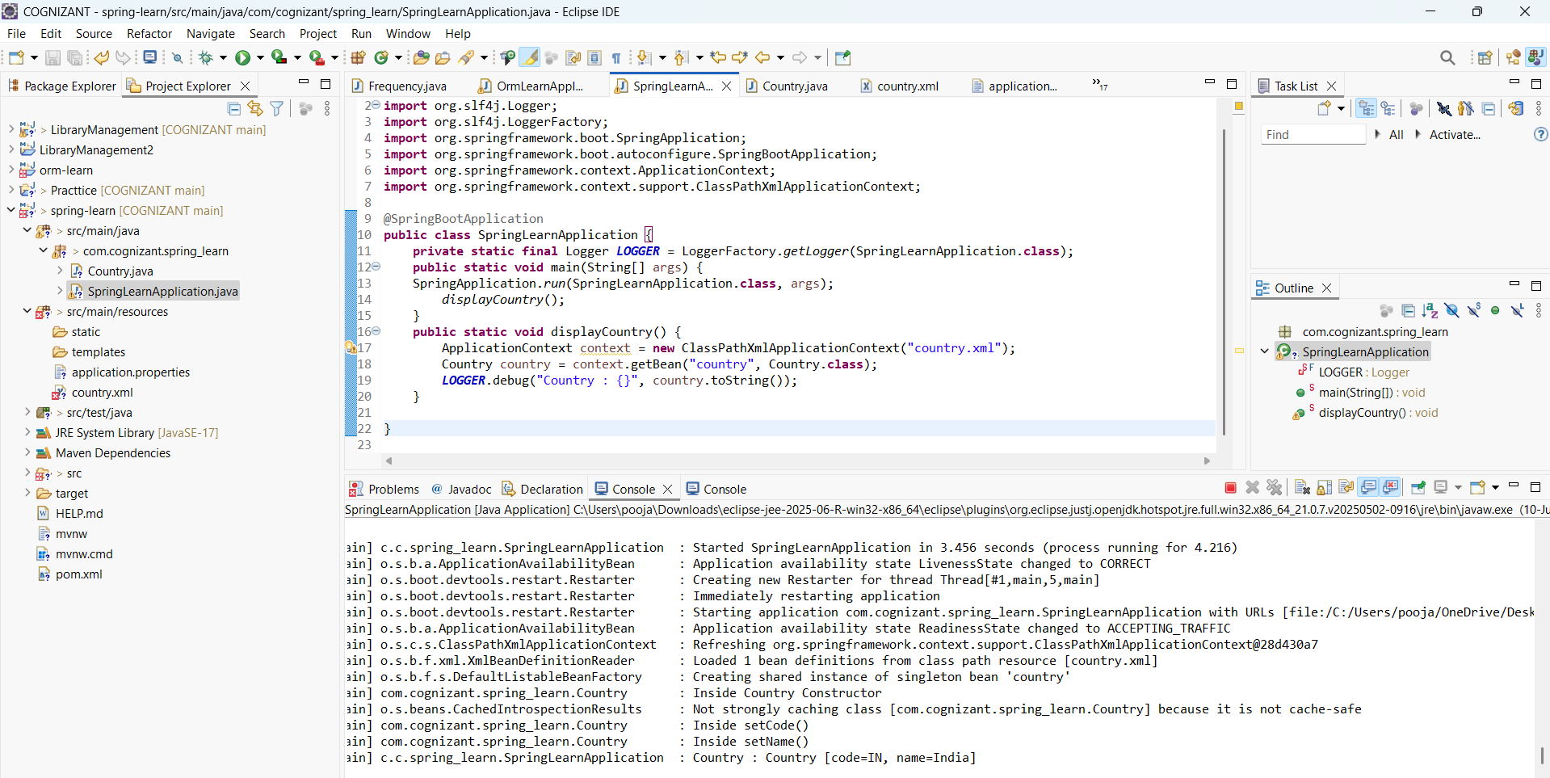

**HANDS ON 3**

**Hello World RESTful Web Service** 

**HelloController.java:**

**package** com.cognizant.spring_learn.controller;

**import** org.slf4j.Logger;

**import** org.slf4j.LoggerFactory;

**import** org.springframework.web.bind.annotation.GetMapping;

**import** org.springframework.web.bind.annotation.RestController;

@RestController

**public** **class** HelloController {

**private** **static** **final** Logger ***LOGGER*** = LoggerFactory.*getLogger*(HelloController.**class**);

@GetMapping("/hello")

**public** String sayHello() {

***LOGGER***.info("START sayHello()");

String message = "Hello World!!";

***LOGGER***.info("END sayHello()");

**return** message;

}

}

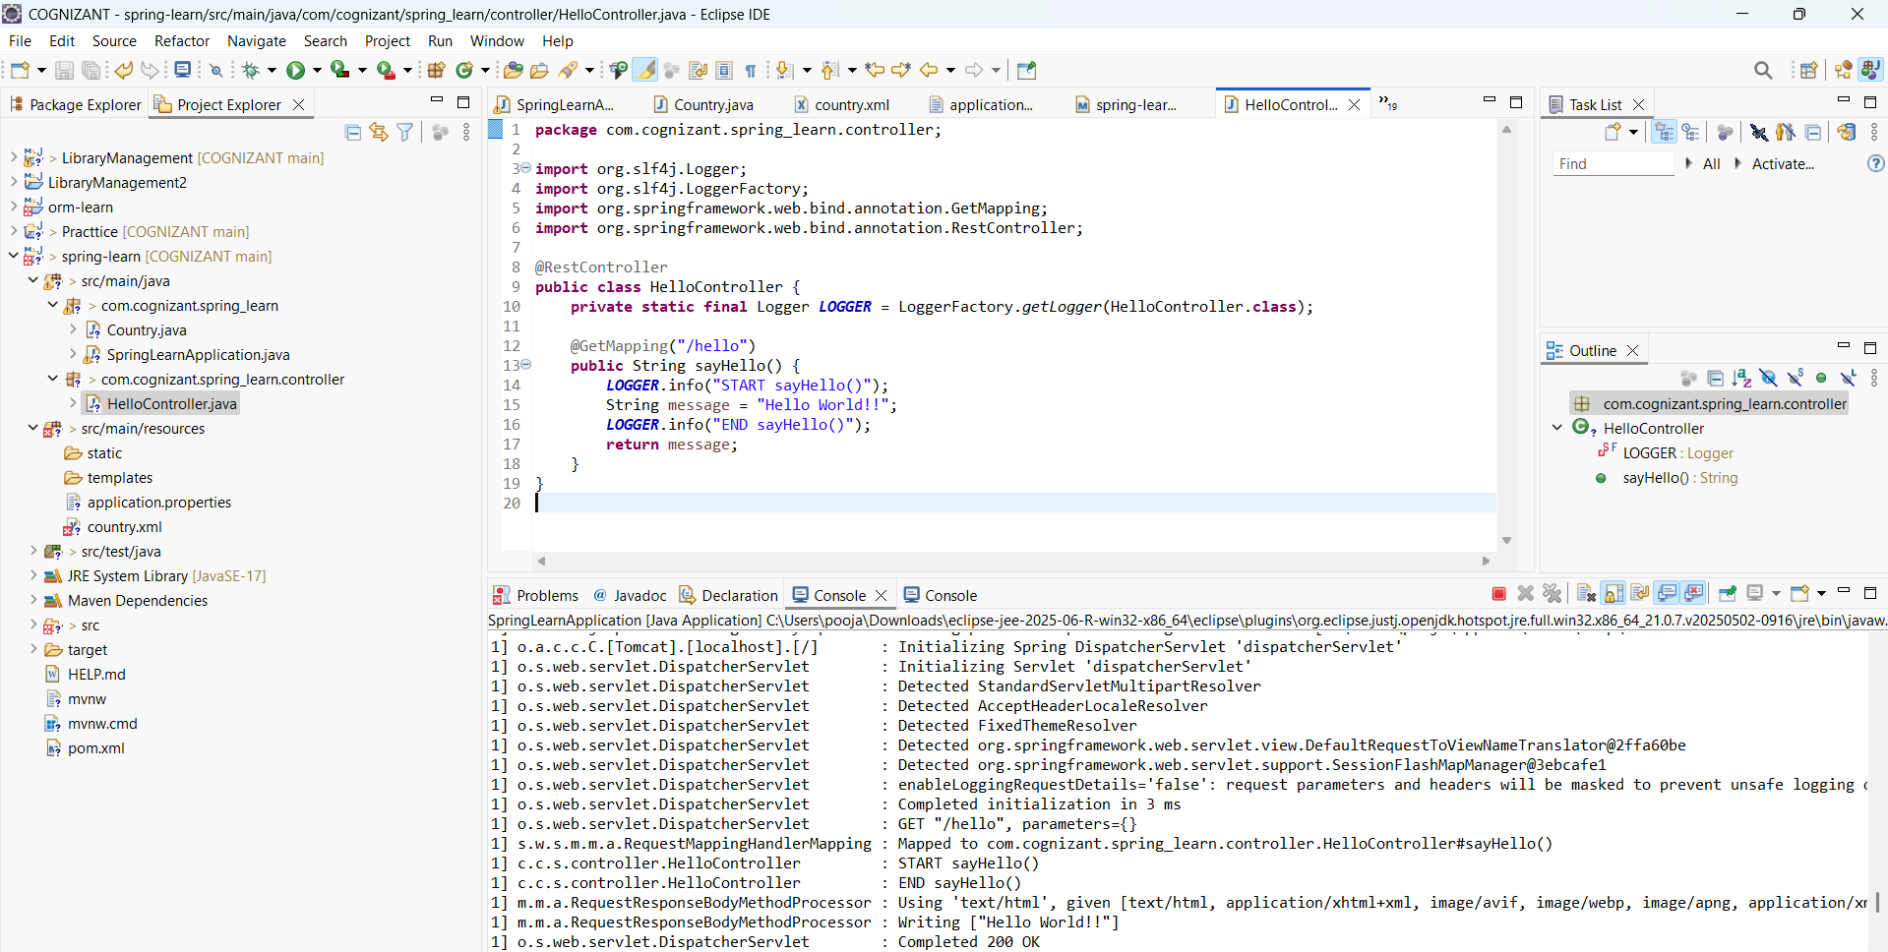

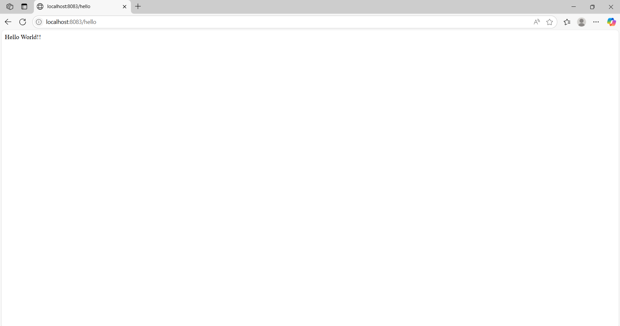

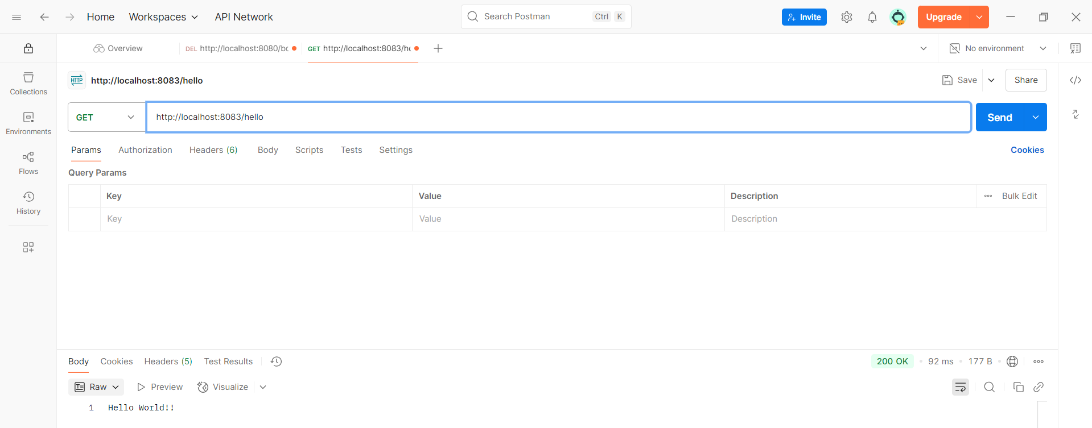

**HANDS ON 4**

**REST - Country Web Service**

**CountryController.java:**

**package** com.cognizant.spring_learn.controller;

**import** com.cognizant.spring_learn.Country;

**import** org.slf4j.Logger;

**import** org.slf4j.LoggerFactory;

**import** org.springframework.context.ApplicationContext;

**import** org.springframework.context.support.ClassPathXmlApplicationContext;

**import** org.springframework.web.bind.annotation.RequestMapping;

**import** org.springframework.web.bind.annotation.RestController;

@RestController

**public** **class** CountryController {

**private** **static** **final** Logger ***LOGGER*** = LoggerFactory.*getLogger*(CountryController.**class**);

@RequestMapping("/country")

**public** Country getCountryIndia() {

***LOGGER***.info("START getCountryIndia()");

ApplicationContext context = **new** ClassPathXmlApplicationContext("country.xml");

Country country = context.getBean("country", Country.**class**);

***LOGGER***.info("END getCountryIndia()");

**return** country;

}

}

**Country.xml:**

<?xml version=*"1.0"* encoding=*"UTF-8"*?>

<beans xmlns=*"http://www.springframework.org/schema/beans"*

xmlns:xsi=*"http://www.w3.org/2001/XMLSchema-instance"*

xsi:schemaLocation=*"http://www.springframework.org/schema/beans*

*http://www.springframework.org/schema/beans/spring-beans.xsd"*>

<bean id=*"country"* class=*"com.cognizant.spring_learn.Country"*>

<property name=*"code"* value=*"IN"* />

<property name=*"name"* value=*"India"* />

</bean>

</beans>

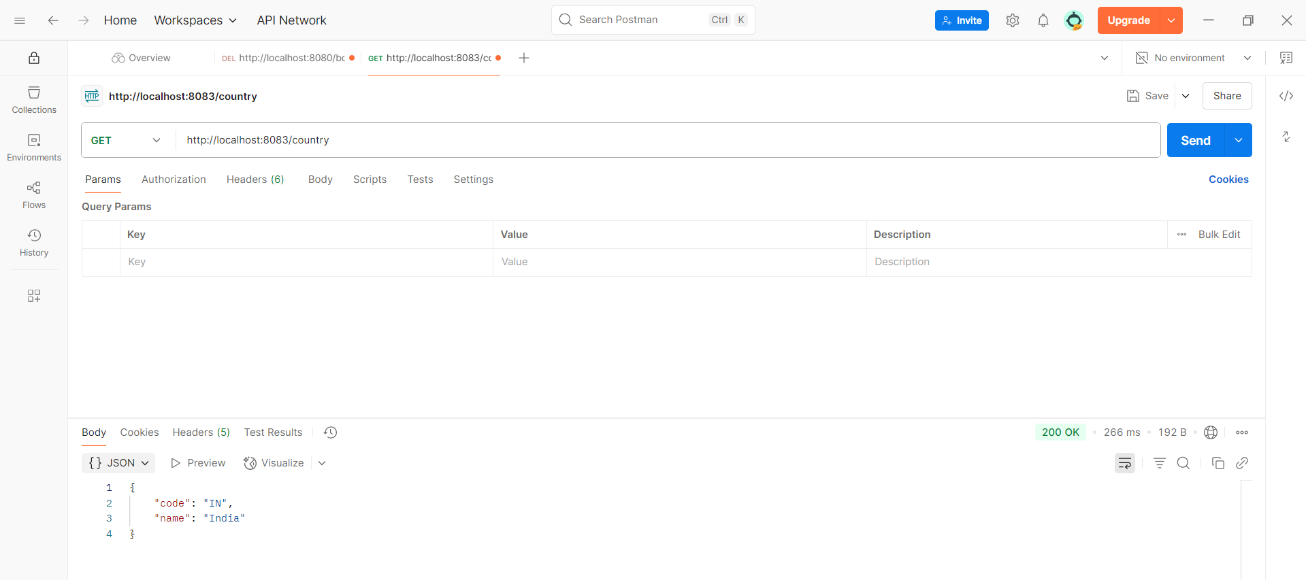

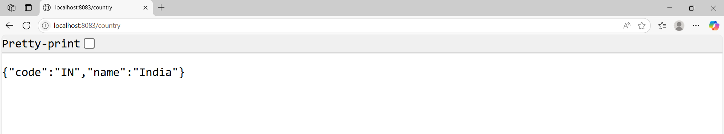

**HANDS ON 5**

**REST - Get country based on country code** 

**CountryController.java:**

**package** com.cognizant.spring_learn.controller;

**import** com.cognizant.spring_learn.Country;

**import** com.cognizant.spring_learn.service.CountryService;

**import** org.slf4j.Logger;

**import** org.slf4j.LoggerFactory;

**import** org.springframework.beans.factory.annotation.Autowired;

**import** org.springframework.web.bind.annotation.*;

@RestController

**public** **class** CountryController {

**private** **static** **final** Logger ***LOGGER*** = LoggerFactory.*getLogger*(CountryController.**class**);

@Autowired

**private** CountryService countryService;

@GetMapping("/countries/{code}")

**public** Country getCountry(@PathVariable String code) {

***LOGGER***.info("START getCountry()");

Country country = countryService.getCountry(code);

***LOGGER***.info("END getCountry()");

**return** country;

}

}

**Country.xml:**

<?xml version=*"1.0"* encoding=*"UTF-8"*?>

<beans xmlns=*"http://www.springframework.org/schema/beans"*

xmlns:xsi=*"http://www.w3.org/2001/XMLSchema-instance"*

xsi:schemaLocation=*"http://www.springframework.org/schema/beans*

*http://www.springframework.org/schema/beans/spring-beans.xsd"*>

<bean id=*"in"* class=*"com.cognizant.spring_learn.Country"*>

<property name=*"code"* value=*"IN"* />

<property name=*"name"* value=*"India"* />

</bean>

<bean id=*"us"* class=*"com.cognizant.spring_learn.Country"*>

<property name=*"code"* value=*"US"*/>

<property name=*"name"* value=*"United States"*/>

</bean>

<bean id=*"de"* class=*"com.cognizant.spring_learn.Country"*>

<property name=*"code"* value=*"DE"*/>

<property name=*"name"* value=*"Germany"*/>

</bean>

<bean id=*"jp"* class=*"com.cognizant.spring_learn.Country"*>

<property name=*"code"* value=*"JP"*/>

<property name=*"name"* value=*"Japan"*/>

</bean>

<bean id=*"countryList"* class=*"java.util.ArrayList"*>

<constructor-arg>

<list>

<ref bean=*"in"*/>

<ref bean=*"us"*/>

<ref bean=*"de"*/>

<ref bean=*"jp"*/>

</list>

</constructor-arg>

</bean>

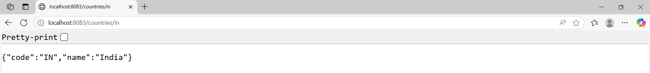

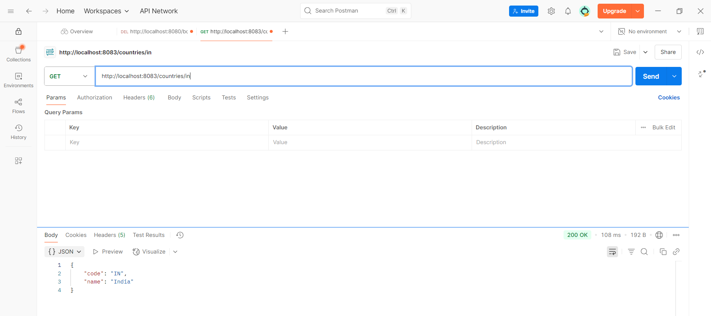

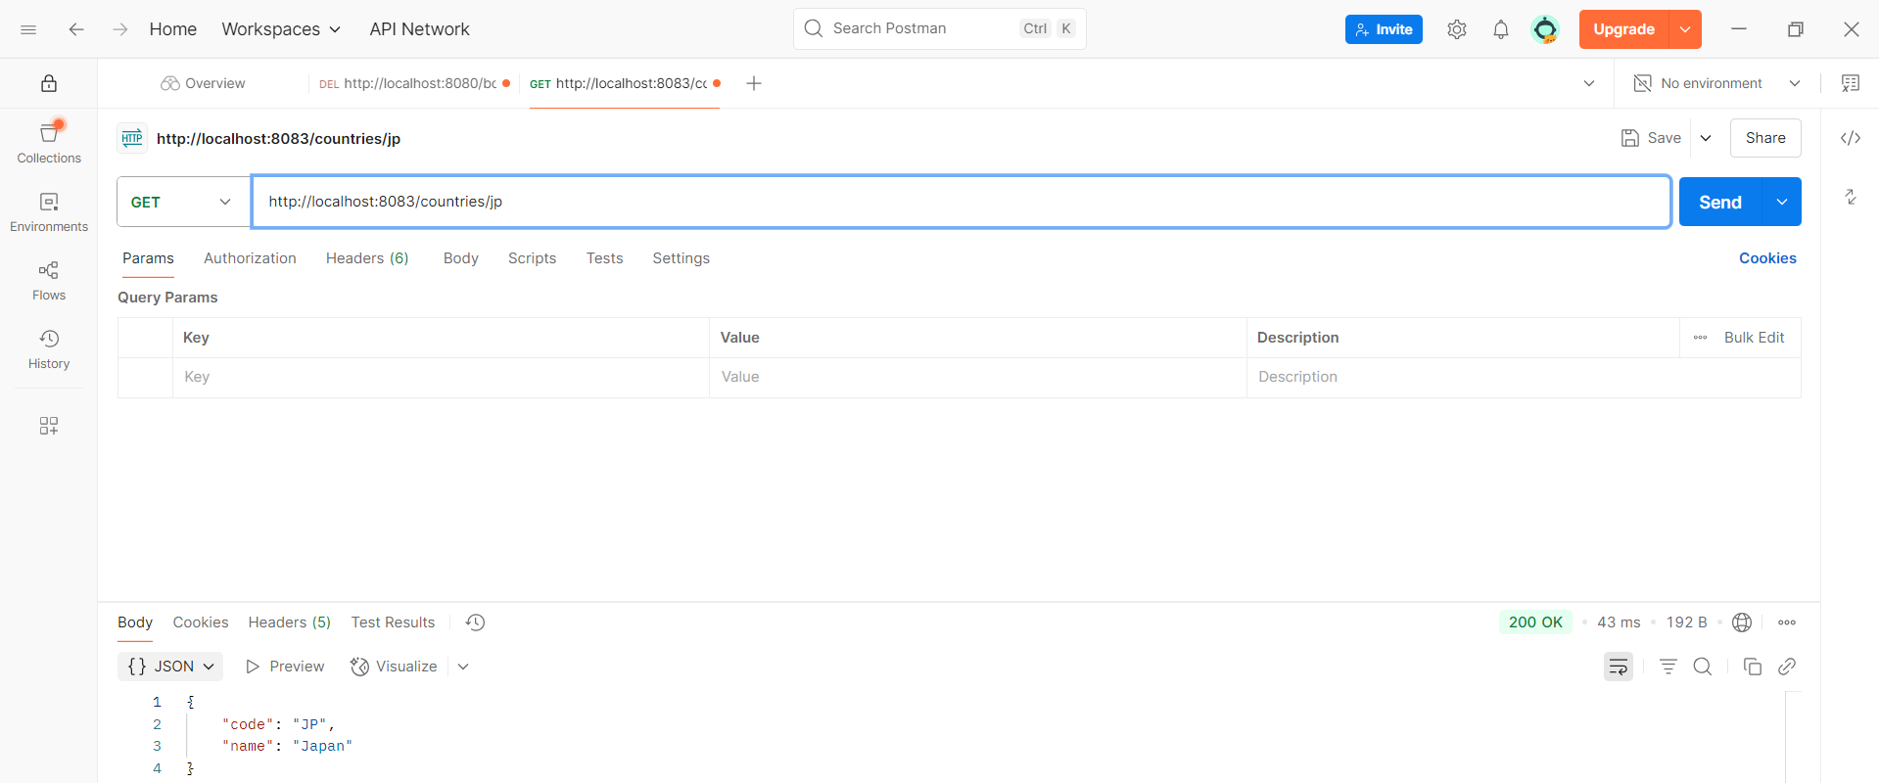

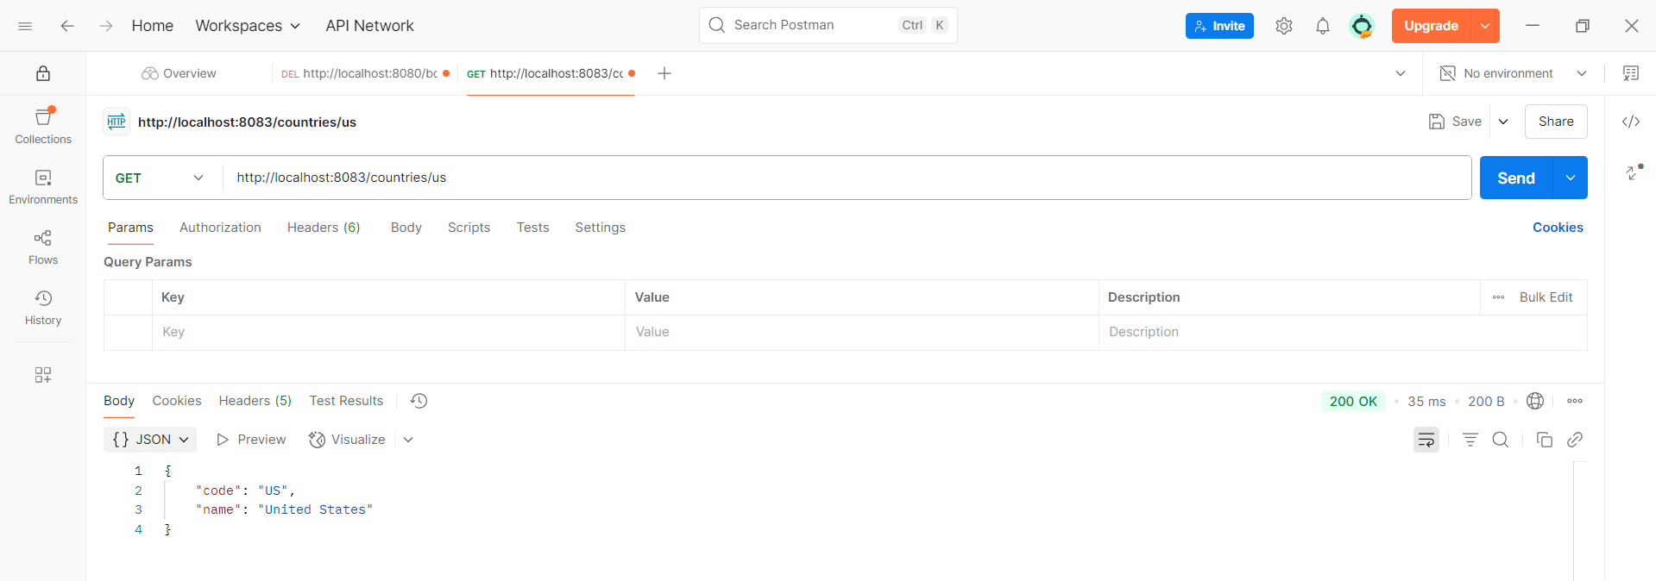

**HANDS ON 6**

**Create authentication service that returns JWT** :

**AuthenticationController.java:**

**package** com.cognizant.spring_learn.controller;

**import** com.cognizant.spring_learn.security.JwtUtil;

**import** org.springframework.beans.factory.annotation.Autowired;

**import** org.springframework.http.ResponseEntity;

**import** org.springframework.web.bind.annotation.*;

**import** java.util.Base64;

**import** jakarta.servlet.http.HttpServletRequest;

@RestController

**public** **class** AuthenticationController {

@Autowired

**private** JwtUtil jwtUtil;

@GetMapping("/authenticate")

**public** ResponseEntity<?> authenticate(HttpServletRequest request) {

String authHeader = request.getHeader("Authorization");

**if** (authHeader == **null** || !authHeader.startsWith("Basic ")) {

**return** ResponseEntity.*status*(401).body("Missing or invalid Authorization header");

}

String base64Credentials = authHeader.substring("Basic ".length());

**byte**[] credDecoded = Base64.*getDecoder*().decode(base64Credentials);

String credentials = **new** String(credDecoded);

String[] values = credentials.split(":", 2);

String username = values[0];

String password = values[1];

**if** (username.equals("user") && password.equals("pwd")) {

String token = jwtUtil.generateToken(username);

**return** ResponseEntity.*ok*().body("{\"token\":\"" + token + "\"}");

} **else** {

**return** ResponseEntity.*status*(401).body("Invalid credentials");

}

}

}

**JwtUtil.java:**

**package** com.cognizant.spring_learn.security;

**import** io.jsonwebtoken.Jwts;

**import** io.jsonwebtoken.SignatureAlgorithm;

**import** io.jsonwebtoken.security.Keys;

**import** java.util.Date;

**import** javax.crypto.SecretKey;

**import** org.springframework.stereotype.Component;

@Component

**public** **class** JwtUtil {

**private** **static** **final** **long** ***EXPIRATION_TIME*** = 600_000; // 10 minutes

**private** **static** **final** SecretKey ***SECRET_KEY*** = Keys.secretKeyFor(SignatureAlgorithm.HS256);

**public** String generateToken(String username) {

**return** Jwts.builder()

.setSubject(username)

.setIssuedAt(**new** Date())

.setExpiration(**new** Date(System.*currentTimeMillis*() + ***EXPIRATION_TIME***))

.signWith(***SECRET_KEY***)

.compact();

}

}

**SecurityConfig.java:**

**package** com.cognizant.spring_learn.config.SecurityConfig;

**import** org.springframework.context.annotation.Bean;

**import** org.springframework.context.annotation.Configuration;

**import** org.springframework.security.config.Customizer;

**import** org.springframework.security.config.annotation.web.builders.HttpSecurity;

**import** org.springframework.security.web.SecurityFilterChain;

@Configuration

**public** **class** SecurityConfig {

@Bean

**public** SecurityFilterChain filterChain(HttpSecurity http) **throws** Exception {

http

.csrf(csrf -> csrf.disable())

.authorizeHttpRequests(auth -> auth

.requestMatchers("/authenticate").permitAll()

.anyRequest().authenticated()

)

.httpBasic(Customizer.*withDefaults*());

**return** http.build();

}

}



