**(6428317 Mukesh P)**

**WEEK 5 MICROSERVICES**

**Creating Microservices for account and loan**

**Account Microservice**

**AccountController.java:**

**package** com.cognizant.account.controller;

**import** org.springframework.web.bind.annotation.*;

**import** java.util.Map;

@RestController

@RequestMapping("/accounts")

**public** **class** AccountController {

@GetMapping("/{number}")

**public** Map<String,Object>getAccountDetails(@PathVariable String number){

**return** Map.*of*(

"number",number,

"type","savings",

"balance",234343);

}

}

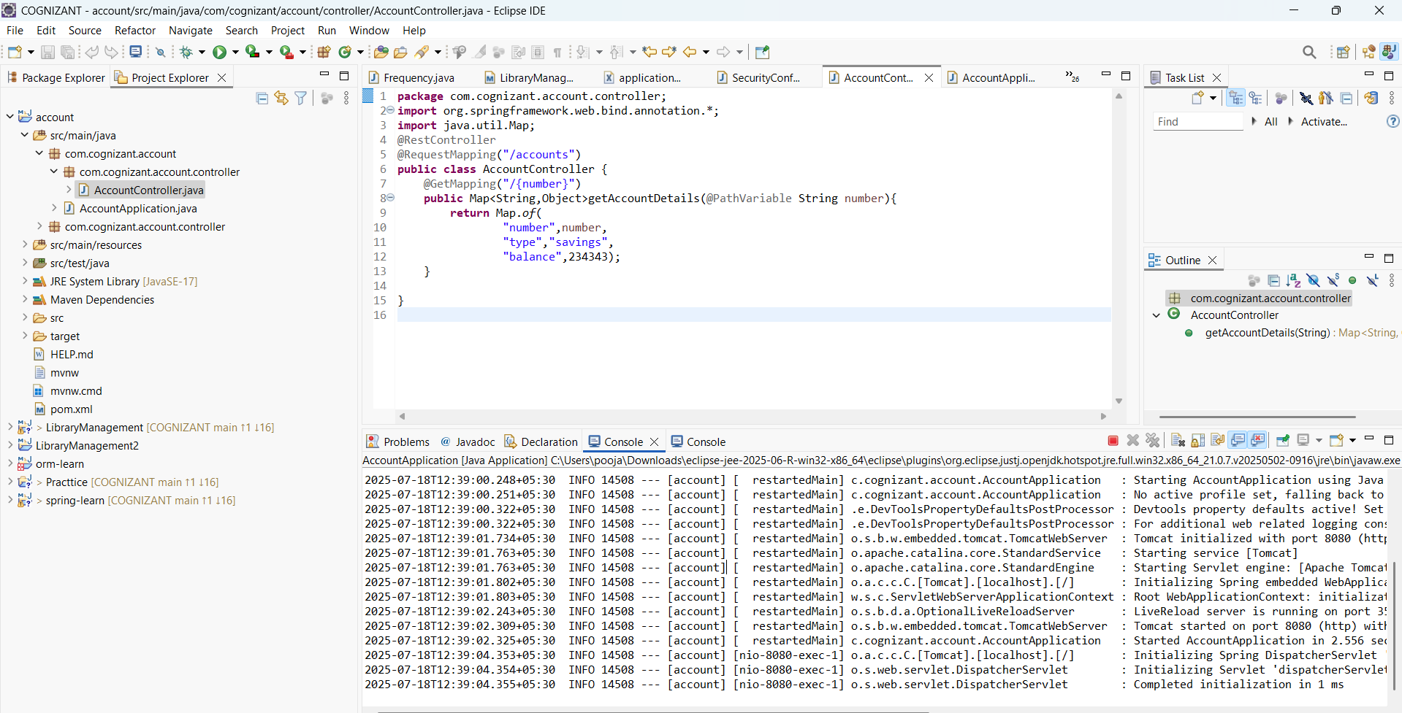

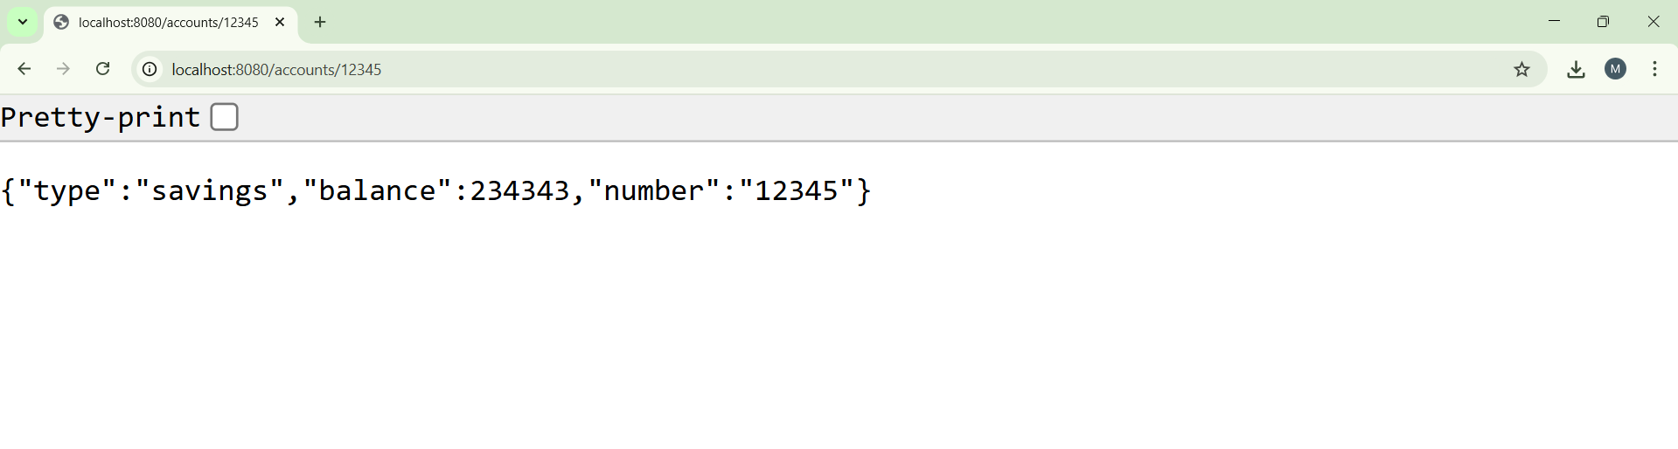

**Loan Microservice**

**LoanController.java:**

**package** com.cognizant.loan.controller;

**import** org.springframework.web.bind.annotation.*;

**import** java.util.Map;

@RestController

@RequestMapping("/loans")

**public** **class** LoanController {

@GetMapping("/{number}")

**public** Map<String, Object> getLoanDetails(@PathVariable String number) {

**return** Map.*of*(

"number", number,

"type", "car",

"loan", 400000,

"emi", 3258,

"tenure", 18

);

}

}

