**A**

**Industrial Training Report**

On

**“Stock Management System”**

Submitted

In Partial Fulfillment of the Requirements

For the Degree of

Bachelor of Technology

In

Computer Science and Engineering

By

**Shahrukh**

**1500410039**

**2015-19**

**IVth Year**

Sponsored by:

**E-GAIN Pvt. Ltd. Delhi**



**Department of Computer Science & Engineering**

**F. E. T., R. B. S. Engineering Technical Campus, Bichpuri, Agra (U. P.)**

**Declaration**

I declare that the industrial training work presented in this report titled “**Stock Management System”**. Submitted to the Computer Science & Engineering Department, R.B.S. ENGGINEERING TECHNICAL CAMPUS, for the award of the Bachelor of Technology degree in **Computer Science & Engineering**, is my original work. I have not plagiarized or submitted the same work for the award of any other degree.

SHAHRUKH

**Certificate**

**ACKNOWLEDGEMENT**

I am grateful to E-GAIN Pvt. Ltd, Delhi for giving me opportunity to carry out the project work in the area of console-based portal designing during my training. I would like to also thank my institute, Raja Balwant Singh Engineering Technical Campus, Agra for giving permission and necessary administrative support to take up the training work at E-GAIN Pvt Ltd, Agra.

Deepest thanks to our Trainer **Mr Tajendar Arora(SCJP)** for his guidance, monitoring, constant encouragement and correcting various assignments of ours with attention and care. He has taken pain to go through the project and training sessions and make necessary corrections as when needed and we are very grateful for that.

SHAHRUKH

**Abstract**

Stock Management System is a web-based application developed using Java programming language. The main objective of this project is to manage a stock for a company or organization, and take care of sales and purchase of products. This project includes various modules and features to add, edit, view and delete stock-management-related things in the system database.

All these processes should be done in an automated manner and for that we require an application so that all the data can be logically and relatively used for accurate outcomes. This system should able to replace the existing technique without any specific moderation and problems.

**Table of Contents**

Declaration i

Certificate ii

Acknowledgement iii

Abstract iv

1. Introduction 1
2. The Training Organization 3
3. Body of Industrial Training 4
   1. Daily Records 4
   2. About the Training 6
   3. Training Schedule and location 8
   4. Learning outcome and work experience 9
      1. Description of Tasks 10
      2. Application of Theory and skills 21
4. Conclusion 23

**5.** References 24

**List of Figures**

Figure 1 19

Figure 2 20

Figure 3 21

Figure 4 22

Figure 5 23

**Chapter -1**

**Introduction**

My training was done under the guidance ofMr**Tajendar Arora**. Where I’ve learned how to develop a DESKTOPAPPLICATION using the Java. In this way, I’ve learned COREJAVA for the complete coding done at the backend of the application. In institute, the training staffs were of four members. They all were well experienced, very helpful, friendly and so much supportive in nature. During my 4 weeks of training session they taught us about everything in java, during my training session which was of 6 weeks, I develop several applications. In this way, I learnt so much about java and moreover the trainers were always available for us during training session and they also provide a facility of online solution of queries after the training period.

In the end of my industrial training I’ve developed few applications which are:

* Notepad
* Stock Management System
* Multimedia Calculator
* Bubble Game

These projects were too much helped me a lot in learning about how to work with Java and develop application with it.

Objectives of the report and write-up are to develop the skills for maintaining the documents of your projects and to prepare a brief note in 1 page.

Training is a learning process that involves the gain of knowledge, sharpening of skills, concepts, rules, and changing of attitude and behavior to enhance the performance.

Industrial training refers to a program which aims to provide supervised practical training within limited time. The training can be carried out either in government organizations or in the private sector institution.

* Industrial training is a process whereby an individual acquires job-related skills, knowledge and a basic understanding of company’s functioning.
* Industrial training introduces students to work culture and industrial practices.
* The industrial training program provides direction to the working world.
* Industrial training refers to work experience that is enough to professional development prior to graduation.
* Training is the acquisition of knowledge, skills, and abilities (KSA) through professional development.

**Chapter-2**

**The Training Organization**

In institute, the training staffs were of four members. They all were well experienced, very helpful, friendly and so much supportive in nature. My training organization was very well maintained. At the training center, all the students able to access internet all the time and also the environment were very amazing there.

**E-GAINPvt Ltd** Mr.Tajendar Arora has around 15 years of rich experience under his belt with regards to imparting Training, Software development, Software support, Education and Consultation services, including high-end technologies like Java, J2EE, Struts, Spring, Hibernate, XML, jQuery, Angular JS, Node JS, C#, .net framework, SQL-Server, Oracle etc. to various corporate in India and Abroad. He is a Sun Certified Trainer holding a list of Credentials from different other corporate. He also has valuable experience in administration of other technologies pertaining to MS-Office Suite - advanced MS-Excel (Basics, Advanced, Financial module), VBA MS-Project, and SQL SERVER.

**E-GAIN Pvt Ltd** reputation and fame has grown tremendously under the guidance of Honorable Mr. Tajendar Arora.

E-GAIN Pvt Ltd is ISO certified training center for the summer trainings, winter training as well as learning coding and programming. They use live projects to teach their students. They have high and latest technology for providing their services. They also have high network connectivity in their organization.

**E-GAIN Pvt Ltd**MrTajendar Arora also member of US Based club called Toastmaster (Soft Skills). he has been into software development with NIIT technologies, Steria UK and delivering on-site training to various Multinational and Governmental Organizations and universities like CTS, IBM, NIIT Technologies,Infogain, HCL, Steria UK, Barclays Bank, APTECH,MSME (Govt. of India), Central Bank of India,CanaraBank,UGI,KP Engineering College, Bundelkhand University etc.

**Chapter-3**

**Body of Industrial Training**

**3.1 Daily Records:**

|  |  |  |  |
| --- | --- | --- | --- |
| **Day** | **Training Time** | **Task Assigned** | **Status of Task** |
| Day- 1 | 07:00 A.M to 9:00 P.M | Reported | Successful |
| Day-2 | 07:00 A.M to 9:00 P.M | Introduction about Java | Successful |
| Day- 3 | 07:00 A.M to 9:00 P.M | Obtaining the Required tools | Successful |
| Day- 4 | 07:00 A.M to 9:00 P.M | Setting up Environment | Successful |
| Day- 5 | 07:00 A.M to 9:00 P.M | Learn about Data Types, Variables and Arrays | Successful |
| Day- 6 | 07:00 A.M to 9:00 P.M | Use of Decision making and looping concept | Successful |
| Day- 7 | 07:00 A.M to 9:00 P.M | Classes and methods | Successful |
| Day- 8 | 07:00 A.M to 9:00 P.M | Inheritance, Final Keyword, Abstract Class | Successful |
| Day- 9 | 07:00 A.M to 9:00 P.M | Wrapper Class, Packages and Object Class | Successful |
| Day-10 | 07:00 A.M to 9:00 P.M | String Handling | Successful |
| Day- 11 | 07:00 A.M to 9:00 P.M | Learn about the Exception Handling | Successful |
| Day- 12 | 07:00 A.M to 9:00 P.M | Multithreading | Successful |
| Day- 13 | 07:00 A.M to 9:00 P.M | Learn about the Applet Programming | Successful |
| Day- 14 | 07:00 A.M to 9:00 P.M | Learn about the Java IO | In progress |
| Day- 15 | 07:00 A.M to 9:00 P.M | Use of Java Collection Frame Work | Successful |
| Day- 16 | 07:00 A.M to 9:00 P.M | Java Regx | Successful |
| Day- 17 | 07:00 A.M to 9:00 P.M | Introduction about the Generics | Successful |
| Day-18 | 07:00 A.M to 9:00 P.M | International& Localization | Successful |
| Day-19 | 07:00 A.M to 9:00 P.M | Serialization | Successful |
| Day-20 | 07:00 A.M to 9:00 P.M | Introduction of Swing | Successful |
| Day-21 | 07:00 A.M to 9:00 P.M | Learn about the Jlabel, Jbutton, JtextField, JpasswordField | Successful |
| Day-22 | 07:00 A.M to 9:00 P.M | Learn about the JtextArea, JradioButton, JcomboBox | Successful |
| Day-23 | 07:00 A.M to 9:00 P.M | Use of Jslider, Jspinner, JprogressBar | Successful |
| Day-24 | 07:00 A.M to 9:00 P.M | Use of JcolorChooser, JfileChooser, Jtree | Successful |
| Day-25 | 07:00 A.M to 9:00 P.M | Use of Jtable, | Successful |
| Day-26 | 07:00 A.M to 9:00 P.M | Learn about the methods of Swing | Successful |
| Day-27 | 07:00 A.M to 9:00 P.M | Learn about the JmenuBar | Successful |
| Day-28 | 07:00 A.M to 9:00 P.M | Learn about the Event Handling | Successful |
| Day-29 | 07:00 A.M to 9:00 P.M | Creating a small Bubble game | Successful |
| Day-30 | 07:00 A.M to 9:00 P.M | Use of JtabbedPan | Successful |
| Day-31 | 07:00 A.M to 9:00 P.M | Creating an Enquiry Form | Successful |
| Day-32 | 07:00 A.M to 9:00 P.M | Use of String pool | Successful |
| Day-33 | 07:00 A.M to 9:00 P.M | Use of String Buffer | Successful |
| Day-34 | 07:00 A.M to 9:00 P.M | Use of Hash Code | Successful |
| Day-35 | 07:00 A.M to 9:00 P.M | Learn about the Cloning of object | Successful |
| Day-36 | 07:00 A.M to 9:00 P.M | Legacy class | Successful |
| Day-37 | 07:00 A.M to 9:00 P.M | Learn about Date and Calendar Classes | Successful |
| Day-38 | 07:00 A.M to 9:00 P.M | Use of Streams | Successful |
| Day-39 | 07:00 A.M to 9:00 P.M | Learn About the DataBase | Inprogress |
| Day-40 | 07:00 A.M to 9:00 P.M | Use of JDBC | Successful |
| Day-41 | 07:00 A.M to 2:00 P.M | Creating a Stock management System application | In progress |
| Day-42 | 07:00 A.M to 2:00 P.M | Design all modules of this application | In progress |
| Day-43 | 07:00 A.M to 2:00 P.M | Remove all the debugs of the project | Successful |
| Day-44 | 07:00 A.M to 9:00 P.M | Tested by guide | Successful |
| Day-45 | 07:00 A.M to 9:00 P.M | Presented to head guide | Successful |

**3.2 About the Training:**

The place where I carried out my training was E-GAIN Pvt Ltd, Delhi. The training was approximately for 6 weeks but when I reported there, they told me that I must stay there till I complete my project. On the first day when I reached there, I went to the concerned guide whose name was written on the letter of E-GAIN Pvt Ltd. I reported to him & then he assigned me the department where I had to work. After that I reported to that department which was assigned to me, then my head guide told me about the training organization and asked me about my academics that what do I know and all. After that he asked me some questions related to C because C is the base of all languages. After that interview section he assigned me a guide and then asked me to report the guide. My guide was also very nice person he also asked me about my academics and after that he told me about his requirement for software and asked me to develop the project. The training was very helpful for me as I learned many things from there i.e. how to work in a team, how to solve the problems which arises during the project.

The place of training was Delhi. There we learned about many new technologies which are in the market now days. This training result is giving many positive points to me.

**Planning Steps**

* Planning is the very important part of any project, before building a project we have to make certain plans which could be beneficial & effective to complete a project effectively, so the steps we followed in planning phase are:
* **Goal Setting**: This is the first & most crucial step of any project i.e. to set a goal to start any work it should be the initial step in every project also I have a set a goal that what work should be carried out. If the goal is known, then only the task can be completely successfully. So, I had also made a goal about the project after which I had analysedanother necessary thing also.
* **Developing the planning premises:** After setting the goals, I analysed about the material/ technology needed to develop the project. I was asked to adjust from those things which were available inside the establishment. I analysed the systems specifications and according to that I finalized the technology in which the project was to be made.
* **Feasibility Study**: Feasibility study is the important part which is to be studied before building a project, this includes each & every detail discussion of the project, according to the discussion in this part it is decided that is the development of the project possible or not. Is there that much finance/ resources easily available which are required to build the project?
* **Deciding the planning period**: After all the tasks & analysis, I divided the tasks into different modules & attempted to assign a time period to all those tasks in which they could get completed. The time which was decided included most of the factors which could cause interruption. But still the time period was divided in such a way that it doesn’t exceeded the overall time period of whole project.

### Formulation of policies & strategies: In this phase, I made various strategies for carrying out my work. The main strategy was to breakdown the work into different parts so that it could become easy to perform that work.

### Preparing operating plans:In this phase, plans which were made, modules which were made were operated and the appropriate work was carried out. The tasks were started on the respective time & the operations were also performed to make the functionality of a product better.

### Integration of plans: After the development of different modules, our main step is to join all those modules in a proper manner so that it fulfills the design of a project, functionality, requirement of a project. While integrating the modules various types of testing is to be performed such as unit testing, integration testing, etc. These all testing techniques are used in order to test the compatibility & functionality of a project with different conditions.

**3.3 Training Schedule and Location:**

My training started on 1th june2018 to 25th july2018. My training time is 7:00 A.M to 9:00 P.M. The duration of theory class is two hours. In these 40 days i worked in a group for project name “Stock Management System”. Mr. Tajendar Arora was my project guide, who guides me during the development of this project. During training my daily routine include two hours of theory classes under by. Tajendar Arora Sir followed by coding classes regarded project development.

**Reported on :** 01 June 2018

**Reporting Time :** 7:00 A.M.

**Reported To** **:** Mr.Tajendar Arora

**Details of Guide**

**Name :** Mr.Tajendar Arora

**Designation :** Android/Java Developer

## Details of the Project

**Name of the Project :** Stock Management System

**Technology Used :** java, My SQL language.

## Location

**Venue :** E-GAIN Pvt Ltd

**City :** Delhi

# 3.4 Learning Outcomes and Work Experience:

I had done the training so that I could be able to learn about the environment of the industry i.e. how an individual works in an industry? What all tasks are assigned when anyone works under the pressure of work? What all tasks are performed by the employee? How is the industry life different from our routine or college life?

In my training period, I got all the answers which were coming in my mind. All doubts are clear during the training. There I was provided with the environment as if I was also the employee of that establishment. During the industrial training I also improve my behaviour and how to react with a team.

**Identity Card:** I was provided with an identity card of that establishment. The employees who were working there were also provided with the identity card. The identity card was treated as the entry pass & attendance for the employees & if someday anyone forgets to bring the pass, then they were not allowed to enter in the establishment. The identity card of any industry to represent the identity of employee that he is the worker of that industry.

**Projects Assigned:** When I spent some days there, I saw that the head of the department assign the project work to the employees working under them without bothering that they know about that or not. This is realised that my condition was also the same as of their, because I was also assigned the task which I don’t had knowledge at all.

**Time Limit:** The project work assigned to them was asked to do within the asked time period, as the decided time passes then the head of their department scolds them a lot. I was also assigned approx. 42 days for completing my project work which was assigned to me.

**Helping Nature:** Other employees who work there,they were of helping nature. They are always ready to help others if they are capable to do so. They never deny helping if they have knowledge about that help. By this nature of theirs I also learned to help others if and only if I have some knowledge about that.

**Regularity:** This is the most important factor of any establishment; in any establishment this is very important that their employees must be regular. I also followed that criteria I went regularly to my establishment & most importantly on time which was assigned to me.

**New Technologies:** I have heard by many people that in an industry people mostly gets that work which they don’t know, they have to learn about that & then they have to carry out the work & they have to complete the work on time. I was also assigned with the task of which I was not having knowledge at all, but still I learned about that technology & completed my work. In this way I learned about a new technology/tool.

# 3.4.1. Description of Tasks:

**20th June 2018**

**Timings: From 07:00 A.M. – 9:00 P.M.**

Today my guide Mr. Tajendar Arora gave me the brief introduction about Java that is to study manages the Java to make communication effective. Java is an open source &platform independent. Java process to be a well – suited programming language. it is found suitable for networked environments involving a great variety of computer and devices.

Java has many characteristics that have contributed to its popularity:

* **Platform independence** - Many languages are compatible with only one platform. Java was specifically designed so that it would run on any computer, regardless if it was running Windows, Linux, Mac, Unix or any of the other operating systems.
* **Simple and easy to use** - Java's creators tried to design it so code could be written efficiently and easily.
* **Multi-functional** - Java can produce many applications from command-line programs to applets to Swing windows (basically, sophisticated graphical user interfaces).

**21stJune 2018**

**Timings: From 07:00 A.M. – 9:00 P.M.**

Today I learned about obtaining the required tools. In this I know what Java is and what its feature set contains. Before we write our first application however, we need to download the required tools and SDKs. For the Java development, we can use a Mac or window PC,or Linux machine. All the tools needed are free and can be download from the web.

The first and most important piece of the software we need to download the **JDK and Eclipse**. It contains a debugger, library and an emulation and documentation. After that we install the Eclipse tools by performs some operations. After that configuring the Eclipse manager which manage all the various version of the JDK currently installed on your computer. Then I learn about JDK that what is its role to developing a Java application for Java development, we should download the JDK.

**22ndJune 2018**

**Timings: From 07:00 A.M. – 9:00 P.M.**

Today I learned how to set an environment and created my first java application. In this application I create a hello world application. This will give me a detailed look at the various components that make up a java project.

**23rd June 2018-24th June 2018**

**Timings: From 07:00 A.M. – 9:00 P.M.**

Today I learned about **“Data Types, Variables and Arrays”.** Every variable in Java has a **Data Type**. Data Type specifies the size and type of value that can be stored. A **Variable**must be declared before it is used in the program. A variable can used to store a value of any data type.

An **Array**is a collection of similar data type. Array can have one or more dimensions.

**24th June 2018**

**Timings: From 07:00 A.M. – 9:00 P.M.**

Today I learn about the use of Control Statement. A programming language uses control statements to cause the flow of execution to advance and branch on changes to the state of a program.

**25thJune 2018**

**Timings: From 07:00 A.M. – 9:00 P.M.**

Today I learn about the **classes and methods**. The class is at the core of java. It is the logical construct upon which the entire java language is built because it defines shape and nature of an object. A class with only data fields has no life. The objects created by such a class cannot respond to any messages. We must add methods that are necessary for manipulating the data contained in the class.

**26thJune 2018**

**Timings: From 07:00 A.M. – 9:00 P.M.**

Today, I learn about **inheritance, final keyword and Abstract class.** When one class acquire the property of another class is called inheritance. The final keyword in java is used to restrict the user. A class that is declared with abstract keyword is known as abstract class in java. It can have abstract and non-abstract methods (method with body).

**28thJune 2018- 29thJune2018**

**Timings: From 07:00 A.M. – 9:00 P.M.**

Today, I learn about the wrapper classes, packages and object classes. Wrapper class in java are the object representation of eight primitive types in java. All the wrapper classes in java are the immutable and final. A java packages is a group of similar types of classes, interface and sub-packages. The object class sits, in java.lang.package at the top of the class hierarchy tree in java development environment. The object class is the parent class of all the classes in java by default.

**30th June 2018**

**Timings: From 07:00 A.M. – 9:00 P.M.**

Today I learn about the string handling. String handling provides a lot of concepts that can be performed on a string such as concatenation of string, comparison of string, find sub string etc.

**01st July 2018**

**Timings: From 07:00 A.M. – 9:00 P.M.**

Today I learn about the exception handling. An exception can be anything which interrupts the normal flow of the program. When an exception occurs program, processing gets terminated and doesn’t continue further. In such cases we get a system generated error message. The good thing about the exception is that they can handle.

**02ndJuly 2018**

**Timings: From 07:00 A.M. – 9:00 P.M.**

Today sir taught us multithreading. Multithreading in java is a process of executing multiple threads simultaneously. Thread is basically a lightweight process.

**03rd July 2018**

**Timings: From 07:00 A.M. – 9:00 P.M.**

Today first of all I checked all assignment question and also asked all quires regarded to assignment. I learn about that how-to communication between fragments. An activity may contain one or more fragments working together to present a coherent UI to the user. It is very important for fragments to communicate with one to another and exchange data.

**04th July 2018**

**Timings: From 07:00 A.M. – 9:00 P.M.**

Today I learned about Applet. Applet is a special type of program that is embedded in the webpage to generate the dynamic content. It runs inside the browser and works at client side.

**05th July 2018- 06th July 2018**

**Timings: From 08:00 A.M. – 2:00 P.M.**

Today I learned about java IO. Java IO is used to process the input and produce the output based on the input. Java uses the concept of stream to make the i/o operations fast.

**07th July 2018- 08th July 2018**

**Timings: From 08:00 A.M. – 10:00 A.M.**

Today I learn about the java collection frame work. Collection in java is a framework that provides an architecture to store and manipulate the group of objects. All the operations that we perform on a data such as searching, sorting, insertion, manipulation, deletion etc. Can be performed by java collection.

**09th July2018**

**Timings: From 08:00 A.M. – 10:00 A.M.**

Today I learn about the java Regex or regular expression is an API to define the pattern for searching or manipulating the strings. It is widely used to define constraint on string such as password and email validation.

**10th July 2018**

**Timings: From 08:00 A.M. – 10:00 A.M.**

Today I learnt about Generics. Generics was first introduced in java5. Now it is one of the most profound feature of java programming language. It provides facility to write algo independent of any specific type of data. Generics also provides type safety.

**11th July 2018- 12th July 2018**

**Timings: From 08:00 A.M. – 10:00 P.M.**

Today I learned about the internationalization and localization. Internationalization abbreviated as |18N characters between the first letter ‘I’ and the last letter ‘N’. Internationalization is a mechanism to create such an application that can be adapted to different languages and regions. Localization is the mechanism to create such an application that can be adapted to specific language and region by adding locale- specific text and component.

**13th July 2018**

**Timings: From 08:00 A.M. – 10:00 P.M.**

Today I learn about serialization. Serialization is a process in which current state of object will be saved in stream of bytes. As byte stream create is platform neutral hence once objects created in one system can be desterilized in another platform.

**14th July 2018- 15th July 2018**

**Timings: From 08:00 A.M. – 10:00 A.M.**

Today I learned about Swing. Swing is a part of JFC (Java Foundation Classes). It has advance lightweight UI component and containers with better look and feel.

**16th July 2018- 17th July 2018**

**Timings: From 08:00 A.M. – 10:00 A.M.**

Today I learned aboutJlabel, Jbutton,jtextField, jpasswordField. The easiest control to use is a label. A label is an object of type label, and it contains a string, which it displays. Labels are the passive controls with do not support any interaction with the user.Jbutton is most widely used control. A jbutton is a component that contains a labeland that generates an event when it is passed.JTextField is a lightweight component that allows the editing of a single line of text. For information on and examples of using text fields, see How to Use Text Fields in The Java Tutorial. JTextField is intended to be source-compatible with java.awt.TextField where it is reasonable to do so.JPasswordFieldis a subclass of the JTextField so it acts like an ordinary text field, but it hides the actual characters typed by showing a series of echo characters such as asterisks (*) or a dot, for security purpose

**18th July 2018- 19th July 2018**

**Timings: From 08:00 A.M. – 10:00 A.M.**

Today I learned about the JTextArea, JRadioButton and JComboBox. A JTextArea is a multi-line area that displays plain text. It is intended to be a lightweight component that provides source compatibility with the java.awt.TextArea class where it can reasonably do so.The class JRadioButton is an implementation of a radio button - an item that can be selected or deselected, and which displays its state to the user. JComboBox is a part of Java Swing package. JComboBox inherits JComponentclass. ... JComboBox can be editable or read- only depending on the choice of the programmer. Constructor of the JComboBox are: JComboBox() : creates a new empty JComboBox.

**21th July 2018- 22th July 2018**

**Timings: From 08:00 A.M. – 10:00 A.M.**

Today I learned about the Jslider, JSpinner and JProgressBar. A JSlider component is intended to let the user easily enter a numeric value bounded by a minimum and maximum value. If space is limited, a spinner is a possible alternative to a slider. JSpinner.ListEditor. A subclass of JSpinner.DefaultEditor whose values are defined by an array or a List.JSpinner.DateEditor. A subclass of JSpinner.DefaultEditor that supports sequences of Date instances. JSpinner.NumberEditor.A progress bar is a widget that displays progress of a lengthy task, for instance file download or transfer. To create a progress bar in swing you use the JProgressbar class. With JProgressBar you can either create vertical or horizontal progress bar.

**23th July 2018- 24th July 2018**

**Timings: From 08:00 A.M. – 10:00 A.M.**

Today I learned about the JColerChooser, JFileChooser and JTree.JColorChooser is a new component of Swing, there is no equivalent class present in AWT. There are three patterns through which the user can choose a color, they are: swatches. A file chooser is a component that provides access to the file system. ... The JFileChooser class provides three methods that display file chooser dialogs: showOpenDialog with an "Open" approve button, showSaveDialog with a "Save" approve button, and showDialog with a user-defined approve button.JTree is a Swing component with which we can display hierarchical data. JTree is quite a complex component. A JTree has a 'root node' which is the top-most parent for all nodes in the tree. A node is an item in a tree. A node can have many children nodes.

**09th August 2018- 17th August 2018**

**Timings: From 08:00 A.M. – 10:00 A.M.**

today sir assigned me a project that was Stock Management System. I designed all the modules of the project. I removed all the debug of the application and my guide tested it.

**20th August 2018**

**Timings: From 08:00 A.M. – 10:00 A.M.**

This was the last day in E-GAIN Pvt Ltd. E-GAIN team support allot and gave us distribute Certificates by director of this team Mr. Tajendar Arora. Whole training was very efficient and skilful I learn allot from this training which increases my skills.

**3.4.2 Application of Theory and Skills:**

Theory and practical are two important things which carry a very important role in any one’s life. Almost all people have theoretical knowledge but only few of them are capable of perform it practically. First,I also studied the theoretical concepts after that slowly-slowly I performed them practically. While my practical implementation I had faced many problems related to my project. But however, I was capable to solve almost all my problem which came to develop the project. Through this I became confident that I can also solve any problem which comes in my way.

There I also learned many more things & that are:

* How to work in an industry
* Regularity
* Punctuality
* Improved my problem-solving skills
* Learned many new technologies
* I can implement these skills in the industry where I will work
* I can use the skill of team work anywhere where it is needed.
* The skills which I learned there will be very much useful for me in my future life.

**PROJECTS UNDERTAKEN**

**Stock management system (Admin Level)** JAVA based with back-end controlled by JDBC.

**Database Used: TOD**

**Objective:**

Main aim in developing **Stock Management System** is to provide an easy way not only to automate all functionalities of an Industry, but also to provide full functional reports to top management of Industry with the finest of details about any aspect of Stock in Industry. The Core purpose of designing “StockManagement System**”** is to manage the task related to the Industry/available stock/Supplier/ Customer and to reduce time to searching of appropriate Supplier or Customer in Industry view.

**JDBC (Java Database Connectivity)** is uses for connecting java application with database. It is Java SE technology, which is install automatically with the JDK software. JDBC is an API (Application programming interface) used to communicate Java application to database in database independent and platform independent manner. It provides classes and interfaces to connect or communicate Java application with database.

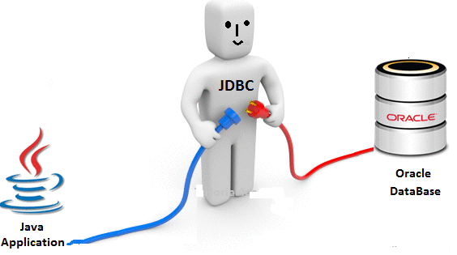

**Figure-1**

**Input from User**:

SupplierId SupplierName Address

CurrentStock Selling GST

CustomerName CustomerId Telephone No

**Modules Provided:**

**Using Encrypted Password**

* Add Records
* Display Records
* Update Records
* Delete Records
* Search Records
* Cancel

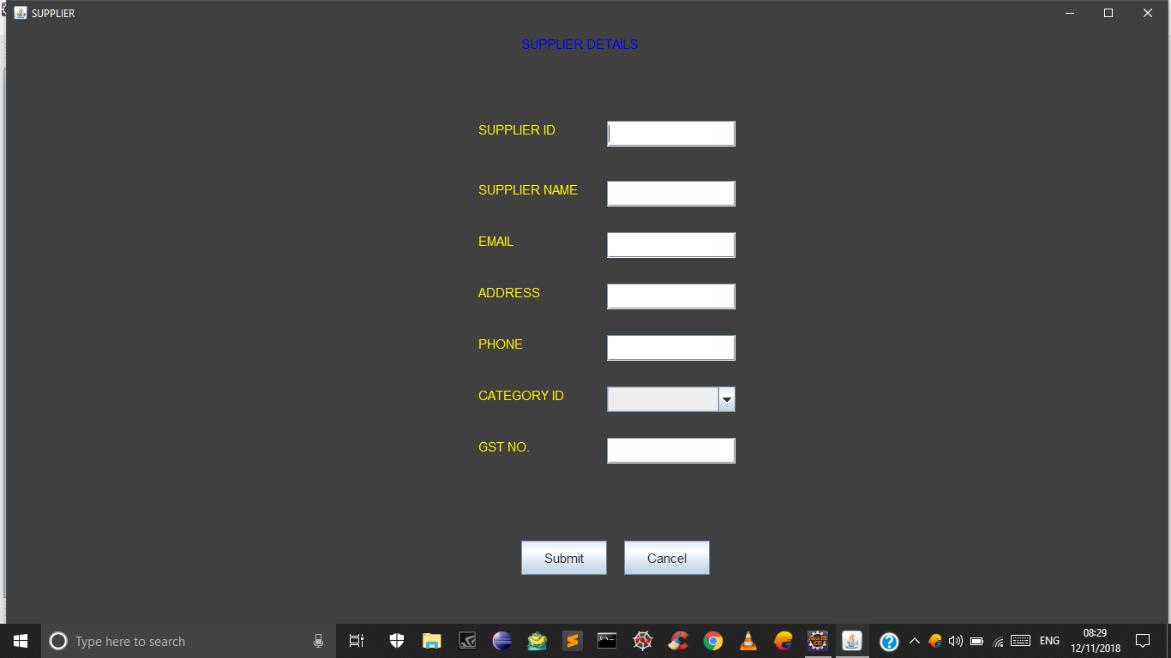

**Figure-2**

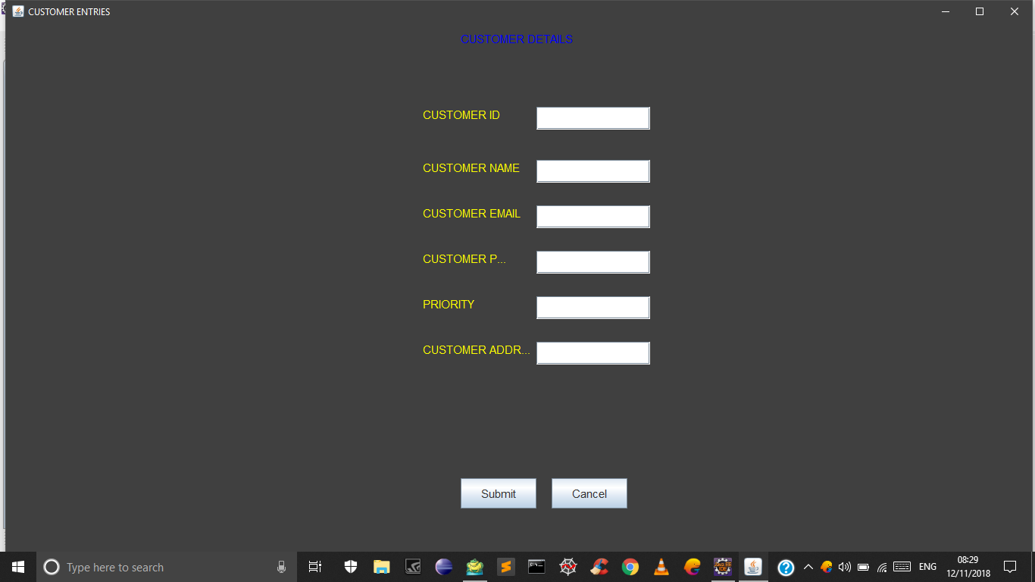

**Figure-3**

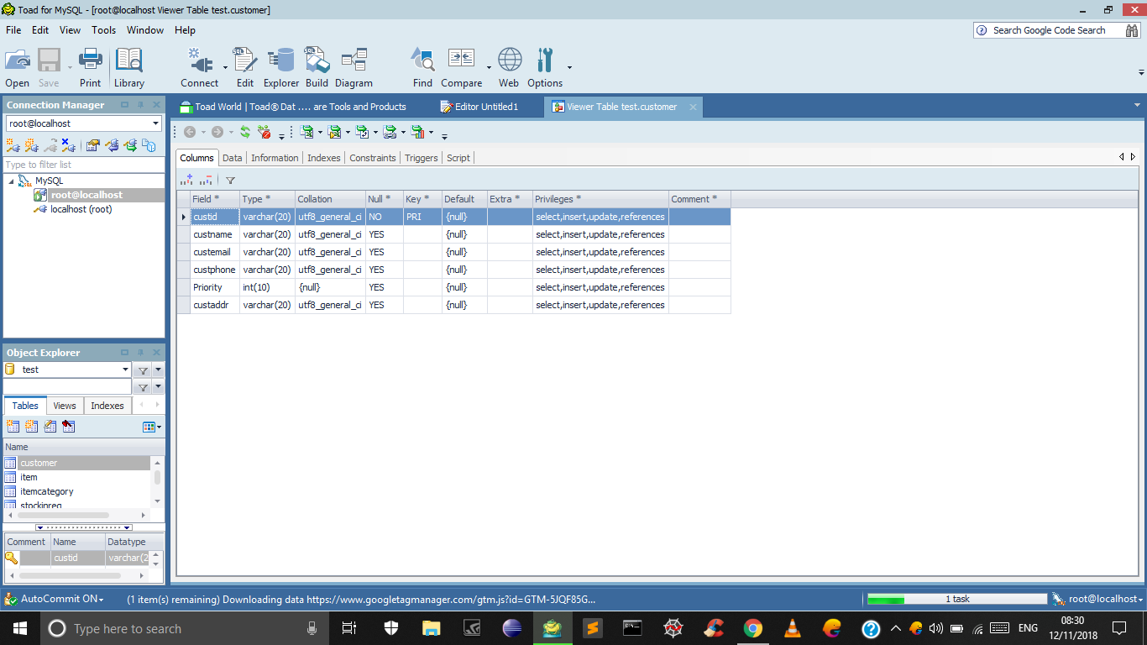

**Figure-4**

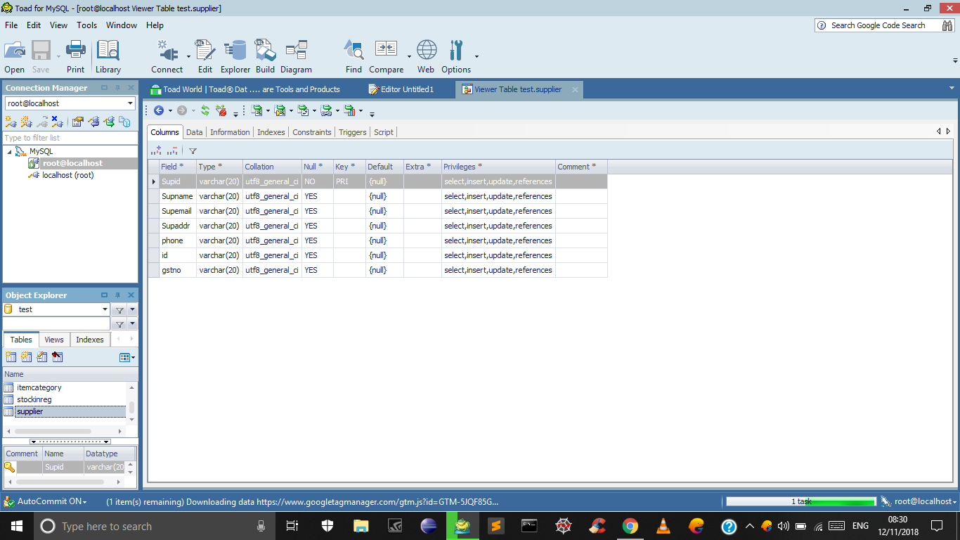

**Figure-5**

**Chapter-5**

**CONCLUSION**

Practical knowledge means thevisualization of the knowledge, which we read in our books. For this, we perform experiments and get observations. Practical knowledge is very important in every field. One must be familiar with the problems related to that field so that he may solve them and become a successful person.

After achieving the proper goal in life, an engineer must enter in professional life. According to this life, he must serve an industry, may be public or private sector or self-own. For the efficient work in the field, he must be aware of the practical knowledge as well as theoretical knowledge.

Due to all above reasons and to bridge the gap between theory and practical, our Engineering curriculum provides a practical training of 45 days. During this period a student work in the industry and get well all type of experience and knowledge about the working of companies and hardware and software tools.

I have undergone my 45 days summer training in 7th semester at **E-GAIN Pvt Ltd**. This report is based on the knowledge, which I acquired during my 45 days of summer training.

**REFERENCES**

* HP Student Reference Guide
* OOPS Concept by Sumita Arora
* Thinking In java (2nd edition)
* Google Group-javatechzone