TFIS Trading Platform
Architecture & Design Manual
Phase 1 – Architecture Blueprint
Version 1.0
Audience: Business users, traders, developers and architects.

Table of Contents
- 1. Introduction
- 2. Vision and Design Philosophy
- 3. Big Picture
- 4. Overall System Architecture
- 5. Major Components
- 6. Data Flow Through the Platform
- 7. Why This Architecture is Different
- 8. Core Design Principles
- 9. Current Platform Status
- 10. Glossary

1. Introduction
TFIS is not a single trading strategy. It is a complete trading platform designed to execute many independent strategies using one common engine. The goal is to build every common capability once and then allow new strategies to reuse those capabilities instead of copying code.
A useful analogy is a modern airport. Every airline has different routes and schedules, but all of them share the same runways, control tower, baggage system and security. In TFIS, strategies are like airlines while the platform provides the common infrastructure.

2. Vision and Design Philosophy
- Build one reusable platform instead of many independent strategy programs.
- Keep business rules inside strategies and generic capabilities inside shared engines.
- Never guess when market evidence is missing. Fail safely.
- Keep every important decision traceable and auditable.
- Design for growth: many strategies, many instruments and many accounts.

3. Big Picture
The platform receives market information, analyses it using shared engines, lets each strategy make its own decision, simulates trades in internal paper mode, records every event and presents the entire system through one operational dashboard.
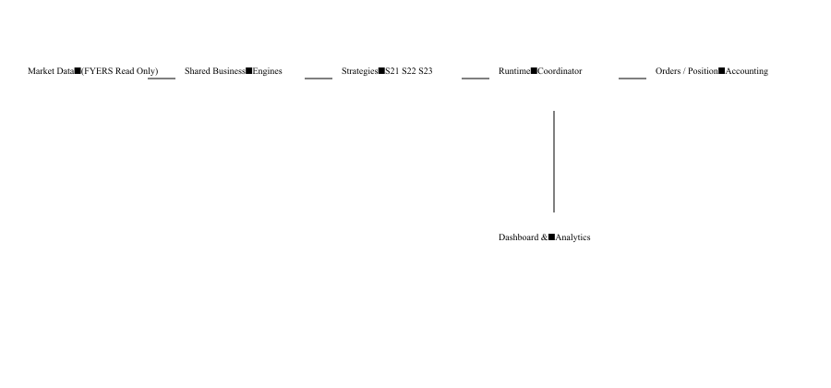
Figure 1: High-level TFIS architecture.

4. Overall System Architecture
Market Data Layer: Collects prices, option chains, Open Interest (OI), historical candles and reference data. During development it uses FYERS in read-only mode.
Shared Business Engines: Monthly Status, Market Structure, Contract Selection, Gap/Missed Entry, Entry Planning and Risk. These engines are generic and reused by every strategy.
Strategy Layer: Contains strategy-specific policy only. Current strategies are S21, S22 and S23.
Runtime Coordinator: Starts the platform, prepares all strategies before market open, coordinates ORPT and RC timings, routes events and manages strategy instances.
Order and Position Layer: Creates internal paper orders, manages PositionCycles and protection without sending real broker orders.
Accounting Layer: Creates TradeFacts, PnLFacts and analytical projections.
Dashboard: Shows the complete system in one place without calculating trading rules.

5. Major Components
Monthly Status Engine: Determines whether an instrument is Bull, Bull Continuation, Bear or Bear Continuation. Every strategy asks this engine instead of calculating its own status.
Market Structure Engine: Calculates reference levels such as previous 2-day and 4-day highs and lows.
Strategy Definition: Contains only the workbook-derived rules for one strategy. It does not own orders, positions or accounting.
Strategy Instance: Represents one running strategy for one instrument and one account.
PositionCycle: Think of this as a diary of one trade. Everything from entry to exit is recorded in one place.
TradeFact & PnLFact: Immutable accounting records used for analytics and reporting.

6. Data Flow Through the Platform
1. Runtime starts.
2. Broker diagnostics verify read-only connectivity.
3. Shared engines calculate Monthly Status and Market Structure.
4. Every enabled strategy prepares a Pre-Market Plan.
5. After market open, Opening Context, ORPT and RC observations are evaluated.
6. Internal-paper orders and fills are simulated.
7. PositionCycle is updated.
8. Accounting creates TradeFacts and PnLFacts.
9. Dashboard reads projections and displays system status.

7. Why This Architecture is Different
Older trading systems often duplicate the same logic in every strategy. TFIS separates reusable capabilities from strategy-specific rules. As a result, S21, S22 and S23 all use the same runtime, accounting, persistence and dashboard.
Traditional Approach | TFIS Approach
Each strategy has its own engine | One shared engine, many strategies
Duplicate order management | One PositionCycle system
Separate accounting | Shared accounting
Different dashboards | Unified operational dashboard

8. Core Design Principles
- Single Source of Truth
- Generic Before Strategy-Specific
- Fail Closed
- Trace Everything
- Configuration Over Code
- Read-only Broker Integration Until Certified
- Reusable Platform
- Operator Transparency

9. Current Platform Status
Current implemented strategies: S21 (BANKNIFTY option selling), S22 (RELIANCE option selling) and S23 (NIFTY option selling).
Current broker integration: FYERS read-only authentication and market-data capture.
Current execution mode: Internal Paper Trading only. No external broker order authority.
Next planned work: Multi-stock S22 expansion, unified market-session observation, premium dashboard refinement.

10. Glossary
OI: Open Interest: number of outstanding option contracts.
ORPT: Order Review/Placement Time: strategy checkpoint before entry.
RC: Recalculation Time used by some strategies.
PositionCycle: Complete lifecycle of one trade.
TradeFact: Permanent record describing one completed trade.
PnL: Profit and Loss.
Internal Paper Trading: Simulated execution with no real broker orders.
Read-only: The system can read broker data but cannot place or modify orders.

Phase 2 Preview
The next document will expand every engine, runtime flow, database model, broker integration, dashboard architecture, sequence diagrams and developer guide in much greater depth.

