TRADING FRAMEWORK INTELLIGENCE SYSTEM (TFIS)
Monthly Status Reference and Implementation Specification
Single source of truth for developers, architects, testers and Codex
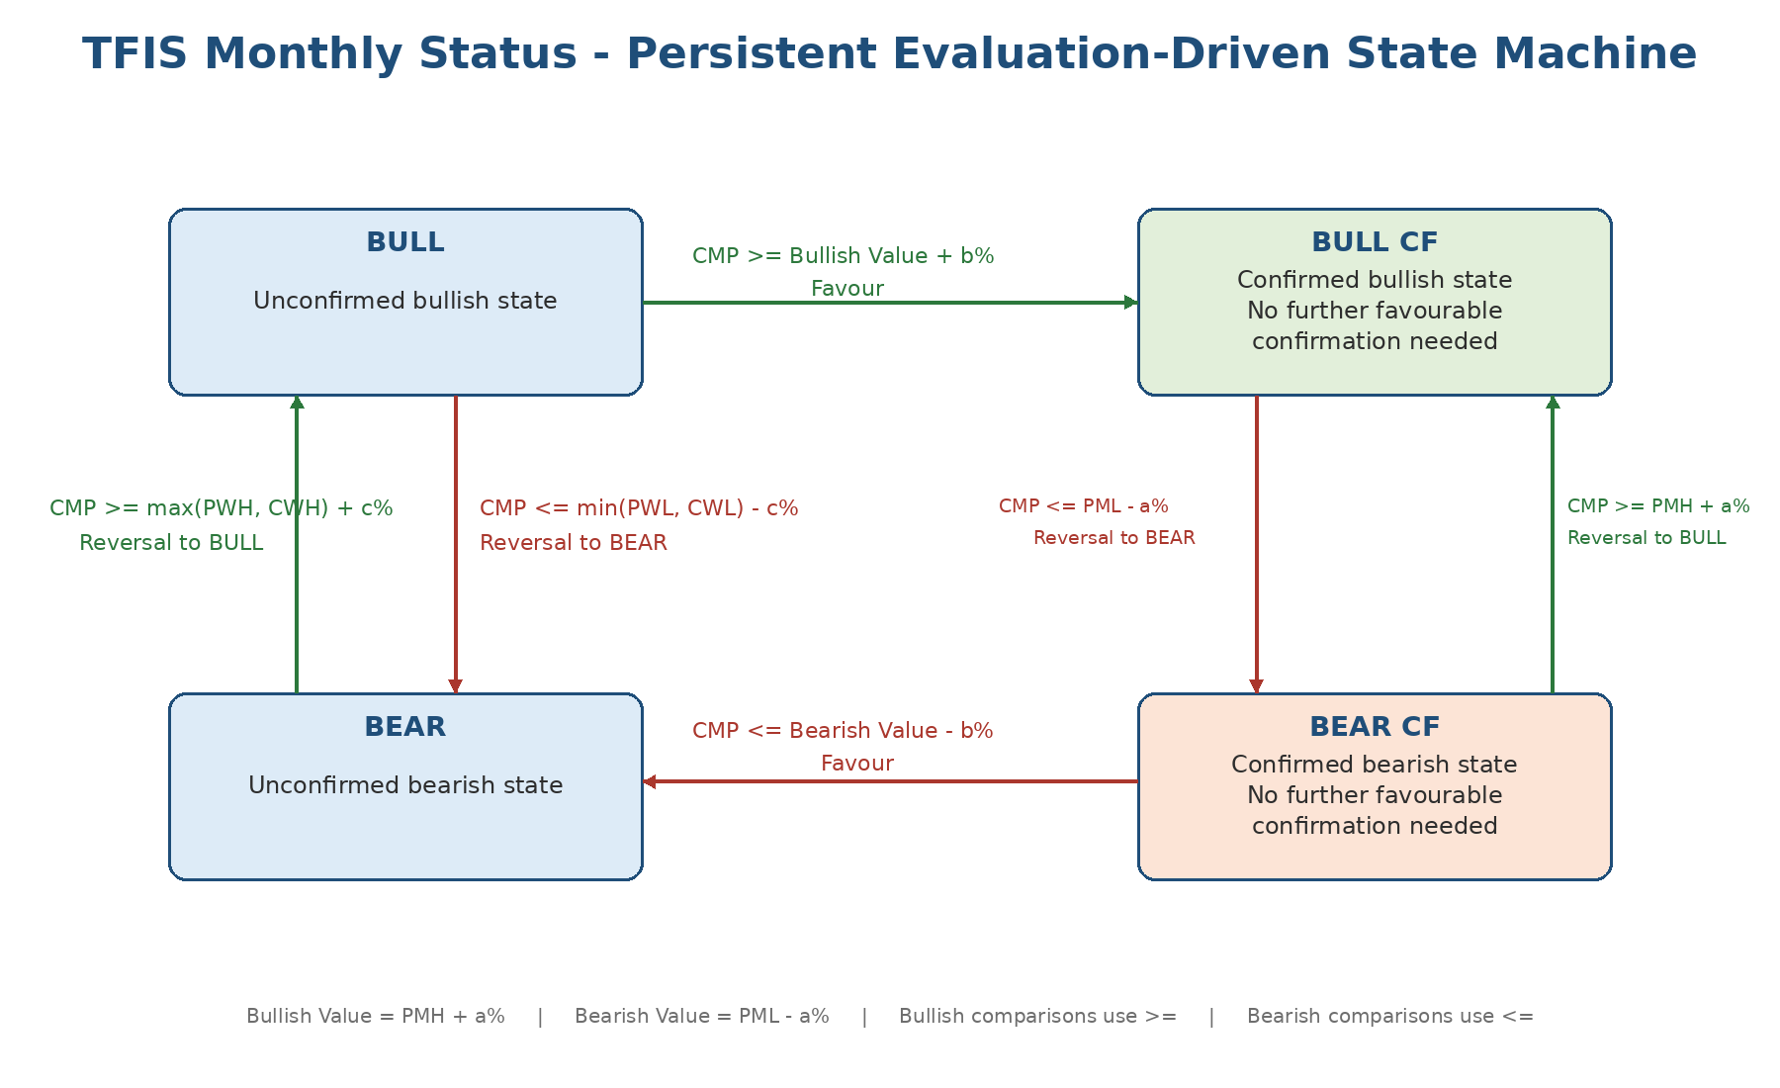
Version 1.0 | Baseline for code implementation and validation | 29 July 2026
Document authority
This document consolidates the All Segment Rules diagrams, the manual NIFTY monthly-status walkthrough, and the strategy-owner clarifications supplied during the TFIS design review. It supersedes older FTAS sections that marked the exact Monthly Status transitions as open. Where this document identifies an unresolved implementation detail, the code must fail closed rather than infer a trading rule.

1. Purpose and Use
Monthly Status is the central directional context for every TFIS strategy. This specification defines the business meaning, calculation process, state transitions, runtime behaviour, data requirements, implementation contract and test obligations. It is designed to be used directly during code design, Codex implementation, code review, replay analysis and acceptance testing.
Audience | How to use this document
Developer | Implement the shared Monthly Status service and consume its result; do not duplicate the logic in strategies.
Architect | Validate state ownership, persistence, dependency direction, mode parity and fail-closed behaviour.
Tester | Build deterministic bootstrap, transition, calendar-boundary and replay-parity scenarios.
Codex | Treat requirements MON-001 onward as the authoritative implementation checklist.
Strategy owner | Confirm threshold tables, data-source rules and any later business clarification.

Completion criterion
The implementation is acceptable only when the same input context and previous status produce the same Monthly Status, reason and evidence in paper, live-decision simulation, backtest and replay.

1.1 Source material and precedence
Priority | Source | Use
1 | This specification and explicit strategy-owner clarifications | Current authority for Monthly Status behaviour.
2 | All Segment Rules monthly-status diagrams | Authoritative state-transition diagrams and segment thresholds.
3 | Determine Monthly Status Manually (7-page walkthrough) | Authoritative bootstrap example and explanatory narrative.
4 | TFIS FTAS / Engineering Specification | Architecture context; older open items are superseded here.
5 | Existing code and tests | Implementation evidence only; not proof of intended correctness.

Known source typo
The manual walkthrough states once that March 2026 is “Bullish Confirmed” after a downside breach. The surrounding calculations and subsequent explanation clearly establish the intended result as BEARISH CONFIRMED. This specification records the corrected meaning while preserving the fact that the source contains a typo.

2. Core Concept
Monthly Status is a persistent, evaluation-driven state machine. It is not a daily trend indicator and it is not recalculated independently from scratch at every market tick. TFIS calculates or refreshes Monthly Status whenever it performs a fresh-order market evaluation. The previously established status is the starting state; CMP at that evaluation moment may cause one permitted transition. If no transition condition is satisfied, the state remains unchanged.
- All TFIS strategies consume Monthly Status before selecting the Bull, Bull CF, Bear or Bear CF strategy branch.
- Historical backward borrowing is used for initialization or recovery when no reliable prior status exists.
- Routine evaluation uses the previously established status and the CMP at the current evaluation time.
- The engine is path-dependent: the current state constrains which transition conditions are applicable.
- UNKNOWN/UNAVAILABLE is not a tradeable branch and must suppress fresh orders.

2.1 States
State | Business meaning | Persistence rule
BULL | Unconfirmed bullish monthly state. | Remains BULL until bullish confirmation or a valid bearish reversal.
BULL_CF | Bullish Confirmed. No further favourable confirmation is required. | Remains BULL_CF until the confirmed-state bearish reversal threshold is met.
BEAR | Unconfirmed bearish monthly state. | Remains BEAR until bearish confirmation or a valid bullish reversal.
BEAR_CF | Bearish Confirmed. No further favourable confirmation is required. | Remains BEAR_CF until the confirmed-state bullish reversal threshold is met.
UNKNOWN | The current month alone does not establish a state during bootstrap. | Borrow the previous month state; not persisted as a tradeable final status.
UNAVAILABLE | Sufficient evidence cannot be obtained safely. | Suppress fresh orders and expose the reason.

3. Definitions and Data Semantics
Token | Definition | Reset / time behaviour
CMP | Current Market Price at the TFIS evaluation moment, from the authoritative segment-specific source. | New value for each fresh-order evaluation.
PMH / PML | Previous calendar/trading month High / Low. | Immutable for the current month.
CMH / CML | Current month High / Low up to the evaluation time. | Reset at start of each new month.
PWH / PWL | Previous week High / Low. | Immutable for the current week.
CWH / CWL | Current week High / Low up to the evaluation time. | Reset at start of each new week.
a% | Primary previous-month breach buffer. | Segment/instrument configuration.
b% | Continuation/confirmation buffer beyond Bullish/Bearish Value. | Segment/instrument configuration.
c% | Weekly reversal buffer for unconfirmed Bull/Bear states. | Segment/instrument configuration.
Bullish Value | PMH + a%. | Calculated from current month’s previous-month reference.
Bearish Value | PML - a%. | Calculated from current month’s previous-month reference.

Percentage convention
“Reference + x%” means Reference × (1 + x/100). “Reference - x%” means Reference × (1 - x/100). Apply the buffer to the named reference, not to CMP and not as an absolute point value.

3.1 Authoritative CMP source by strategy segment
Strategy family | Monthly Status price source
Index Futures | Corresponding index futures price.
Stock Futures | Corresponding stock futures price.
Index Option Selling / Buying | Corresponding index spot/underlying price.
Stock Option Selling / Buying | Corresponding stock spot/underlying price.
Commodity strategies | Corresponding commodity futures price.
Equity strategies | Corresponding cash-equity/spot price, subject to strategy configuration.

4. Segment Parameter Table
Segment / instrument group | a% | b% | c%
NIFTY | 0.75% | 0.75% | 0.15%
BANKNIFTY | 0.75% | 0.75% | 0.15%
ALL STOCKS | 2.50% | 2.00% | 1.00%
USDINR | 0.15% | 0.05% | 0.05%
GBPINR | 0.15% | 0.05% | 0.05%
JPYINR | 0.15% | 0.05% | 0.05%
EURINR | 0.15% | 0.05% | 0.05%
GOLD | 0.50% | 0.50% | 0.12%
SILVER | 0.70% | 0.70% | 0.15%
CRUDE | 2.00% | 1.50% | 0.30%
NATURAL GAS | 2.00% | 2.00% | 0.50%

Configuration requirement
These values must be configuration data with effective versioning. They must not be hard-coded as one global set. Any future change must identify the instrument group, effective date, specification revision and regression scenarios.

5. Authoritative State-Transition Rules

Figure 1. Authoritative Monthly Status state machine.

5.1 Transition matrix
Current state | Favour / confirmation condition | Result | Reversal condition | Result
BULL | CMP >= Bullish Value + b% | BULL_CF | CMP <= min(PWL, CWL) - c% | BEAR
BULL_CF | No additional favourable confirmation required | Remain BULL_CF | CMP <= PML - a% | BEAR
BEAR | CMP <= Bearish Value - b% | BEAR_CF | CMP >= max(PWH, CWH) + c% | BULL
BEAR_CF | No additional favourable confirmation required | Remain BEAR_CF | CMP >= PMH + a% | BULL

Boundary rule
Bullish conditions use greater-than-or-equal (>=). Bearish conditions use less-than-or-equal (<=). Equality at the threshold is a valid transition.

5.2 Why confirmed-state reversal differs from unconfirmed-state reversal
An unconfirmed Bull or Bear can reverse using weekly structure plus c%, because the direction has not yet reached confirmation. A confirmed state requires the stronger opposite previous-month threshold (PML - a% for Bull CF, PMH + a% for Bear CF). The implementation must not apply the weekly reversal rule to a confirmed state or the previous-month reversal rule to an unconfirmed state.

6. Historical Bootstrap and Backward Borrowing
Bootstrap is required when no reliable previously established Monthly Status is available, such as first initialization, incomplete persisted state, a new instrument, or historical backfill. The process evaluates the current month against the previous month. If the month does not establish a valid state, it borrows the previous month’s status and continues backward until a determinable state is found.
1. Treat the month being evaluated as Current Month and the immediately preceding month as Previous Month.
2. Calculate Bullish Value = PMH + a% and Bearish Value = PML - a%.
3. Use CMH to test upward/bullish conditions and CML to test downward/bearish conditions.
4. If CMH reaches the bullish threshold, establish BULL; if it also reaches Bullish Value + b%, establish BULL_CF.
5. If CML reaches the bearish threshold, establish BEAR; if it also reaches Bearish Value - b%, establish BEAR_CF.
6. If neither side establishes a state, mark that month UNKNOWN and evaluate the previous month against its previous month.
7. Stop at the latest month with a determinable state.
8. Propagate that state forward through unresolved months, applying any later valid transitions in chronological order.
9. If sufficient history still cannot establish a state, return UNAVAILABLE and suppress fresh orders.
NIFTY walkthrough result
In the supplied 03 June 2026 example, June borrowed May, May borrowed April and April borrowed March. March breached the February bearish threshold and the additional b% confirmation threshold; therefore March was BEARISH CONFIRMED, and that status propagated through April, May and June until a later valid transition.

7. Chronology and “Latest Valid Signal”
If both bullish and bearish criteria are satisfied within the same relevant month, week or historical interval, the final status cannot be derived from unordered OHLC extremes alone. The transition sequence must be reconstructed from ordered observations or ordered TFIS evaluation points. The latest valid transition is authoritative.
Example
If price first breaches the bearish criterion in the first half of a week and later reverses and breaches the applicable bullish criterion, the final result is bullish because the bullish transition is later. The opposite sequence produces a bearish result.

- Do not resolve competing transitions by fixed code order such as “check Bull first, otherwise Bear.”
- Do not assume the higher absolute excursion is the final state.
- When weekly/monthly OHLC proves that both thresholds were crossed but not which occurred last, use ordered lower-timeframe data.
- For routine live operation, only actual TFIS fresh-order evaluation points create persisted transitions; the engine is not continuously polling Monthly Status.
- For replay/backtest, reproduce the same evaluation timestamps and process them chronologically.

8. Routine Evaluation at Fresh-Order Time
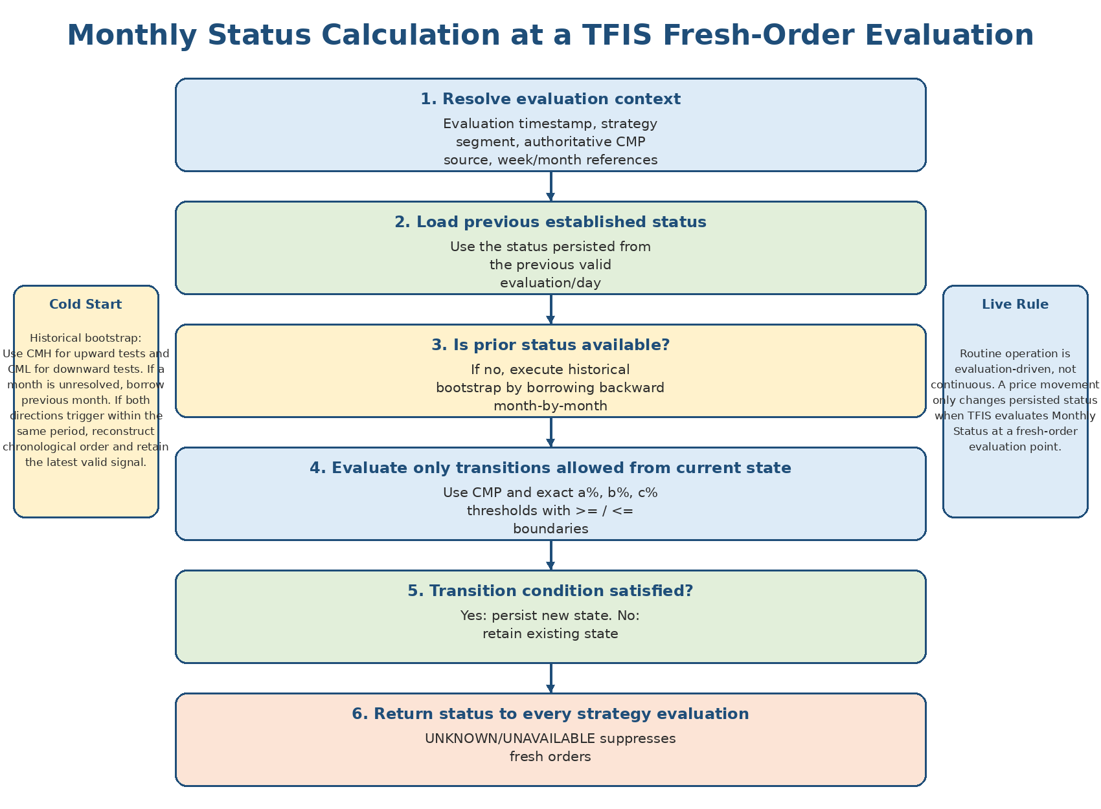
Figure 2. Runtime evaluation flow.
1. Resolve the strategy instance, segment, evaluation timestamp and authoritative CMP source.
2. Load the previously established valid Monthly Status, normally from the previous evaluation/day.
3. Resolve PMH, PML, PWH, PWL, CWH and CWL as of the evaluation time.
4. Evaluate only the transition conditions permitted from the current state.
5. If a valid transition condition is satisfied, persist the new state with reason and evidence.
6. If no valid transition is satisfied, retain the previous state.
7. Return the resolved status to the strategy-selection layer before any entry, gap, strike, premium, OI, stop or target formula is evaluated.
8. If status is UNKNOWN/UNAVAILABLE, suppress fresh orders and expose a named reason.
Important correction
TFIS does not continuously monitor Monthly Status on every tick. Monthly Status is evaluated when TFIS performs a fresh-order calculation. An intraday threshold crossing that is not present at an evaluation point does not automatically create a persisted transition in routine operation.

9. Functional Requirements
ID | Requirement
MON-001 | Monthly Status shall be an explicit enum: BULL, BULL_CF, BEAR, BEAR_CF, UNKNOWN or UNAVAILABLE.
MON-002 | Every fresh-order evaluation shall resolve Monthly Status before selecting a strategy branch.
MON-003 | Routine evaluation shall start from the previously established valid state.
MON-004 | Routine evaluation shall use CMP from the segment-specific authoritative source at the evaluation timestamp.
MON-005 | If no transition condition is satisfied, the previous state shall be retained.
MON-006 | Bullish comparisons shall use >= and bearish comparisons shall use <=.
MON-007 | BULL shall transition to BULL_CF only at CMP >= Bullish Value + b%.
MON-008 | BULL shall transition to BEAR only at CMP <= min(PWL, CWL) - c%.
MON-009 | BULL_CF shall transition to BEAR only at CMP <= PML - a%.
MON-010 | BEAR shall transition to BEAR_CF only at CMP <= Bearish Value - b%.
MON-011 | BEAR shall transition to BULL only at CMP >= max(PWH, CWH) + c%.
MON-012 | BEAR_CF shall transition to BULL only at CMP >= PMH + a%.
MON-013 | Confirmed states shall remain confirmed on favourable movement; no further confirmation state exists.
MON-014 | Bootstrap shall borrow backward month-by-month until a determinable state is found.
MON-015 | Bootstrap shall use CMH for upward tests and CML for downward tests.
MON-016 | If both directions are triggered within one period, chronological order shall determine the latest valid signal.
MON-017 | CWH/CWL shall reset at the start of a new week; CMH/CML shall reset at the start of a new month.
MON-018 | Monthly Status shall persist across week/month boundaries until a valid transition occurs.
MON-019 | UNKNOWN/UNAVAILABLE shall never silently map to a tradeable strategy branch.
MON-020 | The same calculation service and rule version shall be used by paper, live-decision, backtest and replay.
MON-021 | Every result shall include previous state, new state, evaluation time, threshold values, rule ID and transition reason.
MON-022 | a%, b% and c% shall be versioned configuration by segment/instrument group.
MON-023 | Monthly Status shall be calculated once upstream and consumed by all strategies; strategies shall not recalculate it.
MON-024 | If historical data is insufficient, the engine shall return UNAVAILABLE and suppress fresh orders.

10. Implementation Data Contract

10.1 Required input
Field | Description | Required validation
evaluation_id | Unique deterministic evaluation identity. | Stable across retries/replay.
evaluation_at | Market-time timestamp for fresh-order evaluation. | Exchange timezone and session-valid.
strategy_instance_id | Strategy/instrument/account identity. | No implicit defaults.
segment / product_type | Futures, Option Sell, Option Buy, Equity, Commodity, etc. | Drives CMP source and parameter group.
cmp / cmp_source | Current Market Price and source identity. | Fresh and appropriate for segment.
previous_status | Previously established Monthly Status. | Required for routine evaluation; optional only for bootstrap.
PMH/PML | Previous month high/low. | Complete previous month and correct source.
CMH/CML | Current month high/low as of evaluation. | Current month only.
PWH/PWL | Previous week high/low. | Complete previous week.
CWH/CWL | Current week high/low as of evaluation. | Current week only.
a/b/c | Configured threshold percentages. | Versioned and correct instrument group.
ordered_history | Ordered lower-timeframe/evaluation evidence when competing signals require sequence resolution. | Market-time ordered.
rule_version | Specification/configuration version. | Persist with output.

10.2 Required output
Field | Description
status | Resolved BULL, BULL_CF, BEAR, BEAR_CF, UNKNOWN or UNAVAILABLE.
previous_status | State used as the starting point.
transitioned | Whether state changed in this evaluation.
transition_reason | Named rule, e.g. MON-011, or retained/unavailable reason.
effective_at | Evaluation market time.
thresholds | Bullish Value, Bearish Value and applicable reversal/confirmation level.
evidence | CMP, PMH/PML, weekly levels, parameter values and ordered evidence where used.
quality_status | VALID, UNAVAILABLE or CONFLICTING.
rule_version | Rule/config version used.

11. Reference Pseudocode
def evaluate_monthly_status(ctx):
validate_context(ctx)
if ctx.previous_status is None:
return bootstrap_monthly_status(ctx)
state = ctx.previous_status
if state == BULL:
if ctx.cmp >= pct_up(ctx.bullish_value, ctx.b_pct):
return transition(BULL_CF, "MON-007")
if ctx.cmp <= pct_down(min(ctx.pwl, ctx.cwl), ctx.c_pct):
return transition(BEAR, "MON-008")
return retain(BULL)
if state == BULL_CF:
if ctx.cmp <= pct_down(ctx.pml, ctx.a_pct):
return transition(BEAR, "MON-009")
return retain(BULL_CF)
if state == BEAR:
if ctx.cmp <= pct_down(ctx.bearish_value, ctx.b_pct):
return transition(BEAR_CF, "MON-010")
if ctx.cmp >= pct_up(max(ctx.pwh, ctx.cwh), ctx.c_pct):
return transition(BULL, "MON-011")
return retain(BEAR)
if state == BEAR_CF:
if ctx.cmp >= pct_up(ctx.pmh, ctx.a_pct):
return transition(BULL, "MON-012")
return retain(BEAR_CF)
return unavailable("unsupported_or_unknown_previous_status")
Precedence note
The unconfirmed BULL and BEAR rules each have one favourable and one reversal condition. Under ordinary CMP evaluation these thresholds are directionally separated. If imported historical evidence proves multiple transitions, do not apply the single-evaluation function once; replay ordered observations/evaluation points through the state machine.

12. Deterministic Validation Matrix
Test ID | Scenario | Expected result
MON-T01 | Prior BULL; CMP exactly Bullish Value + b% | BULL_CF; equality triggers.
MON-T02 | Prior BULL; CMP exactly min(PWL,CWL) - c% | BEAR; equality triggers.
MON-T03 | Prior BULL; neither condition | Retain BULL.
MON-T04 | Prior BULL_CF; CMP exactly PML - a% | BEAR.
MON-T05 | Prior BULL_CF; favourable rise | Retain BULL_CF.
MON-T06 | Prior BEAR; CMP exactly Bearish Value - b% | BEAR_CF.
MON-T07 | Prior BEAR; CMP exactly max(PWH,CWH) + c% | BULL.
MON-T08 | Prior BEAR; neither condition | Retain BEAR.
MON-T09 | Prior BEAR_CF; CMP exactly PMH + a% | BULL.
MON-T10 | Prior BEAR_CF; favourable fall | Retain BEAR_CF.
MON-T11 | Current month unresolved; previous month unresolved; third month BEAR_CF | Borrow and propagate BEAR_CF.
MON-T12 | History insufficient | UNAVAILABLE; fresh order suppressed.
MON-T13 | Both bearish then bullish thresholds breached in ordered history | Final state reflects later bullish transition.
MON-T14 | Both bullish then bearish thresholds breached in ordered history | Final state reflects later bearish transition.
MON-T15 | Week boundary | CWH/CWL reset; status persists.
MON-T16 | Month boundary | CMH/CML reset; status persists.
MON-T17 | Option strategy receives futures CMP instead of spot | Reject context/data quality failure.
MON-T18 | Futures strategy receives spot CMP | Reject context/data quality failure.
MON-T19 | UNKNOWN status reaches strategy selector | No trade; explicit reason.
MON-T20 | Same input in paper/backtest/replay | Identical status, thresholds, reason and evidence.

13. Architecture and Code-Review Rules
- Provide one shared Monthly Status service. Do not embed transition rules in S21, S23 or any future strategy module.
- Persist the last valid status and its evidence separately from current week/month aggregations.
- Make routine evaluation a pure deterministic function of previous state plus current context.
- Keep bootstrap/recovery logic separate from routine transition evaluation.
- Use an explicit segment-to-CMP-source resolver; do not infer from strategy naming conventions.
- Record requirement IDs and threshold calculations in the decision trace.
- Paper, live-decision, backtest and replay must call the same domain service.
- Do not allow the strategy selector to default UNKNOWN/UNAVAILABLE to Bull or Bear.
- Do not change state because the executable contract rolls or expires.
- Do not use current-day market structure as a substitute for Monthly Status.

13.1 Minimum codebase audit checklist
Review question | Pass condition
Where is the single state-transition function? | One shared domain implementation with no strategy-specific forks.
How is prior status loaded? | Versioned persisted status with effective time and source.
How is cold start handled? | Backward borrowing with deterministic chronological propagation.
How is CMP selected? | Explicit segment/product resolver and source trace.
Are operators correct? | >= for bullish, <= for bearish, with equality tests.
Are weekly/monthly resets correct? | Calendar-aware reset of CWH/CWL and CMH/CML only; status persists.
Can both-side breaches be ordered? | Ordered evidence is required where OHLC is ambiguous.
Can UNKNOWN trade? | No; fail closed.
Are all runtime modes aligned? | Shared service and parity fixtures.
Is rollover isolated? | Contract change does not itself change status.

14. Common Misinterpretations to Avoid
Incorrect implementation | Correct rule
Recalculate Monthly Status independently from monthly OHLC every day. | Start from the persisted previous status and evaluate permitted transitions at fresh-order time.
Continuously monitor every tick and persist every crossing. | Routine Monthly Status is evaluation-driven; persist transitions at TFIS evaluation points.
Use one Bull/Bear flag and discard CF. | Bull, Bull CF, Bear and Bear CF are distinct states.
Apply weekly reversal to Bull CF/Bear CF. | Confirmed states reverse using previous-month thresholds.
Apply previous-month reversal to unconfirmed Bull/Bear. | Unconfirmed states reverse using weekly max/min plus c%.
Resolve both-side monthly breaches by checking one condition first. | Use chronological order; latest valid signal wins.
Use futures price for all strategies. | Use segment-specific authoritative CMP source.
Reset Monthly Status on Monday or month start. | Reset current-week/month extremes only; state persists.
Treat UNKNOWN as neutral and continue. | UNKNOWN/UNAVAILABLE suppresses fresh orders.
Let each strategy calculate its own Monthly Status. | Calculate once upstream and share.

15. Codex Implementation Instruction
When this document is supplied to Codex, use the following instruction together with the repository path:
Treat “TFIS Monthly Status Reference and Implementation Specification v1.0” as the authoritative Monthly Status business specification.
Before modifying code:
1. Read the complete document.
2. Map every MON requirement to current code and tests.
3. Report gaps with file/class/function/line evidence.
4. Do not infer or simplify rules.
5. Keep bootstrap and routine evaluation separate.
6. Use the existing persisted status at each fresh-order evaluation.
7. Use the segment-specific CMP source.
8. Fail closed for UNKNOWN/UNAVAILABLE.
9. Use one shared service across paper, live-decision, backtest and replay.
10. Add deterministic tests for MON-T01 through MON-T20.
Where current code disagrees with this document, report the conflict before changing trading behaviour.

16. Acceptance Gate
Gate | Required evidence
Business parity | All MON-001..MON-024 mapped to implementation or explicitly marked missing.
Test parity | MON-T01..MON-T20 pass deterministically.
Mode parity | Same input produces same result in paper/live-decision/backtest/replay.
Persistence | Restart restores the same prior status and evidence.
Auditability | Every transition/retention has reason, thresholds and inputs.
Strategy integration | Every strategy selects branch from the shared resolved status.
Safety | UNKNOWN/UNAVAILABLE prevents fresh orders.

Approval status
This v1.0 document is ready to serve as the Monthly Status reference for architecture design, Codex implementation, codebase audit and regression-test creation. Changes to the business rules require an explicit version update and strategy-owner approval.

Appendix A. Worked Bootstrap Summary - NIFTY, 03 June 2026
Month evaluated | Comparison | Result
June 2026 vs May 2026 | June CMH below May PMH bullish threshold; June CML breached May PML but not Bearish Value. | UNKNOWN; borrow May.
May 2026 vs April 2026 | May high below April high; May low above April low. | UNKNOWN; borrow April.
April 2026 vs March 2026 | April low below March PML but not below PML - 0.75%. | UNKNOWN; borrow March.
March 2026 vs February 2026 | March CML below Bearish Value and below Bearish Value - 0.75%. | BEAR_CF.
Propagation | April, May and June unresolved after March. | June status at the example time = BEAR_CF.

