DESIGN AND ANALYSIS OF ALGORITHM
23CSE211
WEEK 1- ACTIVITY

1.Program to find the sum of first n natural numbers using user defined function
Program Code:
#include <stdio.h>

int sumOfNatural(int n) {
int sum = 0;
for (int i = 1; i <= n; i++) {
sum += i;
}
return sum;
}

int main() {
int n;
printf("Enter number: ");
scanf("%d", &n);

printf("Sum of first %d natural numbers = %d\n",n, sumOfNatural(n));
return 0;
}

Output:

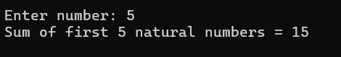

2. Program to find the sum of squares of first n natural numbers using user defined function

Program Code:

#include <stdio.h>

int sumOfSquares(int n) {
int sum = 0;
for (int i = 1; i <= n; i++) {
sum += (i*i);
}
return sum;
}

int main() {
int n;
printf("Enter number of terms: ");
scanf("%d", &n);

printf("Sum of squares of first %d natural numbers = %d\n",n, sumOfSquares(n));
return 0;
}

Output:
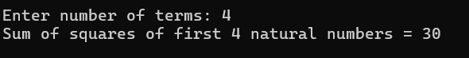

3. Program to find the sum of cubes of first n natural numbers using user defined function

Program Code:
#include <stdio.h>

int sumOfCubes(int n) {
int sum = 0;
for (int i = 1; i <= n; i++) {
sum += (i*i*i);
}
return sum;
}

int main() {
int n;
printf("Enter number of terms: ");
scanf("%d", &n);

printf("Sum of cubes of first %d natural numbers = %d\n",n, sumOfCubes(n));
return 0;
}

Output:
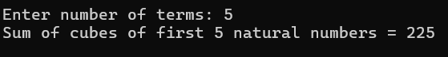

4. Program to find factorial of a natural number using recursive function

#include <stdio.h>

int factorial(int n) {
if (n == 0 || n == 1){
return 1;
}
else{
return n * factorial(n - 1);
}
}
int main() {
int n;
printf("Enter a natural number: ");
scanf("%d", &n);

if (n < 0) {
printf("Factorial is not defined for negative numbers.\n");
} else {
printf("Factorial of %d = %d\n", n, factorial(n));
}

return 0;
}
Output:
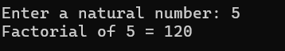

5.Program to transpose a 3x3 matrix

Program Code:

#include <stdio.h>
int main() {
int arr[3][3];
printf("Enter elements of a 3x3 matrix:\n");
for (int i = 0; i < 3; i++) {
for (int j = 0; j < 3; j++) {
printf("arr[%d][%d]: ",i,j);
scanf("%d", &arr[i][j]);
}
}
printf("\nTranspose of the matrix:\n");
for (int i = 0; i < 3; i++) {
for (int j = 0; j < 3; j++) {
printf("%d ", arr[j][i]);
}
printf("\n");
}
return 0;
}
Output:
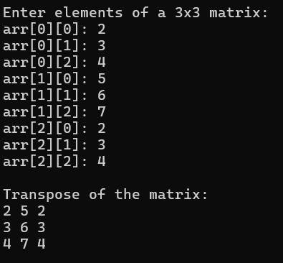

6.Program to print Fibonacci Series upto a given number using user defined function

Program Code:

#include <stdio.h>

// User-defined function to print Fibonacci series
void printFibonacci(int n) {
int a = 0, b = 1, next;
if (n >= 1)
printf("%d ", a);
if (n >= 2)
printf("%d ", b);
for (int i = 3; i <= n; i++) {
next = a + b;
printf("%d ", next);
a = b;
b = next;
}
}

int main() {
int n;

printf("Enter the number of Fibonacci terms to display: ");
scanf("%d", &n);

if (n <= 0) {
printf("Please enter a positive number.\n");
return 0;
}

printf("First %d Fibonacci numbers:\n", n);
printFibonacci(n);

printf("\n");
return 0;
}

Output:
