DESIGN AND ANALYSIS OF ALGORITHM
23CSE211
WEEK 5- ACTIVITY

1. Merge Sort

Program Code:
#include <stdio.h>

void merge(int arr[], int left, int mid, int right)
{
int i, j, k;
int n1 = mid - left + 1;
int n2 = right - mid;

int L[n1], R[n2];

for (i = 0; i < n1; i++)
L[i] = arr[left + i];
for (j = 0; j < n2; j++)
R[j] = arr[mid + 1 + j];

i = 0;
j = 0;
k = left;

while (i < n1 && j < n2)
{
if (L[i] <= R[j])
arr[k++] = L[i++];
else
arr[k++] = R[j++];
}

while (i < n1)
arr[k++] = L[i++];

while (j < n2)
arr[k++] = R[j++];
}

void mergeSort(int arr[], int left, int right)
{
if (left < right)
{
int mid = left + (right - left) / 2;

mergeSort(arr, left, mid);
mergeSort(arr, mid + 1, right);

merge(arr, left, mid, right);
}
}

int main()
{
int n, i;

printf("Enter number of elements: ");
scanf("%d", &n);

int arr[n];

printf("Enter elements:\n");
for (i = 0; i < n; i++)
scanf("%d", &arr[i]);

mergeSort(arr, 0, n - 1);

printf("Sorted array:\n");
for (i = 0; i < n; i++)
printf("%d ", arr[i]);

printf("\n");
return 0;
}

Output:
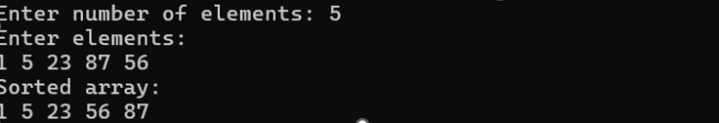

2. Quick Sort

Program Code:
#include <stdio.h>

void swap(int *a, int *b)
{
int temp = *a;
*a = *b;
*b = temp;
}

int partition(int arr[], int low, int high)
{
int pivot = arr[high]; // pivot element
int i = low - 1;

for (int j = low; j < high; j++)
{
if (arr[j] <= pivot)
{
i++;
swap(&arr[i], &arr[j]);
}
}

swap(&arr[i + 1], &arr[high]);
return i + 1;
}

void quickSort(int arr[], int low, int high)
{
if (low < high)
{
int pi = partition(arr, low, high);

quickSort(arr, low, pi - 1);
quickSort(arr, pi + 1, high);
}
}

int main()
{
int n;

printf("Enter number of elements: ");
scanf("%d", &n);

int arr[n];

printf("Enter elements:\n");
for (int i = 0; i < n; i++)
scanf("%d", &arr[i]);

quickSort(arr, 0, n - 1);

printf("Sorted array:\n");
for (int i = 0; i < n; i++)
printf("%d ", arr[i]);

printf("\n");
return 0;
}

Output:

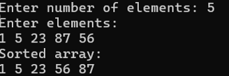

3. Binary Search Tree

Program Code:

#include <stdio.h>
#include <stdlib.h>

struct Node
{
int data;
struct Node *left, *right;
};

struct Node* createNode(int value)
{
struct Node* newNode = (struct Node*)malloc(sizeof(struct Node));
newNode->data = value;
newNode->left = NULL;
newNode->right = NULL;
return newNode;
}

struct Node* insert(struct Node* root, int value)
{
if (root == NULL)
return createNode(value);

if (value < root->data)
root->left = insert(root->left, value);
else if (value > root->data)
root->right = insert(root->right, value);

return root;
}

void inorder(struct Node* root)
{
if (root != NULL)
{
inorder(root->left);
printf("%d ", root->data);
inorder(root->right);
}
}

int search(struct Node* root, int key)
{
if (root == NULL)
return 0;

if (key == root->data)
return 1;
else if (key < root->data)
return search(root->left, key);
else
return search(root->right, key);
}

int main()
{
struct Node* root = NULL;
int n, value, key;

printf("Enter number of nodes: ");
scanf("%d", &n);

printf("Enter values:\n");
for (int i = 0; i < n; i++)
{
scanf("%d", &value);
root = insert(root, value);
}

printf("Inorder traversal (sorted): ");
inorder(root);
printf("\n");

printf("Enter element to search: ");
scanf("%d", &key);

if (search(root, key))
printf("Element found in BST\n");
else
printf("Element not found in BST\n");

return 0;
}

Output:

