DESIGN AND ANALYSIS OF ALGORITHM
23CSE211
WEEK 3- ACTIVITY
GRAPH TRAVERSAL ALGORITHMS

A
B C
D E F

1)Breadth First Search:
Algorithm: Start from A and visit all nodes level by level (left to right)
A -> B -> C -> D-> E-> F
Program:
#include <stdio.h>
#define MAX 10
int graph[MAX][MAX], visited[MAX];
int queue[MAX], front = -1, rear = -1;

void bfs(int start, int n)
{
int i;
queue[++rear] = start;
visited[start] = 1;
while (front != rear)
{
int current = queue[++front];
printf("%c ", current + 'A');
for (i = 0; i < n; i++)
{
if (graph[current][i] == 1 && visited[i] == 0)
{
queue[++rear] = i;
visited[i] = 1;
}
}
}
}
int main()
{
int n, i, j, start;
printf("Enter number of nodes: ");
scanf("%d", &n);
printf("Enter adjacency matrix:\n");
for (i = 0; i < n; i++)
{
for (j = 0; j < n; j++)
{
scanf("%d", &graph[i][j]);
}
visited[i] = 0;
}
printf("Enter starting node (0 for A, 1 for B, ...): ");
scanf("%d", &start);
printf("BFS Traversal: ");
bfs(start, n);
return 0;
}

Output:

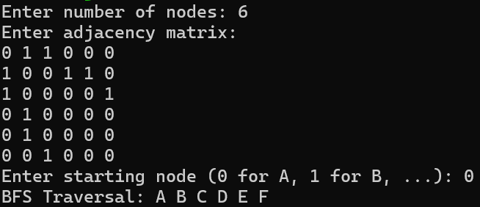

2)Depth First Search:
Algorithm: Start from A and go to depth of the tree (left to right)
A -> B -> D -> E -> C -> F
Program:
#include <stdio.h>
#define MAX 10
int graph[MAX][MAX], visited[MAX];
void dfs(int node, int n)
{
int i;
visited[node] = 1;
printf("%c ", node + 'A'); // Print node
for (i = 0; i < n; i++)
{
if (graph[node][i] == 1 && visited[i] == 0)
{
dfs(i, n);
}
}
}
int main()
{
int n, i, j, start;
printf("Enter number of nodes: ");
scanf("%d", &n);
printf("Enter adjacency matrix:\n");
for (i = 0; i < n; i++)
{
for (j = 0; j < n; j++)
{
scanf("%d", &graph[i][j]);
}
visited[i] = 0;
}
printf("Enter starting node (0 for A, 1 for B, ...): ");
scanf("%d", &start);

printf("DFS Traversal: ");
dfs(start, n);
return 0;
}
Output:

