**GIT Download Link for Windows**

[**https://git-scm.com/downloads**](https://git-scm.com/downloads)

**follow below important installation steps:**

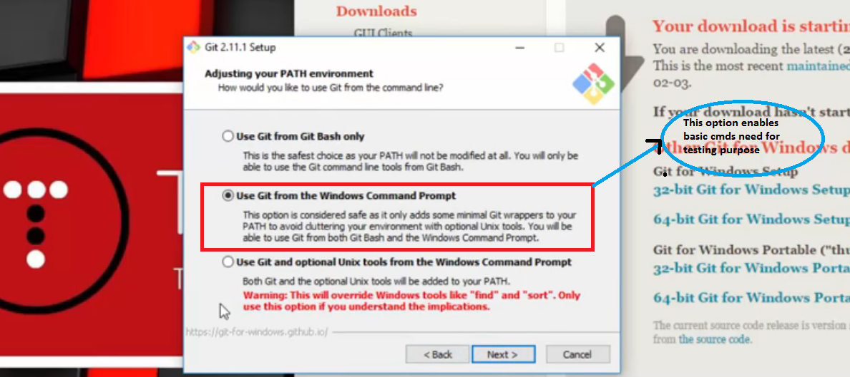

**Post Installation:**

**In windows cmd prompt type: >**git -–version **to check installation is successful**

**Please follow this video tutorial for detail:**

[**https://www.youtube.com/watch?v=SWYqp7iY_Tc**](https://www.youtube.com/watch?v=SWYqp7iY_Tc)

**Basic Git commands:**

$git init

$touch login.html <-to create

$git status

$git add index.html/*.html/.

$git commit -m 'your comments'

$git branch mybranch

$git checkout master

$git merge mybranch<-merge 2 branch

Git Remote cmd:

$git remote

$git remote add origin <https://github.com/mukeshslg/seleniumPOM.git>

$git remote

$git push -u origin master

--

$git pull

**CSS WRTING:**

a[href='projects'] or

tagname[attributename='attValue'][att2='val2'] here@ and // not req

li[id='menu_doc']>a

#mainContent>:nth-child(1) [here #mainContent is for id tag as in xpath]

**XPATH WRITING:**

//tagname[@attrname='attvalue']

//a[@href='/project/']

//a[@title='Selenium project']

//a[contains(text,'Download')] ->for text present in UI

---

li[@id='menu_doc']/a

//a[@href='/project/']

//a[@title='Selenium project' and @id='kuchbhi']

---

//a[starts-with(@id , 'u')] ->handle dynamic obj or cSS:Starts with: a[id^='u'] End with a[id$='u']

More content coming up…