Queries and View

1. All account whose balance is smaller than 500.

**A**: select account_number from account where balance < 500;

1. all name of customers whose city is in Brooklyn

**A**: select customer_name from customer where customer_city='Brooklyn';

1. Calculate the average salary of all employees and show the average salary as “avg_salary”

**A**: select avg(salary) as avg_salary from employee ;

1. Calculate the number of customer for each account

**A**: select account_number, count(distinct customer_name) from depositor group by account_number;

1. Show all account_number, branch_name and corresponding branch_city

**A**: select account_number, branch.branch_name, branch_city from account, branch

where account.branch_name=branch.branch_name;

6. Select sum(assets) ,branch_city from branch group by branch_city;

*7. View*

Create

VIEW my_report AS

select d.customer_name,branch_city, b.branch_name, a.account_number, balance, bb.loan_number, l.amount as 'loan amount' from branch b

left join account a

on b.branch_name = a.branch_name

left join depositor d

on a.account_number = d.account_number

left join borrower bb

on d.customer_name = bb.customer_name

left join loan l

on bb.loan_number = l.loan_number

order by d.customer_name;

**Web Application:**

We have created a web application to show how the changes are made on data from the front end as the end user will have no idea on how to write queries on SQL database. The web application is built on .NET Framework 4 using ASP.NET, and we have used C# language to write code.

In this banking website, user can login and add account, remove account, add branch, make payments into personal and loan accounts and, withdraw from personal accounts and clean loan amount. In home page the admin can view all information from all the tables related to Accounts, Customer, Loans.

We will go through the website with some screenshots of webpage

1. 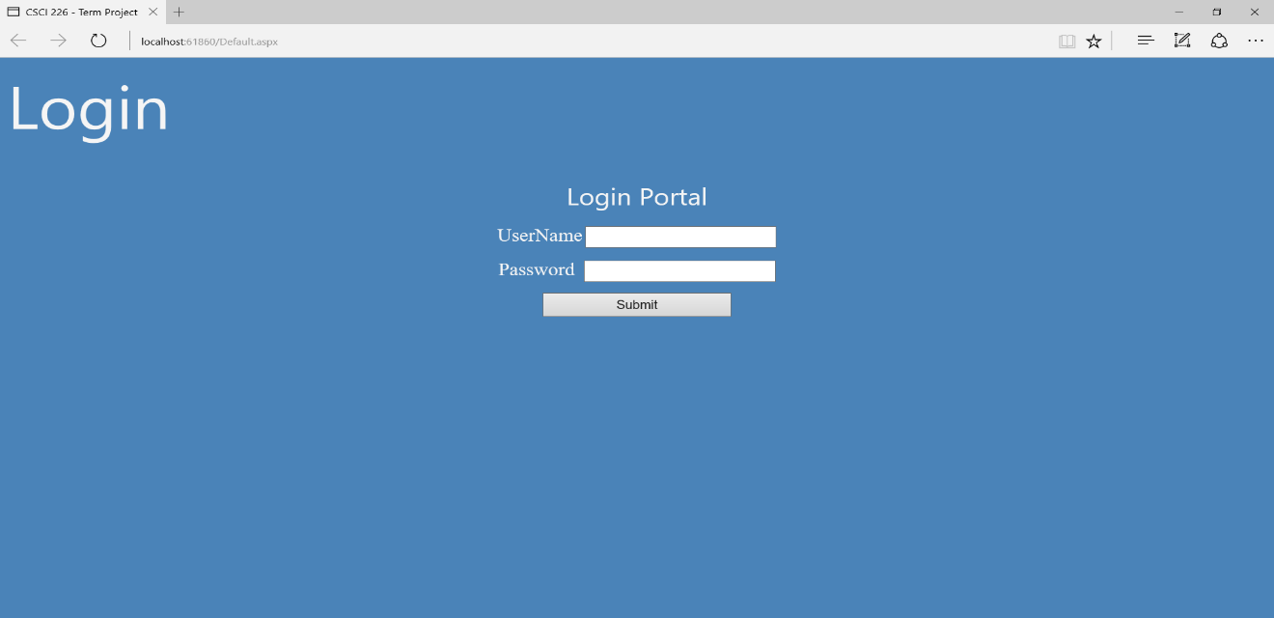**Login Page:**

1. There is a check on if admin account exists or not.

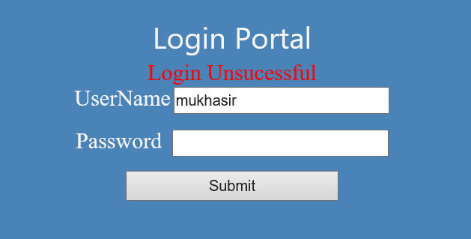

1. If we successfully login then we are redirected to home page which shows all accounts and buttons which on click can perform operations such as add account, remove account, add branch, deposit in personal or loan account, withdraw from personal or clear loan.

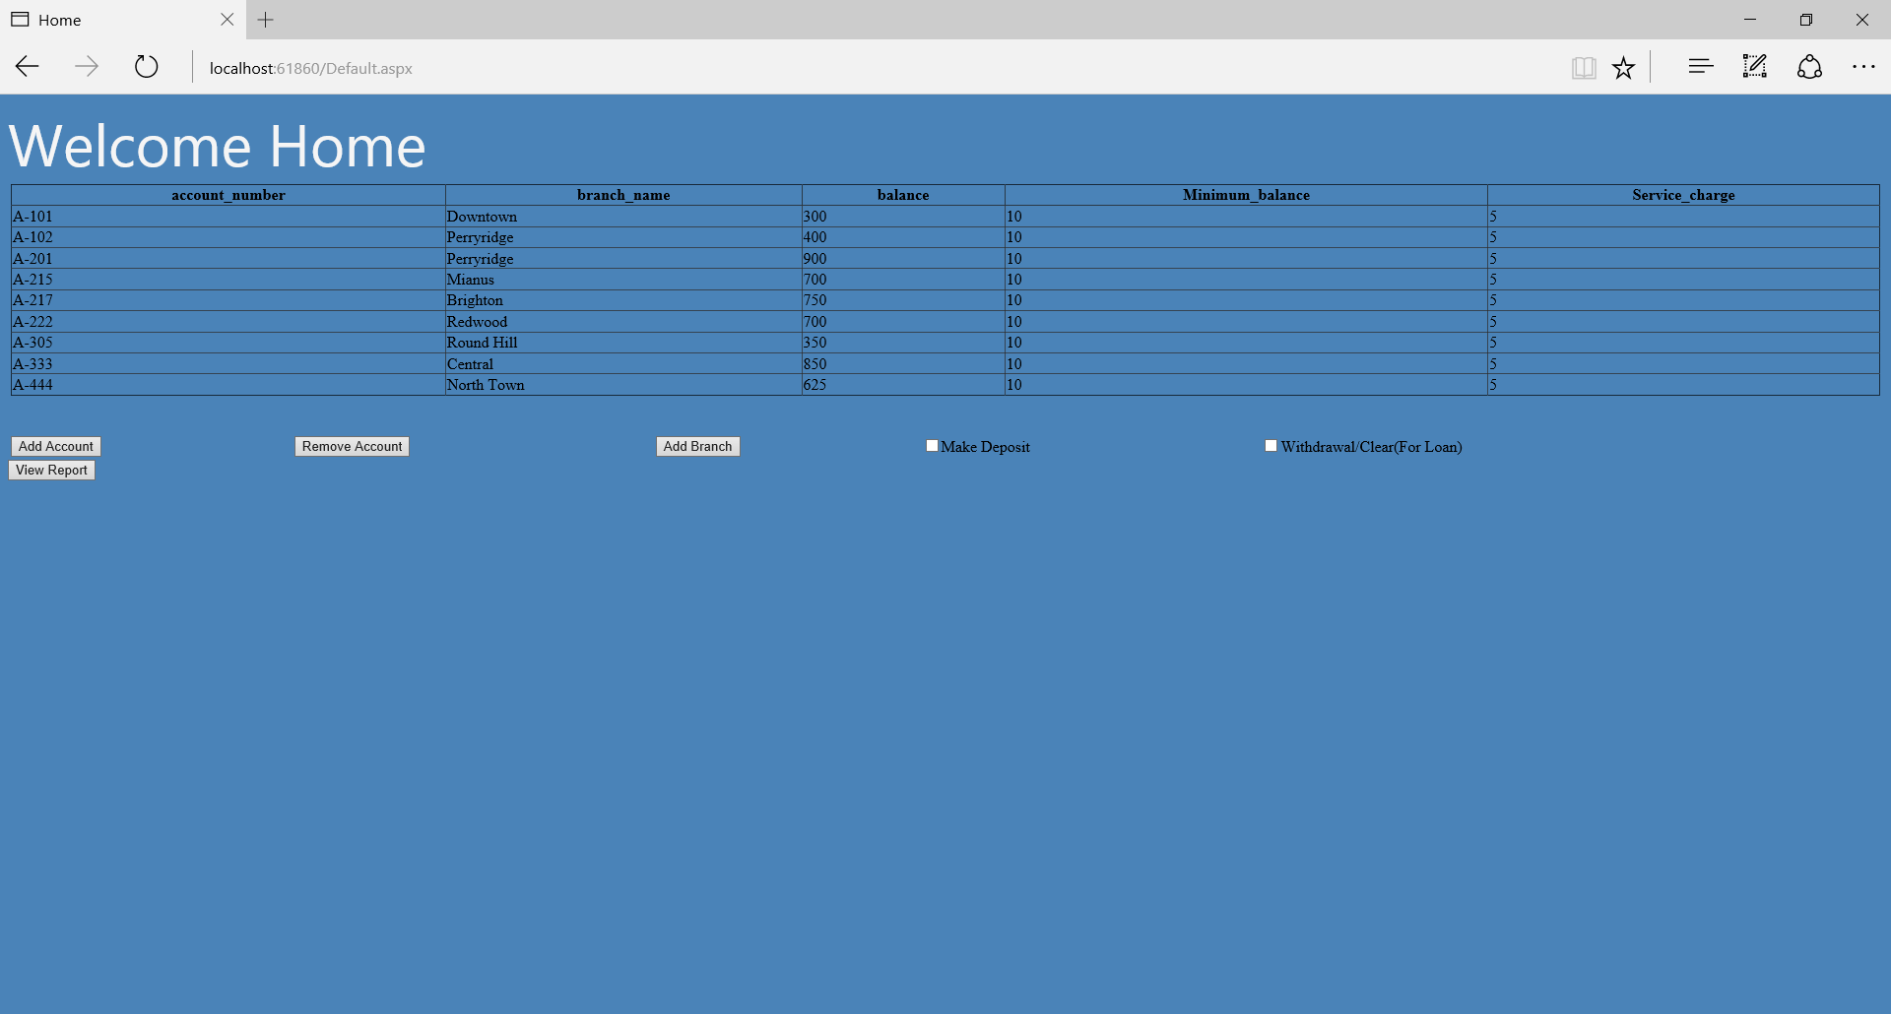

1. Now If we click on Add Account button then we will be redirected to Account Registration page where general information is requested.

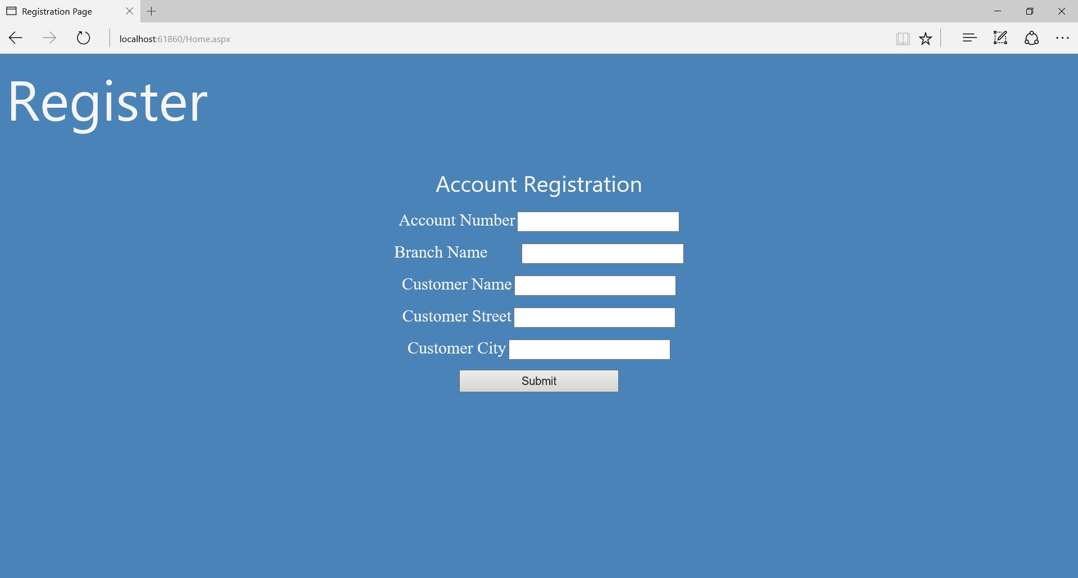

1. Once we fill the data and click on submit we will connect to MySql Database and execute stored procedure “” which adds account into the respective tables. If the account creation is successful then we redirect to successful registration page from where we can go to home page.



1. After successful registration, we go to Home page. Now if we click Remove account here then a textbox will come up, if we enter Account number and click on remove account button then the account will be removed from database.

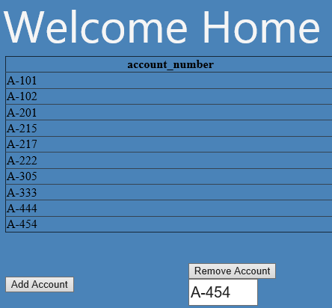

When we account is refreshed, then the table will be refreshed.

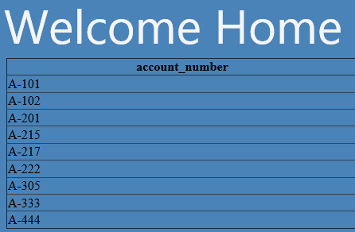

1. Now we have functionality to Add branch, when we click on Add branch button it will be redirected to page below.

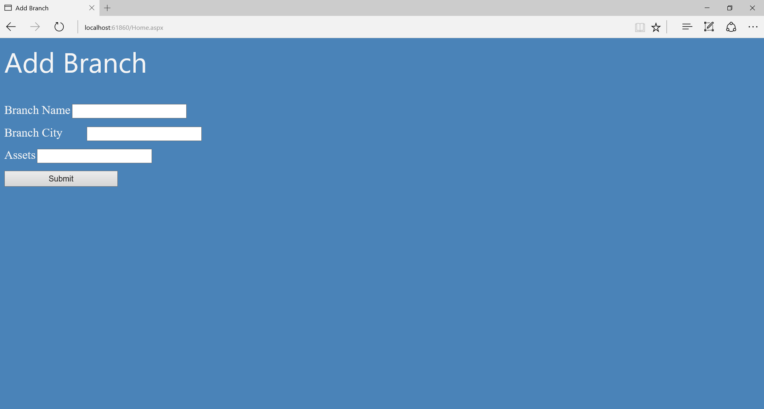

1. Fill in the values in the field and by clicking in the submit button we can add the branch.
2. We also have functionality to make a deposit into Personal Account or Loan Account by selecting the check box “Make Deposit”



Go to Payment Portal and type respective account number (Personal or Loan) and amount and click in “Make Payment” button to make payment and display the current and previous balance.



We can have similar page for loan



1. Similar to make payment we have withdrawal from personal account and clear loan account. When we select withdraw/clear then if we select personal we go to the page mentioned below:



If loan is selected then we will have only Loan Account Info where we will make remaining loan amount as “Zero”

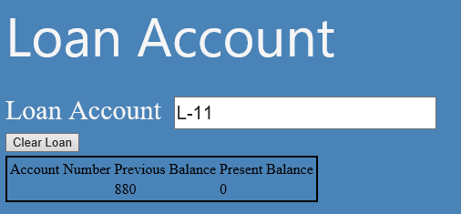

1. Finally, we display all report by joining all the tables when you click on “View Report” button.\

