Industry 4.0 and Cloud Computation

Real-Time Machine Health Monitoring and Predictive Maintenance System using ESP32 and ML
- Project group-01 Details
Name | Roll No.
Akash Mukherjee | 214225001
Bairi Krishna Kanth | 214225002
Bhide Mausam Surendra | 214225003
Bir Bahadur | 214225004
- Problem Statement

IoT-Based CPS for Real-Time Equipment Health & Fault Detection (Continuous monitoring of vibration, temperature, load and queue length).
- Objective

- To develop an IoT-based Cyber-Physical System (CPS) for real-time equipment health monitoring.
- To continuously monitor key parameters such as vibration,temperature, queue length, current of a machine.
- To analyse sensor data and detect faults based on threshold and trend analysis.
- To implement adaptive intelligence for predicting potential failures.
- To design a real-time dashboard for visualization of equipment health status and alerts.
- To provide decision support and basic actuation for improving equipment reliability.

- Methodology

Data Acquisition - Sensor data is collected using temperature, vibration, current, and IR sensors interfaced with an ESP32. The system monitors temperature, vibration, load, and queue length, where queue and processing time are estimated using IR-based job tracking.
Data Preparation - Raw data is pre-processed to remove noise and inconsistencies. A hybrid dataset is formed by combining real-time data with synthetic samples

Feature Engineering- Data normalization is performed, and key features such as degradation index, anomaly score, and remaining useful life are derived to enhance model performance.

Model Training - A Random Forest model is trained on the prepared dataset due to its robustness, ability to handle nonlinear relationships, and effectiveness with multi-sensor data.

Prediction and Decision-Making - Real-time sensor data is input to the model to classify system states (normal, warning, fault). Based on predictions, alerts are generated via LED, buzzer, and IoT platforms.

Cloud Integration - Data is transmitted to a cloud platform for real-time visualization, monitoring, and predictive maintenance support.
- Observations and Results

- Real-time monitoring of temperature, vibration, current, and queue is achieved.
- Load increase led to higher current and processing time, indicating congestion.
- Temperature and current showed rising trends under sustained load.
- Abnormal conditions (high vibration, current spikes) were clearly detected.
- The model accurately classified systems states and triggered alerts.
- System demonstrated effective fault detection and predictive maintenance capability.

- Photographs of prototype

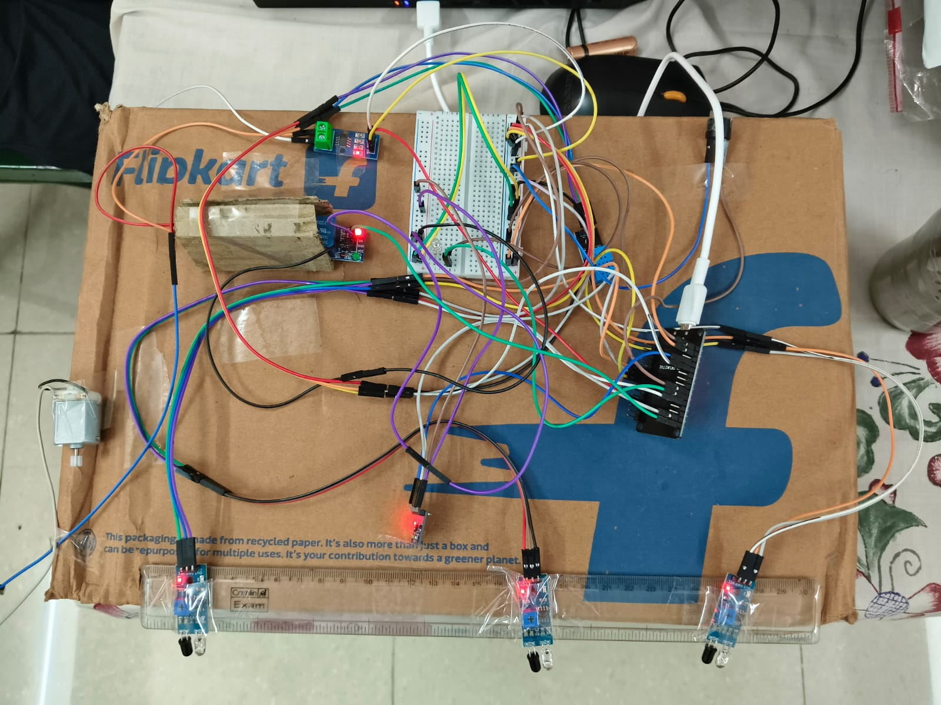

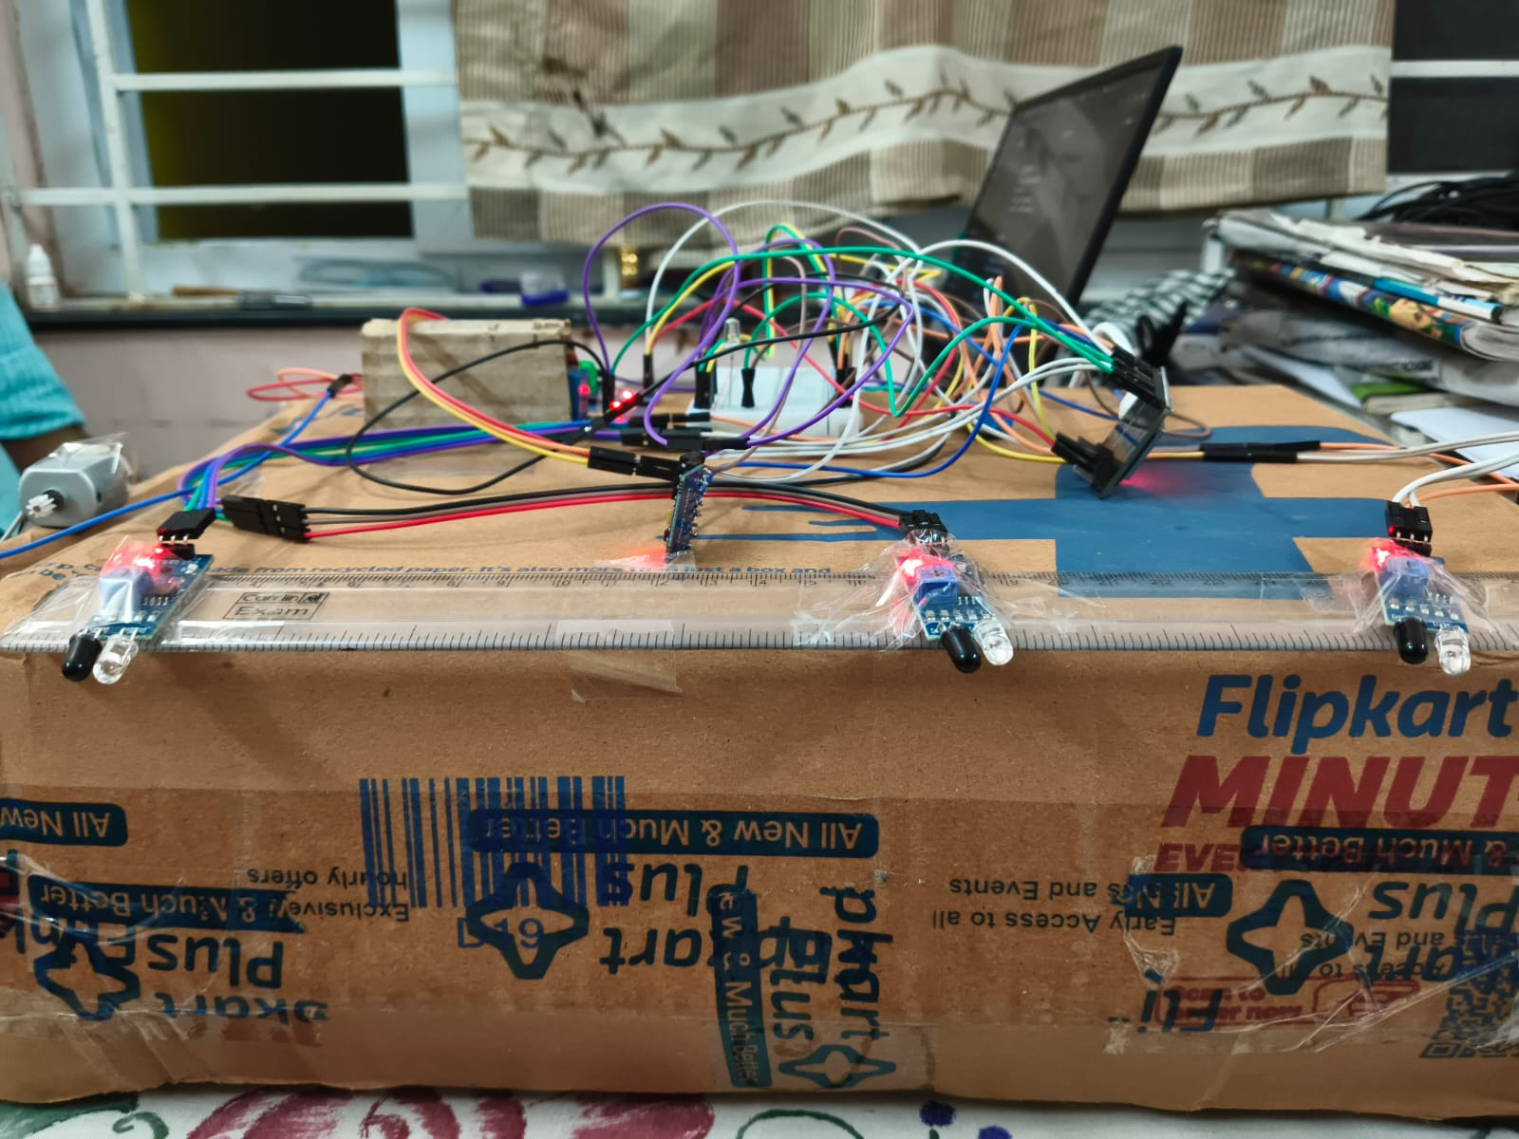
- Cost-Benefit Analysis

The proposed smart monitoring system for the cyber-physical production setup provides significant value when compared with its implementation cost. The major cost components include the ESP32 microcontroller, sensors such as DHT11 and MPU6050, IR sensors, current sensor module, and supporting components like wires, LED, and buzzer. Since most of these components are low-cost and easily available, the overall hardware cost remains within an affordable range for prototype development.

From a benefit perspective, the system offers real-time monitoring of machine conditions including temperature, vibration, current consumption, and queue status. This helps in early detection of abnormalities, thereby reducing the chances of unexpected machine failure and production downtime. The alert system using LED and buzzer also ensures immediate attention without requiring continuous human supervision.

Although the system does not generate direct revenue, it contributes to cost savings by preventing equipment damage and improving productivity. When compared to industrial monitoring solutions, this setup provides a cost-effective alternative suitable for small-scale industries and academic prototypes.
- Societal Impact of project

This project supports the development of smart and safer industrial environments by enabling real-time monitoring of machine conditions. It helps improve workplace safety by detecting abnormal situations such as overheating, excessive vibration, or high current at an early stage, thereby reducing the risk of accidents and equipment failure.

The project encourages technical learning and awareness of modern technologies such as IoT and cyber physical systems among students, contributing to skill development and future innovation in industrial automation.
- Conclusion
This project successfully demonstrates a low-cost cyber-physical production monitoring system using sensors integrated with ESP32. It effectively monitors key parameters such as queue status, process time, temperature, vibration, and current to provide real-time insights into machine performance.The system helps in identifying abnormal conditions at an early stage and improves operational awareness without requiring continuous human intervention.
Overall, the project shows how simple IoT-based solutions can enhance industrial monitoring, improve efficiency, and serve as a foundation for advanced smart manufacturing applications in the future.

