|  |
| --- |
| Cloud Testing Assignment 1: |
| Create a VM and install docker and test the images inside the container with the commands. |

Logged in AWS Management console and created an Instance from Template in EC2 Instance dashboard.

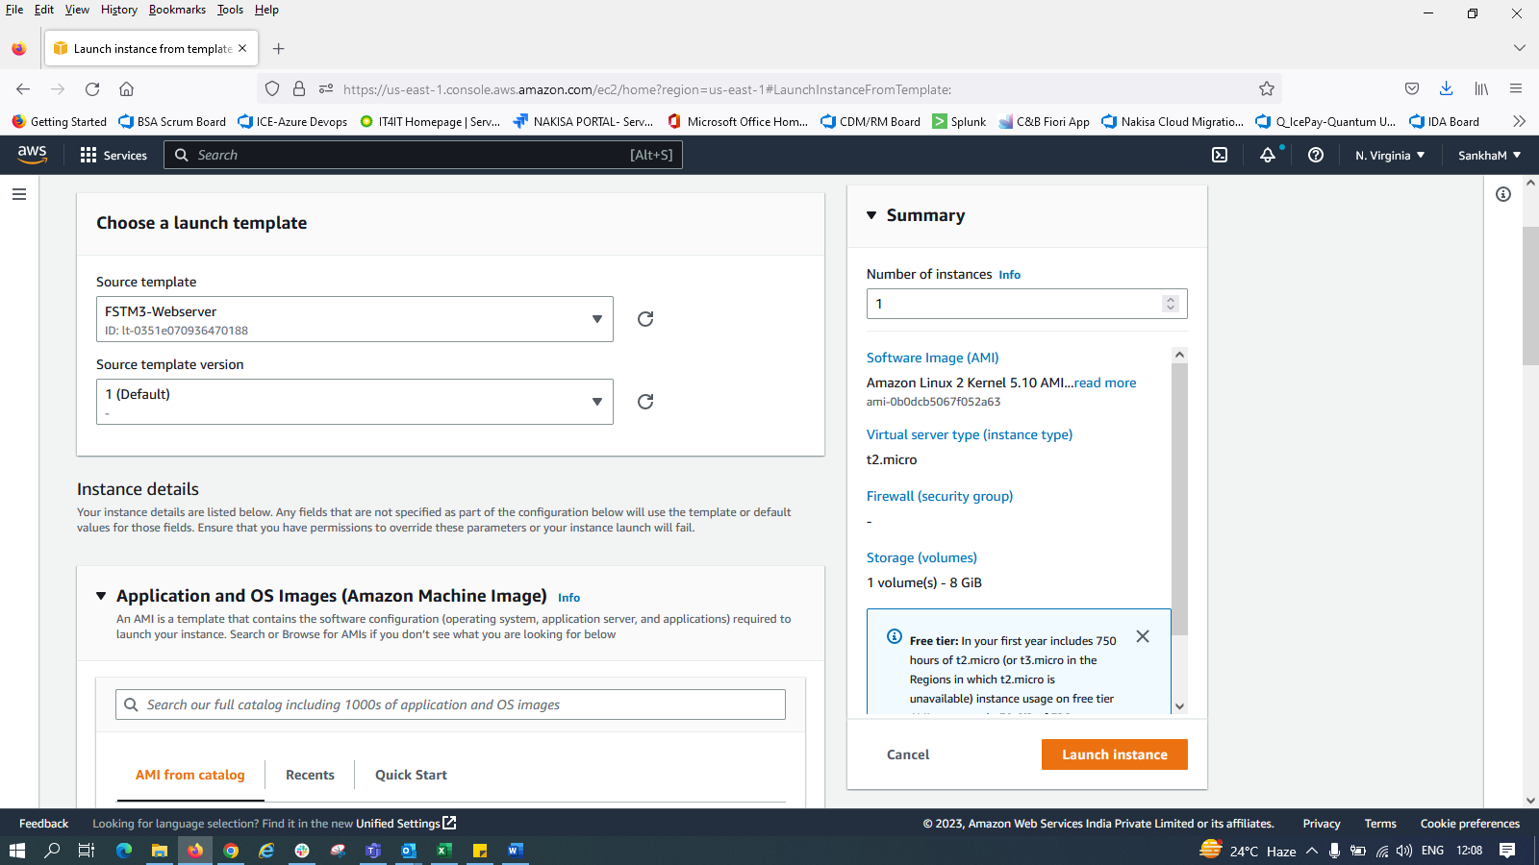

New keypair created for the Instance:

Instance started and running:

Connected with putty using the key pair file:

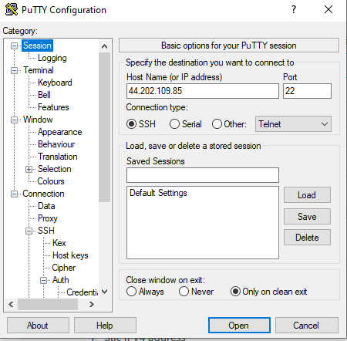 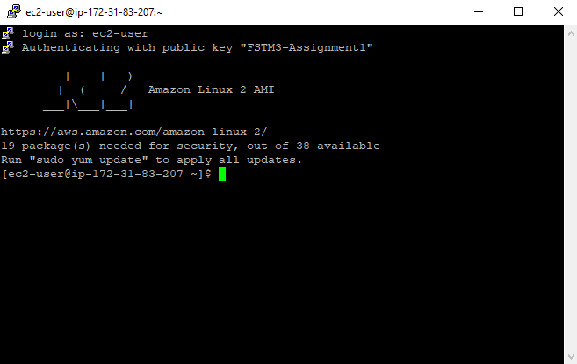

|  |
| --- |
| **Install Docker:** |
| sudo amazon-linux-extras install docker |

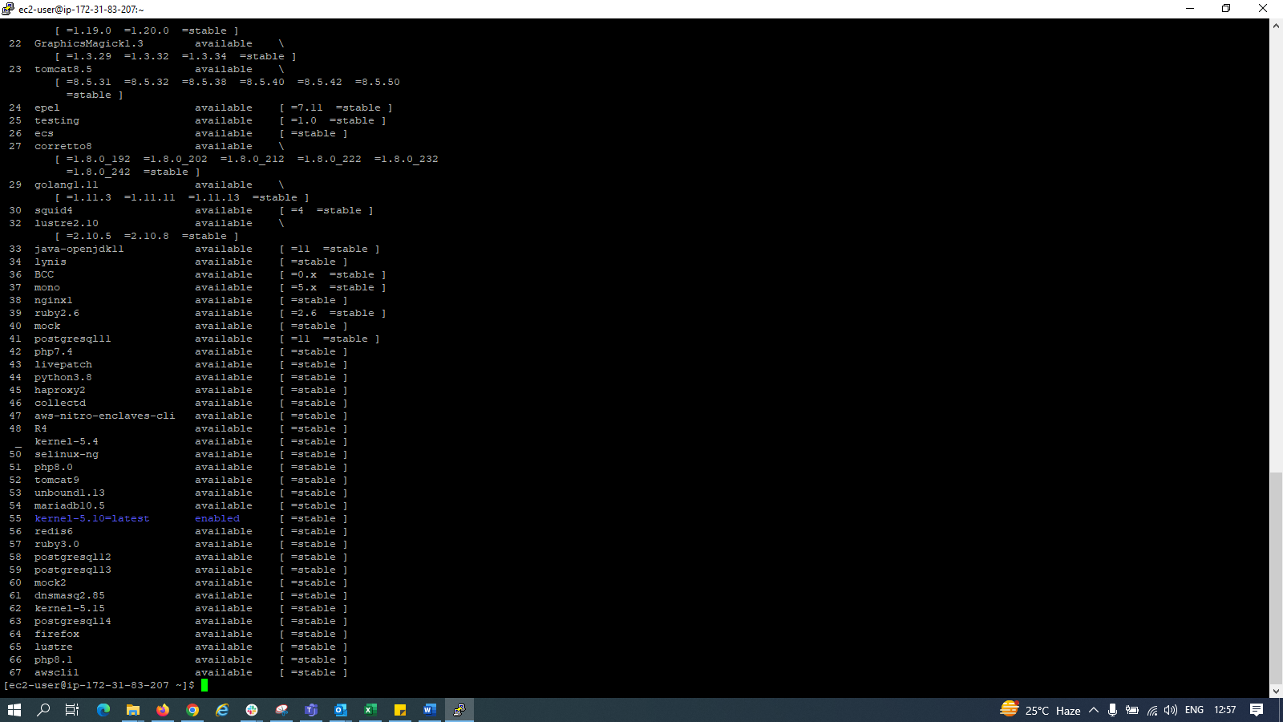

|  |
| --- |
| **To update the docker package:** |
| sudo yum update |

|  |
| --- |
| **Starting Docker:** |
| sudo service docker start |



|  |
| --- |
| **To check the docker version/whether docker is installed:** |
| docker version |

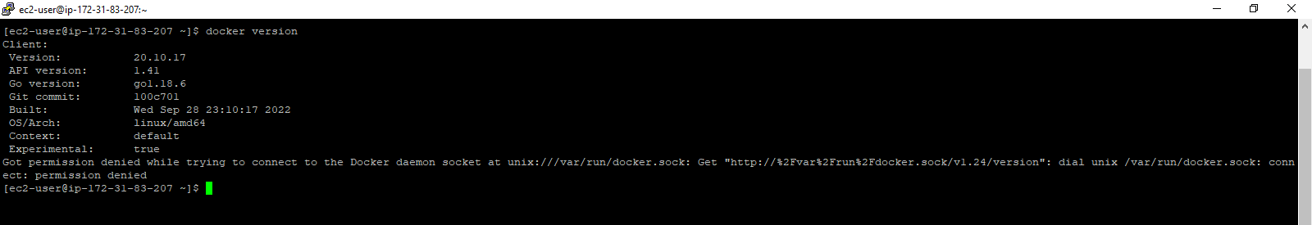

|  |
| --- |
| **To check for docker images:** |
| sudo su [to give the superuser rights to current user] |
| cd ../.. |
| docker images |

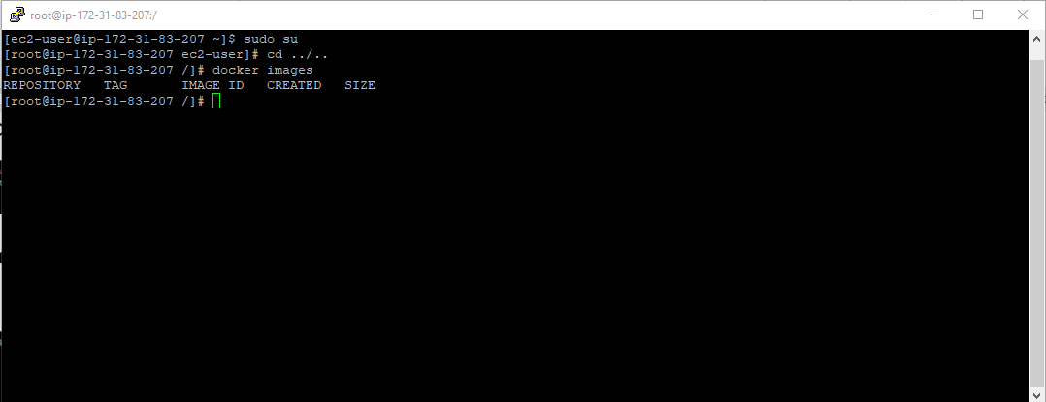

Installing Ubuntu Image from hub.docker.com

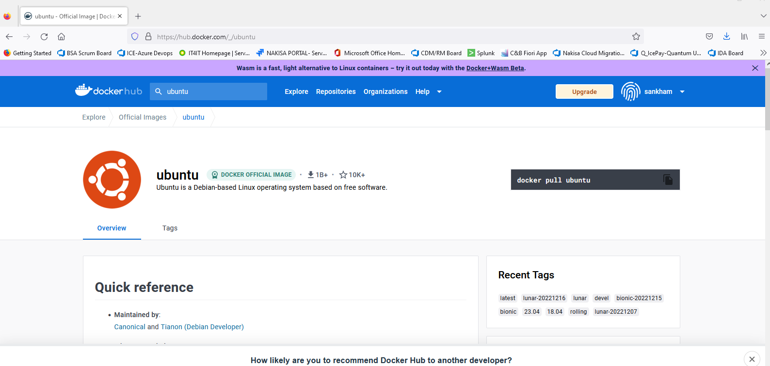

docker pull ubuntu

Installing mongoDB image : docker pull mongo

Checking images:

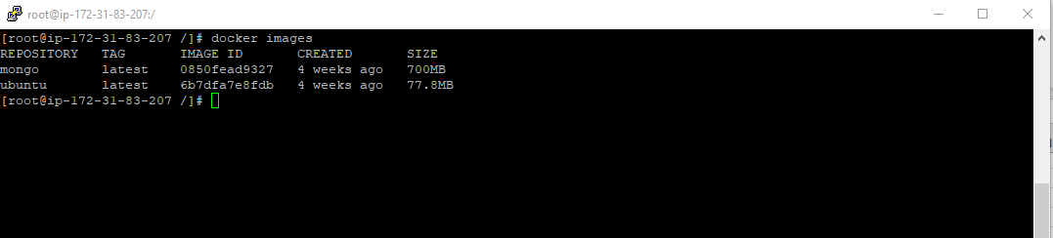

Creating container for ubuntu and mongoDB:

docker run -itd ubuntu [running docker in detacked mode]

docker run -itd mongo [running docker in detacked mode]



|  |
| --- |
| **To check if container is created - list of containers:** |
| docker ps -a [list of all containers] |
| docker ps [list of running containers] |





The result is same as both the containers are running.

Entering inside the ubuntu docker:

docker exec -it <dockerid> /bin/bash

******************* End ******************