|  |
| --- |
| Cloud Testing Assignment 2: |
| Install ansible and connect the nodes to master and execute the adhoc commands on ansible masternode vm and test the packages installed or not. |

Logged in AWS Management console and created two Instances – 1 for Ansible Server and the other for Ansible node from Template in EC2 Instance dashboard.

Instance started and running:

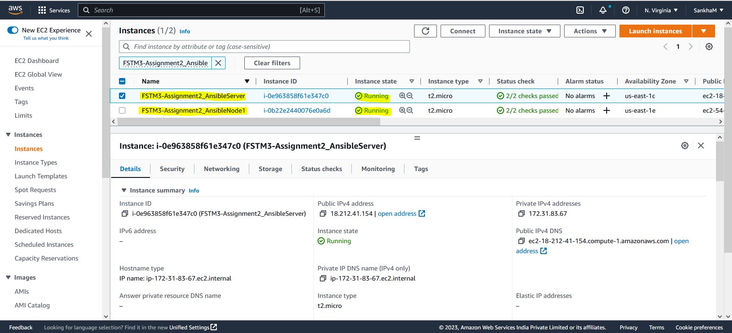

Connected the Ansible Server instance with putty using the key pair file:

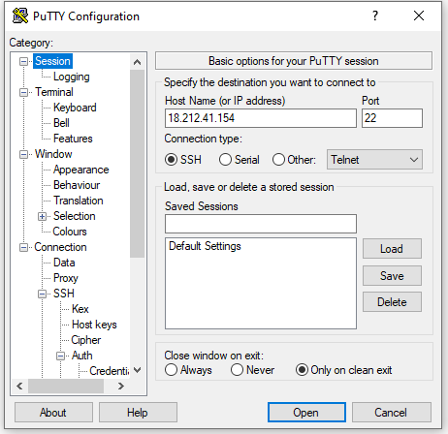

Ansible Installation in VM (AnsibleServer instance):

sudo yum update

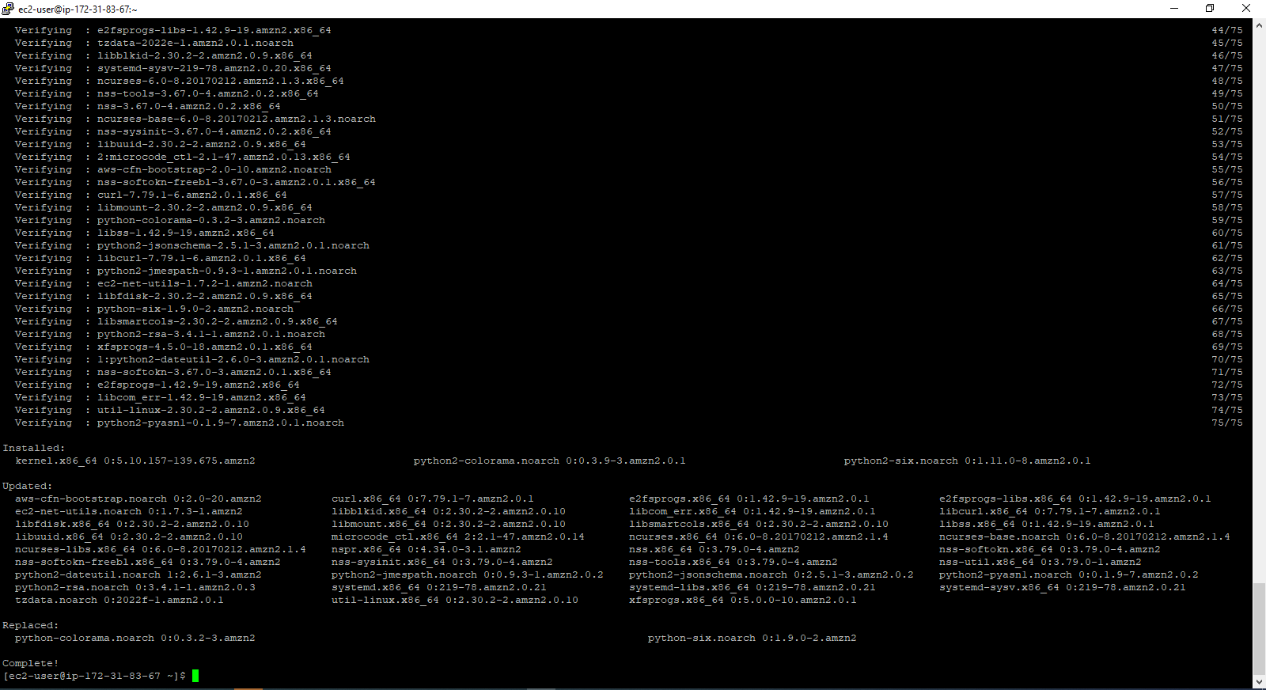

sudo amazon-linux-extras install epel

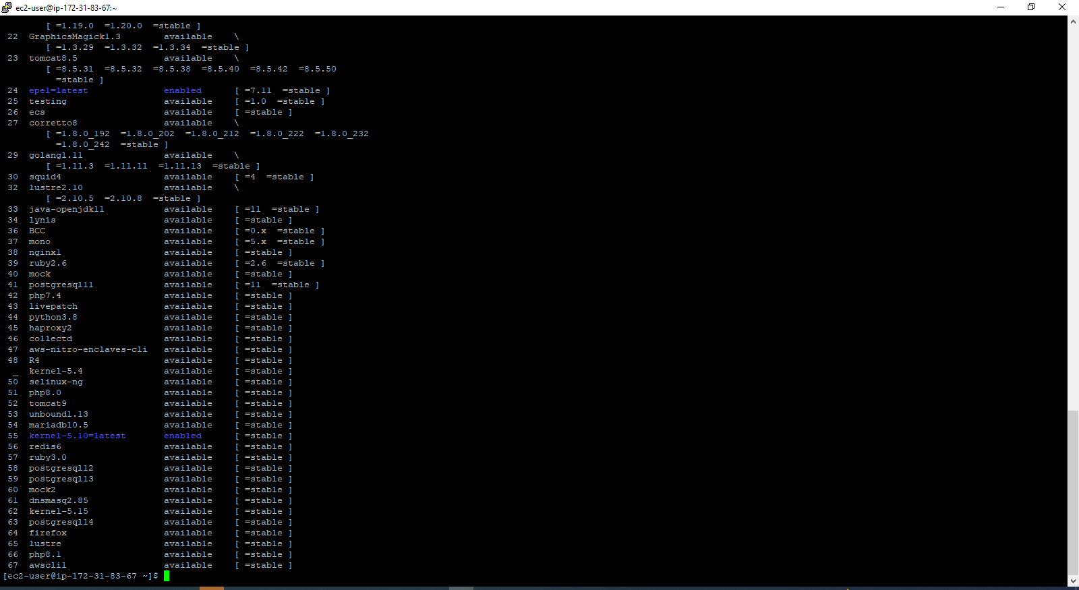

sudo yum install ansible -y

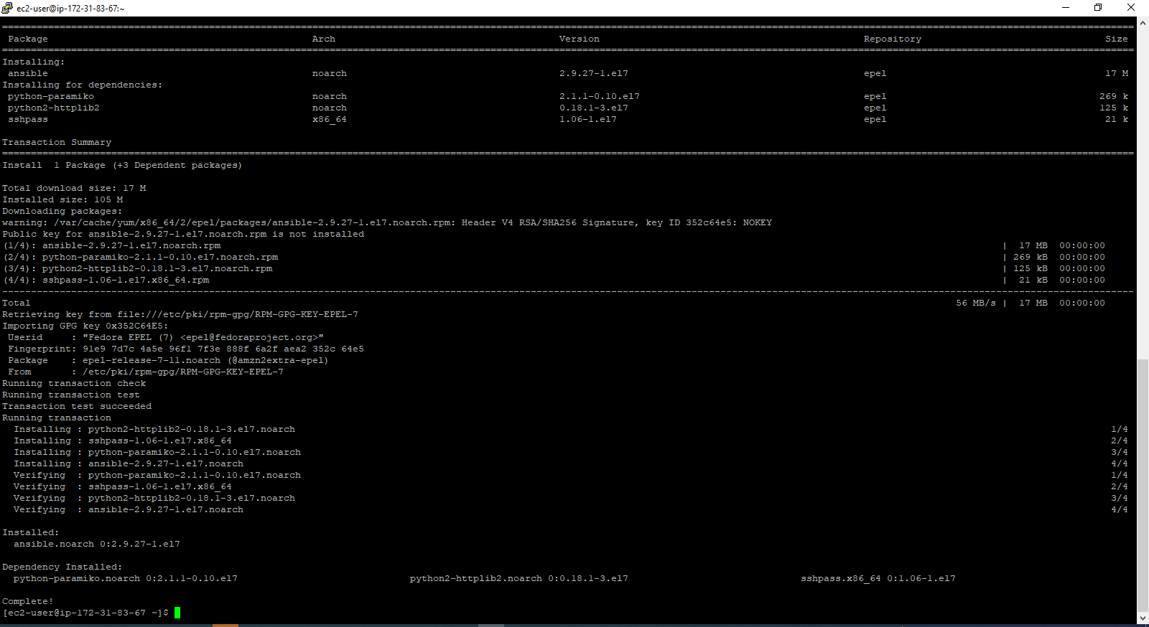

ansible –version [checking ansible version]

Config path file copied - /etc/ansible/ansible.cfg

Viewing the ansible.cfg file:

cat /etc/ansible/ansible.cfg

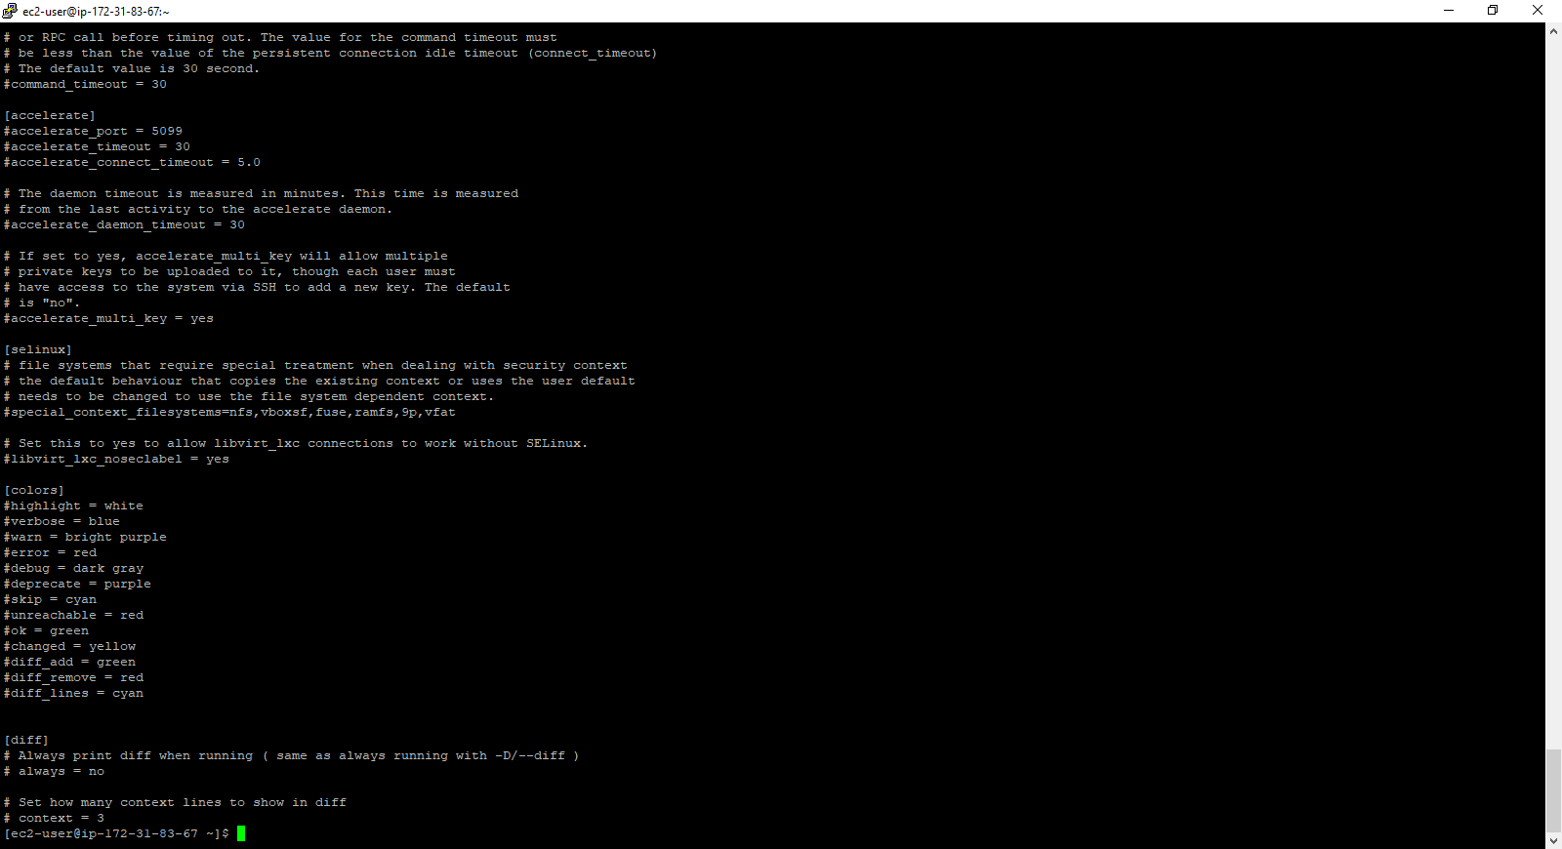

Installing python:

sudo yum install python -y

Installing openssl:

sudo yum install openssl -y

|  |
| --- |
| **Making SSL connection between Ansible Server and the Node [Node instance should be running].** |
| **In Ansible Server:** |

cd .ssh

ls

The authorised keys will be displayed.

cat authorized_keys [It will show the contents of authorized_keys files]

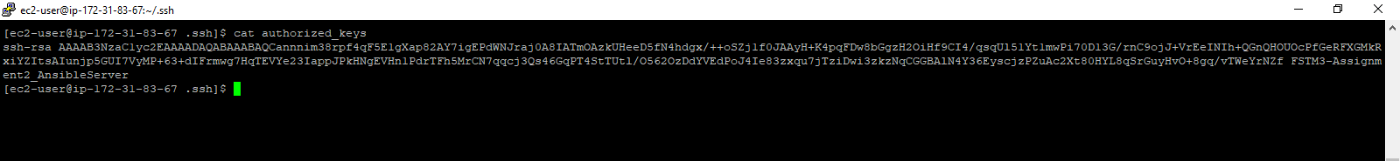

ssh-keygen [to generate the public and the private key files for the ansible server machine]

ls [id_rsa.pub file (public key file is generated)]

cat id_rsa.pub [It will show the content of the public key file generated]

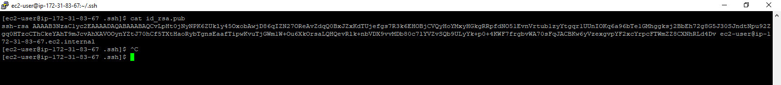

Copy the content of the public key file of ansible server and paste in a new file of Notepad.

Connect the AnsibleNode1 in browser:

Run the below commands in AnsibleNode1:

cd .ssh

ls [You will see authorized_keys]

cat authorized_keys [It will show the contents of authorized_keys file for the ansible node]

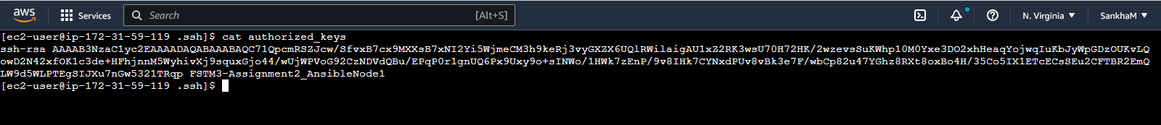

In the AnsibleNode1, open the authorized_keys file in vi editor:

vi authorized_keys

Add the copied public key of the ansible server and paste it in the end of the file. Save it with :wq!

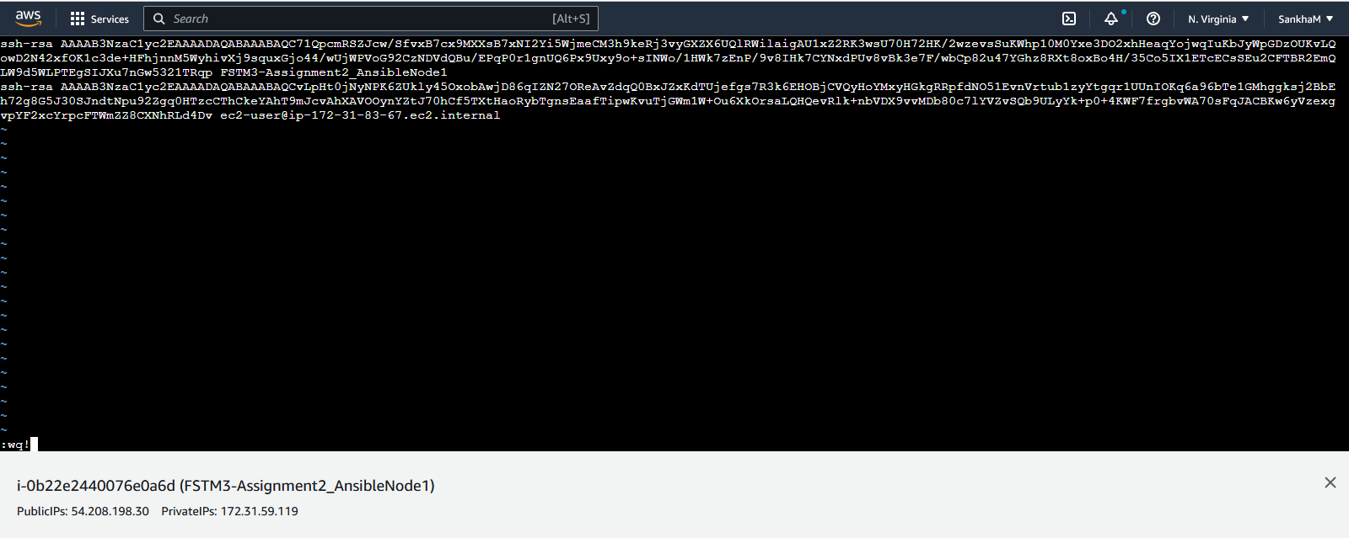

In the Ansible Server, run the below commands:

|  |
| --- |
| cd /etc |
| ls -ll |grep ansible |
| cd ansible |
| ls -ll |

Check that the ansible.cfg and hosts.cfg file is available. You can view the content with cat command as well.

Check if the server is reachable to the ansible node:

ssh ec2-user@54.208.198.30 [public ip of Ansible node running].

vi hosts [open the host file under the ansible folder and add the public iP of the ansible node]

|  |
| --- |
| Open a new session of ansible server and run: |
| ssh ec2-user@54.208.198.30 [ip address of the ansible node] |

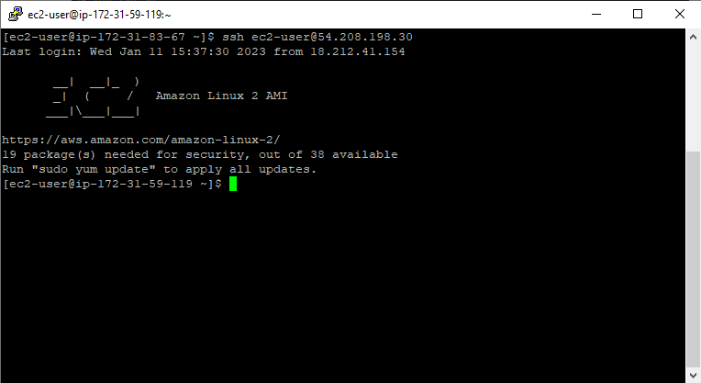

exit [to come out of node connection]

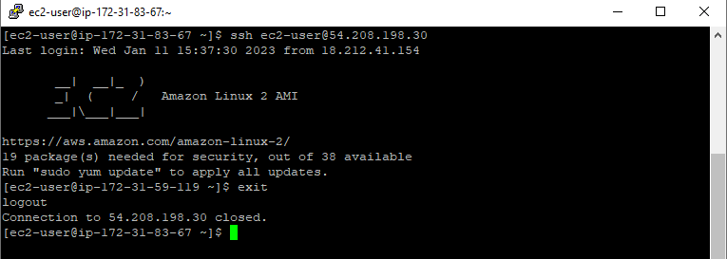

ansible all -m ping [ to check the Ansible server connects to ansible node]

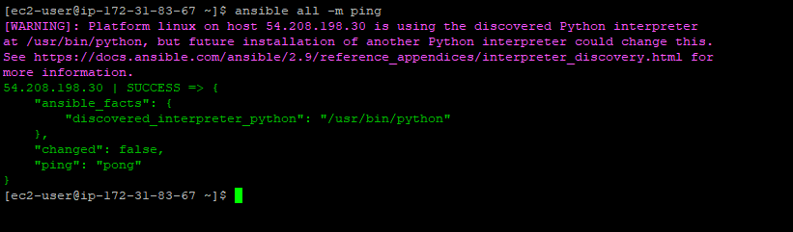

**Installing packages in all ansible nodes parallely**

ansible all -m yum -b -a "name=git" [Installing git package in all ansible nodes]

ansible all -m yum -b -a "name=httpd state=present" [Installing httpd package in all ansible nodes]

ansible all -b -a "yum install java -y" [Installing java package in all ansible nodes]

Connect to AnsibleNode instance and check that the installed packages are available:

Ls -ll |grep java [java folder will be available]

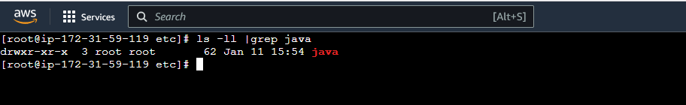

**Uninstalling package from all the Ansible nodes (from Ansible Server)**

ansible all -b -a "yum remove httpd -y" [Uninstalling httpd package from all ansible nodes]

******************* End ******************