|  |
| --- |
| Cloud Testing Assignment 3: |
| Launch minikube cluster and execute the commands to test the pod, container with the kubectl commands |

Opened the Kubernetes minikube URL as below:  
<https://kubernetes.io/docs/tutorials/hello-minikube/#open-dashboard-with-url>

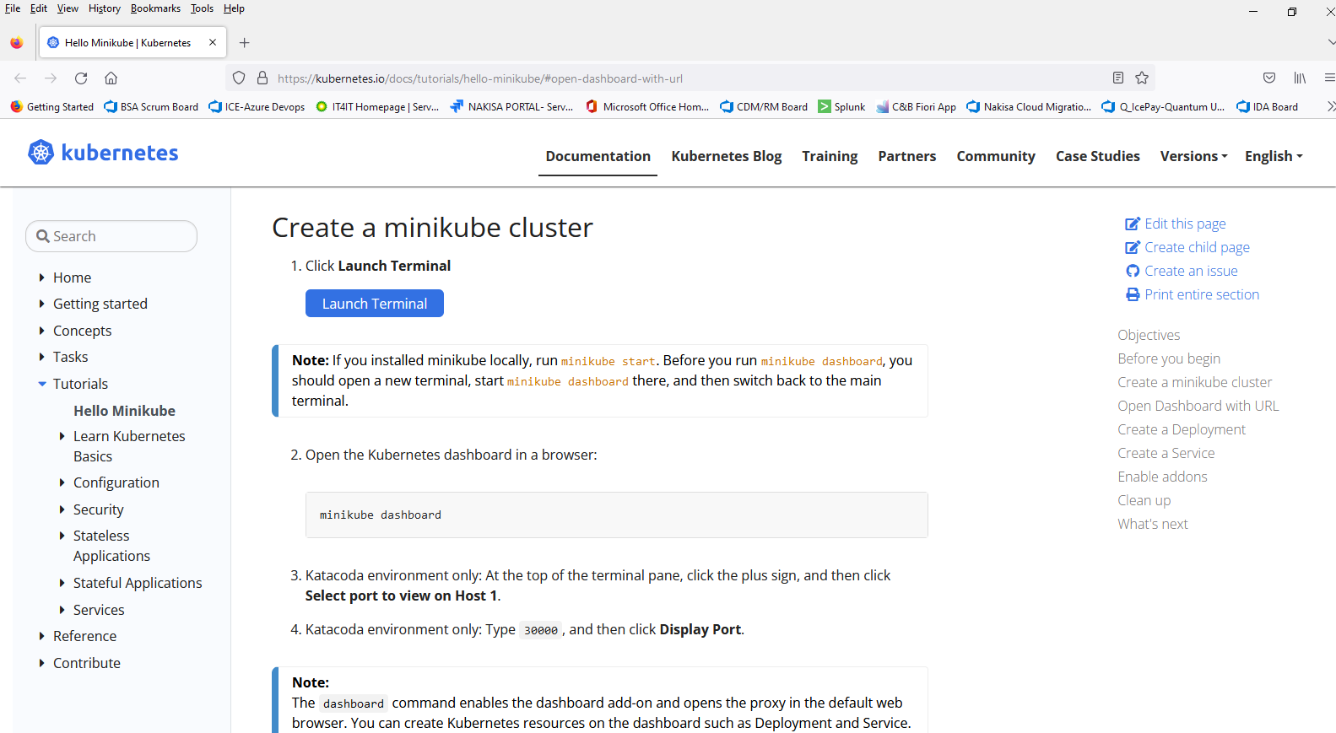

Launched the minikube terminal:

Run the below commands to run the Katacode environment:

At the top of the terminal pane, click the plus sign, and then click **Select port to view on Host.**

Katacoda environment only: Type 30000, and then click **Display Port**.

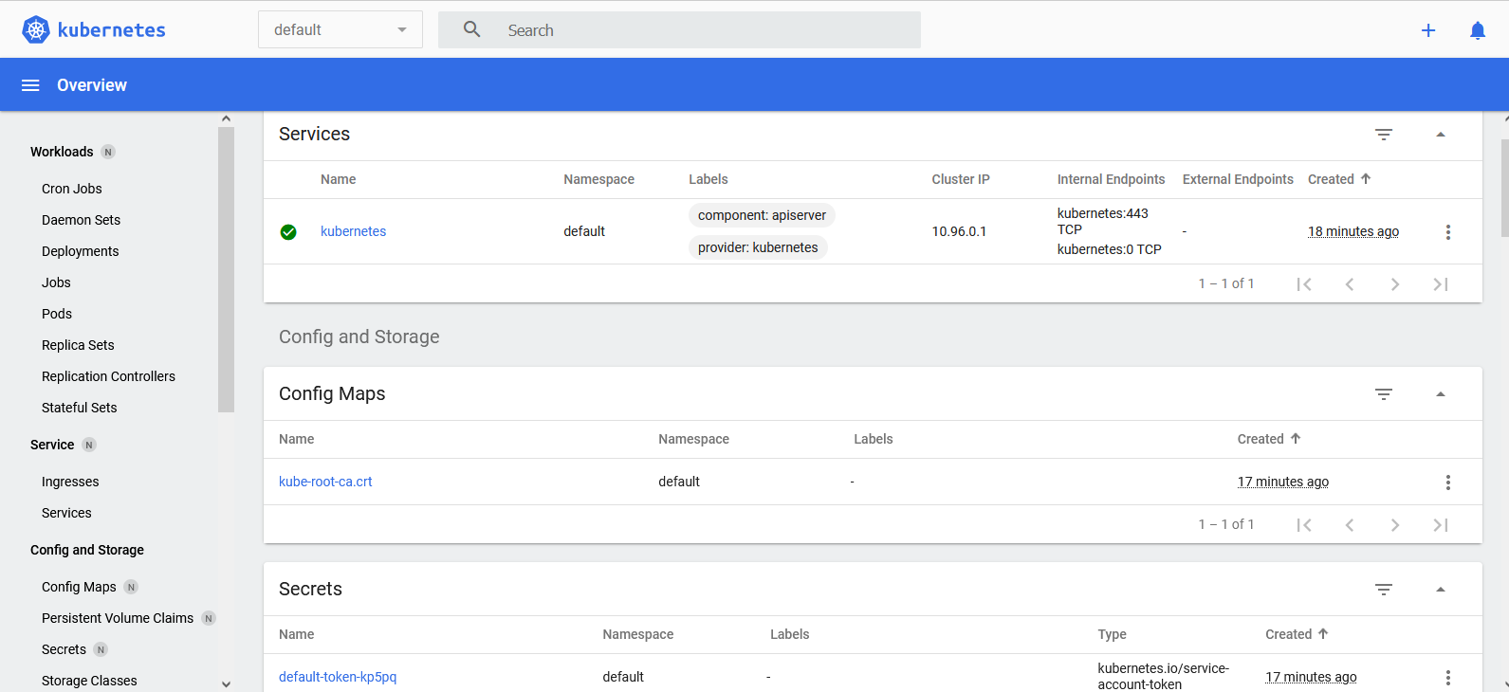

Open a new Terminal (clicking on the + sign) in the Terminal window.

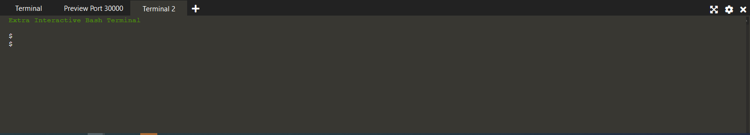

Type the below commands for creating a deployment ‘fstm3-node’:

kubectl create deployment fstm3-node --image=registry.k8s.io/e2e-test-images/agnhost:2.39 -- /agnhost netexec --http-port=8080

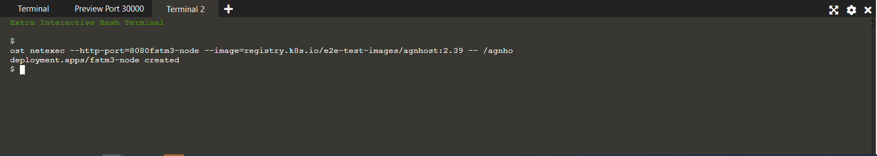

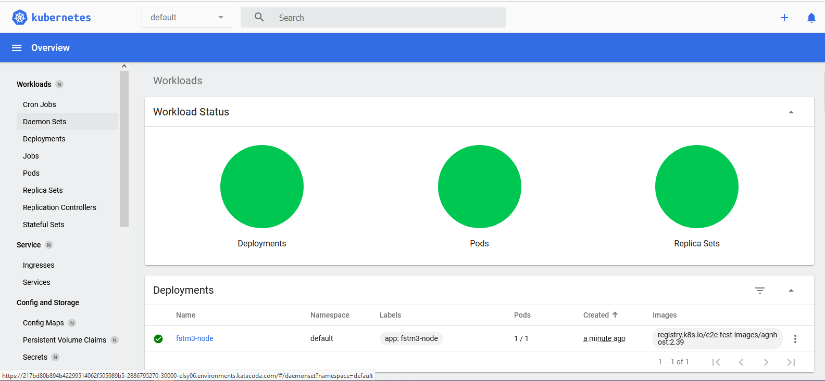

Deployment ‘fstm3-node’ created.

View the deployment in the terminal:

kubectl get deployments [View the Deployment]

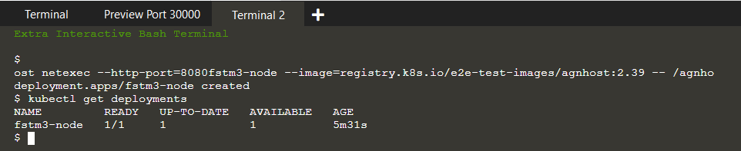

Viewing the pods created:

Kubectl get pods

Viewing Cluster events:

kubectl get events

Viewing kubectl configuration:

Kubectl config view

Viewing the services:

kubectl get services

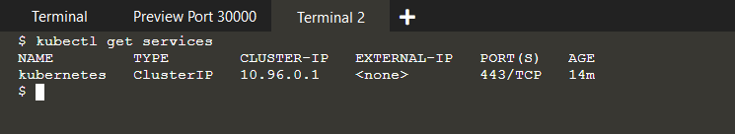

Exposing the node to public internet:

kubectl expose deployment fstm3-node –type=LoadBalancer –port=8080

Viewing services:

kubectl get services

Dashboard view:

Making the service accessible through an external IP:

minikube service fstm3-node

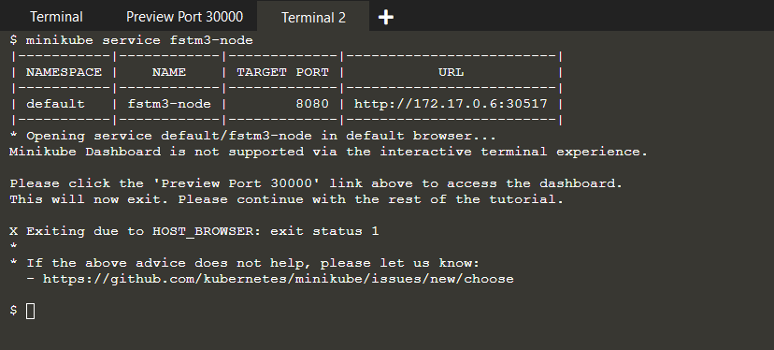

Select the Katacode environment with display port as 30517

Dashboard view of pods:

Creating Namespace:

kubectl create ns fstm3 [namespace name]

Getting the namespaces:

kubectl get ns [kubectl get namespace]

Getting nodes details:

kubectl get nodes

Getting pod details:

kubectl describe pods

Viewing the pod and services:

kubectl get pod,svc -n kube-system

Deleting the services and the deployment:

kubectl delete service fstm3-node

kubectl delete deployment fstm3-node

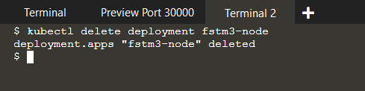

Stopping minikube VM:

minikube stop

Type exit to logout

The terminal can be closed.

******************* End ******************