**Assignment 1.1**

**Steps to Import Acadgild SandBox into Oracle VM**

1. Install Oracle VM through the link

https://download.virtualbox.org/virtualbox/5.1.24/VirtualBox-5.1.24-117012-Win.exe

1. After installing the Virtual Box, install Acadgild Sandbox through the link

https://drive.google.com/file/d/0Bxr27gVaXO5sZi1XTkhkLUUxUmc/view

1. Following are the steps to import the Acadgild Sandbox in Oracle VM:
2. On the Oracle VM, Click on File -> 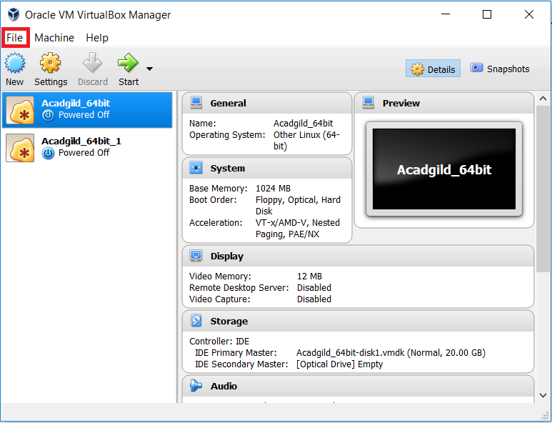

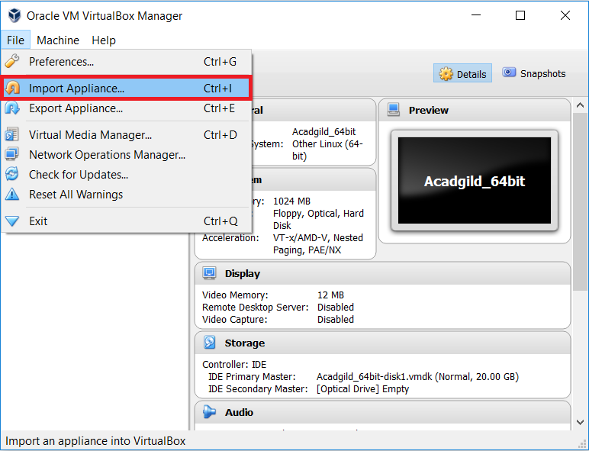

1. Now browse to the folder location where the Acadgild Sandbox has been downloaded/saved and click on next to import.

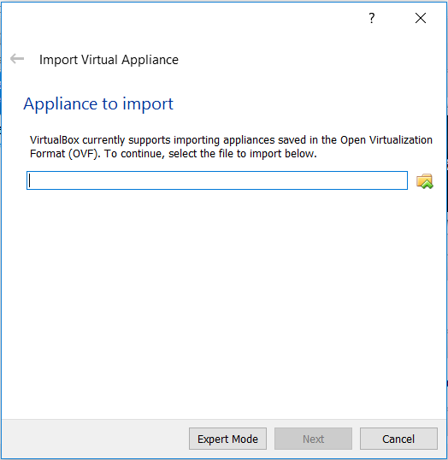

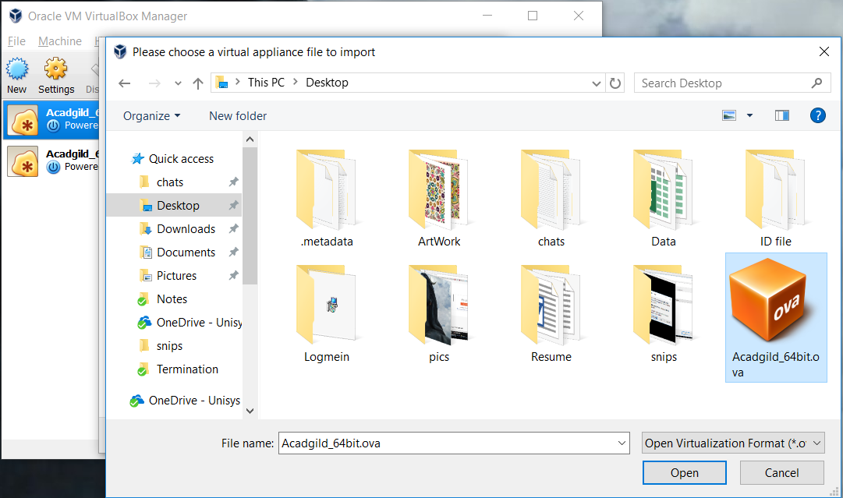

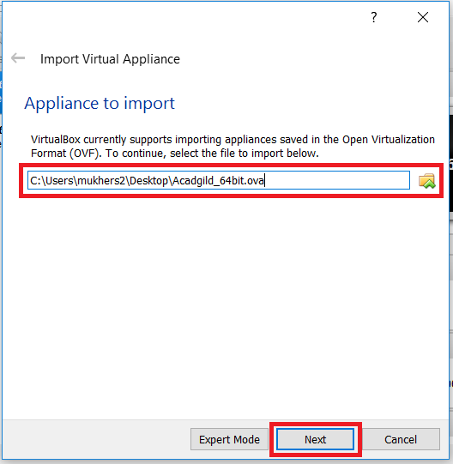

1. Now click on Import for the Acadgild Sandbox got get imported into Oracle VM.
2. Once the import has been completed successfully, you shall find the SandBox towards the left pane of Oracle VM.

