**Assignment 1.2**

1. **Pwd**: Present Working Directory (pwd). This will give an output of the current directory that you are working on.

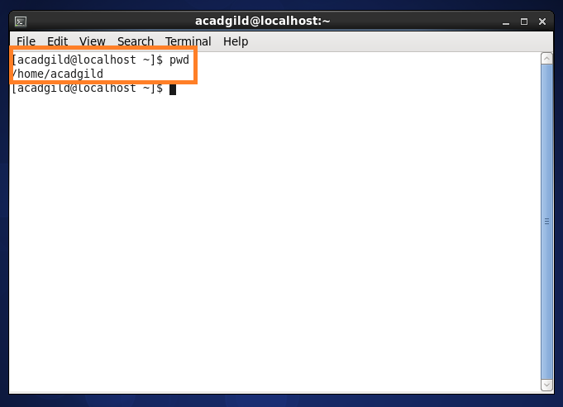

1. **Vi** : Visual Editor. Vi will show the contents of the file you wish to see. The command is “vi <filename>. In vi we can edit the file in 2 modes:

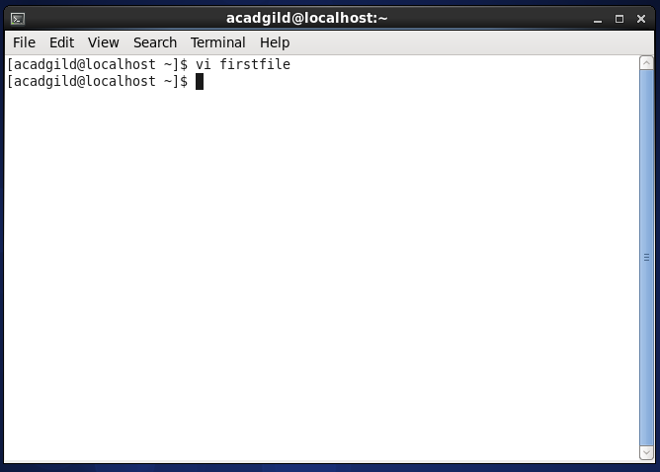

1. **Control mode**: This will show you the contents present in the file that you wish to see. We cannot edit when in control mode. To enter the control mode press **Esc** button.

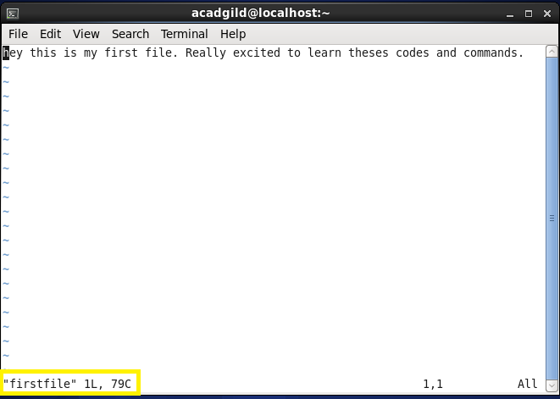

1. **Insert mode**: If you wish to edit the file contents, press the **I** button, and you will notice, towards the bottom of the terminal you will **INSERT**. Now you can edit the file content. \

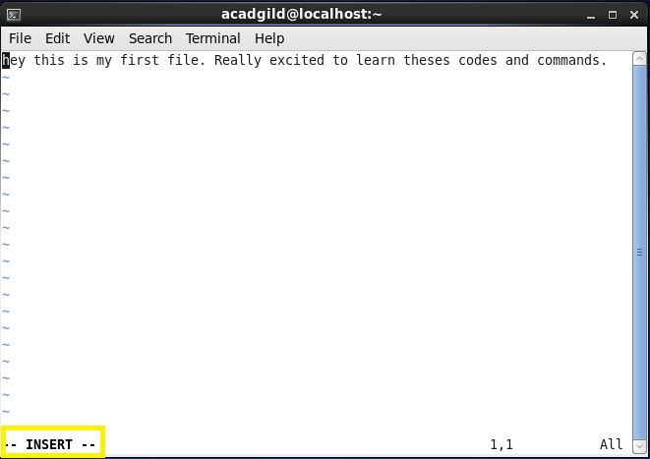

1. **Touch**: This command is used to update the access date or modification date of a file.

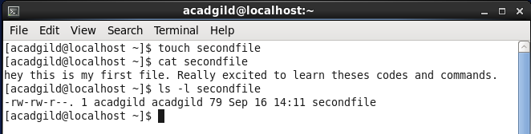

1. **mkdir**: mkdir is a command to create a directory.

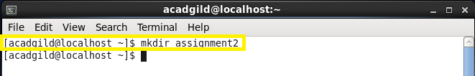

1. **rm** : This command is used to remove a file from a directory.

In the below screen shot you will first notice there is a file name “First”. After running the command “rm first”, the file has been removed.

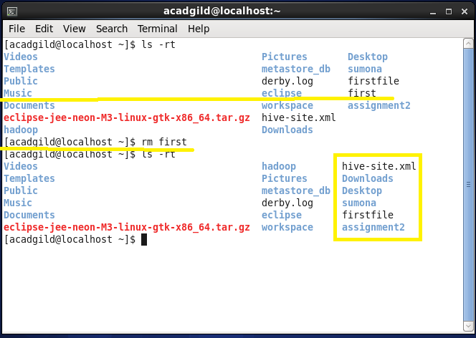

1. **ls**: This command will list all the files and folders.

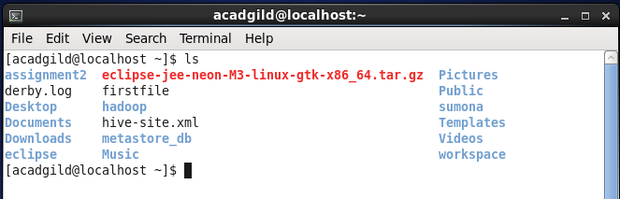

Also, we can use the command “ls –rt”, this will list the files in the reverse time stamp.

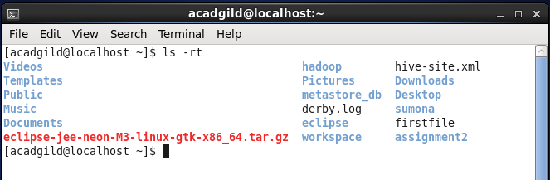

1. **Echo**: This command prints the output of string or script being entered on the screen.

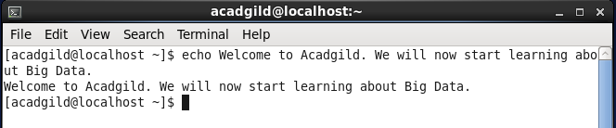

1. **cat** : This command is used for creating single or multiple files, and view their contents

To create a file, the syntax is “cat >*filename*”. After this you may type the content you wish to and to save and close tap Ctrl+D.

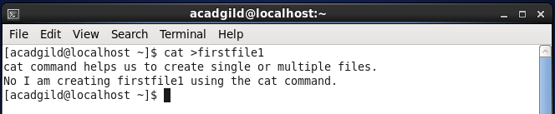

To view the content of the file, the command is “cat *filename*”.

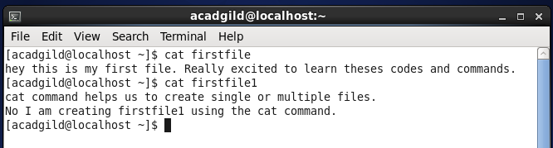

1. **who** : This command will show who all are logged in at the moment. Also the command ***whoami*** will show who are you logged in as.

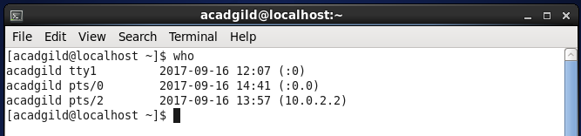

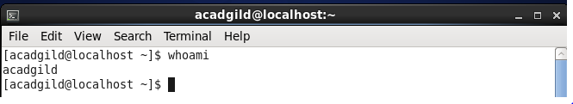

1. **cd** : This command is used to change the directory. Example, there is directory created as “alphabets”, and you wish to end that directory. The command used will be “cd alphabets” or if you wish to go to the sub folder in alphabets, the command will be “cd alphabets\ABC”.

As per the screen shot, I have entered the directory name “Sumona”

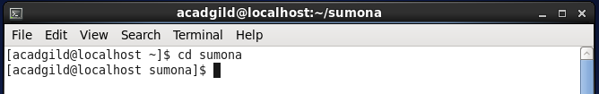

1. **Date:** This command will show the exact time stamp, with the date and standard time format.

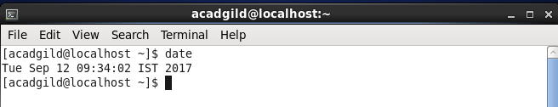

1. **Cal** : This command shows the calendar. You can specify the year of which you would like see the calendar.

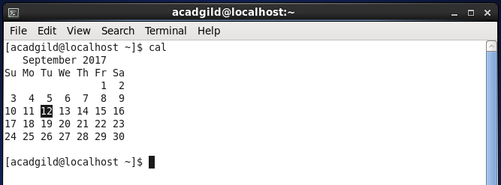

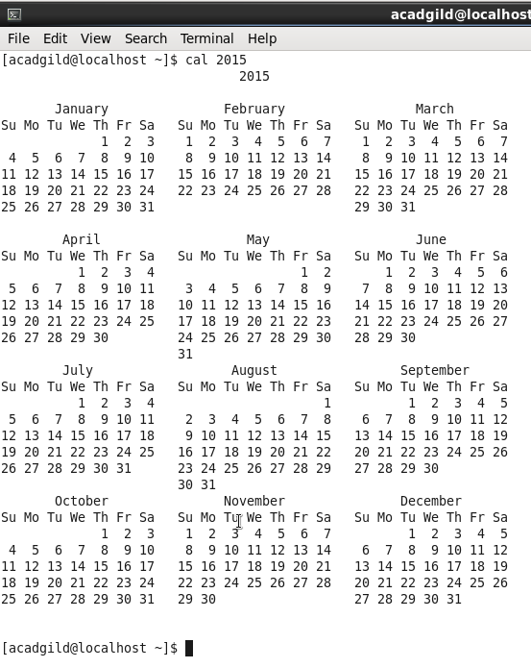

1. **mv :** This command is used to move one file to another. This command deletes the first file and over writes the content of the second file (to which the first file has been moved to). However, the source and destination directory shall be the same.

In the following screen shots, you will first notice that under the directory Sumona, there are 3 files, assignmemt1, firstfile and secondfile.

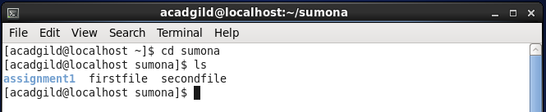

These are the contents of firstfile and secondfile

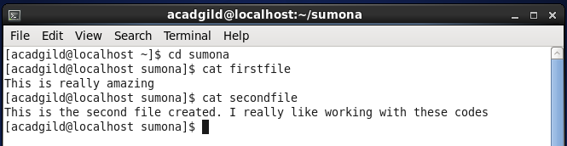

Now we have moved the firstfile to secondfile, as you can see that the firstfile has been removed and the contents in the secondfile has been over written with that of firstfile.

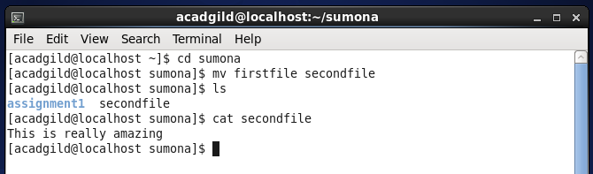

1. **cp:** This command is used to copy contents for one file to another, maybe from the same /different directory.

In the following screen shot, you will notice I have two files *firstfile* and *secondfile*.

When I run the command “*cp firstfile secondfile*” . the content form firstfile gets copied to secondfile and over-writes the content in the second file. However in this command, no files gets deleted.

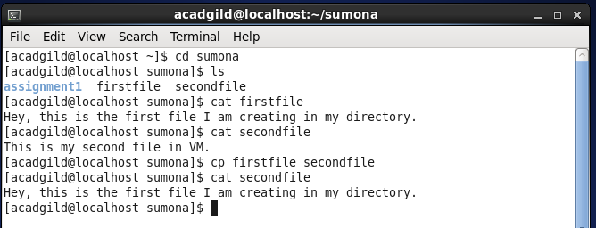

1. **Which:** This command is used to show full path of a shell command. Following are few examples.

