**Assignment 4.3**

Created a file **student_details.txt** and uploaded the in the folder **/user/acadgild/test**

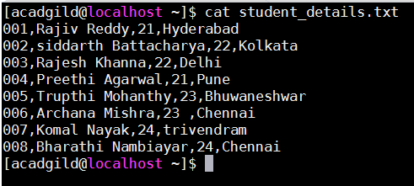

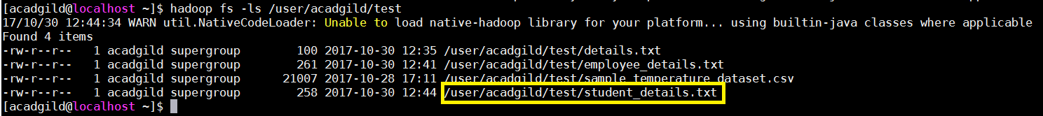

First, we have group the relation **student_details** using the **Group All** operator, and store the result in the relation **named student_group_all** as shown below.

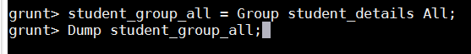



Command to count number of tuples in the relation.



**Output:**

