**Assignment 5.2**

1. Top 5 destination most visited

Loaded the **DelayedFilghts.csv** and **airports.csv**

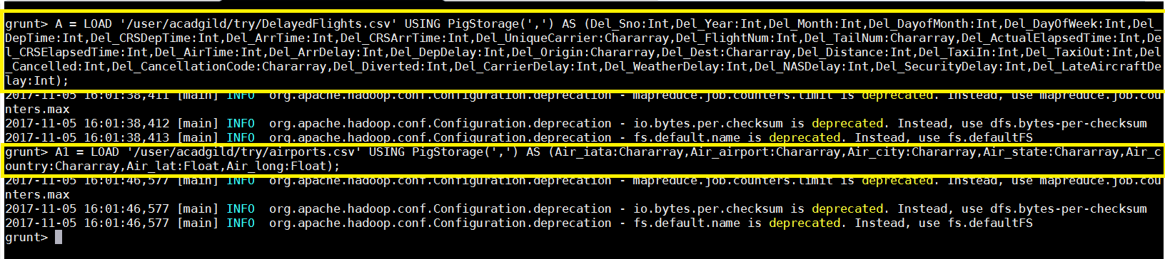

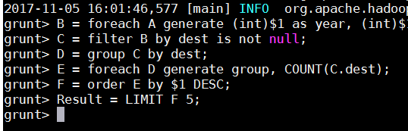

**Output:**

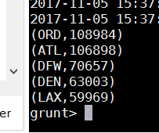

1. Which month has most number of cancellation due to bad weather.

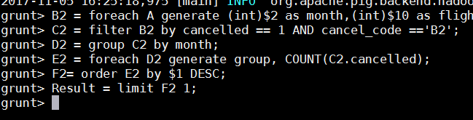

1. Top 10 origins with the highest AVG departure delay

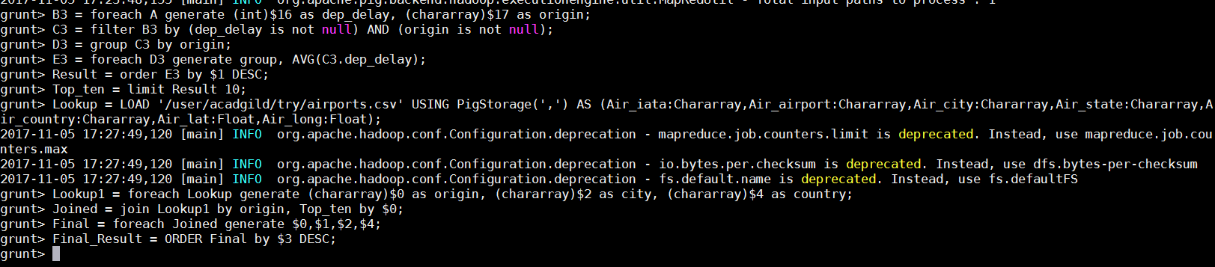

1. Which route has seen maximum diversions

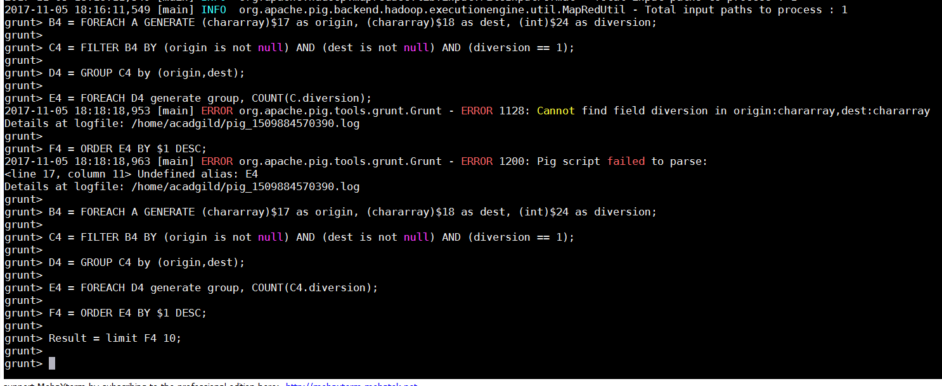

**Output:**

