**Assignment 5.3**

1. List players selected in Qualifying round (Defense>55)

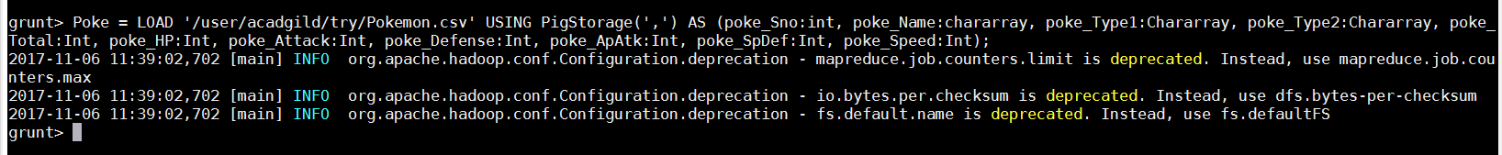

Filtered the data for qualifiers and generated the Sno., Name and Defense number

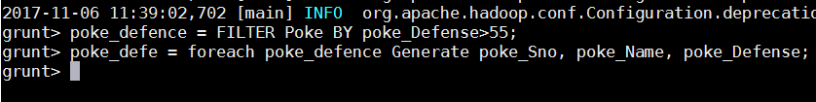

**Output:**

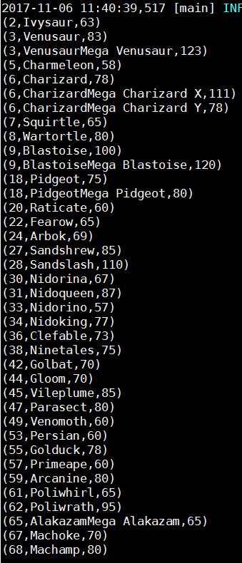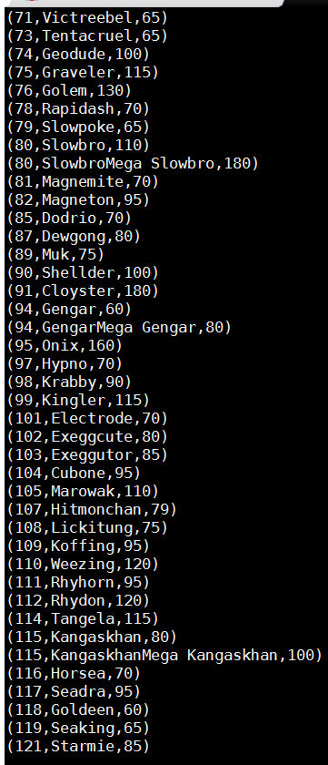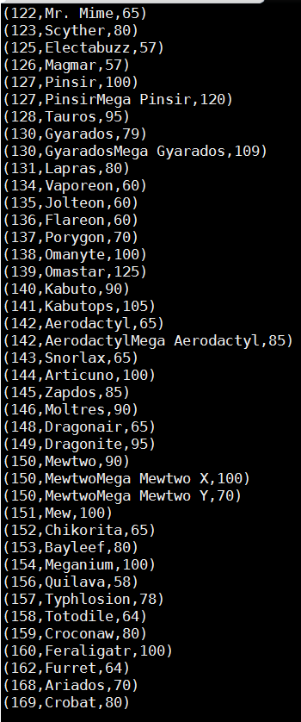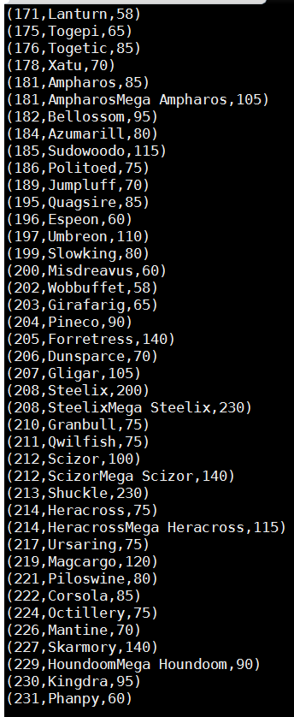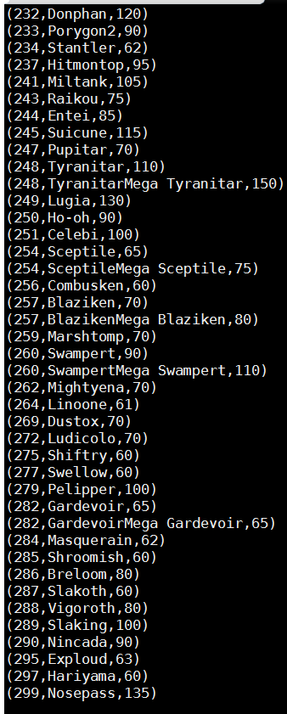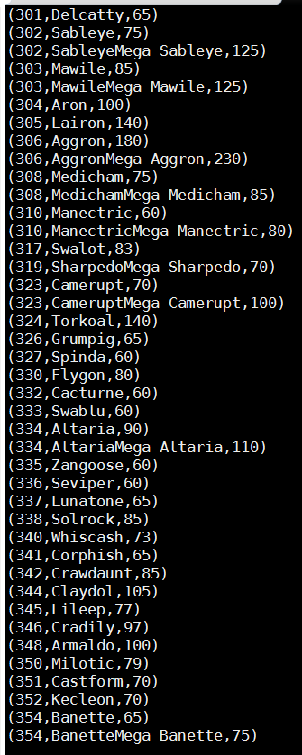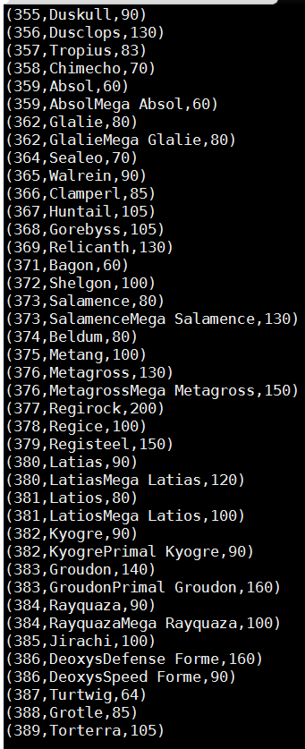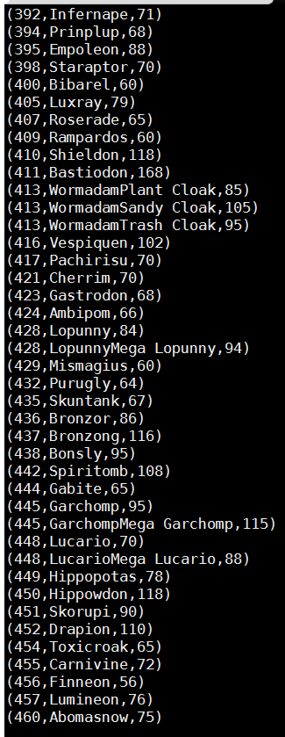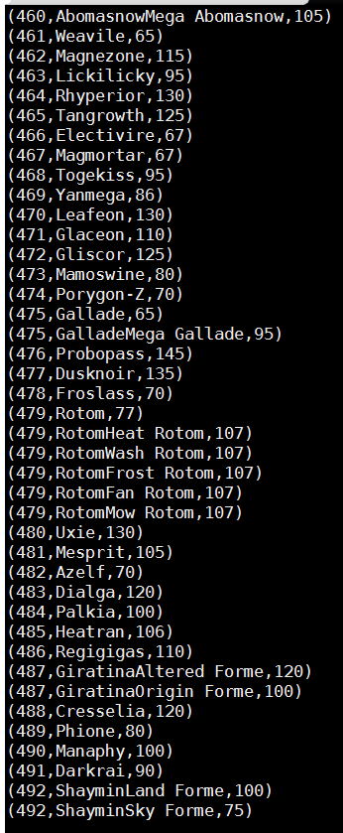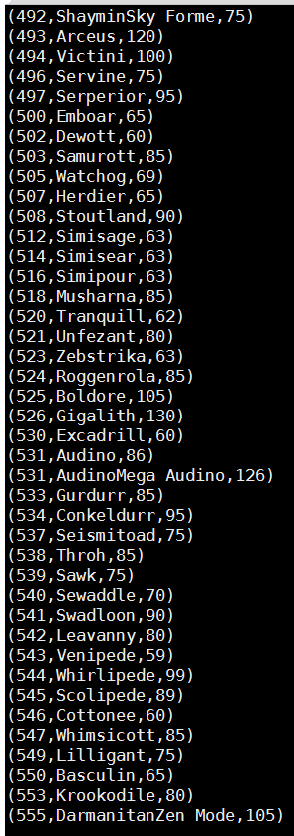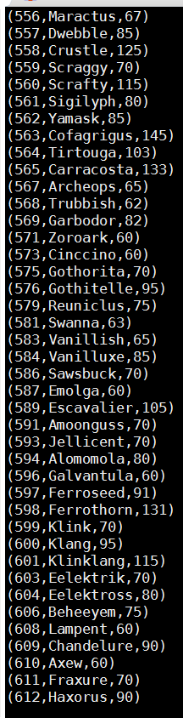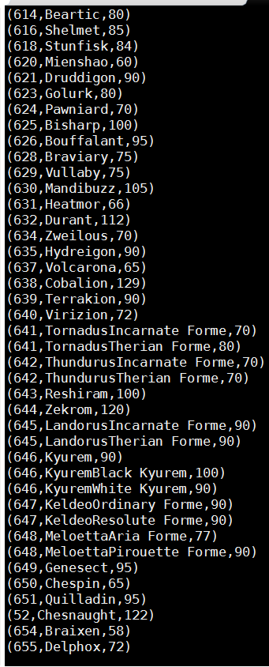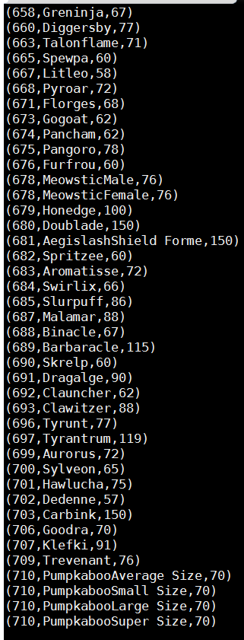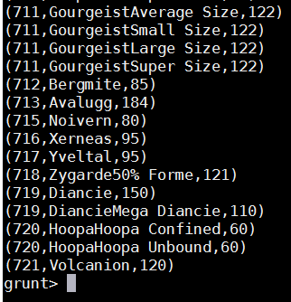

1. Number of players taking part in competition after getting selected



**Output:**

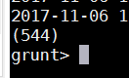

1. Use random() to generate random values:



**Output:**

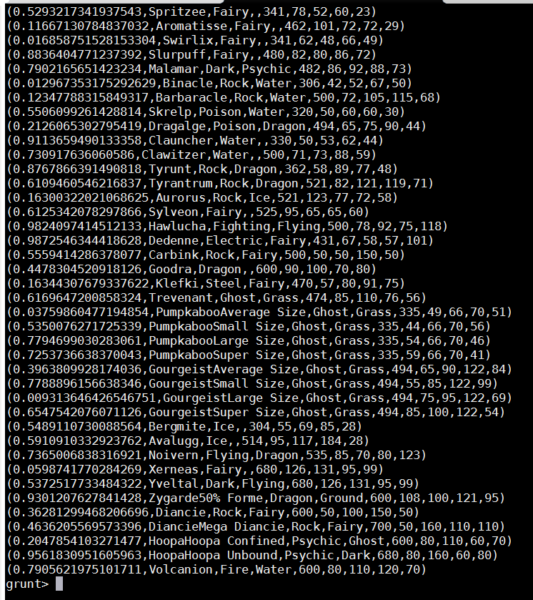

1. Order the random() in descending order:

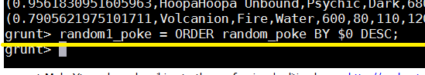

**Output:**

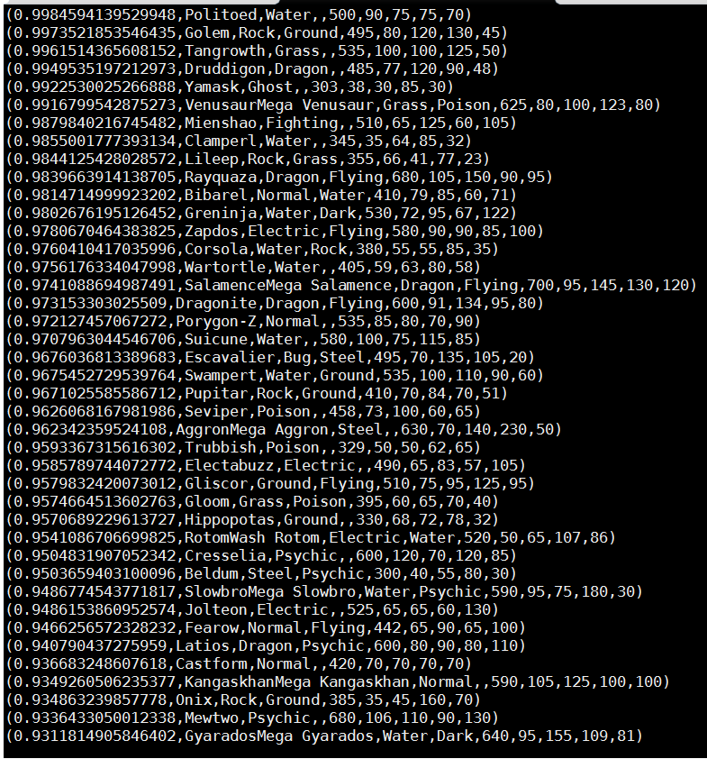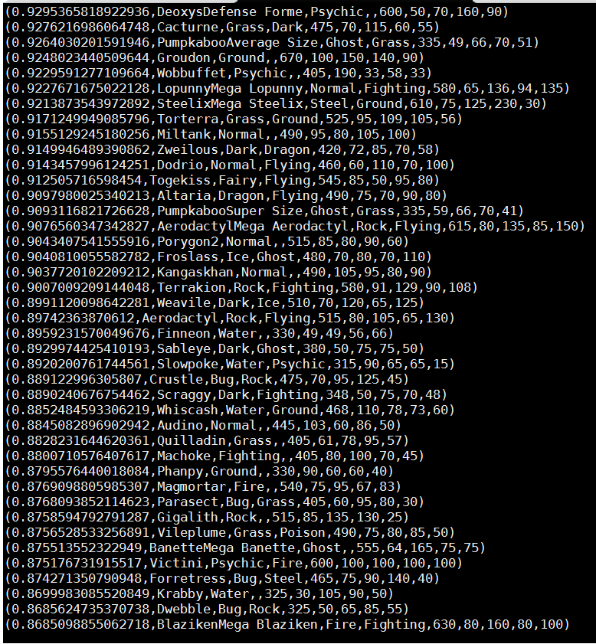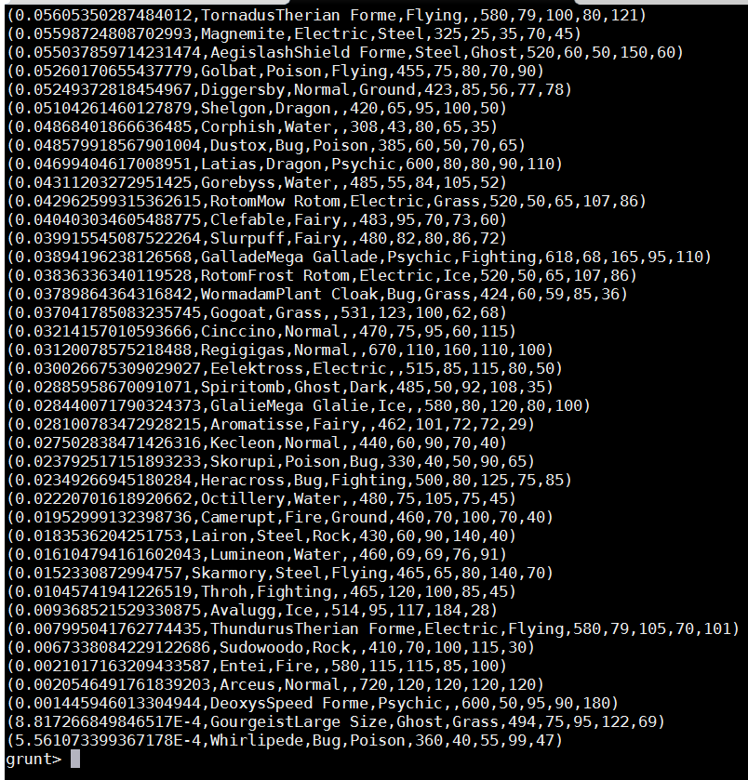

1. Order the random () in descending order for new relation:



**Output:**

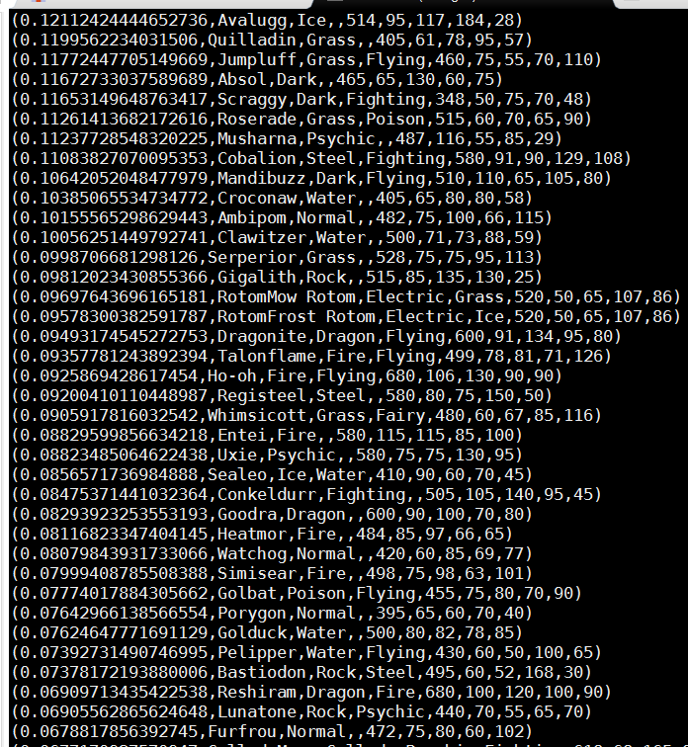

1. Limit of records for both the random output:

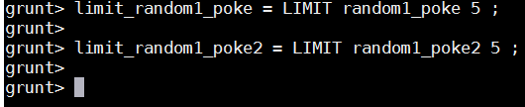

**Dump of limit_random1_poke:**

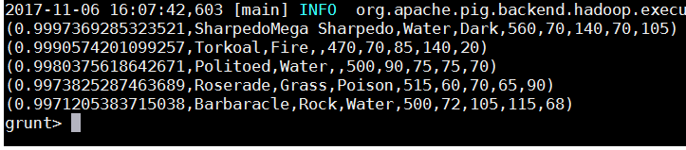

**Dump of limit_random1_poke2:**

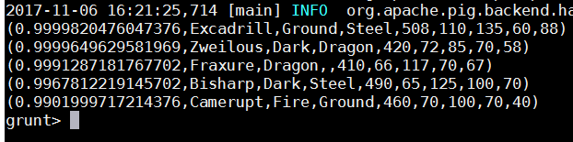

1. Store the data on a local drive to announce for the final match. By the name player1 and player2 (only show the NAME and HP).

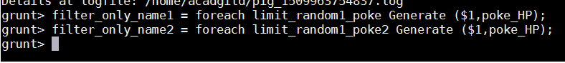

**Dump of filter_only_name1**

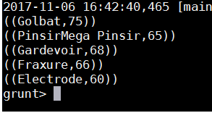

**Dump of filter_only_name2**

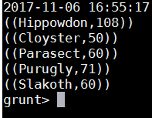

Stored the data “**Dump of limit_random1_poke**” into **/user/acadgild/try/pig/player1.txt**



Stored the data “**Dump of limit_random1_poke2**” into **/user/acadgild/try/pig/player2.txt**



Display of the files being stored in the local drive.

