**Assignment 6.1**

Created a dataset and loaded with Hadoop

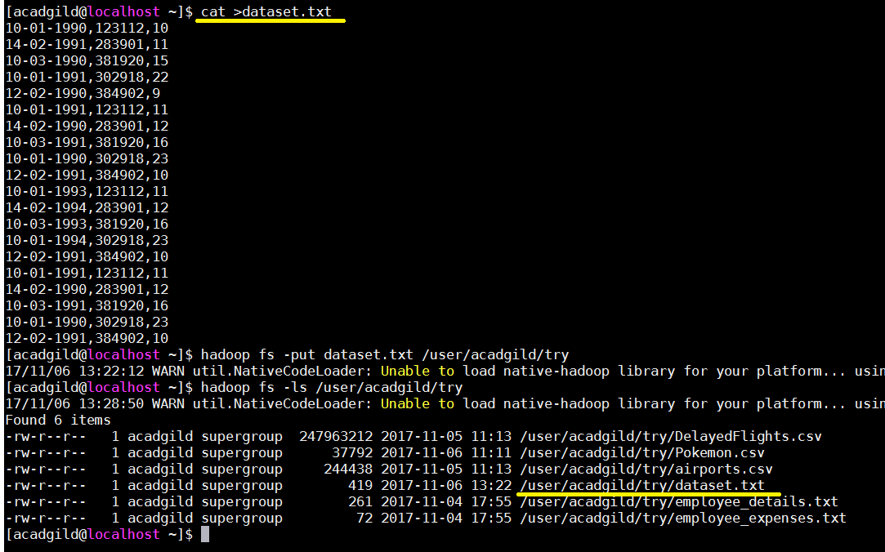

1. Create a database **custom** and table **temperature_data**

Created the database

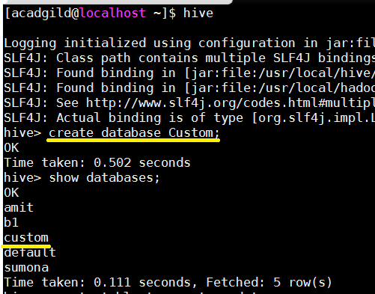

Created the table **temperature_data** with **‘,’ DELIMITED**

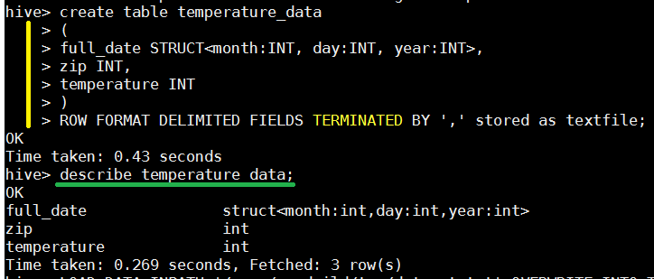

Loaded the **dataset.txt** into the table **temperature_data**

