**Assignment 6.2**

1. Fetch date and temperature from temperature_data where zip code is greater than 300000 and less than 399999.

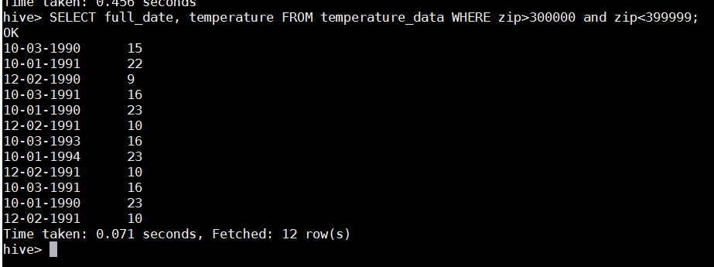

1. Maximum temperature for the corresponding year:



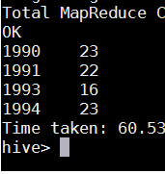

1. VIEW for the about query



**Output:**

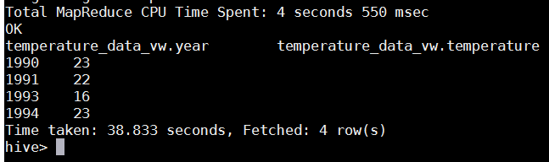

1. Export the view to Local file system delimited by ‘|’

Loaded the VIEW into **/user/acadgild/load**



