**Assignment 8.1**

Created the data **employee.txt** and loaded into **/user/acadgild/test**

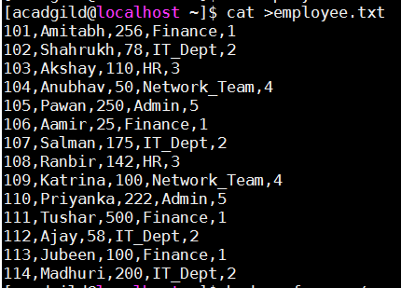

Created a table **employee** and loaded the data **emplpoyee.txt** into it.

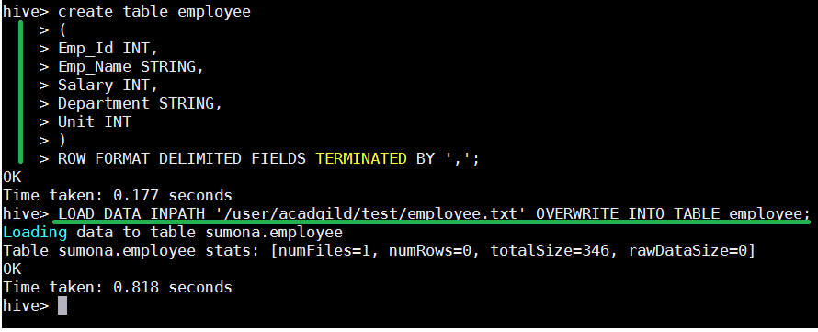

1. List of employee’s ho receive a salary less than 100 compared to their immediate employee with higher salary in the same unit.

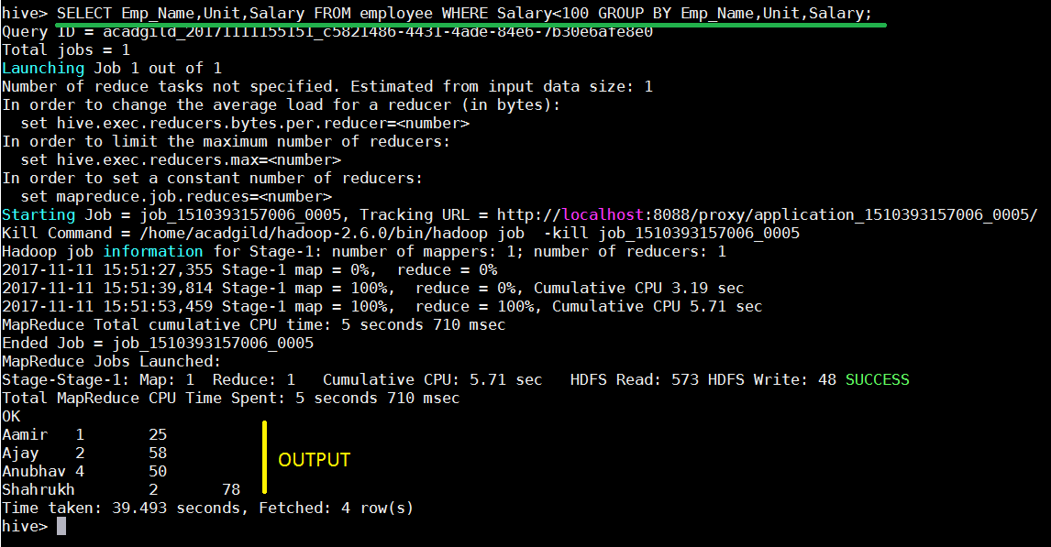

1. List of employee’s who draw higher salary than the average salary of the department.

