**Assignment 5.1**

1. Top 5 employee with highest rating:

Commands:

1. Loaded the employee_details table into emp_det.

emp_det = LOAD '/user/acadgild/try/employee_details.txt' USING PigStorage(',') AS (emp_id:int, emp_name:chararray, emp_salary:int, emp_rating:int);

1. Listed the employee’s in descending order of rating

top_emp_rating = ORDER emp_det BY emp_rating desc;

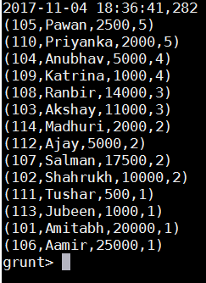

1. Generated the top 5 employee’s name and ID as per the rating

output_rating = foreach top_emp_rating Generate emp_id, emp_name;

limit_emp_rating = limit output_rating 5;

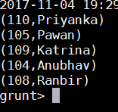

1. Top 3 employee’s with highest salary.
2. Loaded the table in Descending order of the salary

top_emp_sal = ORDER emp_det BY emp_salary desc;

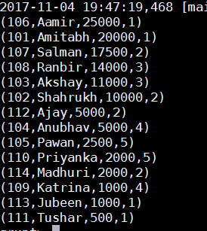

1. Top 3 employee’s with highest salary in descending order

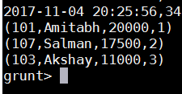

1. Employee’s with maximum expense:
   * 1. Joined the Employee Details and the Employee Expenses table

joined_data = join emp_det by emp_id , emp_exp by emp_id;

* + 1. Loaded the data in descending order of maximum expenses

top_emp_expense = ORDER joined_data BY emp_expenses desc;

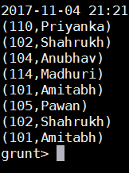

1. Employee’s name in Employee expense table:

id_name = foreach top_emp_expense Generate emp_exp::emp_id, emp_det::emp_name;

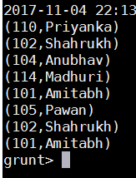

1. Missing record from Employee details table and Employee expenses table
   * + - 1. Grouped the data from both the table

cogroup_data = COGROUP emp_det by emp_id, emp_exp by emp_id;

* + - * 1. Data of the missing record from both the table

isempty_data = filter cogroup_data by IsEmpty(emp_det);

