Trip Advisor Dashboard : For Hotels in Las Vegas

1. Upload data to PowerBI (link here: “https://github.com/mukhilDS/dashboards“)
2. Data preprocessing

Hotel stars have wrong data type (should be decimal instead of categorical)

& 4,5 is given here so we must replace “,” with “.”

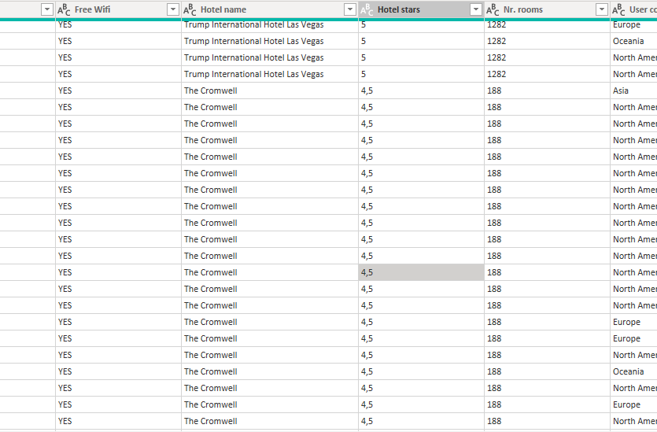

Execution:-

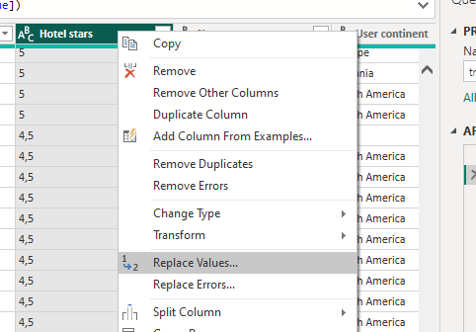

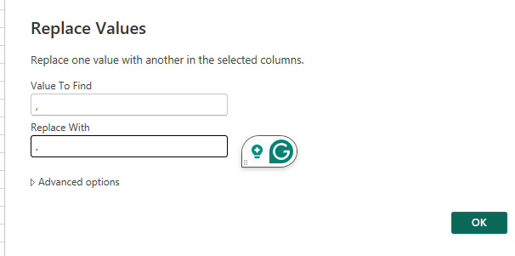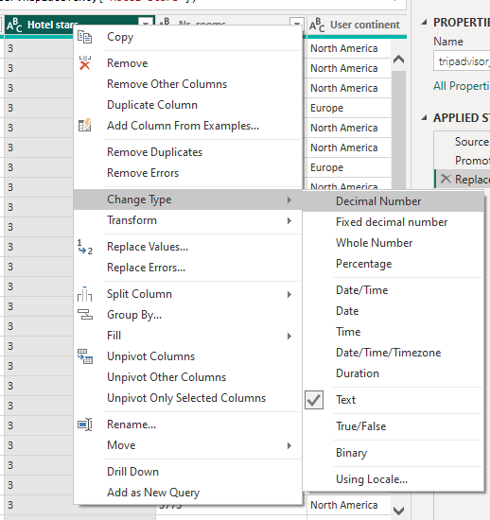

* Now, we have converted “,” to “.” and change it to decimal numbers.

Score – It is the rating of the user (don’t confuse it with rating of hotel)