**Important**

If you decide to write new data or change current data, there are some rules you should follow to avoid errors:

1. Always test locally. By this I mean when you modify a json file with data, do not write the data into firebase yet.

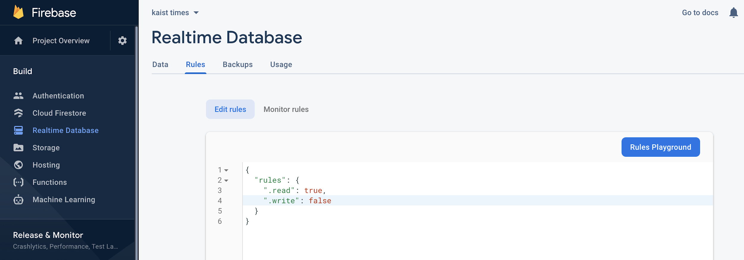

Set “.write” property to false and

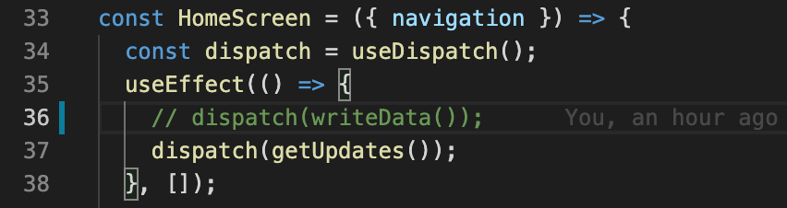

Comment line “dispatch(writeData())” inside HomeScreen.js. Afterwards, you can freely test your code.

1. After you are ready to publish the update, you must set the ".write” property to true and uncomment “dispatch(writeData())” inside HomeScreen.js. After the data has been updated, set those parameters to their initial values as in step 1.

**Add new bus type and its stops as well as timetable**

File update sequence: busTravelTimes.json -> busTimetable.json -> options

1. If there is no travel time corresponding to desired bus stops inside busTravelTimes.json, you have to specify it inside the file so that arrival times would be calculated correctly.

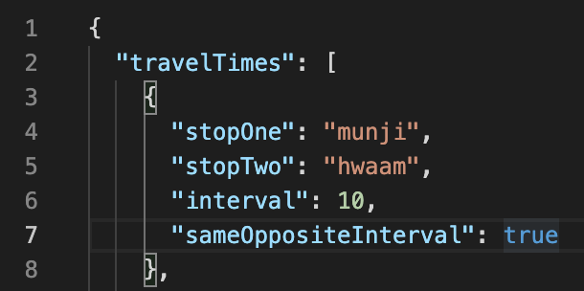

1. Inside busTimetable.json, you can follow an already existing timetable structure to add a new timetable. You need to add a new key and object as its value. Here, the key must be exactly the same as bus type name_id. Inside “route”, every bus stop has to equal the corresponding bus stop’s name_id.

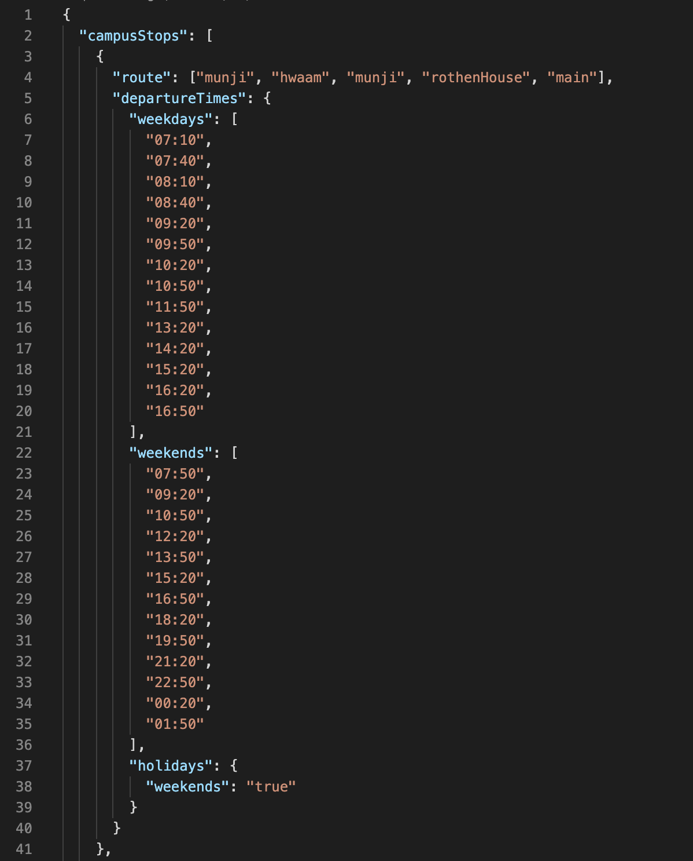

1. Options have to be updated at the end because the end user would see it. And if the first two steps were not followed before this step, then there will be errors. **Important: id attributes must have unique values**. Additionally, if you decide to provide sub items by using the **children** attribute, then I recommend making the name_id of the parent to be the same as the name_id of its first child since selecting parent should provide some data.

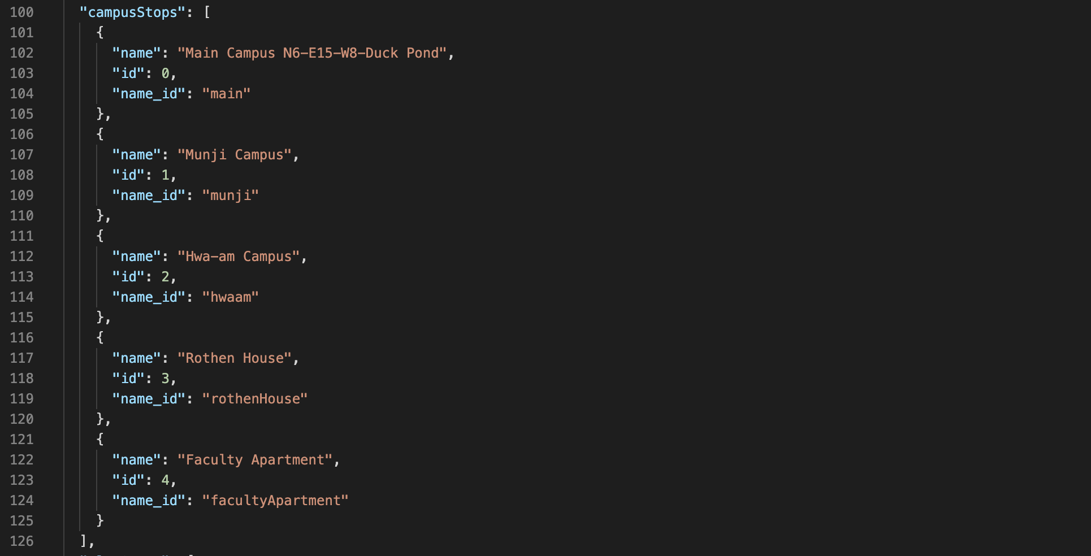

At the end, you should add the new bus type, if any, to busTypes list.

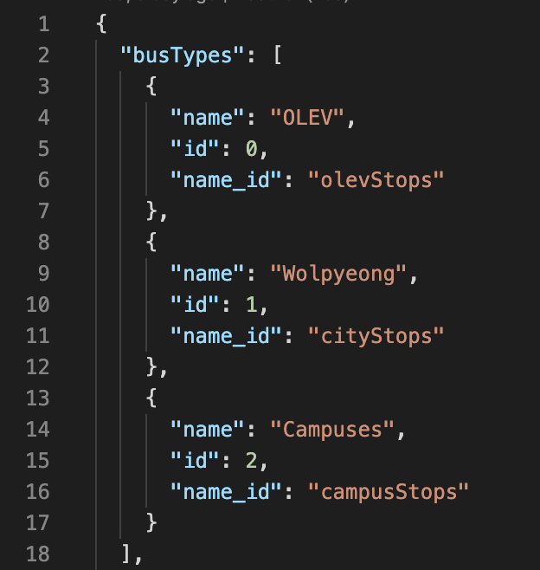

**Add new operating hours**

File update sequence: operatingHours.json -> options

1. If you are adding a new category, then you must provide a new object with the name of the category. Inside “locations” you then provide each individual facility name and its operating hours.

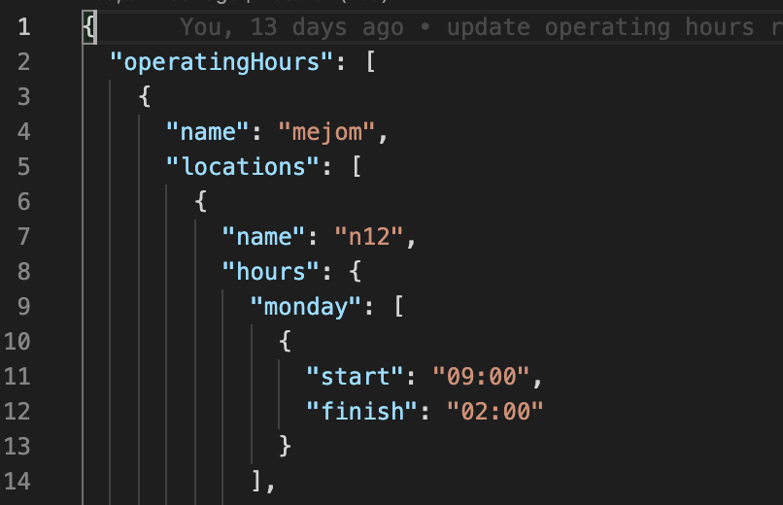

1. Inside options, you must make sure that “id” property of each facility must have unique value. If ids are not unique, then when selecting a facility with duplicate id, the first facility with the id will be selected.

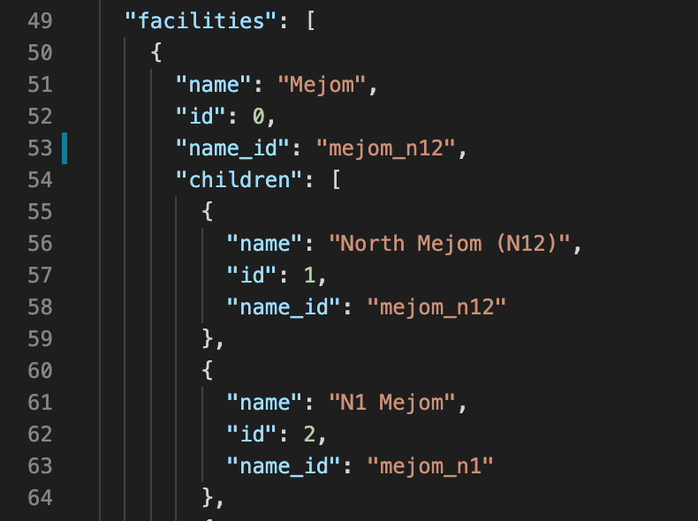

**Additional Props**

1. Some days other than holidays, a facility owners might decide to close their facility due to personal reasons. Since if we consider those dates as holidays, other data will be affected and we do not want other facilities or bus schedules to be affected because of one exception. To handle this scenario, you can add **closed** property with a list of days in the format **MM-DD**.

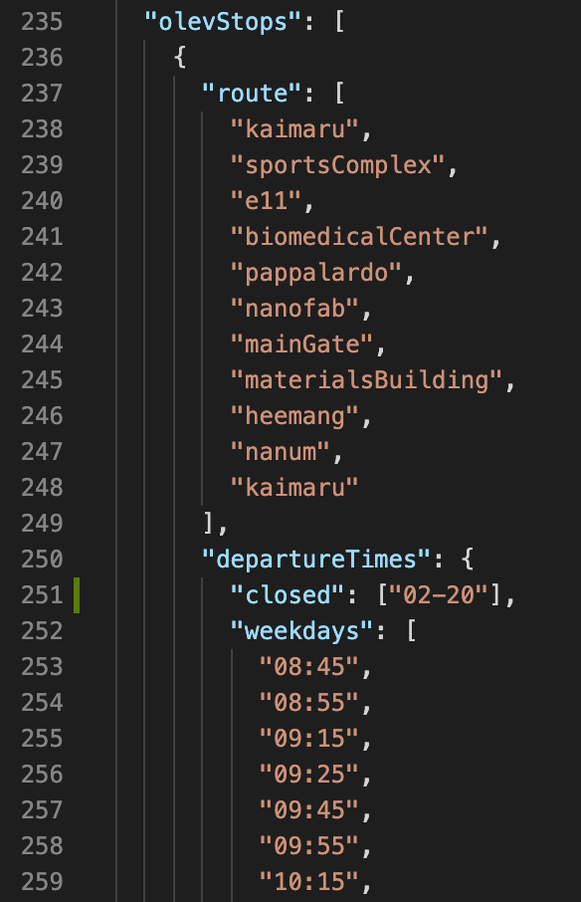 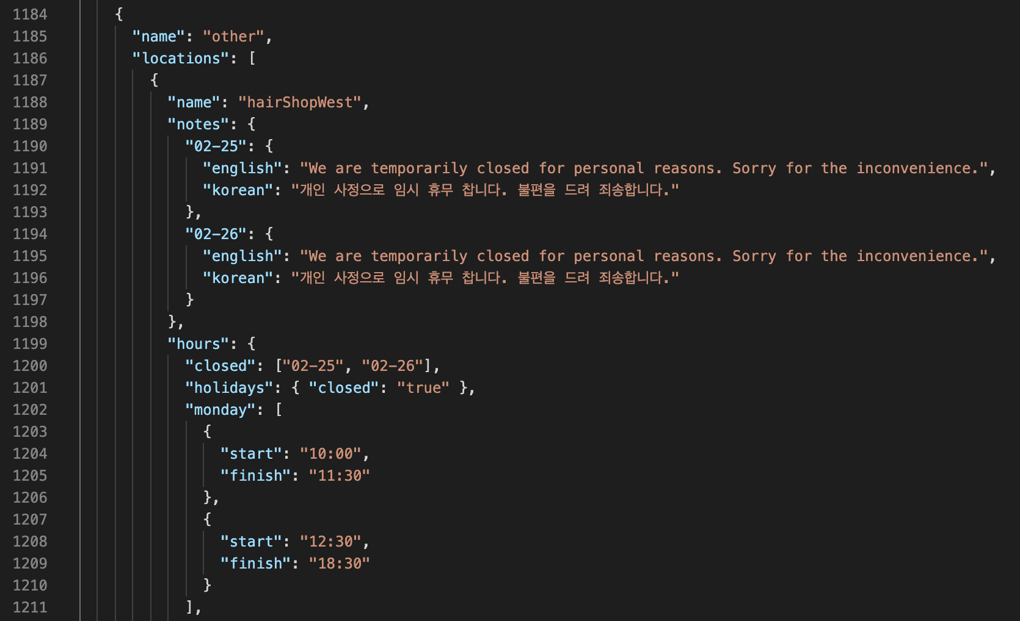

1. There might be cases when you want to provide a timetable for a specific date. Let’s say ISSS office decided to close earlier due to volunteer day (last Wednesday of each month). With the same reasoning about holidays as in the previous part, we cannot just add that day to the holidays array. To handle this scenario, you can provide key in the format **MM-DD** and provide value of the updated time. **Note,** firebase does not store empty arrays. If you want to indicate that a facility/bus does not operate on that day, use **closed** property in part 1.

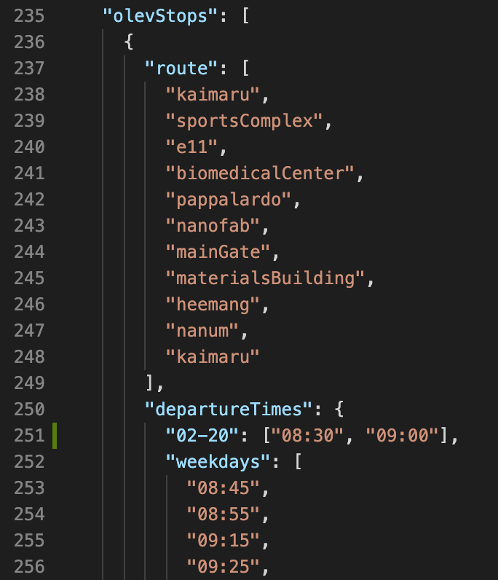 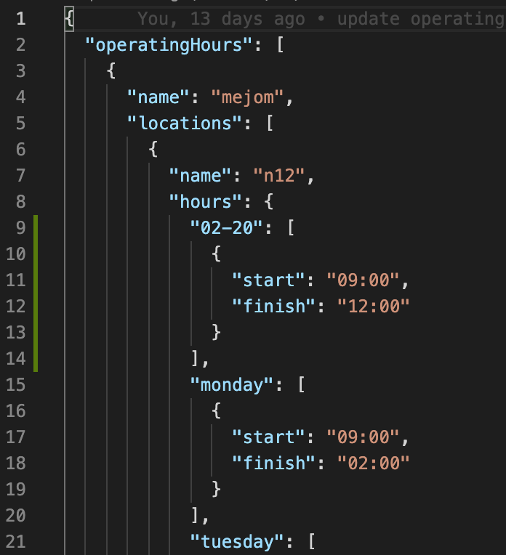

**Handle holidays**

File update sequence: busTimetable.json or operatingHours.json -> holidays.json

1. Inside busTimetable.json, you may add **holidays** property with object value. If you do not provide **holidays** property, then it will be considered as if the bus operates regularly. You could also provide **regular** property to achieve the same result. If the bus does not operate on holidays, you can provide **closed** property. Both **regular** and **closed** properties ignore its values. In other words, if you set the value of **regular** to false**,** then it will still be considered as if it is regular. If you do not want either **regular or closed,** then delete those properties. All of the times (array of strings representing departure times) **must** be provided inside **hours** property. If you want to provide time for a specific date of holiday, then you can provide property in a form of **MM-DD** and with object value that can have aforementioned properties. Lastly, you may also provide either **weekdays or weekends** property to get times for weekdays or weekends if during holidays the bus operates according to already existing times. In the following example, specific dates would take precedence over other default values such as **closed**. If, for instance, we have 02-18, then it will result in empty data because there is no specific 02-18 key inside holidays and hence it will be defaulted to **closed.**

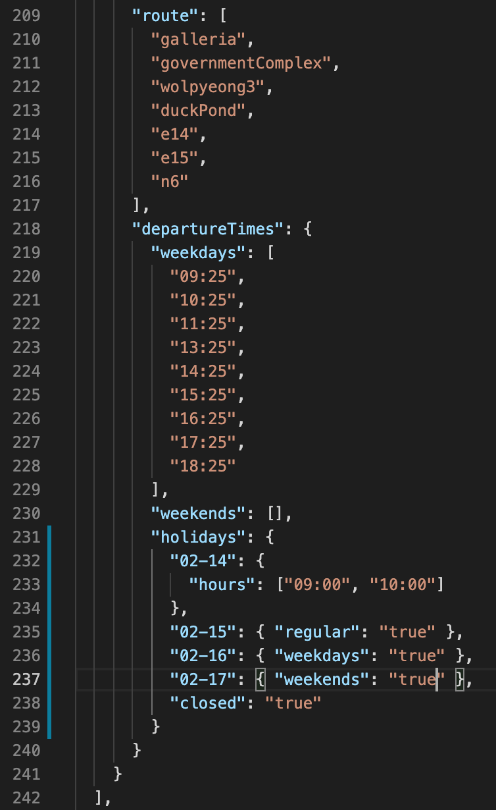 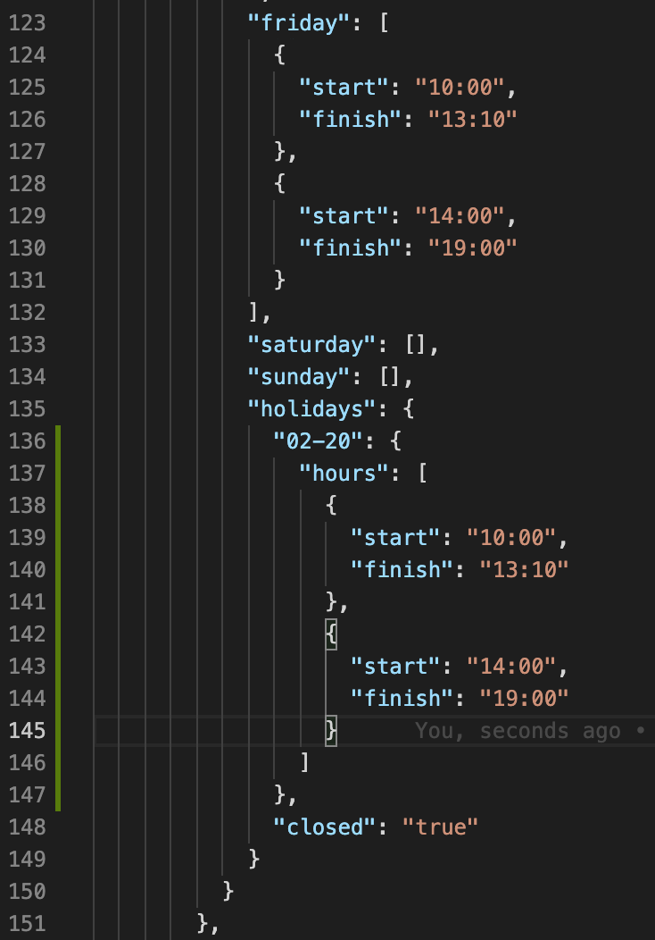

1. Inside operatingHours.json, it is very similar to the previous point. Two differences are: values of **hours** property is the same as with other operating hours (array of objects with **start and finish** properties), and properties **monday, tuesday, …, sunday** instead of **weekdays or weekends.**
2. Finally, you would update holidays.json where **dates** property has an array of strings of form **MM-DD** as a value.

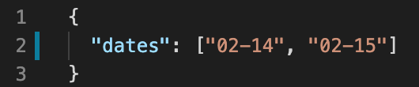

**Add notes**

File update sequence: busTimetable.json or operatingHours.json

1. Inside busTimetable.json, you can add **note** property for a specific object that contains **route and departureTimes** properties. **note** has an object value. Inside the object, you may provide **weekends or weekdays** properties and string as a value that will contain the note you want to show users. If note applies to any day, then you can provide **any** property which will show the note in any day.

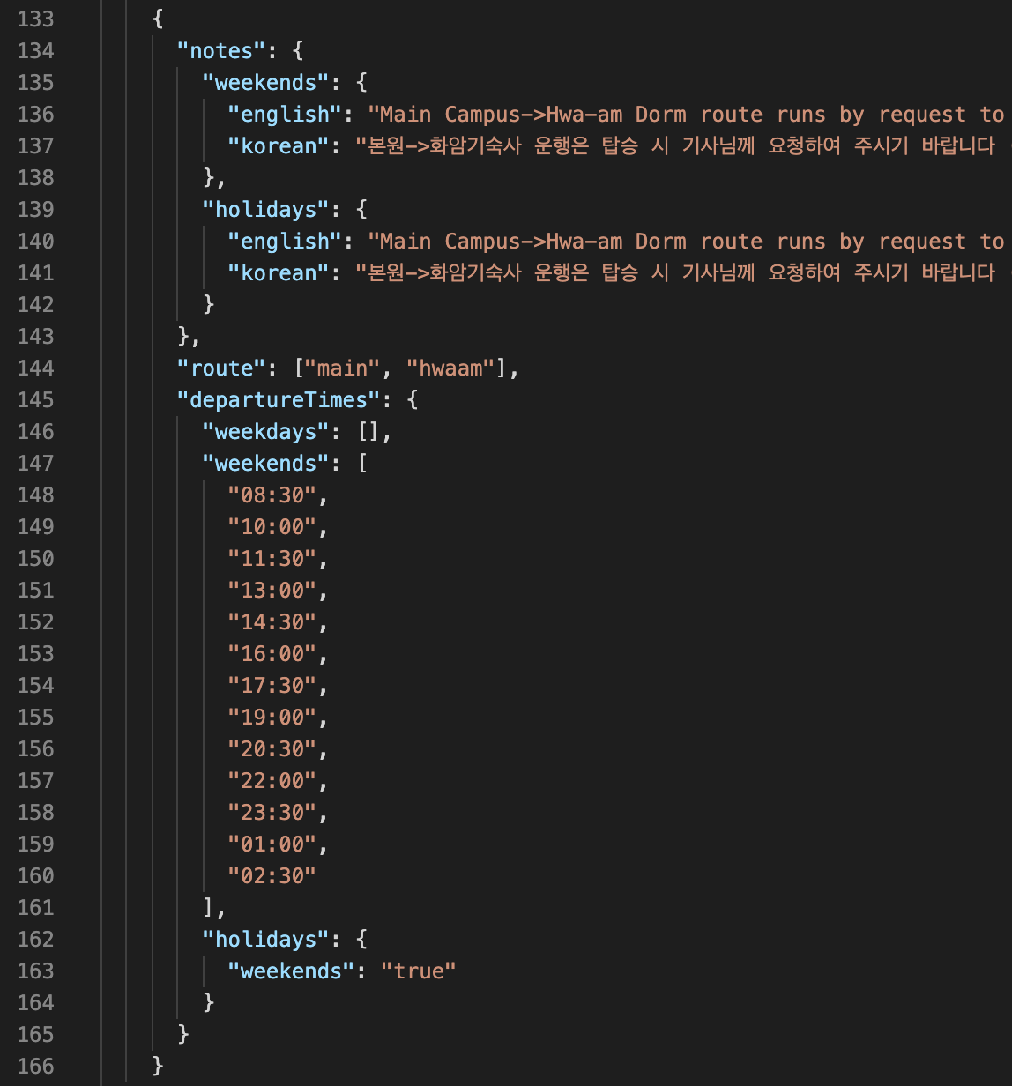 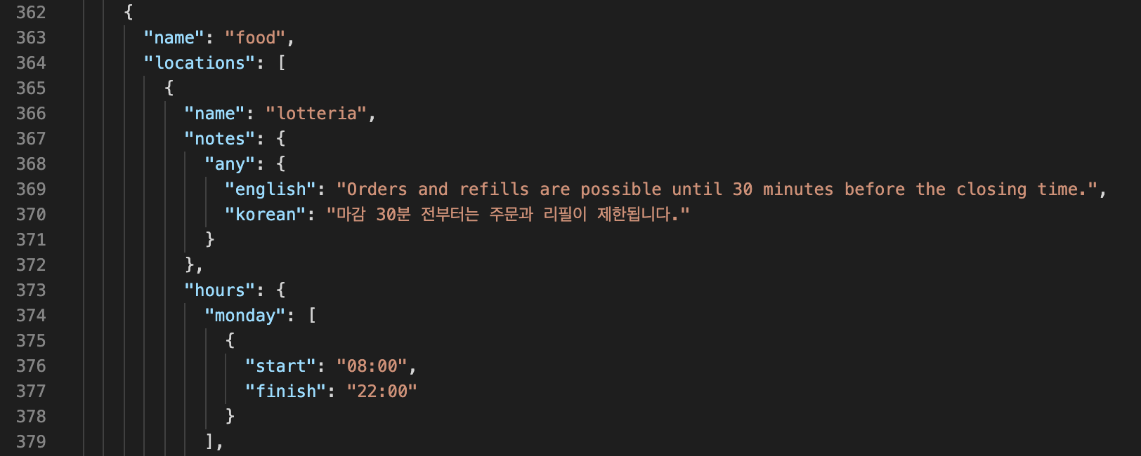

1. Similarly inside operatingHours.json, you can add **note** property for a specific object that contains the nameof a facility and optionally **hours** property. If **hours** property is not provided, we assume that the facility is temporarily closed and you should provide a note to tell that the facility is temporarily closed. Instead of **weekends or weekdays**, you can provide **monday, tuesday, …, sunday** as a property to show a note during those days.

