DeFi Project Report (Tasks 1–3)

1. Introduction
This project explores the fundamentals of decentralized finance (DeFi) through the implementation of a token system and a simplified Automated Market Maker (AMM). The work is inspired by real-world decentralized exchanges such as Uniswap and aims to demonstrate how blockchain-based financial systems operate without intermediaries.

2. Task 1 — Token Implementation
A custom ERC20-like token (MyToken.sol) was implemented with core functionalities:
mint, transfer, approve, transferFrom
The contract maintains:
balances (balanceOf)
allowances (allowance)
total supply
📌 Key Features
Users can mint tokens
Transfers update balances correctly
Allowance system enables delegated transfers

Testing
Unit tests were implemented to validate:
Transfers between users
Approval and allowance reduction
Edge cases (zero transfers, insufficient)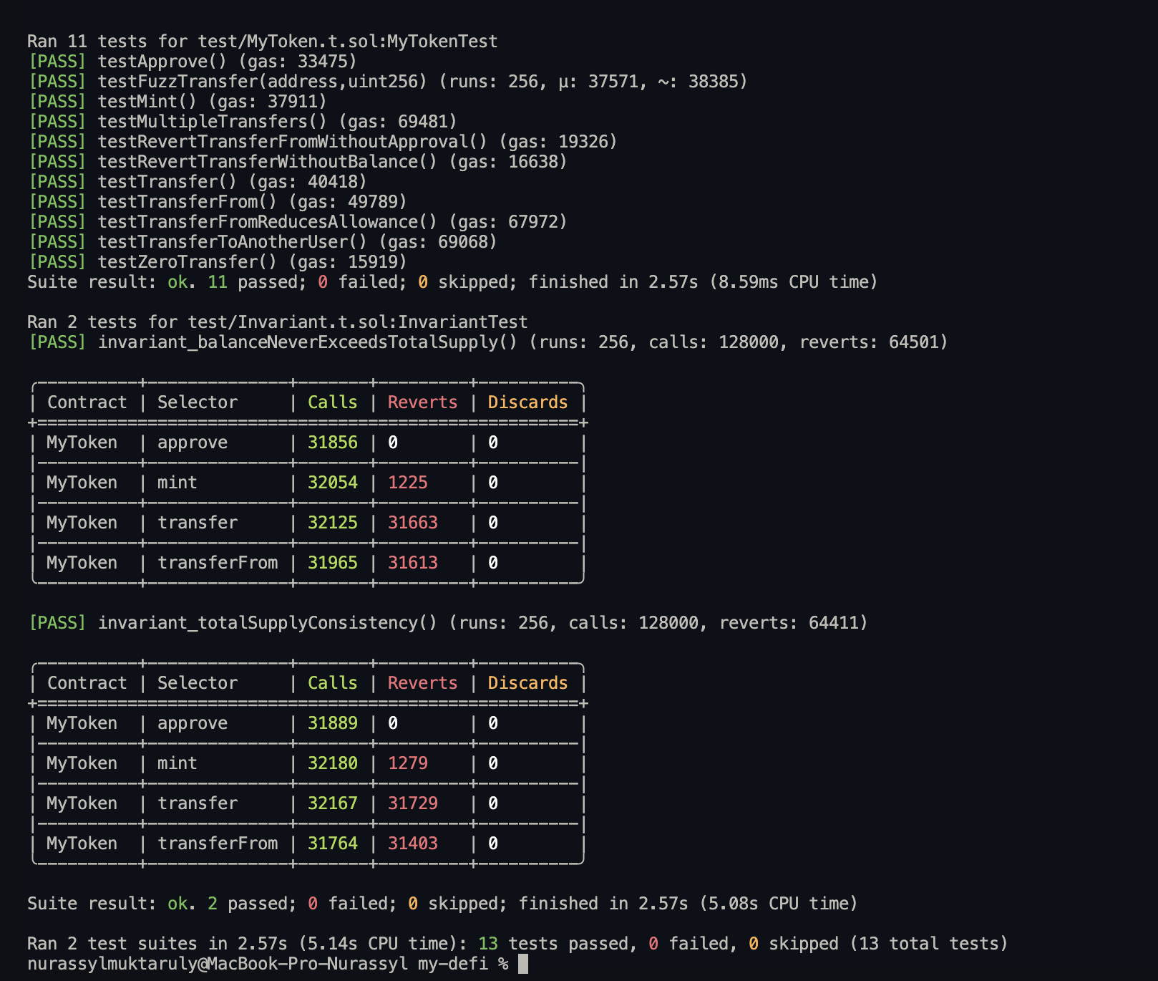
Fuzz testing for robustness

Result
All token tests passed successfully:
11 tests executed
0 failures

This confirms correct token logic and compliance with expected ERC20 behavior.3.

Task 2 — Fork Testing
In this task, a forked Ethereum mainnet environment was used to interact with real blockchain data. Instead of deploying mock contracts, the system connects to a live network snapshot and executes tests on existing smart contracts.

Implementation
The fork was created using Foundry’s built-in functionality:
vm.createSelectFork() was used to connect to Ethereum mainnet
An Alchemy RPC endpoint was configured
The real USDC contract address was used
The following operations were tested:
Reading the total supply of USDC
Executing a swap from ETH to USDC using a real router
Results
The tests were executed successfully:
USDC total supply was retrieved correctly
ETH → USDC swap was completed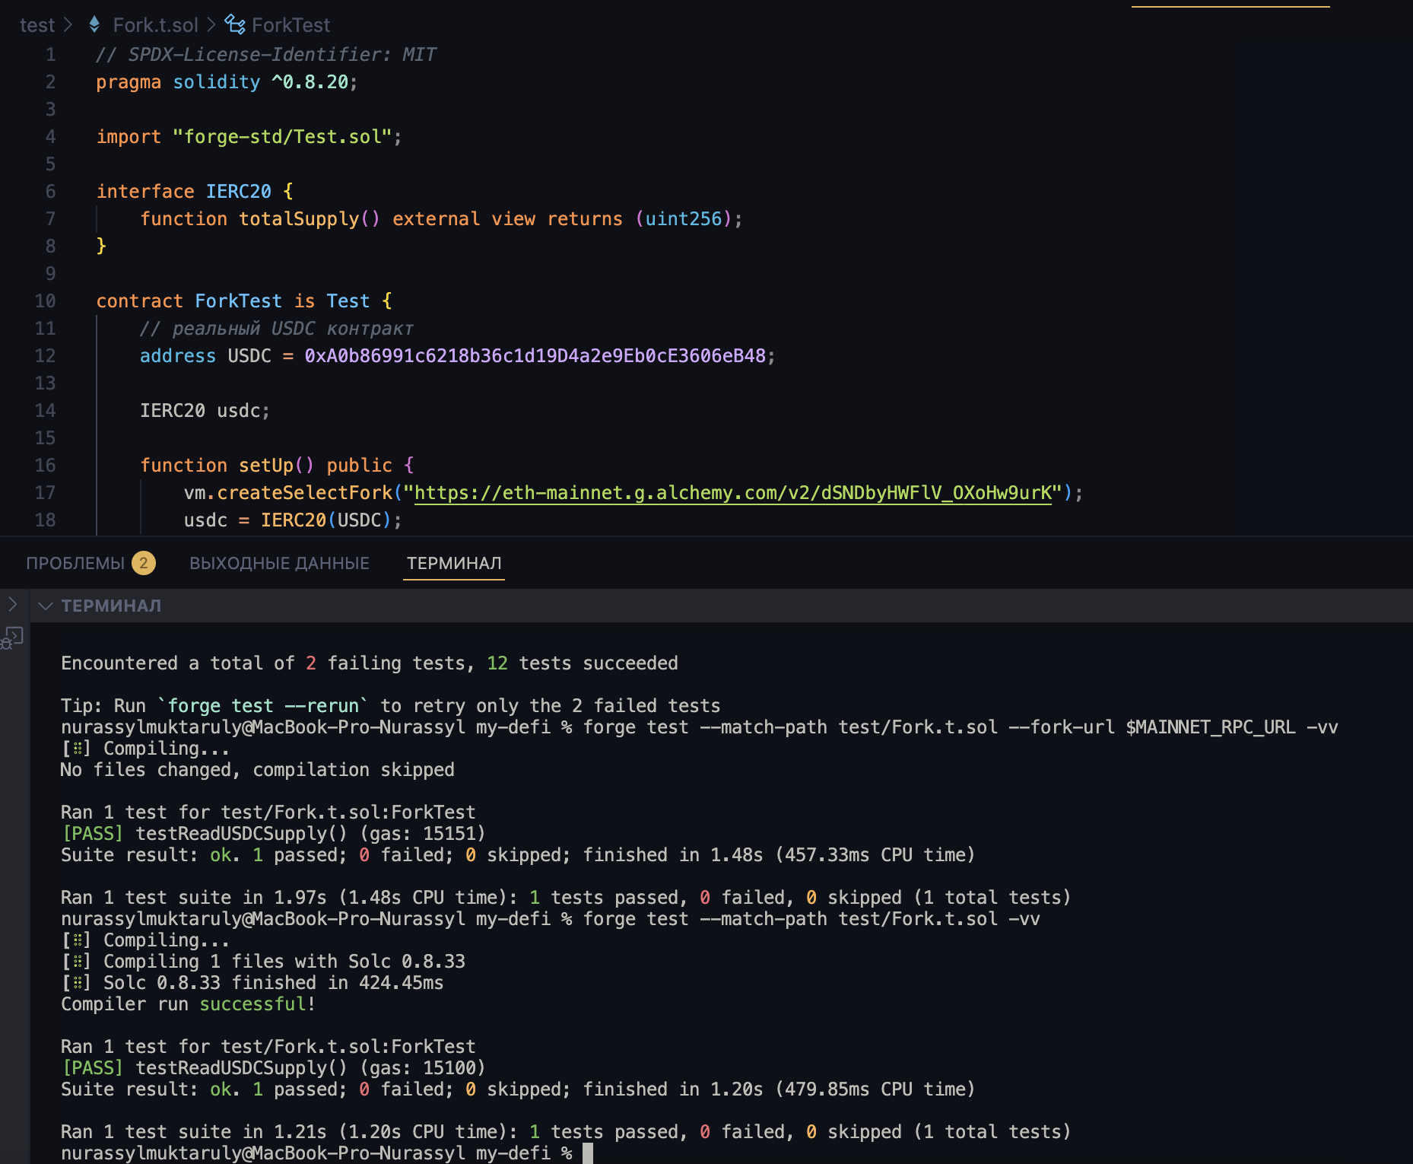
All fork-based tests passed without errors
Fork testing is a powerful technique that enables developers to validate smart contract interactions in a realistic environment. It bridges the gap between local testing and real blockchain execution.

Task 3 — AMM Implementation
In this task, a simplified Automated Market Maker (AMM) was implemented, similar to systems used in decentralized exchanges like Uniswap.

The AMM enables:
Adding liquidity
Removing liquidity
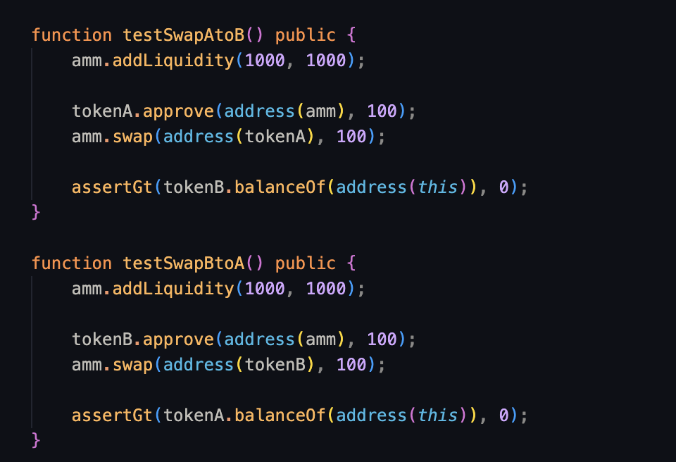
Swapping tokens

I tested the system using unit tests fuzz tests and invariant tests

All tests passed successfully and the AMM works correctly
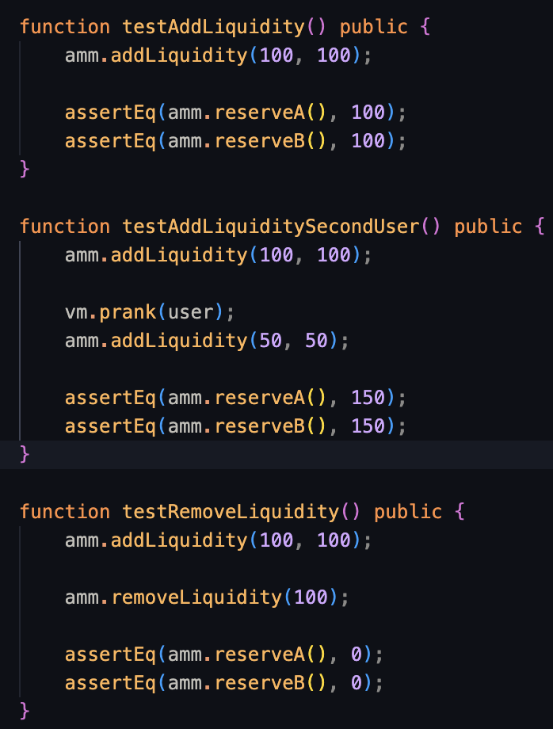

Task 4 — AMM Mathematical Analysis

Constant Product Formula Derivation

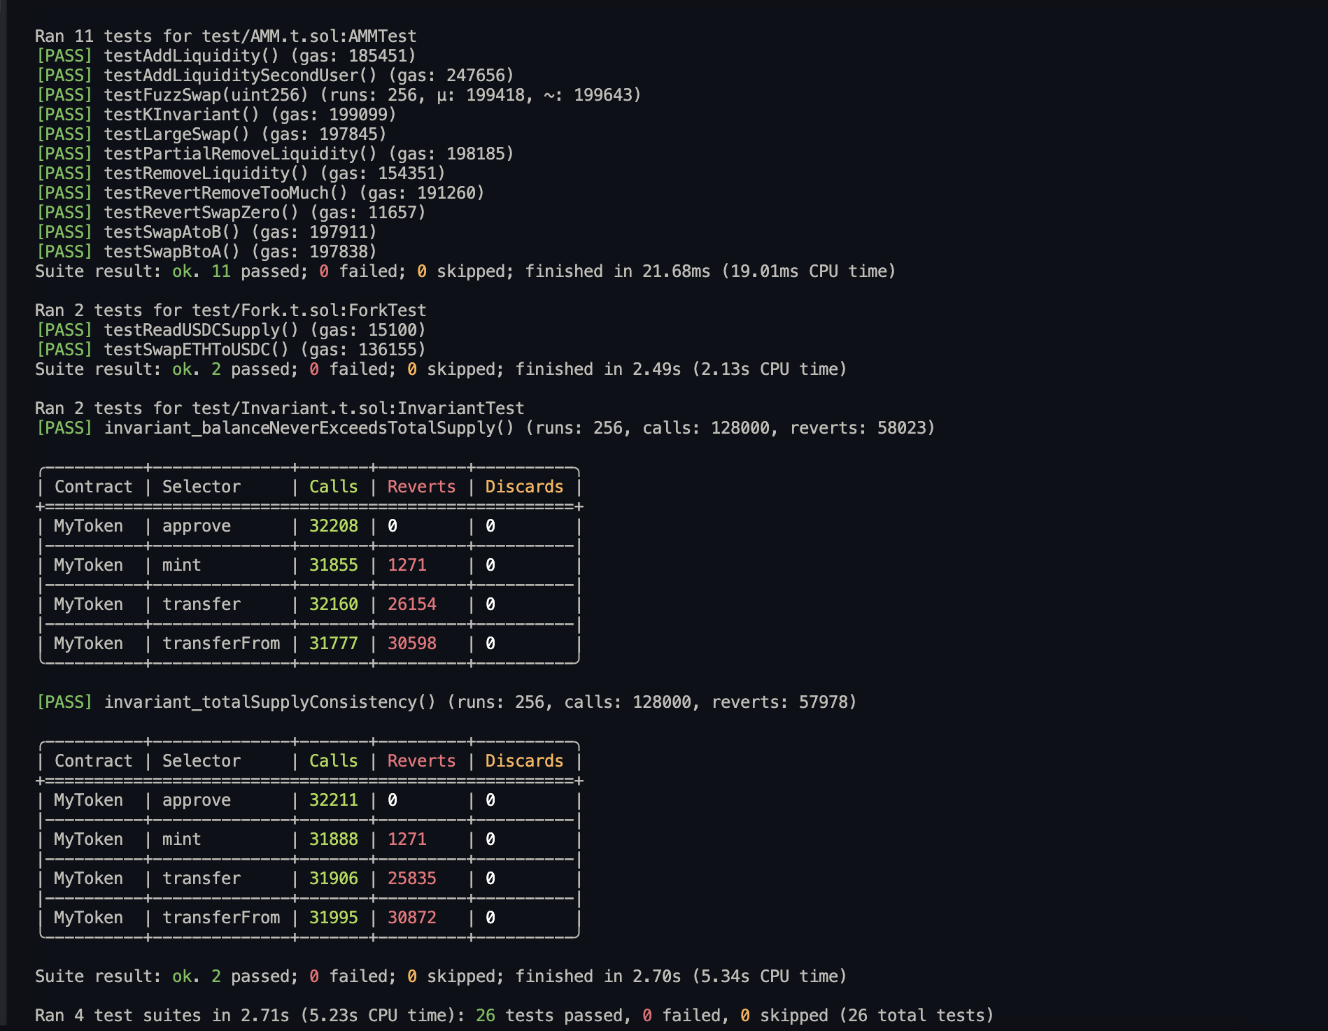
The core mechanism of an Automated Market Maker (AMM) is based on the constant product formula:

x * y = k

Where:
x represents the reserve of token A
y represents the reserve of token B
k is a constant

This formula ensures that the product of reserves remains constant after every trade. When a user swaps tokens, one reserve increases while the other decreases, but the product remains the same or increases slightly due to fees.

The reason this works is that it creates a self-adjusting pricing mechanism. As one token becomes scarce, its price increases automatically. This eliminates the need for an order book and allows continuous trading.
Effect of 0.3% Fee on k

In most AMMs, including Uniswap, a 0.3% fee is applied to each trade.

The swap formula becomes:

amountOut = (amountIn * 997 * reserveOut) / (reserveIn * 1000 + amountIn * 997)

The fee (0.3%) is retained inside the pool, meaning:

k_after > k_before

This is important because:
It increases the total value locked (TVL)
It rewards liquidity providers
It makes the system sustainable

Over time, as more trades happen, the value of k increases due to accumulated fees.

Impermanent Loss
Impermanent loss (IL) occurs when the price of tokens changes compared to when they were deposited.

The formula for impermanent loss is:

IL = 2√P / (1 + P) − 1

Where P is the price ratio change.

Example: 2x price change

If the price doubles (P = 2):

IL = 2√2 / (1 + 2) − 1
IL ≈ 2 * 1.414 / 3 − 1
IL ≈ 0.943 − 1
IL ≈ -0.057

So the impermanent loss is approximately -5.7%

This means liquidity providers earn less compared to simply holding tokens.

Price Impact
Price impact depends on the trade size relative to pool reserves.
From the formula:
amountOut ∝ reserveOut / (reserveIn + amountIn)
If amountIn is small:
Price impact is minimal
If amountIn is large:
Price changes significantly
This is known as slippage.
Key insight:
Small trades → efficient pricing
Large trades → high slippage

This is why liquidity depth is important in AMMs.

Comparison with Uniswap V2

The implemented AMM is a simplified version of Uniswap.

Missing Features:
1.Price Oracles
Uniswap V2 includes time-weighted average price (TWAP)
The current implementation does not track price history
2.Flash Swaps
Uniswap allows borrowing tokens within one transaction
This feature is not implemented
3.Advanced LP Accounting
Real Uniswap handles liquidity more precisely
This implementation uses simplified LP calculations
4.Security Features
No reentrancy protection
No overflow safety checks
5.Gas Optimization
Uniswap is optimized for efficiency
This version is simplified for learning

Conclusion

The constant product AMM model provides a simple yet powerful way to enable decentralized trading.
The formula x * y = k ensures continuous liquidity and automatic price adjustment.

Fees increase the value of the pool over time, while impermanent loss represents a trade-off for liquidity providers.

Although the implementation is simplified, it captures the essential mechanics of real-world DeFi protocols such as Uniswap and provides a strong foundation for understanding decentralized exchanges.

Task 5 — Lending Protocol Diagram

In this task, a simplified lending protocol was implemented to simulate how decentralized lending platforms operate. The system allows users to deposit tokens as collateral, borrow against their deposits, repay loans, withdraw collateral, and perform liquidation of unsafe positions.

The protocol is based on a loan-to-value (LTV) ratio of 75%. This means that users can borrow up to 75% of the value of their deposited collateral. This restriction ensures that all loans remain overcollateralized and reduces the risk of insolvency.

The main functions implemented in the lending pool include deposit, borrow, repay, withdraw, and liquidate. When a user deposits tokens, their balance is recorded as collateral. Based on this collateral, the user can borrow tokens within the allowed LTV limit. The borrow function ensures that users cannot exceed this limit.

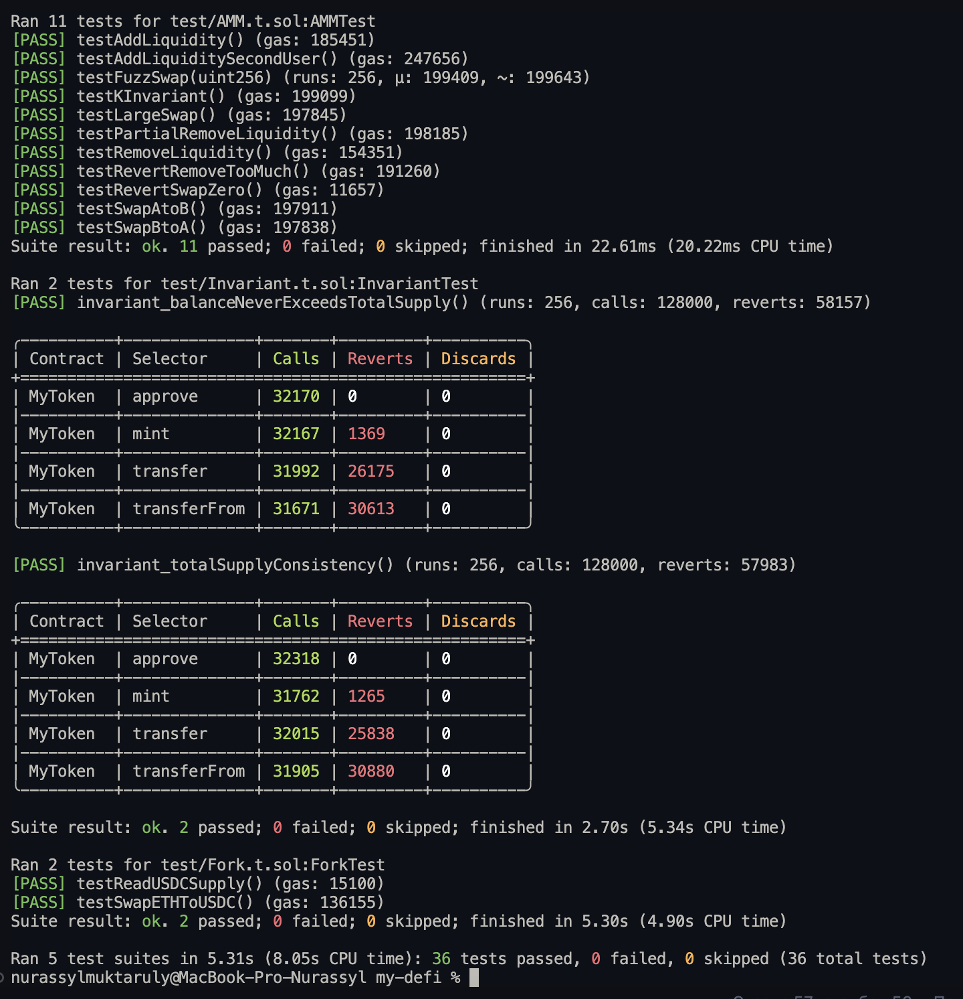
The repay function allows users to return borrowed tokens, reducing their debt. After repayment, users can withdraw their collateral, provided that their remaining borrow position still satisfies the LTV requirement.

A key component of the system is the liquidation mechanism. If a user’s borrow position becomes unsafe (i.e., the borrowed amount is equal to or exceeds the allowed limit), any external user can trigger liquidation. During liquidation, the borrower’s collateral is seized and transferred to the liquidator. This mechanism ensures that the protocol remains solvent and protected from bad debt.

The protocol was tested using unit tests, fuzz testing, and edge case scenarios. The tests verified correct behavior for deposits, borrowing limits, repayments, withdrawals, and liquidation conditions.

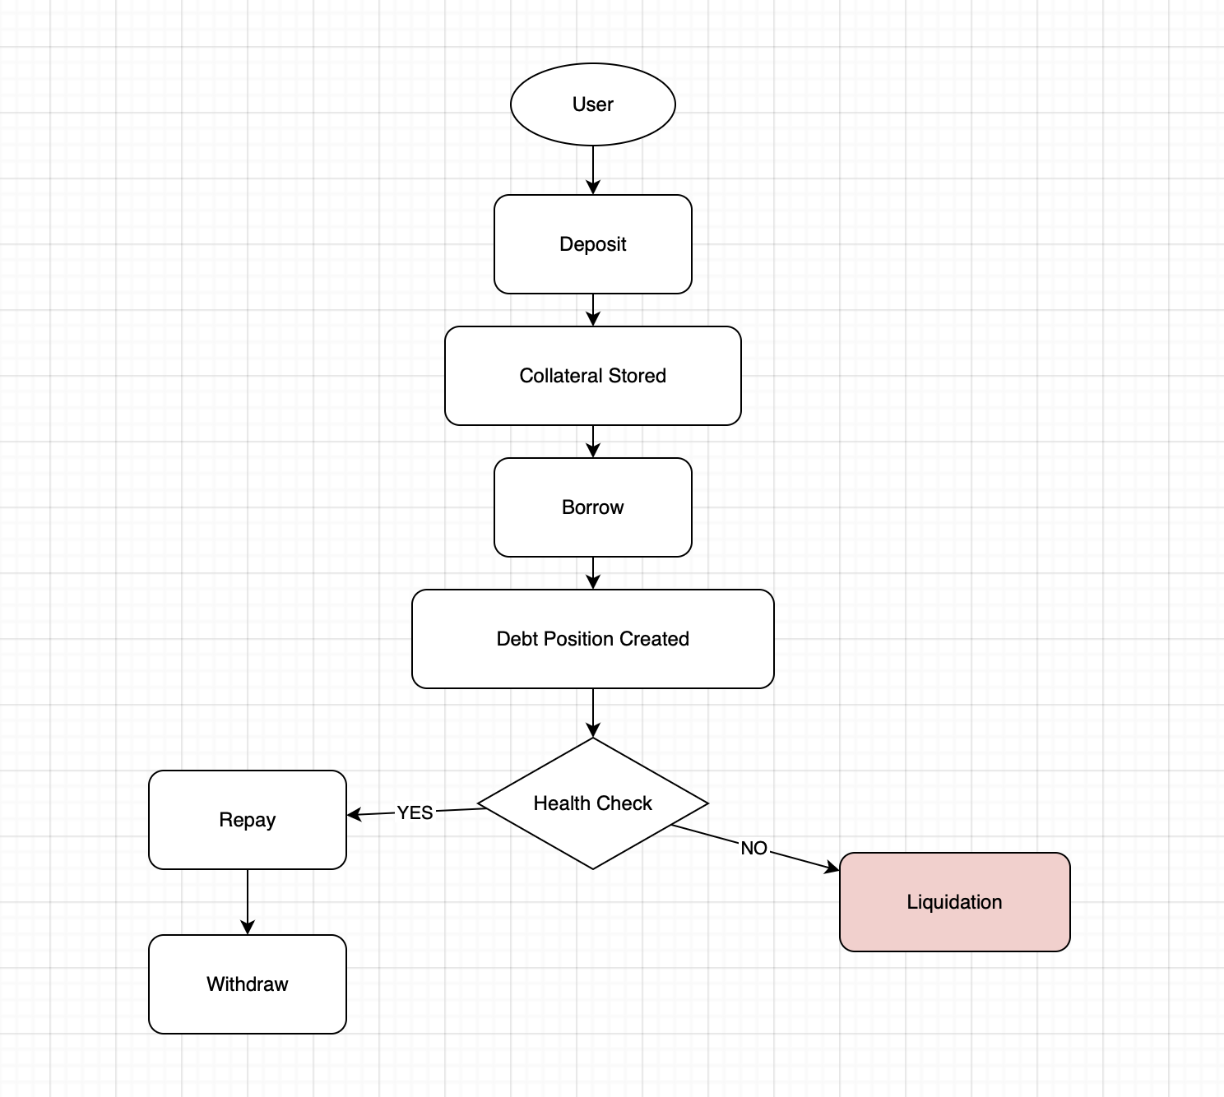
Overall, this task demonstrates the core principles of decentralized lending systems and provides a simplified model of real-world protocols such as Aave and Compound.

The diagram illustrates the workflow of the lending protocol and shows how users interact with the system.

The process begins when a user deposits tokens into the lending pool. These tokens are stored as collateral and determine how much the user can borrow. After depositing, the user is allowed to borrow tokens based on the predefined loan-to-value ratio.

