**FUTURE SALES PREDICTION**

**723721243034:MUKILAN M**

**Phase 3 Submission Document**

**Project:** Future Sales Prediction



**Introduction:**

"In today's dynamic business landscape, the ability to predict future sales is a critical component of strategic decision-making. Accurate sales forecasts enable organizations to allocate resources, plan inventory, and develop effective marketing strategies. In this report, we will delve into the methods, data analysis, and key factors that contribute to forecasting future sales.

**Here's an introduction to Future Sales prediction:**

1. Future sales prediction is a vital component of modern business strategy.
2. It involves a blend of data analytics, consumer behavior, and market trends.
3. Technology is rapidly transforming the sales prediction landscape.
4. Artificial intelligence and machine learning play a crucial role in enhancing accuracy.
5. Accurate sales forecasts aid inventory management and resource allocation.
6. Data-driven decision-making is reshaping the future of sales prediction, offering businesses unprecedented precision and strategic advantages.

**Content for Project Phase 3:**

Innovating stock price prediction by exploring regression techniques like Linear Regression for improved Prediction accuracy.

1. Fundamental Analysis is the process of forecasting a company's future profitability based on its current business environment and financial performance.

2. Technical analysis, on the other hand, entails reading charts and analyzing statistical data to identify stock market trends. Here we'll concentrate on the technical analysis.

**Data Source**

A good data source for prediction using deep learning should be Accurate, Complete, Covering the geographic area of interest, Accessible.

Dataset Link:(<https://www.kaggle.com/datasets/chakradharmattapalli/future-sales-prediction>)

The dataset contains several variables, including Sales, Radio , Tv, Newspaper.

A future sales prediction dataset typically consists of historical sales data, often organized by time periods, product categories, and geographical regions. It may include various relevant features such as pricing information, promotional activities, seasonal trends, and customer demographics. To enhance accuracy, additional data like economic indicators, competitor information, and social media sentiment may be incorporated. With advancements in machine learning and artificial intelligence, these datasets are growing in complexity, allowing businesses to develop more precise predictive models. They serve as a foundation for training algorithms that forecast future sales, helping organizations optimize inventory, pricing, and marketing strategies.

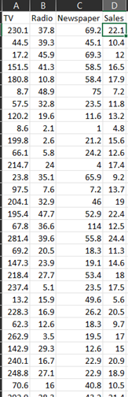

**Data Collection and Preprocessing:**

* Importing the dataset: Obtain a comprehensive dataset containing relevant features.
* Data preprocessing: Clean the data by handling missing values, outliers, and categorical variables. Standardize or normalize numerical features.
* The date column has been formatted as per the coding requirement.

**Exploratory Data Analysis (EDA):**

* Visualize and analyze the dataset to gain insights into the relationships between variables.
* Identify correlations and patterns that can inform feature selection and engineering.
* Present various data visualizations to gain insights into the dataset.
* Explore correlations between features and the target variable (Future Sales prediction).

**Innovation:**

Innovating stock market prediction using linear regression is a challenging endeavour due to the inherent complexity of financial markets. While linear regression is a simple and interpretable method, innovating in this space involves employing it in novel ways and enhancing its capabilities

**Program:**

import pandas as pd

import numpy as np

from sklearn.model_selection import train_test_split

from sklearn.preprocessing import StandardScaler

**DATA LOADING:**

#importing required Dataset

Data=pd.read_csv("C:/Users/KUMARAGURU/OneDrive/Documents/Sales.csv")

Data

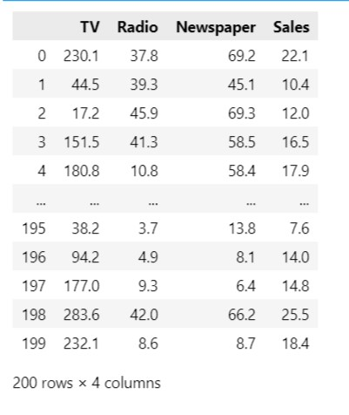

**# checking the null values**

data.isnull()

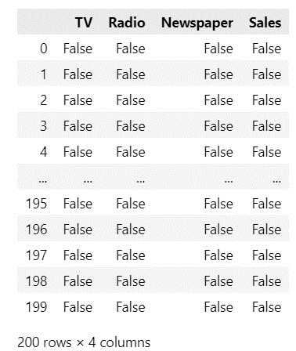

#checking data types

data.dtypes

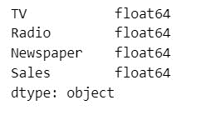

**# Counting all null values**

df.isnull().sum()

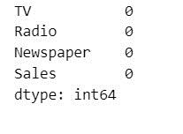

**Plotting the Data**

import pandas as pd

import numpy as np

import matplotlib.pyplot as plt

import seaborn as sns

# Load your dataset (replace 'your_dataset.csv' with your actual data file)

data = pd.read_csv("C:/Users/KUMARAGURU/OneDrive/Documents/Sales.csv")

# 1. Handle Missing Data

# Impute missing numerical values with the mean

data.fillna(data.mean(), inplace=True)

# 2. Feature Selection (if needed)

# Drop irrelevant columns

# data = data.drop(['product_id'], axis=1)

# 3. Encoding Categorical Data (if applicable)

# Convert categorical variables into numerical form using one-hot encoding

# data = pd.get_dummies(data, columns=['category'])

# 4. Split the Data into Training and Testing Sets

# Code for splitting is omitted here; refer to the previous code example for that.

# 5. Data Visualization

# Histogram for the 'sales' column

plt.figure(figsize=(8, 6))

plt.hist(data['Sales'], bins=20, color='blue', edgecolor='black')

plt.title('Sales Distribution')

plt.xlabel('Sales')

plt.ylabel('Frequency')

plt.show()

# Correlation Heatmap

correlation_matrix = data.corr()

plt.figure(figsize=(10, 8))

sns.heatmap(correlation_matrix, annot=True, cmap='coolwarm')

plt.title('Correlation Heatmap')

plt.show()

# Pairplot (scatter plots for numerical features)

sns.pairplot(data, diag_kind='kde')

plt.suptitle('Pairplot of Numerical Features', y=1.02)

plt.show()

# Boxplot for sales by category (if 'category' is a feature)

plt.figure(figsize=(10, 6))

sns.boxplot(x='Radio', y='Sales', data=data)

plt.title('Sales by radio')

plt.xlabel('Category')

plt.ylabel('Radio')

plt.xticks(rotation=45)

plt.show()

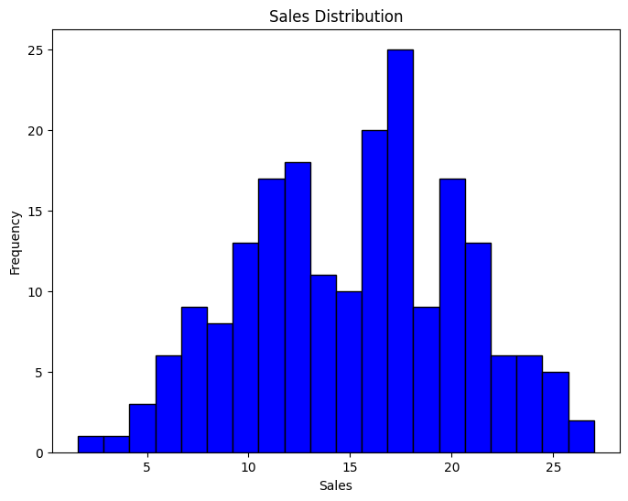

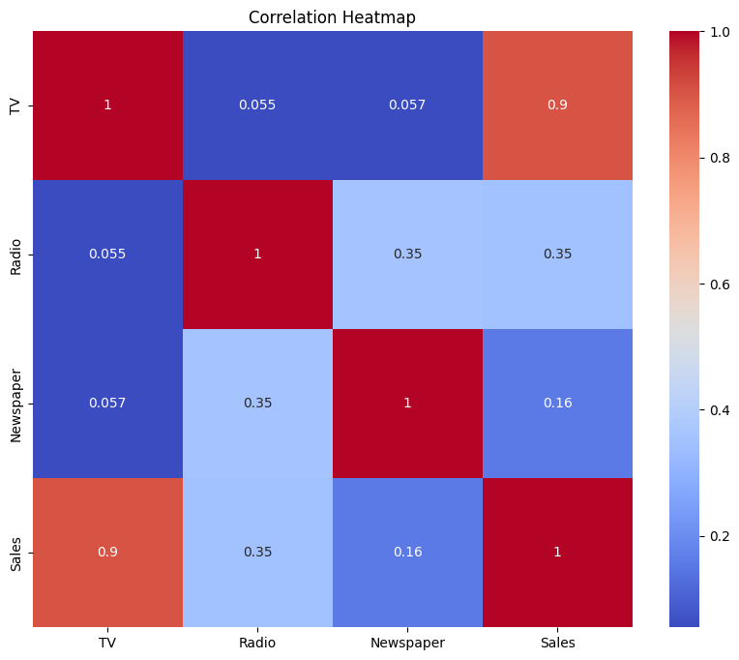

**Conclusion:**

In conclusion, the field of future sales prediction is undergoing a profound transformation in the digital age. With the integration of advanced technologies and data-driven insights, businesses are better equipped than ever to anticipate market trends and consumer behavior. This not only fosters more accurate forecasting but also empowers companies to optimize their resources and increase profitability. As we continue to embrace the power of artificial intelligence and data analytics, the future of sales prediction holds immense potential for businesses seeking a competitive edge in an ever-evolving marketplace. Embracing these innovations will be essential for staying ahead and thriving in the dynamic world of commerce.

**Future scope :**

The future scope of sales prediction is poised for significant advancements. It includes personalized recommendations, real-time analytics, and sentiment analysis for better customer understanding. IoT integration enhances supply chain efficiency, while augmented reality and blockchain add innovative dimensions to forecasting. Cross-industry applications extend its reach. Sustainability predictions and ethical considerations are essential for socially responsible practices. Subscription-based models gain predictive insights, and quantum computing promises faster, more accurate forecasts. The scope is broad, encompassing global markets and promising transformative potential for businesses that embrace these ideas to navigate an increasingly data-centric and dynamic marketplace.