**FUTURE SALES PREDICTION**

**723721243034: MUKILAN M**

**Phase 4 Submission Document**

**Project:** Future Sales Prediction



**Introduction:**

"In today's dynamic business landscape, the ability to predict future sales is a critical component of strategic decision-making. Accurate sales forecasts enable organizations to allocate resources, plan inventory, and develop effective marketing strategies. In this report, we will delve into the methods, data analysis, and key factors that contribute to forecasting future sales.

**Here's an introduction to Future Sales prediction:**

1. Future sales prediction is a vital component of modern business strategy.
2. It involves a blend of data analytics, consumer behavior, and market trends.
3. Technology is rapidly transforming the sales prediction landscape.
4. Artificial intelligence and machine learning play a crucial role in enhancing accuracy.
5. Accurate sales forecasts aid inventory management and resource allocation.
6. Data-driven decision-making is reshaping the future of sales prediction, offering businesses unprecedented precision and strategic advantages.

**Content for Project Phase 4:**

Innovating stock price prediction by exploring regression techniques like Linear Regression for improved Prediction accuracy.

1. Fundamental Analysis is the process of forecasting a company's future profitability based on its current business environment and financial performance.

2. Technical analysis, on the other hand, entails reading charts and analyzing statistical data to identify stock market trends. Here we'll concentrate on the technical analysis.

**Data Source**

A good data source for prediction using deep learning should be Accurate, Complete, Covering the geographic area of interest, Accessible.

Dataset Link:(<https://www.kaggle.com/datasets/chakradharmattapalli/future-sales-prediction>)

The dataset contains several variables, including Sales, Radio , Tv, Newspaper.

A future sales prediction dataset typically consists of historical sales data, often organized by time periods, product categories, and geographical regions. It may include various relevant features such as pricing information, promotional activities, seasonal trends, and customer demographics. To enhance accuracy, additional data like economic indicators, competitor information, and social media sentiment may be incorporated. With advancements in machine learning and artificial intelligence, these datasets are growing in complexity, allowing businesses to develop more precise predictive models. They serve as a foundation for training algorithms that forecast future sales, helping organizations optimize inventory, pricing, and marketing strategies.

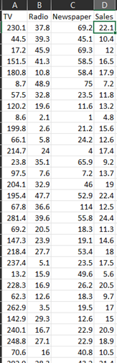

**Data Collection and Preprocessing:**

* Importing the dataset: Obtain a comprehensive dataset containing relevant features.
* Data preprocessing: Clean the data by handling missing values, outliers, and categorical variables. Standardize or normalize numerical features.
* The date column has been formatted as per the coding requirement.

**Exploratory Data Analysis (EDA):**

* Visualize and analyze the dataset to gain insights into the relationships between variables.
* Identify correlations and patterns that can inform feature selection and engineering.
* Present various data visualizations to gain insights into the dataset.
* Explore correlations between features and the target variable (Future Sales prediction).

**Innovation:**

Innovating stock market prediction using linear regression is a challenging endeavour due to the inherent complexity of financial markets. While linear regression is a simple and interpretable method, innovating in this space involves employing it in novel ways and enhancing its capabilities

**Program:**

#Import required packages

import pandas as pd

import numpy as np

from sklearn.model_selection import train_test_split

from sklearn.linear_model import LinearRegression

from sklearn.metrics import mean_squared_error, r2_score

import matplotlib.pyplot as plt

**DATA LOADING:**

#importing required Dataset

data =pd.read_csv("C:/Users/MUKILAN/OneDrive/Documents/Sales.csv")

Data

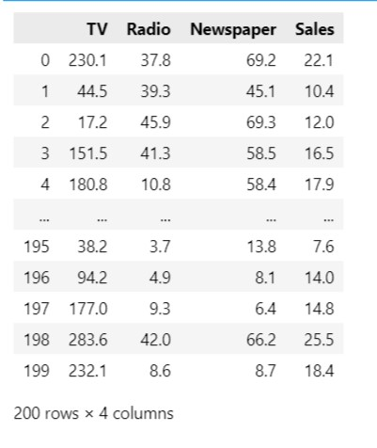

**#training the model**

X = data[["TV", 'Radio']]

y = data['Sales']

X_train, X_test, y_train, y_test = train_test_split(X, y, test_size=0.2, random_state=42)

# performing linear regression

model = LinearRegression()

model.fit(X_train, y_train)

y_pred = model.predict(X_test)

mse = mean_squared_error(y_test, y_pred)

r2 = r2_score(y_test, y_pred)

print(f"Mean Squared Error: {mse}")

print(f"R-squared: {r2}")

Mean Squared Error: 2.846616122131541

R-squared: 0.907879780262465

future_data = pd.DataFrame({'TV': [232.1], 'Radio': [8.6]})

future_sales_prediction = model.predict(future_data)

print(f"Predicted Future Sales: {future_sales_prediction[0]}")

Predicted Future Sales: 18.330556007348868

**Plotting the Data**

plt.scatter(y_test, y_pred, color='blue', label='Actual vs. Predicted Sales')

plt.xlabel('Actual Sales')

plt.ylabel('Predicted Sales')

plt.title('Actual vs. Predicted Sales')

plt.legend()

plt.show()

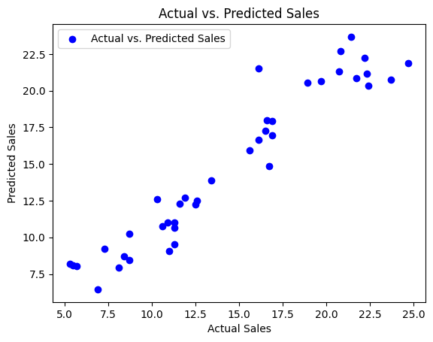

**Conclusion:**

The conclusion for future sales prediction is that accurate and effective sales forecasting is crucial for businesses to make informed decisions, allocate resources efficiently, and achieve their growth objectives. To improve future sales prediction, it's essential to leverage a combination of historical data analysis, market research, and advanced forecasting techniques, including machine learning and predictive analytics. Furthermore, staying adaptable and continuously refining the forecasting models as new data becomes available is imperative to account for changing market dynamics and consumer behavior. By doing so, organizations can enhance their competitiveness and ensure they are well-prepared to navigate the ever-evolving landscape of sales and customer demand.