Report on Gun Murders

MukilaR

5 October 2018

## Introduction

This is a report on 2010 gun murder rates obtained from FBI reports. The original data was obtained from [this Wikipedia page](https://en.wikipedia.org/wiki/Murder_in_the_United_States_by_state).

This data has 51 rows and 6 columns.

library(tidyverse)

load("rda/murders.rda")

## Basic scatterplot

First, we create a scatterplot for total murders versus population size. 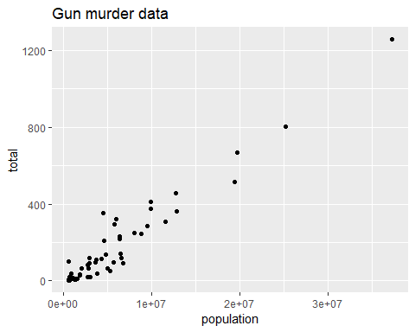

## Adding labels

To the above scatter plot, we add the state abbreviations as labels and use different colors to represent the different regions. 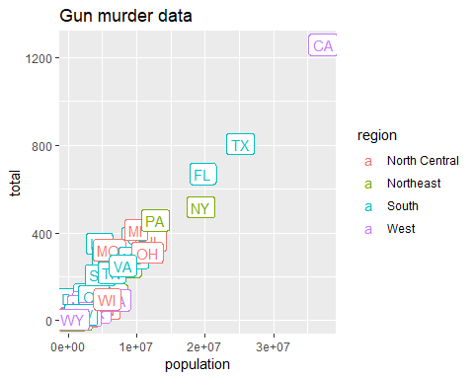

Now we are going to change the axes to log scales to account for the fact that the population distribution is skewed. 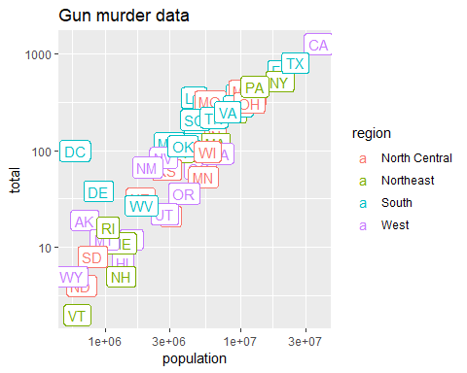

## Creating a chart for different regions

Let us compare the gun homicide rates across regions(North Central, Northeast, South, West) of the US. 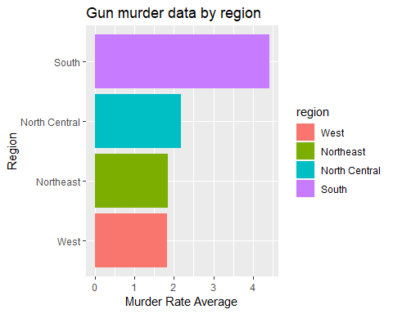

From the above graph, we can see that the Western and Northeastern region have the lowest gun murder rates. So, is it a wise decision to move to the West? To investigate this further, we make a boxplot of murder rates by region, showing all points.

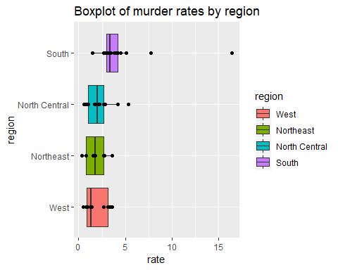 The boxplot clearly shows that the western region has the lowest median of murder rate compared to other regions in the US.

## Murder rate by state

We note the large state to state variability by generating a barplot showing the murder rate by state:

