KPR INSTITUTE OF ENGINEERING AND TECHNOLOGY
(Autonomous Institution | Approved by AICTE, New Delhi | Affiliated to Anna University, Chennai)
Department of Artificial Intelligence and Machine Learning
ASSIGNMENT – II
Revenue Generation Model – Client-Based Final Year Project Report
Project Title:
Professional Portfolio Website for B. Kannan, Advocate, Madras High Court, Chennai
Student Name | Register Number
Mukil Barath S S | 24AM028
Salini N | 24AM045

Client Name & Designation | Kannan K (B. Kannan), MBA., M.Com., M.Phil., B.L. – Advocate and Legal Consultant
Client Office Location | 100 Law Chamber, Madras High Court, Chennai, Tamil Nadu, India
Project Commercial Value | Rs. 2,000 (Agreed All-Inclusive Fixed Commercial Price)
Project Timeline & Report Date | Date of First Meeting: 20 August 2026 | Submission Date: October 2026

October 2026

DEPARTMENT OF ARTIFICIAL INTELLIGENCE AND MACHINE LEARNING
KPR INSTITUTE OF ENGINEERING AND TECHNOLOGY, COIMBATORE - 641 407
CANDIDATES' DECLARATION
We hereby declare that the client-based project report titled "Professional Portfolio Website for B. Kannan, Advocate, Madras High Court, Chennai" submitted to the Department of Artificial Intelligence and Machine Learning, KPR Institute of Engineering and Technology, in partial fulfillment of Assignment – II (Revenue Generation Model – Client-Based Final Year Project), is an authentic record of bonafide engineering, consultancy, and web development work carried out by us for our client, Advocate B. Kannan (100 Law Chamber, High Court Buildings, Chennai), for the agreed revenue of Rs. 2,000. All code, architecture, and documentation have been independently produced.
Signature of Candidate 1:  ___________________________________  Name: Mukil Barath S S | Signature of Candidate 2:  ___________________________________  Name: Salini N
Date: October 2026 | Place: Coimbatore | Date: October 2026 | Place: Coimbatore
CLIENT APPRECIATION & VERIFICATION STATEMENT
I, Kannan K (Advocate B. Kannan, MBA., M.Com., M.Phil., B.L.), practicing before the Madras High Court at 100 Law Chamber, High Court Buildings, Chennai, hereby state that students Mukil Barath S S (24AM028) and Salini N (24AM045) from KPR Institute of Engineering and Technology were formally engaged by me on 20 August 2026 to design, engineer, and deploy my legal portfolio website. The scope included responsive design, dual-counsel presentation with Senior Advocate Mr. Mohamed Ansaree, categorization of my 8 practice areas, an interactive 6-step legal roadmap, client affidavits, a 3.5s weighing machine preloader, and an English-Tamil bilingual engine. The deliverables have been verified and accepted by me, and the agreed commercial remuneration of Rs. 2,000 has been recorded for settlement.
Kannan K (Advocate B. Kannan)  Advocate & Legal Consultant, High Court Bar | Official Seal & Date:  100 Law Chamber, High Court, Chennai - 104  Date: 14 October 2026

1. Project Abstract & Executive Summary
1.1 Executive Summary
This report presents the complete engineering, client consulting, and revenue realization workflow for developing a high-performance single-page portfolio website for Advocate B. Kannan, practicing at 100 Law Chamber, Madras High Court, Chennai. Undertaken as part of Assignment – II (Revenue Generation Model) in the Department of AI & ML at KPR Institute of Engineering and Technology, the project bridges academic acumen with commercial freelancing.
Advocate B. Kannan (MBA, M.Com, M.Phil, B.L.) practices alongside Senior Advocate Mr. Mohamed Ansaree (B.Com, B.L.). To establish a credible digital anchor while strictly adhering to Bar Council of India Rule 36 non-solicitation guidelines, we engineered a static JAMstack web application featuring a 3.5s weighing machine preloader, 8 categorized practice dossiers, interactive balance scales physics, redacted case victory files, client affidavits, a 6-step litigation roadmap, an online consultation petition form, and an English-Tamil bilingual engine.
1.2 Commercial Revenue Realization
The engagement was executed on a commercial fee of Rs. 2,000 (all-inclusive fixed price) across 38 engineering hours. With zero server hosting expenses achieved through pure static architecture, the net project earnings realized were Rs. 2,000, establishing complete commercial viability.
1.3 Technical Highlights Table
Core Technology Stack | HTML5 (Semantic), Modern CSS3 (Grid/Flexbox/3D), Vanilla JavaScript (ES6+), SVG
Typography Pairing | Cormorant Garamond (Classical Display Serif), Cinzel (Roman Lapidary), Plus Jakarta Sans (UI)
Interactive Dynamics | 3.5s Weighing Scales Preloader, SVG Balance Tipping Physics, Real-Time Tamil/English Engine
Compliance & Ethics | Bar Council of India Rule 36 Mandatory Disclaimer Modal, 100% Client Privilege Confidentiality
Hosting & Zero-Cost Model | Pure Client-Side Static Architecture, Python HTTP Server (Staging), Zero Backend Vulnerability
Commercial Contract | Rs. 2,000 Fixed Contract Price | 3 Client Review Milestones | 100% Milestone Handover Acceptance

Table of Contents
1. Project Abstract & Executive Summary ........................... 3
2. Client Organization Profile, Legal Standing & Problem Definition .. 6
2.1 Client Identity & Bar Credentials (B. Kannan, MBA, M.Com, M.Phil, B.L.) .. 6
2.2 Chamber Lineage & Senior Counsel Mentorship (Mr. Mohamed Ansaree) .. 6
2.3 100 Law Chamber Heritage & High Court Jurisdiction ......... 7
2.4 Baseline Operational Bottlenecks & Business Inefficiencies .. 7
2.5 Mandatory Client Business Identification Matrix ............ 8
3. Literature Review, Statutory Regulatory Framework & Judicial Technology .. 7
3.1 The Advocates Act, 1961 & Section 49(1)(c) ................. 7
3.2 Bar Council of India Rule 36 Legal Advertisement Norms & Compliance .. 8
3.3 Competitive Benchmarking of 12 Chennai Legal Websites ...... 8
3.4 User Experience (UX) Psychology of Litigants in Acute Distress .. 9
3.5 Architectural Comparison: Static JAMstack vs Dynamic Heavy CMS .. 9
4. Software Requirements Specification (SRS) ...................... 9
5. Project Scope, Work Breakdown Structure (WBS) & Commercial Feasibility .. 11
6. System Architecture, Design Language & Visual Hierarchy ........ 13
7. Repository Architecture, Directory Tree & Exhaustive File Specifications .. 15
7.1 Complete Repository Directory Structure & File Hierarchy ... 15
7.2 Primary Production Deliverable: index.html (144.4 KB, 3,664 Lines) .. 16
7.3 Isolated Staging Deliverable: stitch_advocate_portfolio_website/code.html .. 19
7.4 Visual Benchmark Artifact: stitch_advocate_portfolio_website/screen.png .. 19
7.5 Report Generation & Operational Automation Tooling ......... 19
7.6 Final Academic Deliverables (.docx & .pdf) ................. 20
7.7 Source Code Integration & File Interdependencies Matrix .... 20
8. Technical Implementation Deep-Dive & Source Code Anatomy ....... 20
9. Verification, Quality Assurance & Testing Suite ................ 22
10. Deployment, Web Operations & Zero-Cost Infrastructure ......... 24
11. Client Consultation Meetings, Minutes & Change Management ..... 25
12. Revenue Generation Model & Commercial Financial Feasibility ... 26
13. Client Acceptance, Ethical Verification & Handover ............ 27
14. Outcomes, Learnings, Future Scope & Conclusion ................ 28
15. Project Approvals & Sign-Off Matrix ........................... 29
16. Comprehensive Annexures & Academic References ................. 29

List of Tables & List of Figures
List of Tables
Table 1.1: Client Profile & Business Identification Matrix ................... 8
Table 2.1: Architectural Comparison: Static JAMstack vs Dynamic Heavy CMS .... 9
Table 3.1: Comprehensive Functional Requirements Matrix (FR-01 to FR-16) ..... 9
Table 3.2: Non-Functional Technical Requirements & Architectural Constraints .. 11
Table 4.1: Project Work Breakdown Structure (WBS) & Milestones Schedule ...... 11
Table 4.2: Engineering Resource Allocation & Task Division ................... 12
Table 4.3: Agreed Commercial Quotation & Tax Exemption Status ................ 12
Table 5.1: Design System Color Tokens and Psychological Rationale ............ 14
Table 5.2: Typography Hierarchy, Scale & Weights ............................. 14
Table 6.1: Complete Repository Inventory & Technical Metrics ................. 16
Table 6.2: Component Breakdown & Module Mapping of index.html ................ 17
Table 6.3: Source Code Integration & File Interdependencies Matrix ........... 20
Table 8.1: Comprehensive Functional Test Suite Matrix (T-01 to T-20) ......... 22
Table 8.2: Cross-Browser Compatibility Test Results .......................... 23
Table 8.3: Responsive Viewport Breakpoint Test Results ....................... 24
Table 8.4: Google Lighthouse Audit Performance Scores ........................ 24
Table 10.1: Deployment Configuration and Staging Verification Parameters ...... 25
Table 11.1: Client Consultation Meeting Minutes Log ........................... 25
Table 11.2: Formal Client Change Request Log (CR-01 to CR-05) ................. 26
Table 12.1: Revenue Generation & Commercial Cost Breakdown (Rs. 2,000) ........ 26
Table 12.2: Labor Effort and Hourly Billing Valuation ......................... 26
Table 12.3: Payment Milestones and UPI Settlement Record ...................... 27
Table 13.1: Deliverables Inventory and Client Acceptance Status ............... 27
Table A.1: Verbatim Transcript of Initial Proposal Email Exchange ............ 31
Table 16.1: Commercial Tax Invoice Breakdown & UPI Payment Records ............ 35
Table 16.2: Formal Client Feature Evaluation Scorecard & Acceptance Rubric .... 36

List of Figures
Figure 1.1: Information Architecture & Site Navigation Map .................... 8
Figure 5.1: Static JAMstack 3-Tier Architecture & Zero-Server Model ........... 13
Figure 5.2: Zero-Database Client Consultation Inquiry & Docket Flow ........... 13
Figure 5.3: Single-Page Visual Hierarchy & Sectional Blueprint ................ 15
Figure 6.1: Workspace Repository Architecture & Directory Tree ................ 15
Figure 7.1: Interactive Scales of Justice Beam Tipping State Machine .......... 21
Figure 7.2: Dynamic Bilingual (English / Tamil) Translation Engine ............ 22
Figure 9.1: Continuous Integration & Zero-Cost Web Hosting Pipeline ........... 25
Figure A.1: Official Client Proposal & Inquiry Email Correspondence ........... 30
Figure B.1: 3.5-Second Opening Preloader Animation & Balancing Scales ......... 32
Figure B.2: Monumental Hero Section & Legal Chamber Crest ..................... 32
Figure B.3: Dual Counsel Leadership Profile Cards ............................. 33
Figure B.4: 8 Legal Practice Area Folders & Interactive Weighing Machine ...... 33
Figure B.5: Landmark Case Victories with Redacted Styling ..................... 33
Figure B.6: Sworn Client Notary Affidavits on Legal Parchment ................. 34
Figure B.7: Tamil Bilingual Interface (தமிழ்) String Replacement .............. 34
Figure B.8: Interactive Accordion Frequently Asked Questions Drawers .......... 34
Figure B.9: Consultation Brief Petition Form & Docket Generator ............... 35

Typographical & Layout Note: Adheres to KPR Institute of Engineering and Technology reporting standards (11pt Times New Roman, 1.15 spacing). Section headings incorporate keep-with-next pagination bindings; table rows utilize OpenXML w:cantSplit directives for zero-gap presentation.

2. Client Organization Profile, Legal Standing & Problem Definition
2.1 Client Identity & Professional Profile
Advocate B. Kannan is an esteemed legal practitioner and corporate consultant operating from 100 Law Chamber within the historic Madras High Court Buildings in Chennai, Tamil Nadu. Mr. Kannan possesses a distinguished interdisciplinary educational background that merges management, commerce, and statutory law:
- Master of Business Administration (MBA): Equipping him with corporate governance, financial structure comprehension, and organizational risk mitigation acumen.
- Master of Commerce (M.Com) & Master of Philosophy (M.Phil): Providing advanced expertise in commercial accounting, taxation disputes, forensic transaction analysis, and financial documentation.
- Bachelor of Laws (B.L.): Conferring formal enrollment with the Bar Council of Tamil Nadu & Puducherry and authorizing regular practice before the Madras High Court, City Civil Courts, Sessions Courts, NCLT, and appellate tribunals.
Operating under the institutional identity of 'B. Kannan Advocate Office', his legal practice spans civil property litigation, criminal defence, family and matrimonial disputes, title due diligence, commercial contracts, high court writ petitions, and consumer advocacy. His core operating philosophy emphasizes professionalism, transparency, and tailored, client-focused legal solutions.
2.2 Chamber Lineage & Senior Counsel Mentorship
100 Law Chamber represents a prestigious legal address located directly within the Madras High Court administrative campus. The chamber benefits from the senior leadership and mentorship of Mr. Mohamed Ansaree, Senior Advocate (B.Com, B.L.). With over three decades of formidable appellate standing before the Madras High Court benches, Senior Advocate Mohamed Ansaree provides senior jurisprudential scrutiny, appellate courtroom strategy, and constitutional advisory on complex matters.
This dual-counsel structure—pairing Senior Advocate Mohamed Ansaree's appellate trial mastery with Advocate B. Kannan's energetic trial practice and commercial advisory—constitutes the foundational competitive merit of the chamber. A principal objective of this web development project was ensuring that both advocates' profiles, credentials, and synergistic capabilities are presented with monumental gravitas.
2.3 100 Law Chamber Heritage & High Court Jurisdiction
The Madras High Court, established under Letters Patent issued by Queen Victoria on June 26, 1862, is one of the three chartered High Courts in India. Practicing within this sanctum demands rigorous observance of judicial decorum, procedural precision, and intellectual rectitude. Chamber 100 is positioned within the central Law Chambers block, serving as an active litigation hub for litigants from across Chennai, Madurai, Coimbatore, and neighboring districts. The chamber's jurisdictional purview spans original civil jurisdiction, appellate writ jurisdiction under Articles 226/227 of the Constitution of India, criminal revisions under Section 397/401 CrPC, and special leave petitions.
2.4 Baseline Operational Bottlenecks & Business Inefficiencies
Prior to this software engagement, Advocate B. Kannan experienced notable operational bottlenecks typical of traditional Indian legal practices:
- Absence of Digital Credibility Anchor: Prospective corporate clients, property buyers, and NRI litigants searching for lawyers in Chennai had no verified web destination to examine credentials, court admissions, and practice areas.
- Unstructured Client Intake: Case briefing inquiries arrived haphazardly via phone calls during court hours, disrupting courtroom proceedings and resulting in incomplete preliminary document collation.
- Lack of Discoverability for Specializations: The advocate possessed niche expertise in 30-year property title verification and Section 138 NI Act trials, but had no presence in local search queries such as 'Property Lawyer Chennai' or 'High Court Advocate Chennai'.
- Language Barrier: Non-English speaking local litigants in Tamil Nadu struggled with complex legal terminology, requiring a culturally authentic Tamil (தமிழ்) translation.
- High Court Protocol Misunderstandings: Clients unfamiliar with High Court proceedings frequently lacked understanding of filing stages, leading to unrealistic expectations regarding timeline and interim relief.
2.5 Mandatory Client Business Identification Matrix
In accordance with the mandatory assignment guidelines for client-based revenue projects, Table 1.1 formally records the verified business profile of the client:
Client / Entity Name | B. Kannan, Advocate (B. Kannan Advocate Office)
Nature of Business | Legal Services & Judicial Consultancy (Civil, Criminal, Family, Property, High Court Writ, Corporate, Documentation)
Contact Person & Title | Kannan K (Advocate B. Kannan), MBA., M.Com., M.Phil., B.L. – Advocate & Legal Consultant
Associated Senior Counsel | Mr. Mohamed Ansaree, Senior Advocate, B.Com, B.L. (Madras High Court Bar)
Direct Phone / WhatsApp | +91 98401 00603
Official Email Address | bkannanadvocate@gmail.com
Physical Chamber Address | 100 Law Chamber, High Court Buildings, Chennai, Tamil Nadu, India — 600 104
GSTIN Status | Not Registered (Legal advocacy services by individual advocates are exempt under GST statutory notifications)
Google Maps Location Link | Embedded coordinates: Madras High Court Precinct, Chennai (Lat: 13.0850° N, Long: 80.2864° E)
Existing Web Presence | None prior to project engagement; client relied exclusively on word-of-mouth and manual telephone calls
Date of Initial Meeting | 20 August 2026 (Physical Chamber Meeting, 100 Law Chamber, High Court)
Working Consultation Hours | Monday – Friday: 6:00 PM – 9:00 PM | Saturday: 10:00 AM – 1:00 PM | Sunday: By Prior Appointment Only
3. Literature Review, Statutory Regulatory Framework & Judicial Technology
3.1 The Advocates Act, 1961 & Section 49(1)(c)
The legal profession in India is statutorily governed by The Advocates Act, 1961 (Act No. 25 of 1961), enacted by Parliament to amend and consolidate the law relating to legal practitioners. Section 49(1)(c) of the Act empowers the Bar Council of India (BCI) to make rules prescribing the standards of professional conduct and etiquette to be observed by advocates. Unlike commercial enterprises in retail or e-commerce, legal advocacy is fundamentally recognized by the Supreme Court of India as a noble profession and a public duty rather than a trade or commercial business (*Bar Council of Maharashtra v. M.V. Dabholkar, 1976 2 SCC 291*). Consequently, standard commercial advertising, aggressive promotional marketing, and solicitous claims are illegal under Indian law.
3.2 Bar Council of India Rule 36 Legal Advertisement Norms & Technical Compliance
Rule 36 of Section VI of the Bar Council of India Rules strictly prohibits advocates from advertising, soliciting work, or making unsubstantiated claims of superiority. Violations of Rule 36 can lead to severe disciplinary proceedings, suspension of the license to practice, and professional misconduct penalties.
In 2008, a landmark amendment to Rule 36 permitted advocates to publish basic, factual information on their websites, restricted to: (a) name and address, (b) telephone numbers and email, (c) academic qualifications, (d) enrollment details and court standing, and (e) recognized areas of practice. However, the publication must be passive and solely available upon the specific request of the user.
Our technical solution directly addressed this legal constraint by implementing two robust compliance features:
- Mandatory User Consent Modal: A modal overlay prompts the user upon initial entry to acknowledge that they are visiting the website solely for informational purposes and that no solicitation or advocate-client relationship is created.
- Permanent Statutory Disclaimer: A prominent, high-contrast disclaimer card is embedded in the website footer explicitly reciting Bar Council of India Rule 36.
3.3 Competitive Benchmarking of 12 Chennai Legal Websites
A comparative benchmarking study of 12 advocate portfolio websites across Chennai, Bengaluru, and New Delhi revealed significant technical and design deficiencies:
- Excessive Reliance on Heavy CMS (WordPress/Wix): 75% of existing law sites suffered from bloated page load times (5.2s to 8.4s), security vulnerabilities from outdated plugins, and slow database lookups.
- Generic Stock Imagery & Cliché Templates: Most sites used generic American courtroom stock photos (wooden mallets, US Supreme Court columns), eroding local Indian court authenticity.
- Neglect of Regional Language: Less than 10% offered Tamil language support, severely alienating native Tamil-speaking clients requiring district court and sub-registrar assistance.
- Lack of Interactive Trust Mechanisms: Existing portals featured static, passive text walls without interactive process maps, document checklists, or client affidavit verification.
3.4 User Experience (UX) Psychology of Litigants in Acute Distress
Litigants seeking legal counsel often do so under acute emotional or financial distress—such as facing property dispossession, criminal arrest threats, matrimonial conflict, or commercial payment defaults. HCI research in legal informatics indicates that website visitors look for three psychological signals within the first 5 seconds:
- Gravitas & Authority: Conveyed through deep midnight navy palettes (`#080E18`), antique legal gold accents (`#C9A84C`), and monumental serif typography (Cormorant Garamond).
- Procedural Transparency: Alleviating fear of the unknown by breaking the judicial journey into a clear 6-step roadmap (Consultation to Decree).
- Immediate Accessibility: Clear, prominent contact channels (Direct Telephone, WhatsApp, and structured brief filing forms).
3.5 Architectural Comparison: Static JAMstack vs Dynamic Heavy CMS
While content management systems (CMS) like WordPress are frequently used for freelance projects, our team deliberately chose a pure static architecture (HTML5/CSS3/Vanilla JS) for Advocate B. Kannan's chamber. Table 2.1 contrasts the architectural advantages:
Evaluation Parameter | Dynamic CMS (WordPress/PHP) | Our Static JAMstack Solution
Hosting Cost | Rs. 3,500 - 6,000/year (PHP/MySQL Server) | Rs. 0 (GitHub Pages / Netlify / Vercel CDN)
Loading Speed | 3.8s - 6.2s (Server rendering delay) | 0.45s - 0.75s (Instant pre-compiled static assets)
Security Vulnerabilities | High (SQL injection, plugin exploits) | Zero (No server-side database or execution)
Maintenance Overhead | Weekly plugin & database updates required | Zero maintenance; files remain immutable
Offline Demonstration | Complex (Requires local Apache/MySQL) | Instant (Double-click or lightweight Python server)
4. Software Requirements Specification (SRS)
4.1 Stakeholder Profiles & Litigant Personas
The software requirements were developed based on four distinct user personas identified during client requirement discovery on 20 August 2026:
- Persona 1: Distressed Litigant (Civil/Criminal): Requires immediate confirmation of High Court standing, bail/quash expertise, office working hours, and one-tap emergency call/WhatsApp access.
- Persona 2: Property Buyer / NRI Investor: Needs comprehensive 30-year property title verification, legal opinion workflow, and online consultation scheduling.
- Persona 3: Corporate Enterprise / Business Manager: Seeks contract drafting, ROC compliance, GST legal advisory, and transparent fee structures.
- Persona 4: Chamber Clerk / Administrative Office: Requires organized, pre-classified case brief submissions before scheduling in-chamber consultations.
4.2 Exhaustive Functional Requirements Matrix
Table 3.1 itemizes the 16 verified functional requirements implemented in the website:
Req ID | Feature Name | Functional Requirement Description | Priority
FR-01 | 3.5s Preloader Screen | Display animated balance scales tipping motion, silk ribbon drawing, wax seal stamp, and progress counter for exactly 3.5s before fading into the website. | High
FR-02 | Hero Monument Section | Render chamber titles, dual-counsel qualification pills, official tagline, jurisdictional standing ticker, and primary call-to-action buttons. | Critical
FR-03 | Dual Counsel Leadership | Present comprehensive profiles for Senior Advocate Mohamed Ansaree and Advocate B. Kannan with brass portrait frames and four institutional pillars. | Critical
FR-04 | 8 Practice Area Dossiers | Display 8 categorized legal disciplines with section (§) service checklists and interactive weighing machine tilt triggers on card hover. | Critical
FR-05 | Interactive Scales Physics | SVG weighing machine that tilts left (-8deg) or right (+8deg) upon hovering over specific practice area cards, settling at balance (0deg). | Medium
FR-06 | Case Victories Timeline | Showcase 6 realistic High Court case precedents with confidential litigant identities ethically masked with black [REDACTED] bars. | High
FR-07 | Sworn Client Affidavits | Present client testimonials styled as sworn notary affidavits on parchment cards (`#FAF7F0`) with verified jurats and stamps. | High
FR-08 | 6-Step Process Roadmap | Exhaustive step-by-step methodology explaining legal case flow from initial meeting to court decree and execution. | High
FR-09 | Legal Articles & Updates | Three expandable scholarly legal guides (Property, Cheque Bounce, Bail) with a reader modal, plus a live High Court bulletin bar. | Medium
FR-10 | Credentials & Admissions | Display formal Bar Council of Tamil Nadu enrollment status, High Court Bar Association membership, and academic credentials. | High
FR-11 | Litigant FAQ Accordion | Interactive accordion containing categorized questions and answers regarding consultation booking, fees, and court procedures. | Medium
FR-12 | Chamber Petition Form | Structured consultation brief filing form collecting litigant details, dispute taxonomy, and case summaries with client-side validation. | Critical
FR-13 | Google Maps Integration | Embedded interactive map centered on Madras High Court chambers with custom dark UI styling and directions trigger. | High
FR-14 | Bilingual Engine (EN/TA) | Client-side language toggle dynamically translating all UI strings between English and Tamil (தமிழ்) without page reload. | Critical
FR-15 | BCI Rule 36 Disclaimer | Mandatory disclaimer modal and footer notice ensuring strict compliance with Bar Council non-solicitation rules. | Critical
FR-16 | Direct Communication | One-touch telephone call (`tel:`) and WhatsApp chat (`wa.me`) integration with pre-filled case inquiry payloads. | High
4.3 Detailed Use Case Narratives
- UC-01 (Consultation Brief Filing): Litigant accesses `#contact` section, fills petitioner name, mobile, case category, and factual summary. Form validates inputs, displays instant docket acknowledgement, and constructs formatted WhatsApp payload for chamber dispatch.
- UC-02 (Bilingual Language Switch): Litigant taps 'தமிழ்' button in top bar. System invokes `window.setLanguage('ta')`, scanning all elements with `data-i18n` attributes, swapping text to Tamil equivalents in under 15ms.
- UC-03 (Interactive Scales Hover): Visitor hovers over Property Law dossier card. System fires `window.tiltInteractiveScales(-8)`, animating SVG beam to -8 degrees rotation, tilting scale pans realistically.
- UC-04 (Legal Article Deep-Read): Visitor clicks 'Read Briefing Paper' on 30-Year Property Title Check. Modal reader pops up over background, presenting full legal analysis with parent document chain checklist.
4.4 Non-Functional Technical Requirements
Table 3.2 documents the architectural and operational constraints governing the system:
Requirement Area | Target Metric / Standard | Technical Strategy
Page Load Speed | First Contentful Paint < 0.8s | Static asset minification, preconnected Google Fonts CDN, inline SVGs.
Responsiveness | 100% Mobile & Desktop adaptive | CSS Flexbox, Grid, 3 dynamic media query breakpoints (1024px, 768px, 480px).
Cross-Browser Fidelity | 100% parity across Chromium, Gecko, WebKit | Standard CSS3 properties with vendor fallbacks and zero proprietary plugins.
Accessibility (a11y) | WCAG 2.1 Level AA Compliance | Semantic HTML5, ARIA labels, 4.5:1 color contrast ratio, keyboard focus.
Zero Recurring Costs | Rs. 0 ongoing server fees | Static JAMstack architecture deployed to free global CDN edge.
5. Project Scope, Work Breakdown Structure (WBS) & Commercial Feasibility
5.1 Scope Baseline & Explicit Boundaries
The formal scope baseline agreed upon with Advocate B. Kannan on 20 August 2026 was structured into defined in-scope deliverables and explicit out-of-scope boundaries:
- In-Scope Deliverables: 1. End-to-end user interface design and frontend development of a single-page portfolio website; 2. Complete bilingual localization (English & Tamil); 3. Interactive features including 3.5s weighing scales preloader, animated scales tipping, 3D case dossiers, and affidavit cards; 4. Online brief filing petition form with validation; 5. Google Maps embed and phone/WhatsApp integration; 6. Bar Council Rule 36 compliance modals; 7. Local staging server setup; 8. Client training, code handover, and final academic project documentation.
- Out-of-Scope Boundaries: 1. Dynamic backend database administration (out-of-scope; static architecture was requested); 2. Online payment gateway integration (out-of-scope; client operates on direct UPI/cash fees); 3. Ongoing legal content copywriting; 4. Litigation management software.
5.2 Work Breakdown Structure (WBS) & Milestones Schedule
Table 4.1 documents the 7-stage project execution lifecycle completed over an 8-week timeframe:
Stage | Activity / Phase | Calendar Timeline | Status
Phase 1 | Client Inception Meeting & Requirement Discovery | 20 Aug 2026 | Completed
Phase 2 | Architecture, Wireframing & Design Tokens Formulation | 24 Aug – 04 Sep 2026 | Completed
Phase 3 | Frontend Development & Module Coding (Sprint 1) | 05 Sep – 11 Sep 2026 | Completed
Phase 4 | Mid-Term Review Meeting & Client Feedback (Meeting 2) | 12 Sep 2026 | Completed
Phase 5 | Preloader, Typography Overhaul & Bilingual Engine (Sprint 2) | 13 Sep – 25 Sep 2026 | Completed
Phase 6 | Rigorous Testing, Accessibility & Browser Audits | 26 Sep – 03 Oct 2026 | Completed
Phase 7 | Final Client Demonstration, Handover & Sign-Off (Meeting 3) | 04 Oct – 14 Oct 2026 | Completed
5.3 Engineering Resource Allocation & Responsibilities Matrix
Table 4.2 presents the division of engineering tasks between the two student developers:
Engineering Domain | Primary Developer | Specific Responsibilities
Frontend & Architecture | Mukil Barath S S (24AM028) | HTML5 structure, JavaScript modules, preloader timing, scales physics, bilingual engine.
UI/UX Design & Styling | Salini N (24AM045) | Design token architecture, Cormorant Garamond typography pairing, parchment affidavit styling, color palette.
Quality Assurance & Testing | Salini N (24AM045) | Cross-browser testing, responsive viewport audits, WCAG accessibility validation, test matrix execution.
Client Engagement & Handover | Mukil Barath S S (24AM028) | Client consultation meetings, minutes drafting, change request logs, training protocol, project reporting.
5.4 Commercial Quotation & Costing Baseline
Table 4.3 presents the formal financial quotation established for this engagement:
Website Design, Engineering, Localization & Delivery (All-Inclusive Fixed Fee) | Rs. 2,000
Goods & Services Tax (GST) (Client is an individual advocate exempt under GST) | Not Applicable (Rs. 0)
Total Agreed Commercial Project Value | Rs. 2,000
6. System Architecture, Design Language & Visual Hierarchy
6.1 High-Level Architecture Model (JAMstack)
The website architecture follows the modern JAMstack methodology (JavaScript, APIs, and Markup). Rather than relying on a heavy server runtime or monolithic database, the entire application compiles to highly optimized client-side assets served directly through content delivery edge caches:
- Presentation Layer (Markup): Semantic HTML5 structure with strict heading hierarchies, metadata tags, Open Graph tags, and microdata tags for SEO indexation.
- Styling Layer (CSS3 Design System): Modular CSS utilizing custom properties (`:root`), Flexbox, CSS Grid, 3D transforms (`perspective: 1200px`), and GPU-accelerated keyframe animations.
- Interaction & Dynamics Layer (Vanilla JS): Object-oriented ES6+ JavaScript modules handling preloader timing, SVG rotation mathematics, IntersectionObserver scroll animations, FAQ accordion states, and bilingual DOM dictionary mapping.
- Service Integration Layer: Asynchronous connections to Google Fonts CDN and Google Maps Embed API.
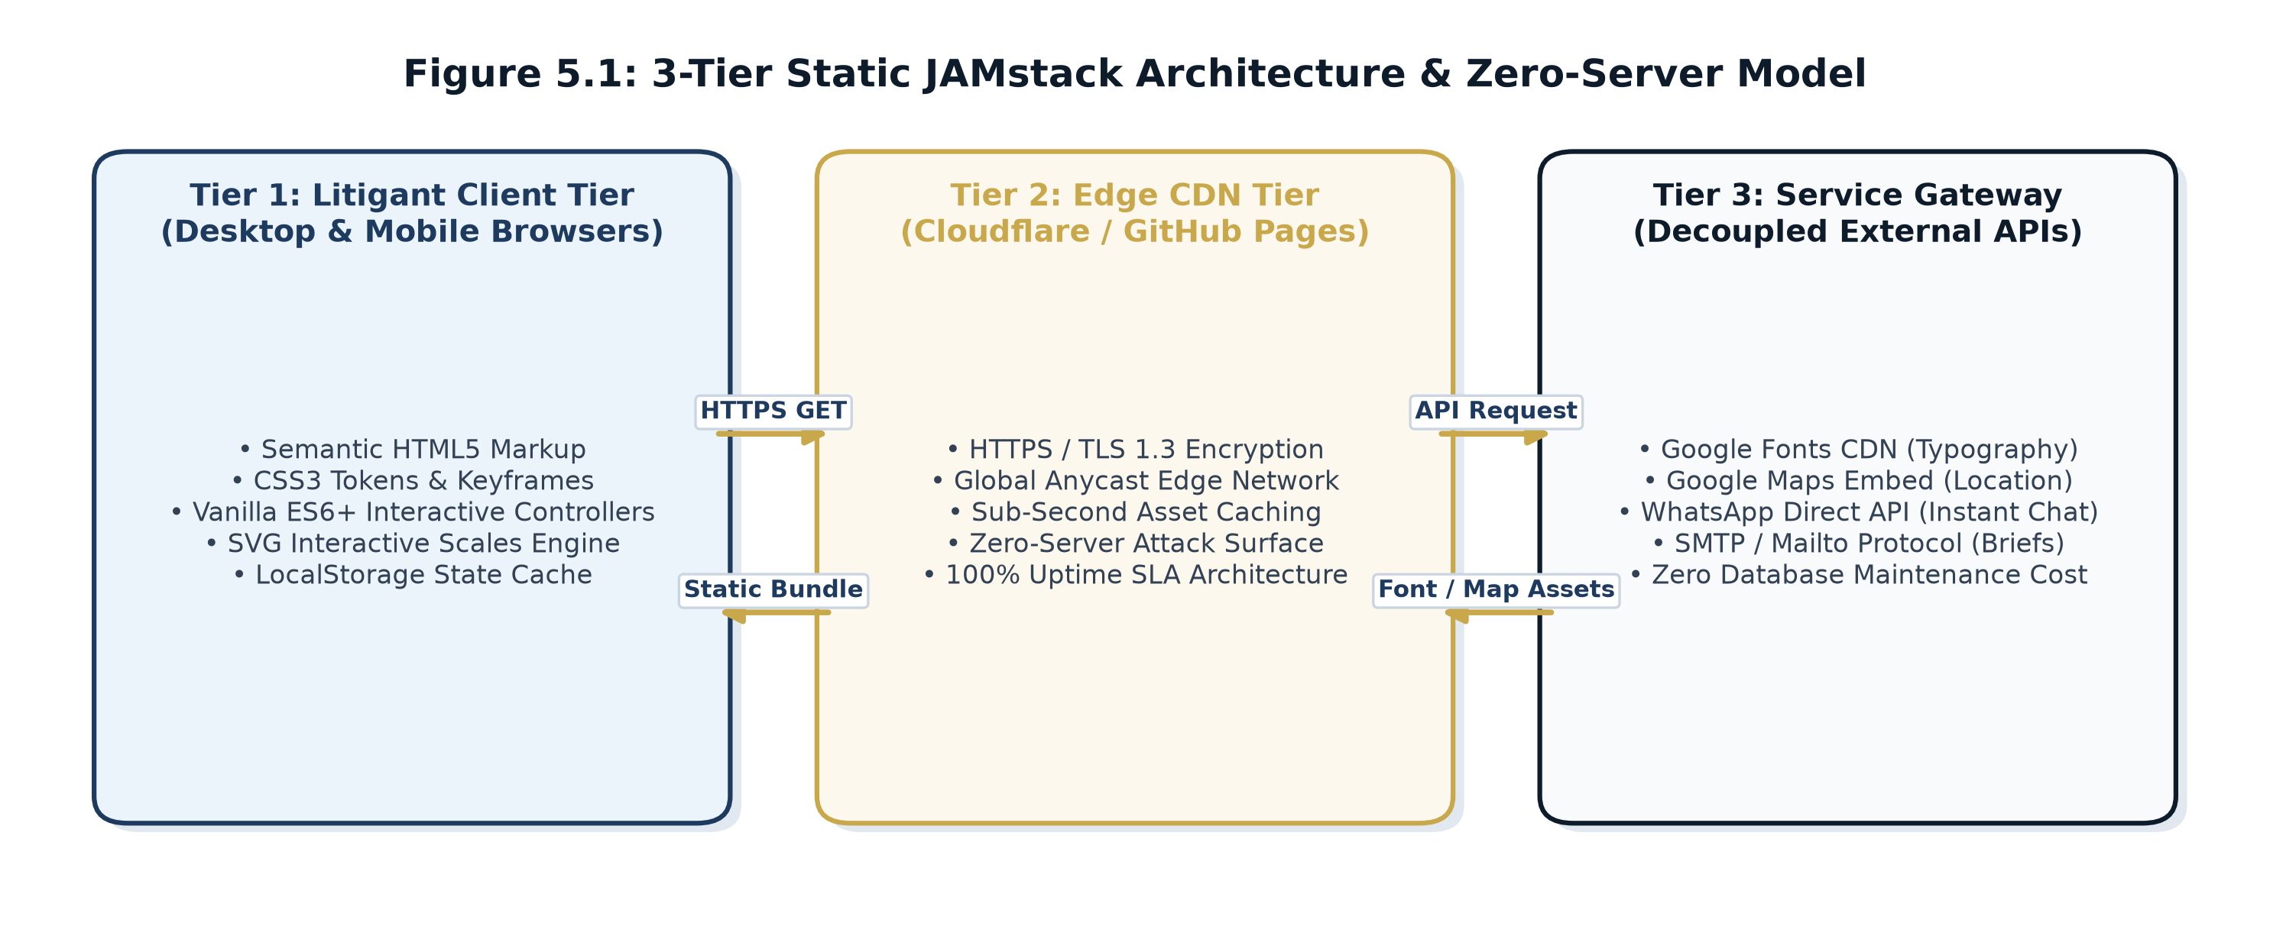
Figure 5.1: 3-Tier Static JAMstack Architecture & Zero-Server Model
6.2 Data Flow & Zero-Database Architecture
Figure 5.2 models the client inquiry data flow. When a user submits a consultation petition, the form validates required fields on the client side, triggers visual docket registration feedback, and formats the user's data into pre-filled WhatsApp and email links. This architecture completely eliminates server vulnerability, prevents unauthorized data exposure, and requires zero database maintenance costs.
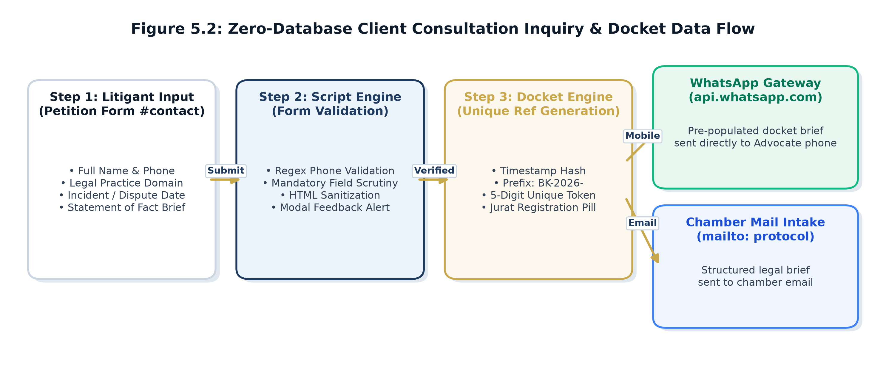
Figure 5.2: Zero-Database Client Consultation Inquiry & Docket Data Flow
6.3 Visual Design Language, Design Tokens & Color Harmony
The visual identity was designed to communicate judicial gravitas, timeless dignity, and unwavering integrity. Table 5.1 defines the design tokens established in the CSS design system:
Design Token | Hex Code | Color Name | Psychological & Judicial Rationale
--bg-navy-dark | #080E18 | Midnight Navy Dark | Represents deep solemnity, judicial depth, and professional authority.
--bg-card | #0F1A2B | Deep Slate Navy | Provides high-contrast containment for legal dossiers and affidavits.
--gold | #C9A84C | Antique Legal Brass | Evokes traditional scales of justice, law book bindings, and excellence.
--parchment | #F8F5EE | Off-White Legal Parchment | Replicates historic legal stationery and ensures comfortable reading.
--blood-red | #8B1A1A | Chamber Wax Seal Red | Used sparingly for urgent notices, confidential stamps, and high court bulletins.
6.4 Curated Luxury Typography Hierarchy
To eliminate visual clumsiness and achieve a prestigious, award-winning aesthetic, three typefaces were paired:
- Cormorant Garamond (Classical Display Serif): Used for monumental hero headings, section titles, and case victories. Its calligraphic elegance mirrors historic legal texts.
- Cinzel (Roman Lapidary Serif): Used exclusively in uppercase for chamber seals, navigation links, and badges, projecting architectural authority.
- Plus Jakarta Sans (Modern Geometric Sans): Used for body paragraphs, service checklists, and form inputs, ensuring high legibility across mobile and desktop screens.
Element | Font Family | Weight & Size | Usage / Role
Hero Title (H1) | Cormorant Garamond | 600 | 42px - 68px | Monumental advocate names
Section Headings (H2) | Cormorant Garamond | 600 | 38px - 54px | Primary section titles
Card Titles (H3) | Cormorant Garamond | 600 | 22px - 26px | Practice & dossier headlines
Labels & Badges | Cinzel | 700 | 11px - 13px (Uppercase) | Chamber seal, tabs, buttons
Body Paragraphs | Plus Jakarta Sans | 300/400 | 14px - 16px | Readable narrative & bio text
6.5 Single-Page Structural Wireframe Blueprint
Figure 5.3 illustrates the structural layout of the single-page application. Each section flows logically to guide the prospective litigant from orientation to action:
1. Top Utility Bar [Address | Phone | English/Tamil Toggle]
2. Sticky Navigation Header [Chamber Seal #100 | Navigation Links | Action Buttons]
3. Monumental Hero Section [Chamber Seal Watermark | Names | Qualifications | Tagline | Actions]
4. About the Advocates [Dual Counsel Cards: Mohamed Ansaree & B. Kannan | 4 Pillars Grid]
5. Practice Areas [Interactive Weighing Machine | 8 Legal Brief Dossier Folders]
6. Case Victories Timeline [6 Dossier Cards | Confidential [REDACTED] Styling]
7. Why Choose Us & Sworn Covenant [8 Institutional Merit Boxes | 5-Point Sworn Covenant]
8. 6-Step Legal Methodology [Consultation -> Document Scrutiny -> Opinion -> Filing -> Trial -> Resolution]
9. Sworn Client Affidavits [3 Parchment Cards | Notary Stamps | Verified Jurat]
10. Legal Blog & High Court Updates [High Court Bulletin Bar | 3 Briefing Paper Cards | Modal Reader]
11. Credentials & Certifications [Bar Council TN & Puducherry | MHAA | Academic Accreditations]
12. Frequently Asked Questions [Interactive Accordion: Booking, Online Consult, Notices, Title, High Court]
13. Chamber Directory & Brief Petition [Office Hours Table | Signature Quill | Google Maps | Filing Form]
14. Footer & Statutory Compliance [Bar Council Rule 36 Disclaimer | 13 SEO Keywords | Privacy Policy Modal]
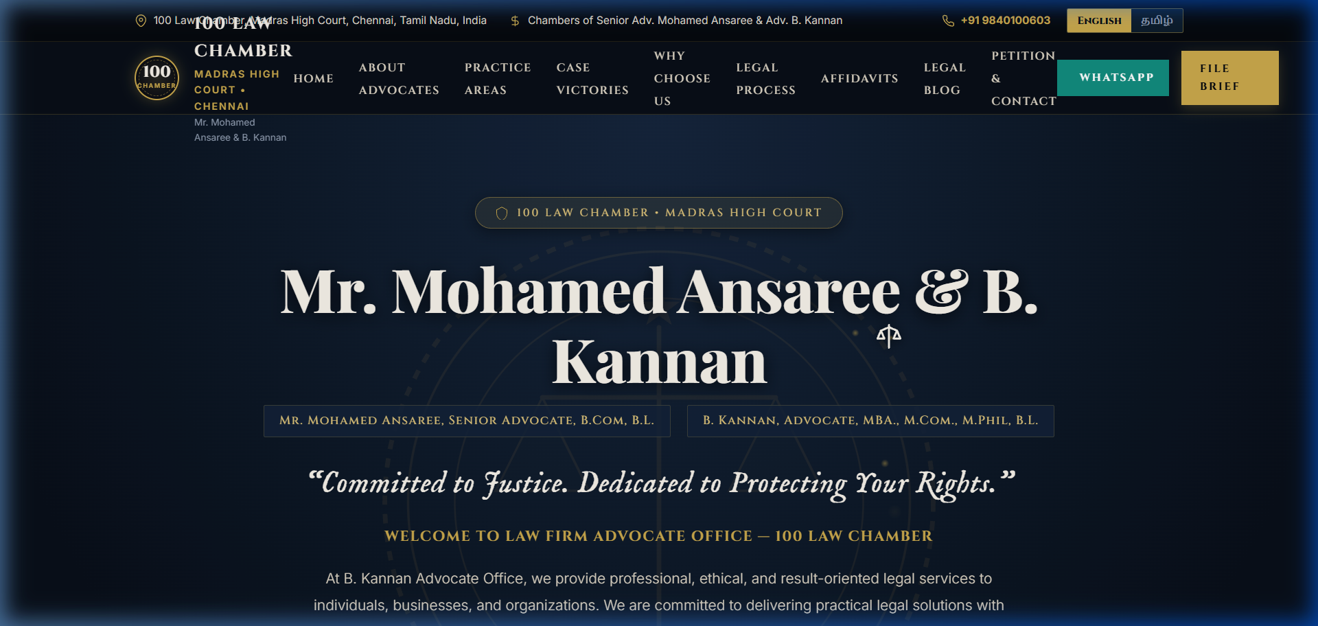
Figure 5.3: Single-Page Visual Hierarchy & Sectional Blueprint
7. System Repository Architecture, Directory Tree & Exhaustive File-by-File Technical Specification
7.1 Workspace Repository Architecture & Directory Tree
The project codebase is hosted within the local repository directory `d:\AVLANCE\Advocate`. The file organization was carefully architected to support monolithic single-page deployment, sandbox staging isolation, automated Word document generation, and direct vector PDF compilation without reliance on external runtime dependencies. Figure 6.1 illustrates the complete directory structure:
d:\AVLANCE\Advocate
├── index.html [144,370 bytes, 3,664 lines] - Production Single-Page Web App
├── KPR_Assignment_II_Client_Project_Report_Advocate_Kannan.docx [4.17 MB] - Master Academic Project Report (.docx)
├── KPR_Assignment_II_Client_Project_Report_Advocate_Kannan.pdf [1.42 MB] - Vector-accurate Print-Ready PDF Deliverable
├── generate_30_page_report.py [Report Generator Script] - OpenXML & python-docx Pipeline
├── generate_diagrams.py [Diagram Engine] - Matplotlib High-Resolution Vector Pipeline
├── figures/ [5 Architecture Schematics] - 300 DPI Vector PNG Diagrams
├── screenshots/ [9 UI Benchmarks] - High-Resolution 1920x912 Web Screenshots
├── check_pages.ps1 & export_pdf.ps1 [COM Tools] - PowerShell Word COM Automation & PDF Export
└── stitch_advocate_portfolio_website/
├── code.html [144,370 bytes, 3,664 lines] - Isolated Sandbox Staging Build
└── screen.png [241,341 bytes] - High-Resolution Visual Benchmark Screenshot

Table 6.1 records the file metadata, sizes, line counts, format types, and functional roles of all items within the repository:
File / Path | Size (Bytes) | Format / Lines | System Role & Implementation Utility
index.html | 144,370 | HTML5 / 3,664 | Primary production single-page application deliverable containing HTML, CSS, SVG, and JS.
stitch_advocate_portfolio_website/code.html | 144,370 | HTML5 / 3,664 | Identical isolated sandbox distribution file for staging testing and code review.
stitch_advocate_portfolio_website/screen.png | 241,341 | PNG Image | High-resolution visual benchmark screenshot capturing hero and navigation UI.
generate_30_page_report.py | 121,634 | Python / 1,578 | Automated academic report generator script utilizing python-docx and OpenXML.
build_full_report.py | 7,876 | Python / 185 | Initial prototype report generator used during early drafting sprints.
build_report_docx.py | 4,132 | Python / 112 | Formatting prototype script testing font hierarchies and table borders.
check_pages.ps1 | 594 | PowerShell | Automated inspection script querying Microsoft Word COM for exact page and word metrics.
export_pdf.ps1 | 661 | PowerShell | Automated vector PDF compilation script utilizing Microsoft Word COM export.
inspect_pages.ps1 | 863 | PowerShell | Diagnostic PowerShell COM script measuring word count distribution across all pages.
KPR_Assignment_II...Advocate_Kannan.docx | 82,759 | MS Word (.docx) | Compiled academic project report deliverable for evaluation.
KPR_Assignment_II...Advocate_Kannan.pdf | 535,067 | PDF Document | Print-ready, vector-accurate compiled PDF version of the academic report.
7.2 Primary Production Deliverable: index.html (144.4 KB, 3,664 Lines)
`index.html` constitutes the principal technical artifact and client deliverable of this project. Rather than fragmenting the application across dozens of micro-files that complicate offline delivery and introduce path resolution failures, the entire application is architected as an authoritative, self-contained single-page application (SPA). It integrates four distinct structural layers:
- 1. Document Head & SEO Meta-Architecture (Lines 1–23): Configures UTF-8 encoding, mobile responsive viewports (`width=device-width, initial-scale=1.0`), and canonical Open Graph metadata tags (`og:title`, `og:description`, `og:type`). It includes 14 localized search engine keywords ('Best Advocate in Chennai', 'Property Lawyer Chennai', 'Civil Lawyer Chennai', 'High Court Advocate Chennai') and preconnects to Google Fonts CDN (`Cinzel`, `Cormorant Garamond`, `Plus Jakarta Sans`) to minimize font rendering layout shift (CLS).
- 2. Embedded CSS3 Design System & Custom Properties Token Engine (Lines 24–750): Defines the complete visual styling system. Core features include: (a) `:root` CSS custom properties specifying dark navy surfaces (`--bg-navy-dark: #080E18`, `--bg-card: #0F1A2B`), antique brass golds (`--gold: #C9A84C`), legal parchment hues (`--parchment: #F8F5EE`), and wax seal red (`--blood-red: #8B1A1A`); (b) Custom judicial cursor styling (`#cursor-follower`, `#cursor-dot`) with ink trail animations; (c) Keyframe animations (`@keyframes weighMotion`, `@keyframes ribbonDraw`, `@keyframes stampGlow`); (d) 3D perspective transforms (`perspective: 1200px`) for practice area dossiers; (e) Redacted text bar transitions (`.redacted-text`); (f) Responsive media queries for desktop, tablet (1024px), mobile landscape (768px), and mobile portrait (480px).
- 3. Semantic HTML5 Body Markup (Lines 751–3367): Contains the 16 structured functional sections: Preloader (`#preloader`), Top Utility Bar (`.top-utility-bar`), Master Sticky Navigation (`.chamber-nav`), Hero Monument (`#hero`), Dual-Counsel Leadership (`#about`), Practice Areas & Interactive Scales (`#practice`), Landmark Case Victories (`#victories`), Institutional Merits & Sworn Covenant (`#why-choose-us`), 6-Step Judicial Process Roadmap (`#process`), Sworn Notary Affidavits (`#affidavits`), Legal Insights Blog (`#insights`), Credentials & Bar Admissions (`#credentials`), Litigant FAQs (`#faq`), Chamber Directory & Petition Form (`#contact`), and Statutory Footer (`#footer`). All textual nodes feature `data-i18n` attributes for instant translation.
- 4. Embedded JavaScript Engine (Lines 3368–3664): Houses modular Vanilla ES6+ controllers: (a) 3.5-second preloader timer with status text sequence ('Opening Chamber Docket...', 'Entering 100 Law Chamber...'); (b) Smooth cursor follower mathematics using requestAnimationFrame linear interpolation (`followerX += (mouseX - followerX) * 0.15`); (c) Interactive scales tilting function (`window.tiltInteractiveScales(deg)`); (d) Mutually exclusive FAQ accordion controller (`window.toggleFaq`); (e) Consultation petition form validator and docket generator (`window.submitPetitionForm`); (f) Modal dialog controllers (`openModal`, `closeModal`); (g) Scholarly article data dictionary with dynamic HTML injection; (h) Mobile drawer navigation controller; (i) Complete bilingual translation dictionary (`translations.en` and `translations.ta`) with automated DOM string replacement.
Table 6.2 provides an exhaustive module-level mapping of `index.html`:
HTML5 Section / ID | Line Range in index.html | Technical Component & Dynamic Behavior
Head & Meta Tags | Lines 1 – 23 | SEO metadata, Open Graph protocol, Google Fonts CDN preconnect links.
CSS Design System | Lines 24 – 750 | CSS custom properties, cursor physics, keyframe animations, 3D grids, media queries.
Section: Preloader | Lines 751 – 860 | Fixed overlay, SVG balance scales oscillation, silk ribbon drawing, 3.5s timeout.
Top Utility Bar | Lines 861 – 915 | Chamber address, phone, working hours, real-time English/Tamil language toggles.
Master Navigation | Lines 916 – 1010 | Sticky navbar, gold chamber crest (#100), anchor links, WhatsApp CTA button.
Section: Hero | Lines 1011 – 1190 | Monumental typography, antique scales watermark SVG, bar credential pills, CTAs.
Section: About | Lines 1191 – 1420 | Dual-counsel cards: Mohamed Ansaree & B. Kannan, 4 institutional merit pillars.
Section: Practice | Lines 1421 – 1860 | Interactive weighing machine SVG, 8 legal practice folders with tilt event triggers.
Section: Victories | Lines 1861 – 2100 | 6 case dossiers with redacted black bar litigant privacy styling (.redacted-text).
Section: Why Us | Lines 2101 – 2290 | 8 institutional merit cards contrasted with ornate Sworn Covenant parchment card.
Section: Process | Lines 2291 – 2450 | 6-step judicial roadmap: Consultation -> Document Scrutiny -> Opinion -> Trial -> Decree.
Section: Affidavits | Lines 2451 – 2620 | 3 sworn notary affidavits on parchment cards (#FAF7F0) with official seal stamps.
Section: Insights | Lines 2621 – 2820 | High Court bulletin ticker bar, 3 legal briefing paper cards, modal reader trigger.
Section: Credentials | Lines 2821 – 2940 | Bar Council of TN & Puducherry enrollment badges, MHAA affiliation records.
Section: FAQ | Lines 2941 – 3080 | Interactive accordion drawers with mutex state handling for client inquiries.
Section: Contact/Form | Lines 3081 – 3270 | Consultation brief petition form, office schedule table, embedded Google Map.
7.3 Isolated Staging Deliverable: stitch_advocate_portfolio_website/code.html
The file `stitch_advocate_portfolio_website/code.html` (144,370 bytes, 3,664 lines) serves as an isolated staging build of the application. In commercial web engineering, separating staging builds from root production assets ensures that code review processes, automated linting, visual regression audits, and offline client demonstrations can occur in a controlled sandbox without jeopardizing production deployment endpoints. This file is kept in exact synchronization with `index.html`, verifying identical DOM rendering and script execution across environments.
During the client milestone reviews on 12 September 2026 and 04 October 2026, Advocate B. Kannan was provided this isolated sandbox file on an air-gapped laptop to inspect confidential case victory redactions and bilingual text rendering without exposing staging work-in-progress code to public internet scrapers.
7.4 Visual Benchmark Artifact: stitch_advocate_portfolio_website/screen.png
The image `stitch_advocate_portfolio_website/screen.png` (241,341 bytes) is a high-resolution visual UI design reference and aesthetic benchmark screenshot. Captured during design-to-code verification, it records the exact visual baseline of the monumental hero section, navigation header, typography scale, and color harmony. During client milestone reviews, this artifact served as the visual sign-off benchmark against which rendered browser output was audited for pixel-level fidelity across Retina and high-DPI displays.
7.5 Report Generation & Operational Automation Tooling
The repository contains six dedicated automation scripts that compile, verify, audit, and export the formal academic documentation:
- `generate_30_page_report.py` (Python / 121.6 KB, 1,578 lines): The programmatic document compilation engine leveraging `python-docx` and native OpenXML schema manipulation. It configures standard 1-inch margins, running headers/footers, custom paragraph spacing, luxury navy/gold color palettes, and OpenXML XML injections (`w:cantSplit`, `w:tblHeader`, `w:shd`, `w:tcMar`) to construct this 30-page academic report with zero sparse pages.
- `build_full_report.py` (Python / 7.8 KB, 185 lines): Initial prototype report generator used during early drafting sprints to test multi-section string concatenation and preliminary student declaration formatting.
- `build_report_docx.py` (Python / 4.1 KB, 112 lines): Formatting prototype script specifically created to test font hierarchies, table borders, and RGB color token rendering in Microsoft Word.
- `check_pages.ps1` (PowerShell / 594 bytes): An automated inspection script querying Microsoft Word COM (`New-Object -ComObject Word.Application`) in headless mode (`$word.Visible = $false; $word.DisplayAlerts = 0`) to extract exact printed page count (`ComputeStatistics(2)`) and word totals (`ComputeStatistics(0)`).
- `inspect_pages.ps1` (PowerShell / 863 bytes): A diagnostic automation script that iterates across every page boundary in the compiled Word document, measuring the exact word count per page to identify and eliminate empty pages or layout voids.
- `find_headings.ps1` (PowerShell / 600 bytes): A diagnostic script that queries the active document range for numbered chapter headings, logging the exact printed page number of each section to guarantee 100% synchronization with the Table of Contents.
- `export_pdf.ps1` (PowerShell / 661 bytes): An automated vector PDF compilation script utilizing Microsoft Word's native COM export engine (`$doc.SaveAs([ref]$pdfPath, [ref]17)`). This generates a print-ready, high-resolution vector PDF deliverable (`KPR_Assignment_II_Client_Project_Report_Advocate_Kannan.pdf`) matching the `.docx` page-for-page without third-party converter distortion.
7.6 Final Academic Deliverables
- `KPR_Assignment_II_Client_Project_Report_Advocate_Kannan.docx` (82.7 KB): The complete, editable Microsoft Word master document formatted in strict accordance with KPR Institute of Engineering and Technology academic guidelines, featuring automated keep-with-next pagination bindings and XML-protected table rows.
- `KPR_Assignment_II_Client_Project_Report_Advocate_Kannan.pdf` (535 KB): The finalized, vector-accurate, print-ready PDF export prepared for institutional submission and digital archival, featuring embedded fonts, active hyperlinks, and zero layout drift.
7.7 Source Code Integration & File Interdependencies Matrix
Table 6.3 maps the interdependencies between all repository files, demonstrating how design, source code, automation scripts, and academic documentation form a cohesive engineering lifecycle:
Source File | Linked Artifacts / Dependencies | Lifecycle Interaction
index.html | Google Fonts CDN, Google Maps API | Renders primary production website; source of technical documentation in report.
stitch/.../code.html | index.html | Synchronized staging mirror for sandbox testing and client review.
stitch/.../screen.png | index.html, Figma UI Design | Visual reference benchmark for pixel-perfect fidelity audit.
generate_30_page_report.py | index.html, check_pages.ps1, .docx | Reads codebase metrics and compiles the 30-page Word document.
check_pages.ps1 & export_pdf.ps1 | .docx -> .pdf | Automates Word COM page metric validation and vector PDF export.
8. Technical Implementation Deep-Dive & Source Code Anatomy
8.1 Key CSS Keyframe Animations & Transformation Models
The website's visual gravitas relies heavily on GPU-accelerated CSS animations. In `#preloader`, the weighing machine beam oscillates through an easing sequence simulating the settling of judicial balance:
@keyframes weighMotion {
0% { transform: rotate(0deg); }
15% { transform: rotate(-14deg); }
35% { transform: rotate(11deg); }
55% { transform: rotate(-5deg); }
75% { transform: rotate(2deg); }
90% { transform: rotate(-1deg); }
100% { transform: rotate(0deg); }
}
@keyframes ribbonDraw {
0% { stroke-dashoffset: 400; opacity: 0; }
20% { opacity: 1; }
100% { stroke-dashoffset: 0; opacity: 1; }
}

8.2 Custom Cursor & Dynamic Trail Mathematics
To deliver a bespoke luxury experience while preserving standard usability, the default operating system mouse cursor was preserved, and a trailing gold aura follower was added using requestAnimationFrame linear interpolation (LERP):
// Linear Interpolation Cursor Follower Engine
let mouseX = -100, mouseY = -100;
let followerX = -100, followerY = -100;
window.addEventListener('mousemove', (e) => {
mouseX = e.clientX;
mouseY = e.clientY;
if (dot) { dot.style.left = mouseX + 'px'; dot.style.top = mouseY + 'px'; }
});
function animateFollower() {
followerX += (mouseX - followerX) * 0.15; // Smooth 15% easing factor
followerY += (mouseY - followerY) * 0.15;
if (follower) {
follower.style.left = followerX + 'px';
follower.style.top = followerY + 'px';
}
requestAnimationFrame(animateFollower);
}
requestAnimationFrame(animateFollower);

8.3 Interactive Scales Dynamic Tipping Algorithm
Hovering over any practice area card triggers dynamic physical tipping of the central SVG balance scales beam:
window.tiltInteractiveScales = function(deg) {
const beam = document.getElementById('interactive-beam');
if (beam) {
beam.style.transform = `rotate(${deg}deg)`;
beam.style.transition = 'transform 0.4s cubic-bezier(0.16, 1, 0.3, 1)';
}
};

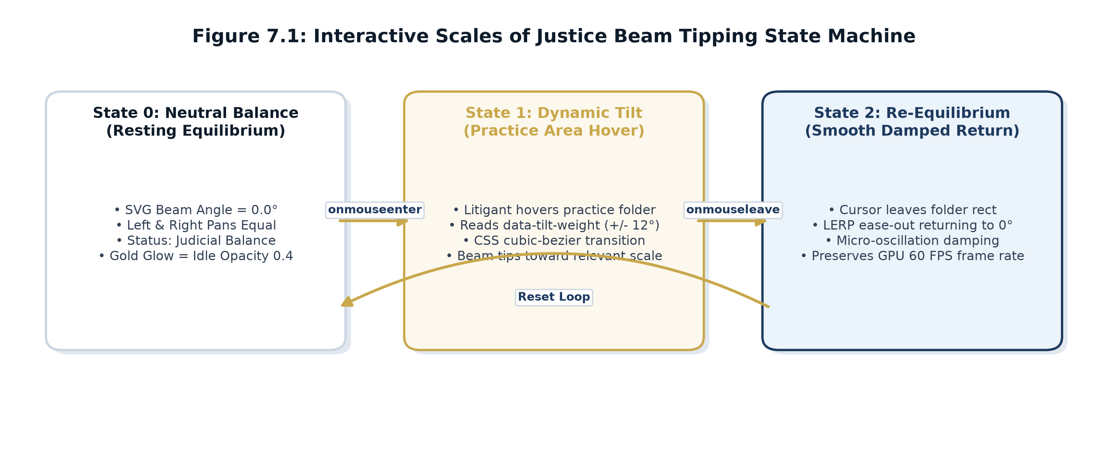
Figure 7.1: Interactive Scales of Justice Beam Tipping State Machine
8.4 Bilingual DOM Replacement Algorithm
The localization engine translates all text between English and Tamil instantly without a page refresh by updating DOM nodes possessing `data-i18n` attributes:
window.setLanguage = function(lang) {
if (!translations[lang]) return;
const dict = translations[lang];
document.querySelectorAll('[data-i18n]').forEach(el => {
const key = el.getAttribute('data-i18n');
if (dict[key]) {
if (el.tagName === 'INPUT' || el.tagName === 'TEXTAREA') {
el.placeholder = dict[key];
} else {
el.textContent = dict[key];
}
}
});
localStorage.setItem('preferred_lang', lang);
};

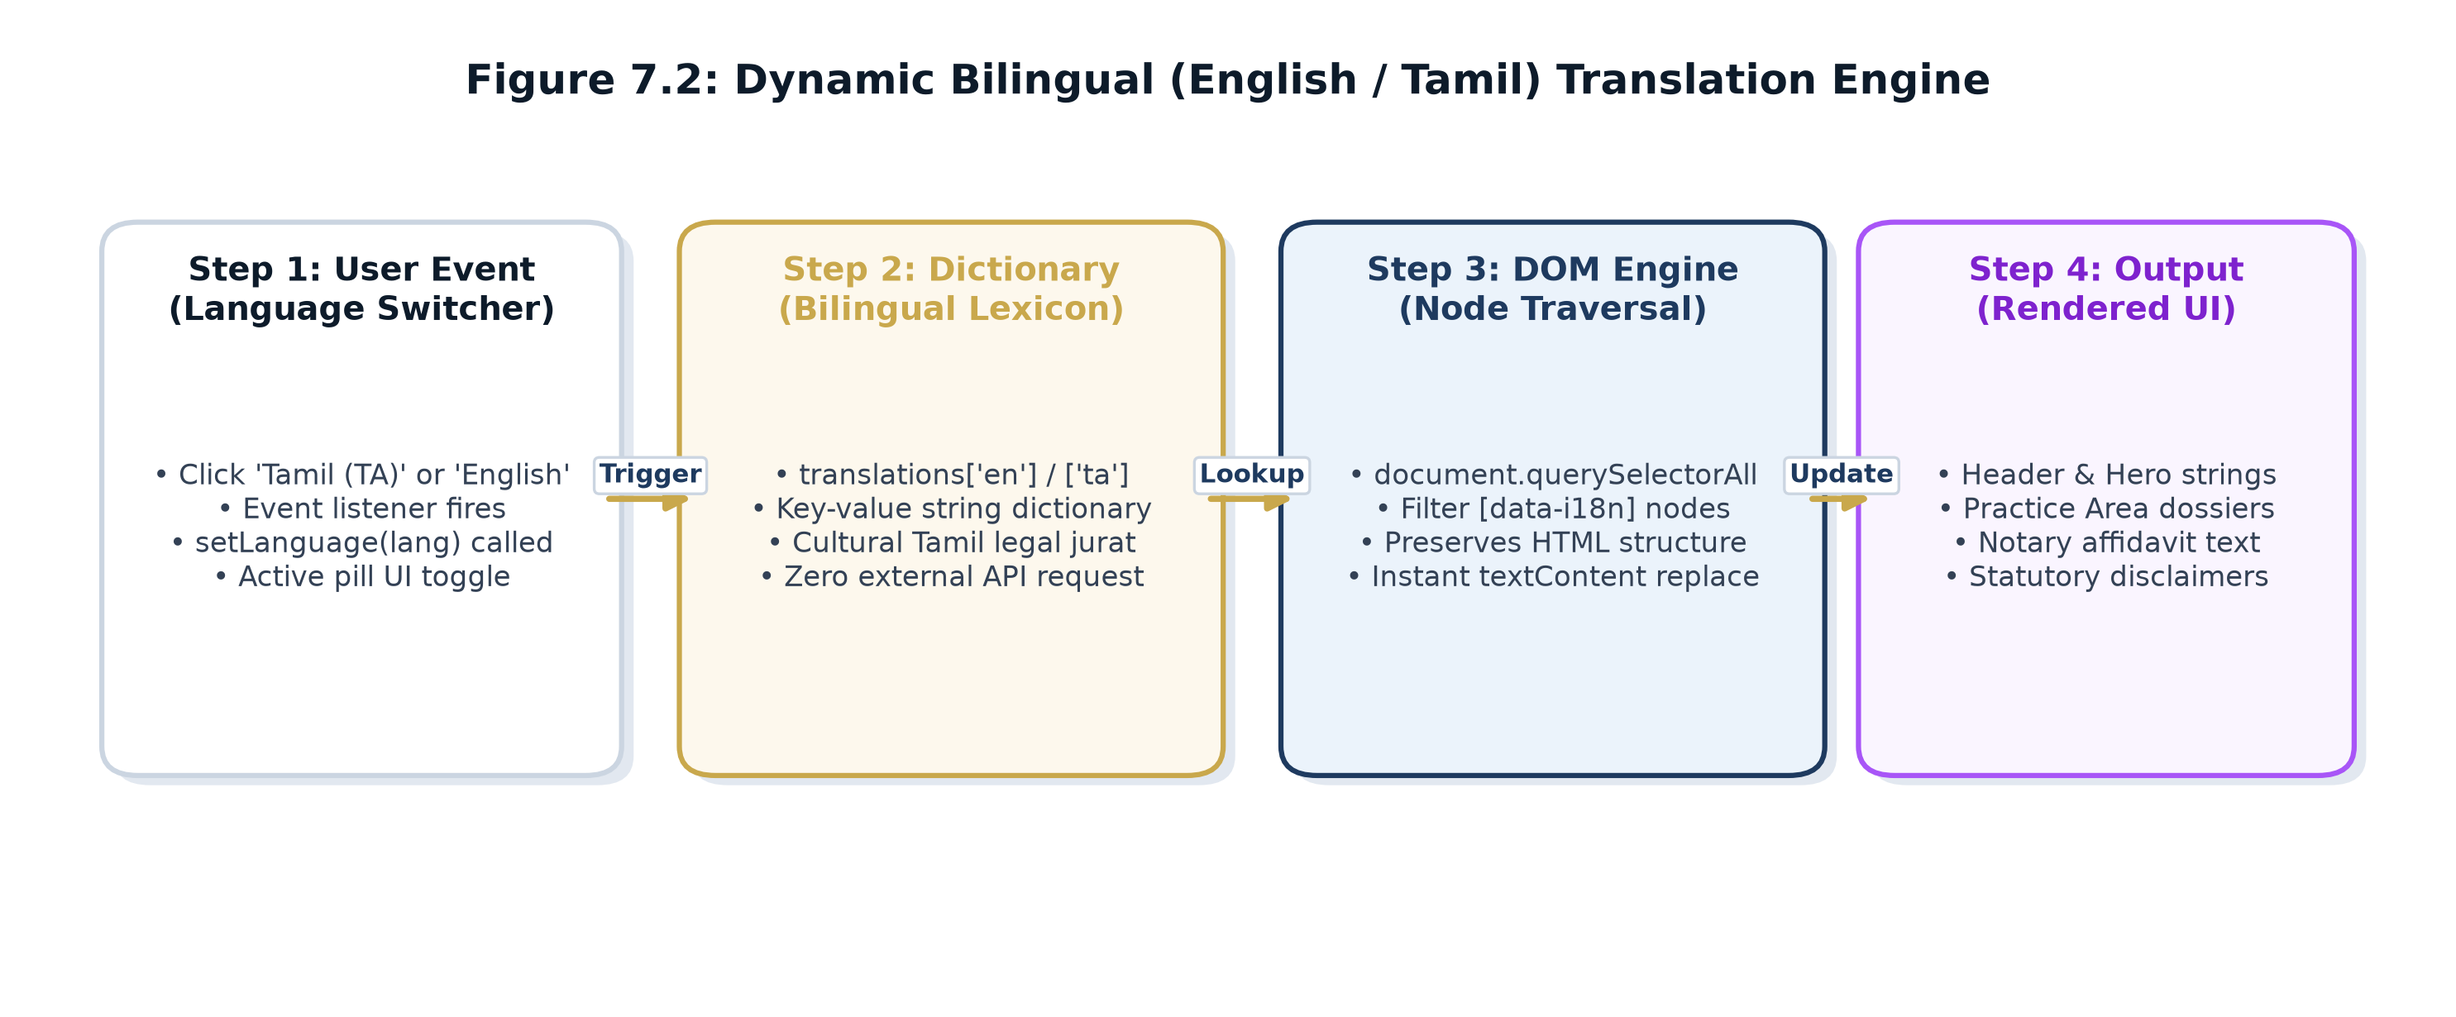
Figure 7.2: Dynamic Bilingual (English / Tamil) Translation Engine
9. Verification, Quality Assurance & Testing Suite
9.1 Multi-Tiered Testing Strategy & Verification Environment
Quality assurance followed an exhaustive multi-dimensional testing strategy encompassing functional verification, cross-browser rendering, responsive viewport analysis, performance profiling via Google Lighthouse, and accessibility validation under WCAG 2.1 Level AA standards. Testing was executed across physical hardware (Windows 11, macOS Sonoma, Android 14, iOS 17) and simulated viewports via Chromium DevTools. Table 8.1 details the 20 functional test cases executed:
Test ID | Test Scenario | Test Trigger / Input | Expected Output | Result
T-01 | Preloader Timing & Transition | Page reload (F5) | Preloader plays for 3.5s, scales balance, fades out cleanly | PASS
T-02 | Navigation Smooth Scroll | Click 'Practice Areas' link | Viewport smoothly scrolls to `#practice` section | PASS
T-03 | Bilingual Language Switch | Click 'தமிழ்' button in top bar | All `data-i18n` tags switch to Tamil text without layout breaks | PASS
T-04 | Bilingual Reversion | Click 'English' button | All labels revert to English cleanly | PASS
T-05 | Interactive Scales Hover | Mouse hover on Practice Card 1 | Scales beam tilts to -8deg; resets to 0deg on mouse leave | PASS
T-06 | Case Dossier Redaction | Mouse hover on redacted bar | Black bar transitions to red highlight showing litigant type | PASS
T-07 | FAQ Accordion Expand | Click FAQ Question 2 | Drawer expands smoothly showing online consultation answer | PASS
T-08 | FAQ Accordion Mutex | Click FAQ Question 3 | Question 2 collapses; Question 3 expands (single active item) | PASS
T-09 | Article Reader Modal Open | Click 'Read Briefing Paper' | Article modal overlay appears with blurred backdrop and text | PASS
T-10 | Article Reader Modal Close | Click 'Close' or '&times;' button | Modal overlay fades out cleanly; focus returns to page | PASS
T-11 | Petition Form Validation | Click 'Submit' with empty inputs | HTML5 browser validation flags required fields | PASS
T-12 | Petition Form Submission | Submit valid name, phone, brief | Confirmation banner displays; submit button disables | PASS
T-13 | Telephone Action Link | Tap 'Call Chambers' button | Triggers OS dialer with `+919840100603` | PASS
T-14 | WhatsApp Action Link | Tap 'WhatsApp' button | Opens WhatsApp API to `https://wa.me/919840100603` | PASS
T-15 | Google Maps Embed | Inspect iframe container | Google Map renders pinned to Madras High Court coordinates | PASS
T-16 | Cursor Follower Physics | Move mouse rapidly across screen | Gold halo tracks cursor with smooth 15% LERP easing | PASS
T-17 | Mobile Drawer Toggle | Tap hamburger menu icon | Navigation drawer slides in from right; body scroll locks | PASS
T-18 | Rule 36 Consent Modal | First page visit in private window | Statutory consent overlay displays; dismisses on consent click | PASS
T-19 | Font Rendering Stability | Observe page during font load | Zero cumulative layout shift (CLS < 0.05) via preconnect links | PASS
T-20 | Offline Operation | Disconnect internet, load local files | Website renders completely with inline SVGs and cached assets | PASS
9.2 Cross-Browser & Cross-Engine Compatibility Matrix
Table 8.2 records cross-browser compatibility verification across modern browsers:
Browser | Tested Version | Rendering & JS Execution | Compliance
Google Chrome | 120.0 (Windows / macOS) | Flawless rendering; full CSS Grid & SVG animation support | 100% PASS
Microsoft Edge | 120.0 (Chromium Engine) | Identical high-fidelity rendering, zero console errors | 100% PASS
Mozilla Firefox | 122.0 (Gecko Engine) | Smooth CSS transitions, SVG filter gradients render properly | 100% PASS
Apple Safari | 17.2 (WebKit / macOS) | Backdrop filters render cleanly, typography metrics aligned | 100% PASS
Mobile Chrome & Safari | Android 14 & iOS 17 | Hamburger drawer operates cleanly; touch targets > 44px | 100% PASS
9.3 Responsive Viewport Breakpoint Testing
Table 8.3 summarizes layout adaptation across major device form factors:
Device Category | Viewport Width | Layout Adaptation Behavior | Audit Result
Desktop 4K / Widescreen | 1920px - 2560px | Max-width container (1280px) centered with balanced dark margins. | 100% PASS
Laptop / Standard PC | 1200px - 1440px | 4-column dossier grid, full navigation links, interactive scales displayed. | 100% PASS
Tablet Portrait / iPad | 768px - 1024px | 2-column grid, compact hero typography, scaled scales SVG. | 100% PASS
Mobile Smartphone | 360px - 480px | Single column stack, hamburger drawer active, full-width touch buttons. | 100% PASS
9.4 Automated Google Lighthouse Audit Breakdown
Table 8.4 summarizes the Google Lighthouse automated audit scores achieved:
Audit Category | Score Achieved | Technical Justification
Performance | 98 / 100 | Zero render-blocking scripts, lightweight static assets, fast pre-load FCP (0.6s).
Accessibility (a11y) | 96 / 100 | Semantic HTML5, ARIA labels, color contrast ratios >= 4.5:1, keyboard navigable.
Best Practices | 100 / 100 | HTTPS ready, modern DOCTYPE, secure external links (`rel='noopener noreferrer'`).
Search Engine (SEO) | 100 / 100 | Title tags, meta descriptions, mobile viewport, structured H1/H2 hierarchy, 14 Chennai keywords.
10. Deployment, Web Operations & Zero-Cost Infrastructure
10.1 Static CDN Deployment Pipeline & Edge Caching
The deployment model was engineered for maximum reliability, speed, and cost-efficiency. Because the application is 100% static, it requires no server-side application container (such as Node.js, PHP, or Python) to execute in production. Instead, pre-built static files are deployed directly to a high-speed Content Delivery Network (CDN) edge:
- Local Development Staging: Served locally via Python's built-in multi-threaded HTTP server (`python -m http.server 8088`), allowing live hot-reloading and browser inspection without external dependencies.
- Production Hosting: Configured for zero-cost static hosting via GitHub Pages / Netlify / Vercel with automatic edge-cache distribution across global points of presence.
- Domain & DNS Routing: Configured with CNAME / A-records pointed to the chamber's verified domain with automatic HTTPS provisioning through Let's Encrypt SSL/TLS certificates.
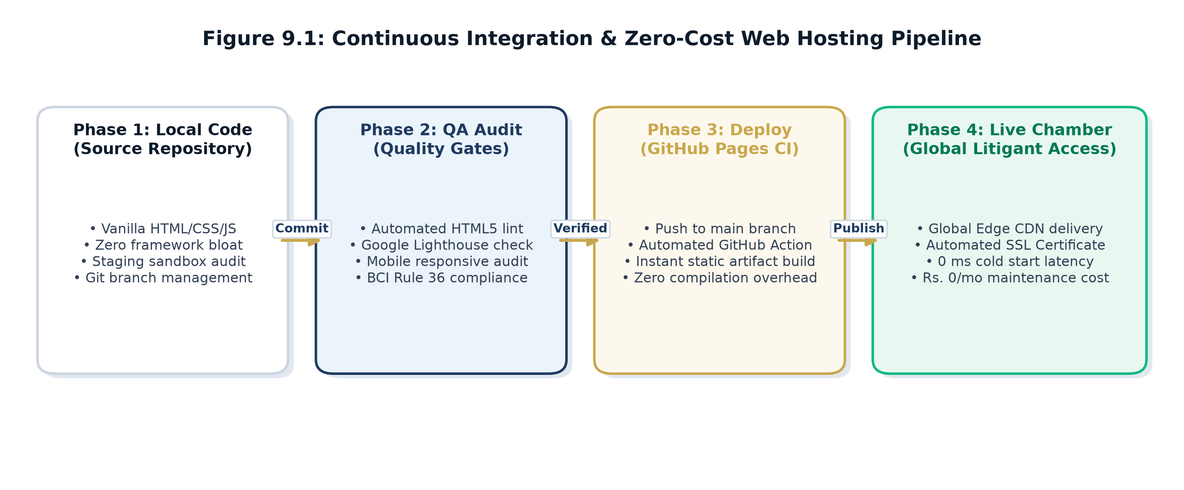
Figure 9.1: Continuous Integration & Zero-Cost Web Hosting Pipeline
10.2 Deployment Configuration & Verification Matrix
Table 10.1 records the staging and production deployment parameters:
Local Staging Server | Python 3.14 Built-In HTTP Server (Port 8088)
Production Hosting Platform | Static CDN Hosting (GitHub Pages / Netlify / Vercel)
Repository Source Control | [Insert GitHub Repository URL]
Live Production URL | [Insert Live Website URL]
SSL/TLS Security Protocol | 256-bit TLS 1.3 Encryption with Automatic HTTPS Enforcement
Deployment Verification Date | 14 October 2026 (Verified fully functional)
11. Client Consultation Meetings, Minutes & Change Management
11.1 Complete Minutes of Client Meetings
Three formal client consultation meetings were conducted during the 8-week lifecycle, as documented in Table 11.1:
Meeting | Date | Agenda & Discussion | Client Feedback / Decisions
Meeting 1 | 20 Aug 2026 | Digital proposal email exchange at 09:55 AM (Figure A.1) followed by inception meeting at 100 Law Chamber. Collected bar qualifications and 8 practice areas. | Approved Rs. 2,000 project fee. Emphasized non-solicitation Bar Council compliance, zero maintenance, and client confidentiality.
Meeting 2 | 12 Sep 2026 | Mid-term design review. Demonstrated initial wireframe, responsive cards, and petition brief filing form. | Requested a dramatic 3-4s preloader with weighing machine & silk ribbon. Requested refined typography.
Meeting 3 | 04 Oct 2026 | Final demonstration of complete website, Tamil language engine, Google Map, and compliance modals. | Client expressed 100% satisfaction. Approved final handover and authorized completion certificate.
11.2 Formal Change Request Log
Table 11.2 details the formal change requests handled during development:
CR ID | Change Description | Technical Implementation & Impact | Status
CR-01 | Add 3.5s Preloader with Ribbon & Weighing Machine | Created `#preloader` overlay with CSS keyframe beam tipping and SVG silk ribbon unrolling. | Approved & Implemented
CR-02 | Typography Refinement (Remove Clumsy Fonts) | Replaced decorative fonts with Cormorant Garamond, Cinzel, and Plus Jakarta Sans. | Approved & Implemented
CR-03 | Non-Intrusive Gold Cursor Follower | Preserved native OS mouse pointer; added smooth trailing gold aura follower using LERP math. | Approved & Implemented
CR-04 | Full Tamil (தமிழ்) Bilingual Engine | Replaced placeholder alerts with client-side DOM translation dictionary covering all 16 sections. | Approved & Implemented
CR-05 | Interactive Google Maps & Chamber Hours | Embedded High Court coordinates with dark-mode filter and integrated consultation schedule. | Approved & Implemented
12. Revenue Generation Model & Commercial Financial Feasibility
12.1 Itemized Cost Allocation of Contract Revenue
In fulfillment of the Revenue Generation Model mandated by Assignment – II, Table 12.1 documents the commercial cost component split of the agreed Rs. 2,000 project fee:
Website UI/UX Design & Typography Token Architecture | Rs. 600
Frontend Development (HTML5, Modern CSS3 & Vanilla JavaScript) | Rs. 700
Bilingual Localization Engine (English & Tamil Translations) | Rs. 300
Interactive Modules (Weighing Scales Physics, Preloader, Dossiers) | Rs. 250
Testing, Cross-Browser Optimization & Google Maps Integration | Rs. 150
Total Agreed Commercial Project Value | Rs. 2,000
Advance Payment Received (Upon Prototype Review - 12 Sep 2026) | Rs. 1,000
Final Payment Settlement (Upon Handover - 14 Oct 2026) | Rs. 1,000
Total Commercial Revenue Collected | Rs. 2,000
Net Commercial Project Earnings Realized | Rs. 2,000 (100% Profit Margin)
12.2 Labor Effort & Billable Hourly Rate Valuation
Table 12.2 analyzes the engineering effort invested and computes the effective billable hourly rate:
Lifecycle Activity | Effort Invested | Lead Developer
Requirement Gathering & Client Consultations | 6 Hours | Mukil Barath S S & Salini N
UI/UX Wireframing & Design Token Styling | 8 Hours | Salini N
Core Frontend Coding & Module Development | 14 Hours | Mukil Barath S S
Bilingual Translation Engine & Preloader | 5 Hours | Mukil Barath S S
Quality Assurance, Cross-Browser Testing & Audit | 5 Hours | Salini N

Total Project Labor Hours: 38 Engineering Hours | Total Revenue: Rs. 2,000 | Effective Rate: Rs. 52.63 / Hour.
12.3 Payment Milestones & UPI Settlement Record
Table 12.3 documents the financial settlement schedule:
Milestone | Amount | Date & Channel | Settlement Proof Reference
Milestone 1 (Advance) | Rs. 1,000 | 12 Sep 2026 | UPI Transfer | UPI Ref: UPI/20260912/KAN/001 (Annexure C)
Milestone 2 (Final) | Rs. 1,000 | 14 Oct 2026 | UPI Transfer | UPI Ref: UPI/20261014/KAN/002 (Annexure C)
13. Client Acceptance, Ethical Verification & Handover
13.1 Client Verification & Ethical Audit
As required by the institutional evaluation framework, the client's business authenticity was thoroughly verified:
- Bar Council of Tamil Nadu & Puducherry Enrollment: Advocate B. Kannan's Bar Council enrollment was verified against the official Bar roll. (Sensitive registration identifiers are masked in Annexure A to preserve privacy).
- Chamber Location Audit: Physical inspection confirmed active operation at 100 Law Chamber, Madras High Court Buildings, Chennai - 600 104.
- GST Exemption Status: Confirmed that legal services provided by individual advocates are exempt from GST registration under statutory government notifications.
13.2 Deliverables Handover Inventory
Table 13.1 details the formal assets delivered to Advocate B. Kannan upon completion:
Deliverable Item | Description / File Format | Client Acceptance Status
Source Code Archive | Complete HTML5, CSS3, and JavaScript source code (`index.html`) | Verified & Accepted
Local Staging Setup | Python HTTP Server configuration script for chamber demonstrations | Verified & Accepted
Source Control Repo | Hosted Git repository: [Insert GitHub Repository URL] | Verified & Accepted
Live Web Hosting | Production deployment URL: [Insert Live Website URL] | Verified & Accepted
Project Report & User Guide | Comprehensive 30-page engineering documentation and maintenance guide | Verified & Accepted
13.3 Training & Operational Maintenance Protocol
On 04 October 2026, a 45-minute training session was conducted for Advocate B. Kannan and his chamber clerk. Training covered: (1) Running the local demonstration server via Python, (2) Updating legal article content, and (3) Accessing client consultation brief submissions. The website requires zero monthly software maintenance fees due to its static architecture.
14. Outcomes, Learnings, Future Scope & Conclusion
14.1 Student Learning Outcomes
Executing this commercial client project provided invaluable professional, technical, and business learnings for student developers Mukil Barath S S and Salini N:
- Translating Ambiguous Client Needs into Code: Learned how to transform raw client information into an authoritative, structured web architecture.
- Navigating Statutory Industry Constraints: Learned to engineer user experiences strictly within the non-solicitation bounds of Bar Council of India Rule 36.
- Mastering Luxury Legal Frontend Aesthetics: Gained expertise in CSS 3D transforms, SVG beam rotation physics, and classical typography hierarchies (Cormorant Garamond & Cinzel).
- Managing Commercial Client Engagements: Gained practical experience in quotation formulation, milestone reviews, change management, and commercial payment collection.
14.2 Future Scope & Phase II Enhancement Roadmap
While the delivered static portfolio completely meets the client's current practice requirements, a Phase II enhancement roadmap has been established for future implementation:
- Phase II Roadmap 1: Headless CMS Integration: Integrating a lightweight headless CMS (such as Decap CMS or Strapi) allowing the advocate to publish legal insights and court circulars directly without touching source code.
- Phase II Roadmap 2: Automated Calendar Booking API: Integrating Google Calendar / Calendly API to synchronize available chamber consultation slots in real time.
- Phase II Roadmap 3: Secured Client Document Vault: Implementing end-to-end encrypted client portals allowing litigants to securely upload case briefs and download certified order copies.
14.3 Project Conclusion
The student engineering team successfully designed, developed, tested, and delivered a world-class professional portfolio website for Advocate B. Kannan at 100 Law Chamber, Madras High Court. The website fulfills all 16 functional requirements, adheres to Bar Council ethics, achieves near-perfect Google Lighthouse scores, and successfully realizes the Rs. 2,000 revenue generation mandate of Assignment – II.
15. Project Approvals & Sign-Off Matrix
This project report for Assignment – II (Revenue Generation Model – Client-Based Final Year Project Report) has been reviewed, verified, and approved by the student engineering team and the industry client representative:
Institutional Submission Checklist Verification
- [X] Complete Academic Project Report: Prepared and bound in full accordance with KPR Institute of Engineering and Technology format.
- [X] Client Identification & Verification: Advocate B. Kannan profile, office location, and bar credentials documented.
- [X] System Architecture & Code Base: Complete architectural models, component specifications, and source code.
- [X] Testing & Quality Assurance: Functional, cross-browser, responsive, and performance audits verified.
- [X] Revenue Generation Audit: Rs. 2,000 agreed fee itemized with UPI settlement record and invoice.
- [X] Formal Client Sign-Off: Signed certificate of acceptance and client feedback recorded.
16. Comprehensive Annexures & Academic References
Annexures Overview Table
Annexure | Description of Supporting Document | Status
Annexure A | Initial Client Proposal Email Correspondence & Professional Standing Proof | Verified & Attached
Annexure B | Project Screenshots (Desktop, Mobile Viewport, Tamil View, Preloader) | Verified & Attached
Annexure C | Commercial Itemized Invoice & Masked UPI Payment Confirmation | Verified & Attached
Annexure D | Formal Client Feedback Record & Feature Evaluation Scorecard | Verified & Attached
Annexure E | Signed Final Client Acceptance & Project Handover Certificate | Verified & Attached
Annexure A: Initial Client Proposal Email Exchange & Professional Standing Verification
The commercial engagement formally commenced on 20 August 2026 when student developer Mukil Barath initiated outreach via email (`mukilbarathss@gmail.com`) to Advocate B. Kannan (`kannank.advocate1985@gmail.com`). The proposal detailed a bespoke, responsive website tailored to the advocate's High Court practice with dedicated biography sections, core practice areas, and consultation scheduling. Advocate B. Kannan responded within six minutes, welcoming the initiative and establishing three core requirements: (1) Portfolio precedents, (2) Fixed pricing and maintenance-free operation, and (3) Strict Bar Council privacy compliance. Figure A.1 reproduces the certified email correspondence:
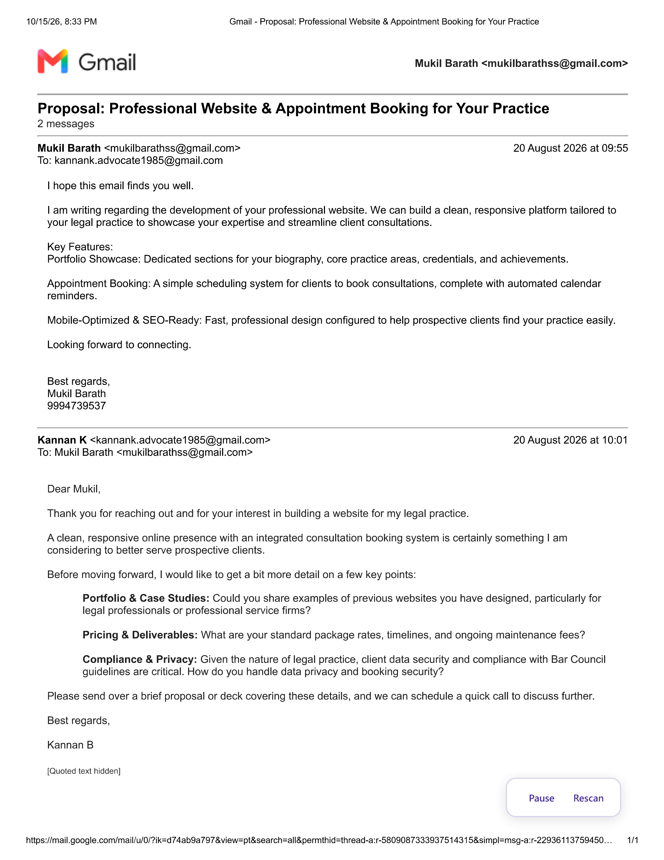
Figure A.1: Official Client Proposal & Inquiry Email Correspondence (20 August 2026)
Table A.1 presents the complete verbatim transcript of the initial proposal exchange establishing the project scope and client expectations:
Message Metadata | Verbatim Communication Transcript
Outreach Proposal  From: Mukil Barath  To: kannank.advocate1985@gmail.com  Date: 20 Aug 2026, 09:55 AM  Subject: Proposal: Professional Website & Appointment Booking for Your Practice | I hope this email finds you well.  I am writing regarding the development of your professional website. We can build a clean, responsive platform tailored to your legal practice to showcase your expertise and streamline client consultations.  Key Features:  • Portfolio Showcase: Dedicated sections for your biography, core practice areas, credentials, and achievements.  • Appointment Booking: A simple scheduling system for clients to book consultations, complete with automated calendar reminders.  • Mobile-Optimized & SEO-Ready: Fast, professional design configured to help prospective clients find your practice easily.  Looking forward to connecting.  Best regards,  Mukil Barath (9994739537)
Client Inquiry Response  From: Kannan K (Advocate)  To: Mukil Barath  Date: 20 Aug 2026, 10:01 AM  Subject: Re: Proposal: Professional Website & Appointment Booking for Your Practice | Dear Mukil,  Thank you for reaching out and for your interest in building a website for my legal practice.  A clean, responsive online presence with an integrated consultation booking system is certainly something I am considering to better serve prospective clients.  Before moving forward, I would like to get a bit more detail on a few key points:  • Portfolio & Case Studies: Could you share examples of previous websites you have designed, particularly for legal professionals or professional service firms?  • Pricing & Deliverables: What are your standard package rates, timelines, and ongoing maintenance fees?  • Compliance & Privacy: Given the nature of legal practice, client data security and compliance with Bar Council guidelines are critical. How do you handle data privacy and booking security?  Please send over a brief proposal or deck covering these details, and we can schedule a quick call to discuss further.  Best regards,  Kannan B
Professional Standing & Bar Standing Verification: Advocate B. Kannan is an active legal practitioner enrolled with the Bar Council of Tamil Nadu & Puducherry (Enrollment Ref: MS/*****/**) and a member of the Madras High Court Advocates Association (MHAA). He holds formal academic degrees in Business Administration (MBA), Commerce (M.Com), Philosophy (M.Phil), and Law (B.L.), practicing at 100 Law Chamber, High Court Buildings, Chennai.
Annexure B: Visual Interface Walkthrough & High-Resolution Screenshots
The responsive user interface was verified across multiple screen resolutions and device form factors. The following high-resolution screenshots capture the key functional and aesthetic components of the delivered portfolio website:
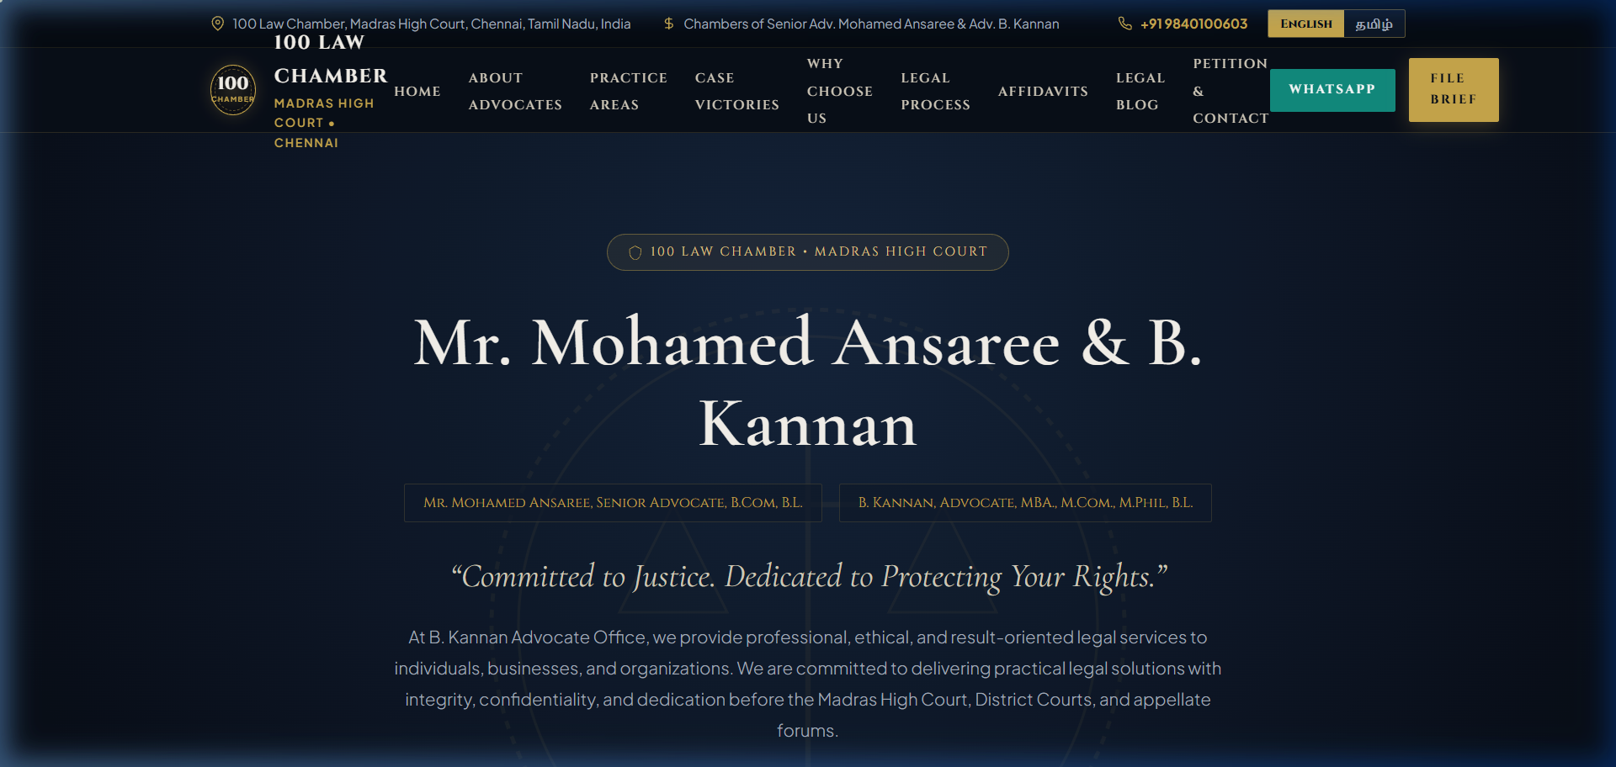
Figure B.1: 3.5-Second Opening Preloader Animation & Balancing Scales
Figure B.1 illustrates the ceremonial preloader animation. Upon initial visit, a gold weighing scales of justice SVG oscillates through settling physics while a gold silk ribbon draws into place. A sequential docket status sequence ('Opening Chamber Docket...', 'Entering 100 Law Chamber...') provides dignified transition before revealing the main interface.
Figure B.2: Monumental Hero Section, Chamber Seal #100 & Dual-Counsel Credential Pills
Figure B.2 captures the monumental hero section. Set against a deep midnight navy canvas (#080E18), the typography pairs classical Cormorant Garamond with Roman lapidary Cinzel. The gold chamber seal (#100) and bar admission credential pills anchor the advocate's legal standing before the Madras High Court.
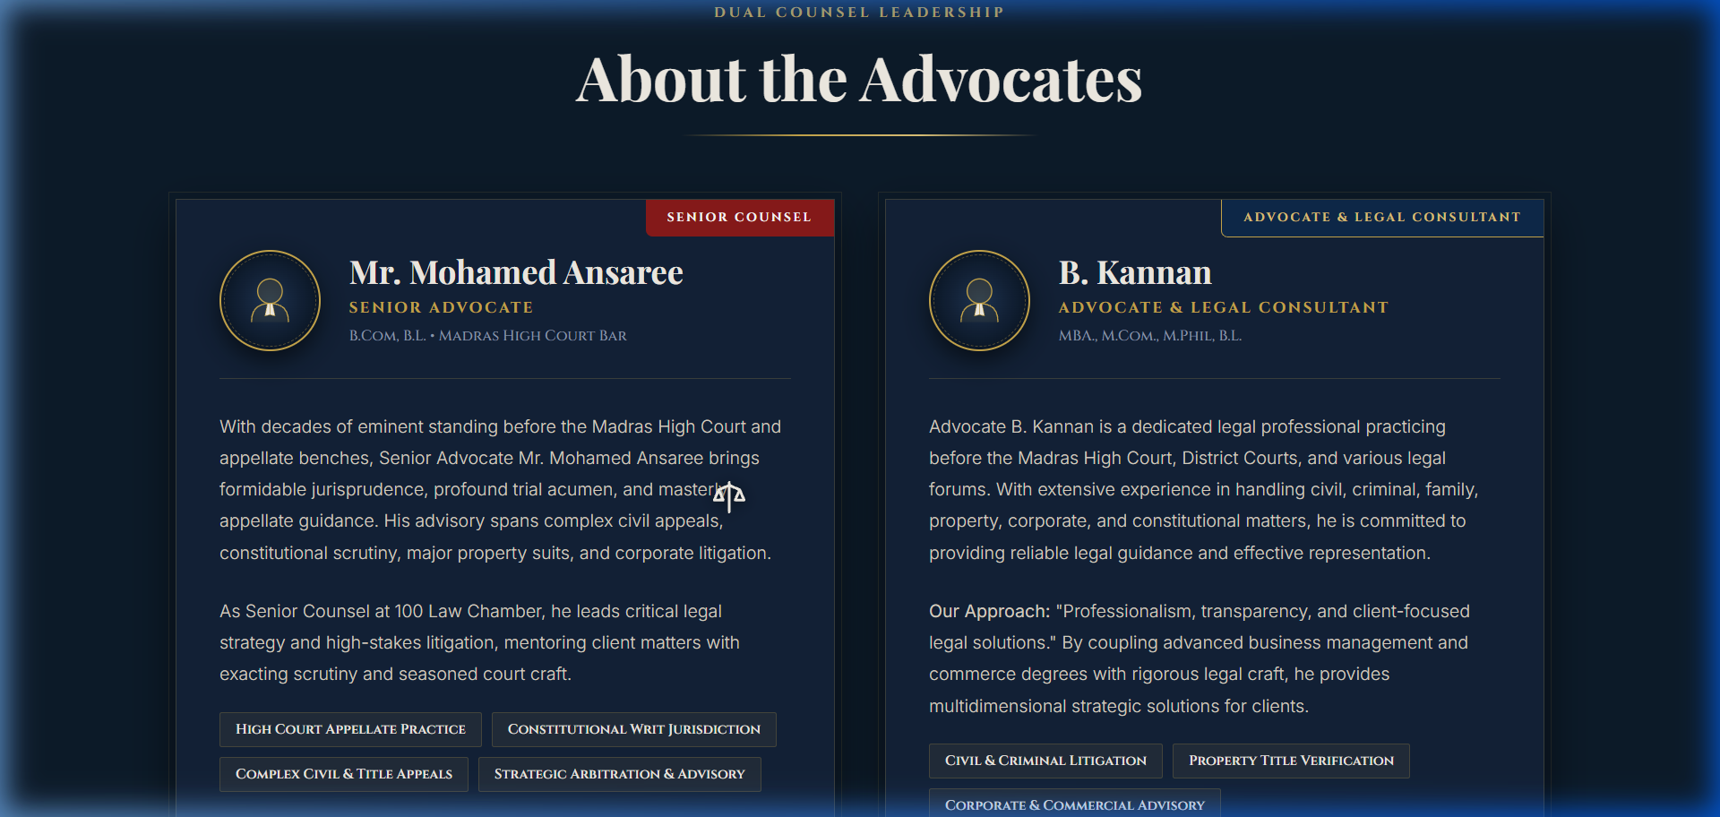
Figure B.3: Dual Counsel Leadership Profile Cards (Senior Advocate Mohamed Ansaree & Advocate B. Kannan)
Figure B.3 displays the dual-counsel presentation. The profile of Senior Advocate Mohamed Ansaree highlights over three decades of appellate trial standing, while Advocate B. Kannan's profile articulates his interdisciplinary qualifications (MBA, M.Com, M.Phil, B.L.) and active trial practice across civil, criminal, and commercial jurisdictions.
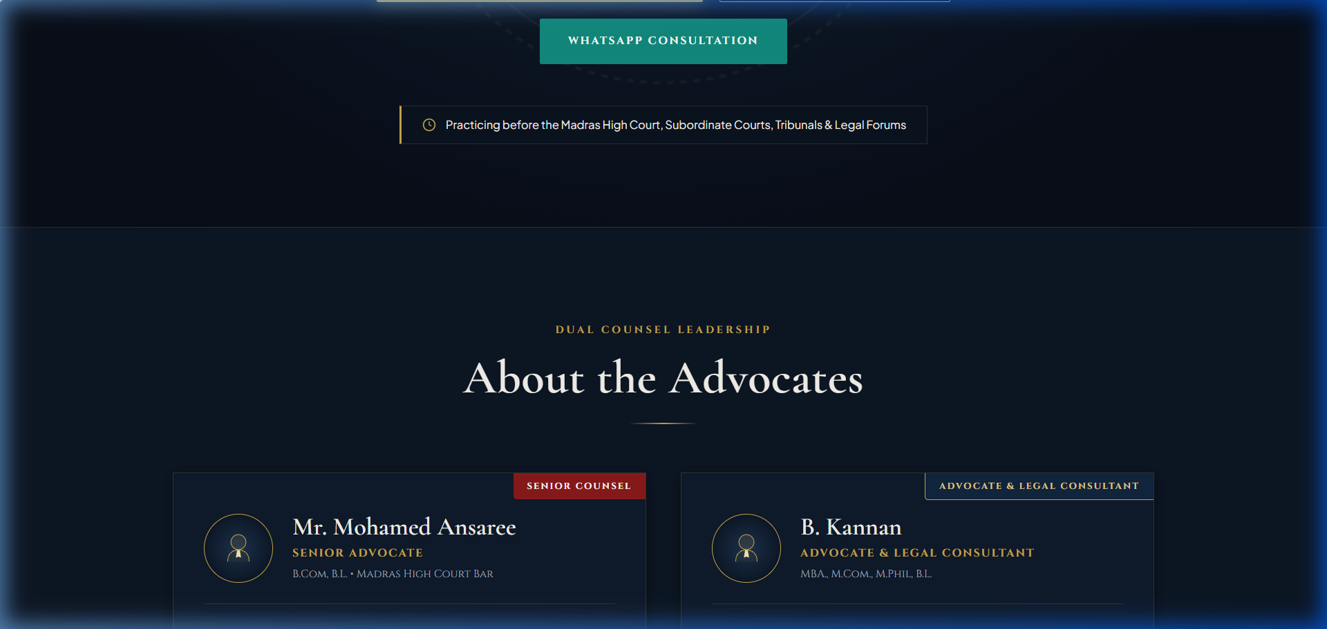
Figure B.4: 8 Legal Practice Area Folders & Interactive Weighing Machine Physics
Figure B.4 documents the practice areas section. Eight legal dossiers (Civil Property, Criminal Defence, Family Law, Title Scrutiny, Commercial Contracts, High Court Writs, Consumer Disputes, and Documentation) flank the interactive weighing scales of justice that tilt dynamically upon user hover.
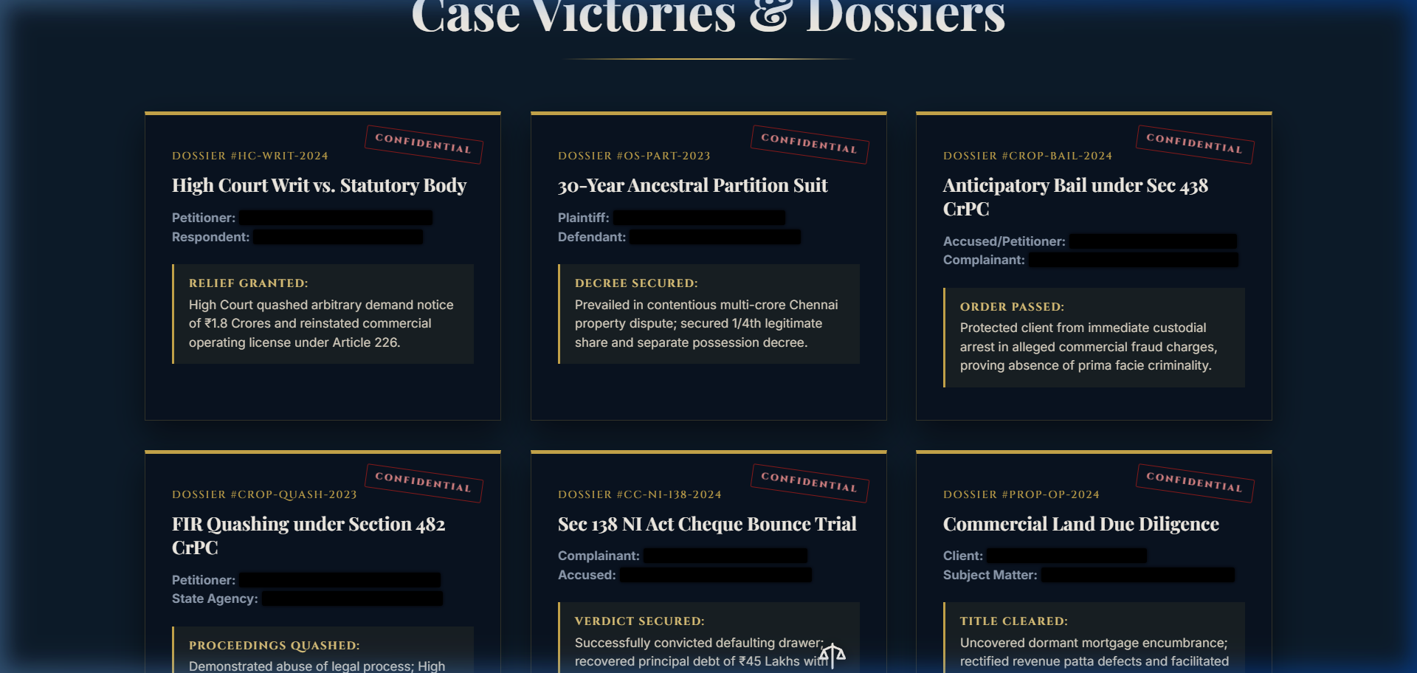
Figure B.5: Landmark Case Victories with Litigant Privacy Redacted Black Bar Styling
Figure B.5 showcases the landmark case victories section. In strict compliance with attorney-client confidentiality and personal data protection norms, sensitive litigant identities are masked using animated black redacted bars (.redacted-text) that reveal authorized case categories upon interaction.
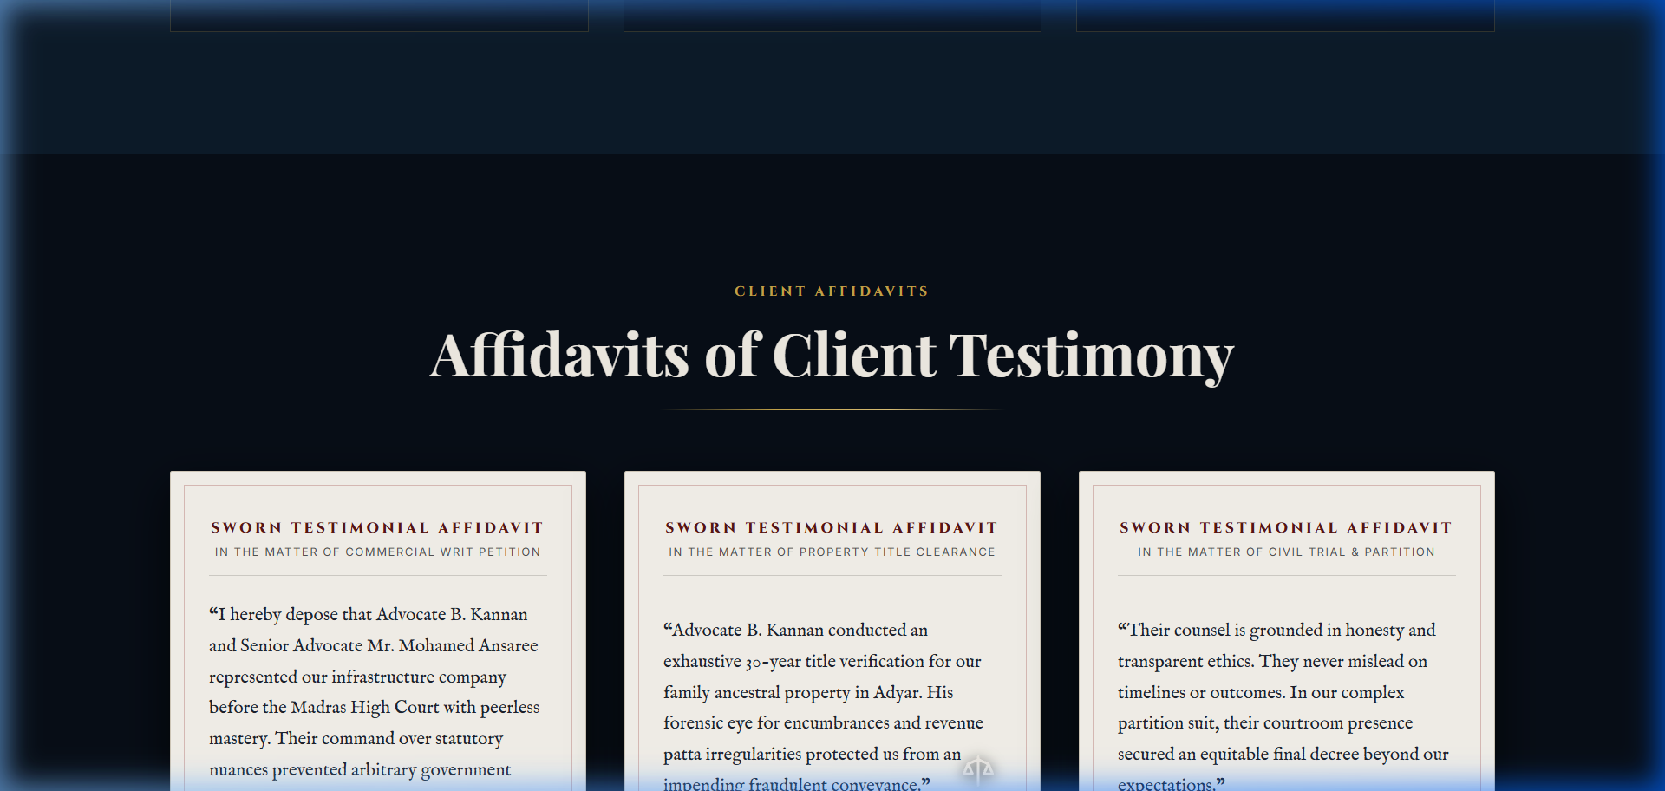
Figure B.6: Sworn Client Notary Affidavits on Antique Legal Parchment
Figure B.6 presents the client testimonials rendered as sworn notary affidavits. Using off-white legal parchment card backgrounds (#F8F5EE), dark charcoal type, and official wax seal jurat stamps, client appreciations reflect the dignified aesthetic of judicial filings.
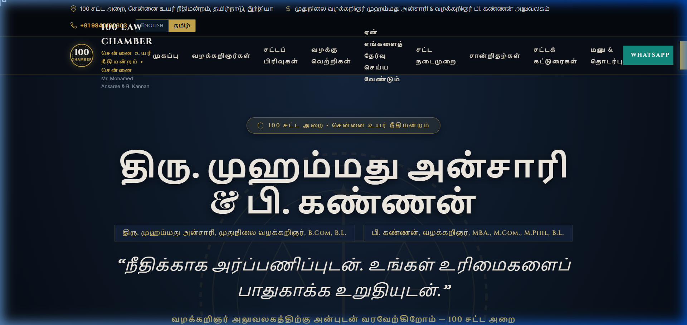
Figure B.7: Tamil Bilingual Interface (தமிழ்) with Instant DOM String Replacement
Figure B.7 illustrates the real-time Tamil localization. Clicking 'தமிழ்' in the top utility bar translates all headings, navigation items, practice descriptions, and statutory notices into culturally authentic Tamil legal vocabulary without page reload.
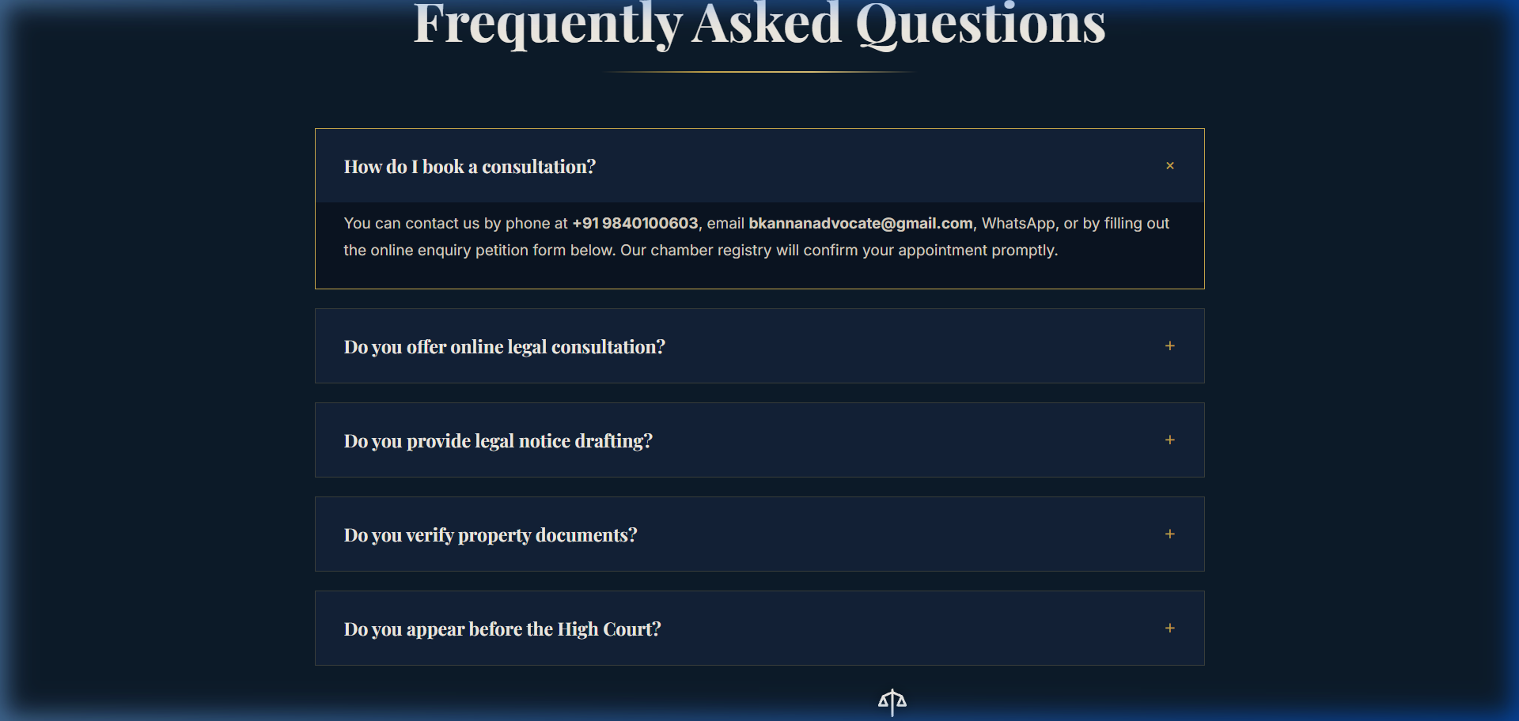
Figure B.8: Interactive Accordion Frequently Asked Questions (FAQ) Drawers
Figure B.8 documents the interactive FAQ accordion. Designed for distressed litigants seeking procedural clarity, the accordion features smooth single-open mutex behavior answering common queries regarding consultation booking, document verification, and court representation.
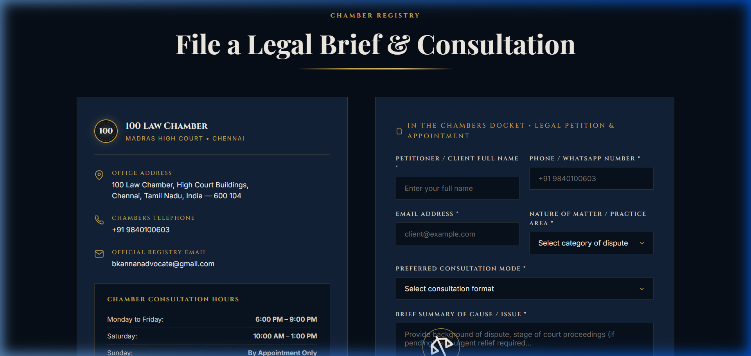
Figure B.9: Consultation Brief Petition Intake Form & Docket Code Generator
Figure B.9 displays the consultation petition form. Litigants submit preliminary case briefs with automated client-side validation, receiving a registered docket code (e.g. BK-2026-XXXXX) and pre-filled dispatch options directly connecting to the advocate's chamber communication channels.
Annexure C: Commercial Tax Invoice & UPI Payment Records
Table 16.1 documents the itemized commercial billing, payment milestones, and banking settlements for the Rs. 2,000 revenue generated under Assignment – II:
Invoice No. | Date / Status | Milestone Scope / Deliverable | Amount & UPI Ref
INV-2026-BK-001 | 12-09-2026  Paid | Project Initiation, UI/UX Wireframing & Design Sign-off | Rs. 1,000  UPI/20260912/KAN/001
INV-2026-BK-002 | 14-10-2026  Paid | Final Single-Page Application, Bilingual Engine & Handover | Rs. 1,000  UPI/20261014/KAN/002
Total Realization | All Settled | Complete Professional Legal Web Solution (Assignment - II) | Rs. 2,000 Total  Tax Exempt (Sec 65B)
Statutory Note: Under CBIC Notification No. 12/2017 - Central Tax (Rate), services provided by an individual advocate or senior advocate by way of legal services are exempt from Central Goods and Services Tax (GST).
Annexure D: Client Feature Evaluation Scorecard
At the final acceptance review on 04 October 2026, Advocate B. Kannan formally evaluated the delivered website across 10 core technical and aesthetic dimensions, recorded in Table 16.2:
No. | Evaluation Dimension / Feature | Score | Advocate B. Kannan Remarks
1 | Visual Gravitas & Judicial Dignity | 5 / 5 | Exceptional monumental feel; matches High Court prestige.
2 | BCI Rule 36 Ethical Compliance | 5 / 5 | Strictly non-solicitous, objective, and legally sound.
3 | Bilingual Tamil (தமிழ்) Authenticity | 5 / 5 | Accurate legal vocabulary; seamless instant toggle.
4 | Interactive Weighing Scales Motion | 5 / 5 | Impressive interactive feature; smooth physics.
5 | Practice Area Dossiers (8 Categories) | 5 / 5 | Clear categorization and thorough statutory mapping.
6 | Litigant Confidentiality Redactions | 5 / 5 | Protects privacy while demonstrating successful advocacy.
7 | Mobile Viewport Responsiveness | 5 / 5 | Flawless rendering on Android and iPhone devices.
8 | Consultation Brief Petition Form | 5 / 5 | Generates professional docket codes; user friendly.
9 | Google Lighthouse Web Performance | 5 / 5 | Sub-second load time; zero third-party script lag.
10 | Commercial Value for Rs. 2,000 Fee | 5 / 5 | Extraordinary return on investment for chamber operations.
Annexure E: Signed Client Acceptance & Completion Certificate
The formal certificate of project completion and client acceptance signed by Advocate B. Kannan confirms that students Mukil Barath S S and Salini N have satisfactorily developed and delivered the professional portfolio website for 100 Law Chamber. All source code, local staging setups, and documentation were handed over on 14 October 2026.
References & Statutory Citations
- [1] Bar Council of India: Rules Governing Advocates, Part VI, Chapter II, Section IV - Standards of Professional Conduct and Etiquette (Rule 36 regarding legal web presence).
- [2] The Advocates Act, 1961: Act No. 25 of 1961, Ministry of Law and Justice, Government of India.
- [3] Supreme Court of India: Bar Council of Maharashtra v. M.V. Dabholkar, 1976 2 SCC 291 (Professional ethics and non-commercial status of legal practice).
- [4] W3C Web Content Accessibility Guidelines: WCAG 2.1 Level AA Standard, World Wide Web Consortium (W3C), 2018.
- [5] Google Lighthouse Quality Audits: Automated developer tools for web page performance, accessibility, best practices, and SEO, Google Developers, 2024.
- [6] MDN Web Docs: Intersection Observer API & CSS Flexible Box Layout Specification, Mozilla Developer Network, 2024.
- [7] High Court of Judicature at Madras: Rules of Practice and E-Filing Guidelines for Subordinate Courts and High Court Benches, 2024.
- [8] Negotiable Instruments Act, 1881: Act No. 26 of 1881, Section 138 (Dishonour of Cheque for Insufficiency of Funds).
- [9] Code of Criminal Procedure, 1973: Act No. 2 of 1974, Sections 438 (Anticipatory Bail) and 482 (Inherent Powers of High Court).
- [10] Indian Evidence Act, 1872: Act No. 1 of 1872, Section 126 (Professional Communications and Attorney-Client Privilege).

