12.12.25 (FridayM) – Fast API responds well. Github updated
--And if in the based of query it can't return nothing then it should be handled nicely. It can return the result close to the user's query. First it can ask the user . Such as if user ask for properties around 1M, but there are not available. Then llm should ask, not available. Should I show you around 1.5 M
16.12
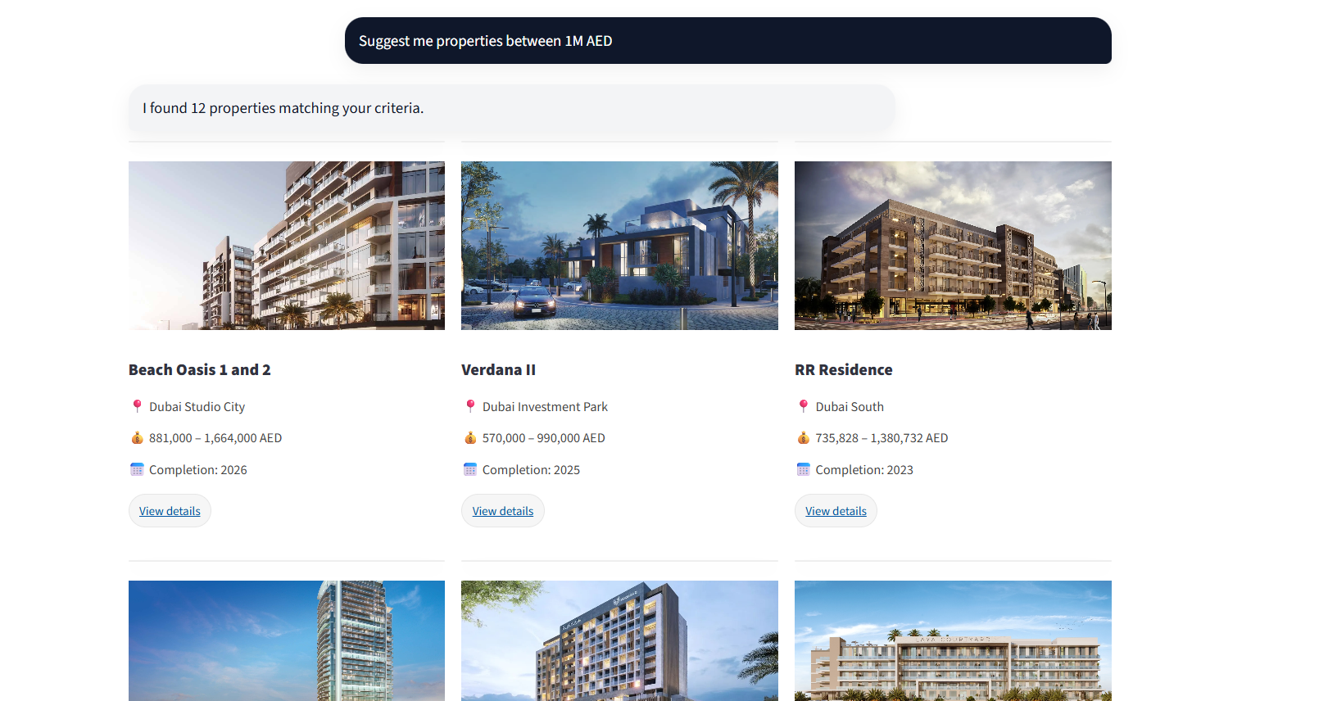
Upcoming:
- When user click on ‘view details’ chatbot should take this query and give a answer.
- Show some dummy query above chatbot box. User can directly click on these.
- Prepare knowledge base. ✅ [https://chatgpt.com/s/t_6944044a46988191a3f1810f49289e89] [FAISS]
- User login after 3 queries. [FAISS-Chroma DB-MongoDB] ✅
- Voice enabling. ✅
- File share enabling.
MongoDB:
username: kazirafi98_db_user
pass: hfqTB5GzCb0LECG8

