Linux Commands

Linux is a Unix-Like operating system. All the Linux/Unix commands are run in the terminal provided by the Linux system. This terminal is just like command prompt of Windows OS. Linux/Unix commands are *case-sensitive.* The terminal can be used to accomplish all Administrative tasks. This includes package installation, file manipulation, and user management. Linux terminal is user-interactive. The terminal outputs the results of commands which are specified by the user itself. Execution of typed command is done only after you press the Enter key.  
15 essential Linux commands :

1. pwd
2. ls
3. cd
4. mkdir & rmdir
5. rm
6. touch
7. man & --help
8. cp
9. mv
10. locate
11. Echo
12. Cat
13. nano, vi, jed
14. Sudo
15. du

Description:  
**1. pwd** — When you first open the terminal, you are in the home directory of your user. To know which directory you are in, you can use the **“pwd”** command. It gives us the absolute path, which means the path that starts from the root. The root is the base of the Linux file system. It is denoted by a forward slash( / ). The user directory is usually something like "/home/username".  
   
**2. Is –**Usethe **"ls"** command to know what files are in the directly you are in.You can see all the hidden files by using the command**“ls –a”.**

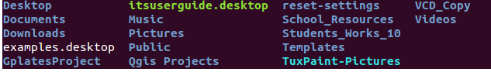

**3. cd—**Use the**"cd ”** command to go to a directory.For example you are in the home folder,and you want to go to the downloads folder,then you can type in **“cd Downloads”.**



**4. mkdir & rmdir**— Use the **mkdir** command when you need to create a folder or a directory. For example, if you want to make a directory called “DIY”, then you can type **“mkdir DIY**”. Remember, as told before, if you want to create a directory named “DIY Hacking”, then you can type “mkdir **DIY\ Hacking**”. Use **rmdir** to delete a directory. But **rmdir** can only be used to delete an empty directory. To delete a directory containing files, use **rm**.  
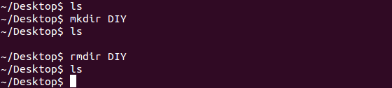

**5. rm-**Use the ‘rm’command to delete files and directions.  


**6.Touch-**the Touch command is used to create a file.  


**7. man & --help** — To know more about a command and how to use it, use the **man** command. It shows the manual pages of the command. For example, “**man cd**” shows the manual pages of the **cd**command. Typing in the command name and the argument helps it show which ways the command can be used (e.g., **cd –help**).

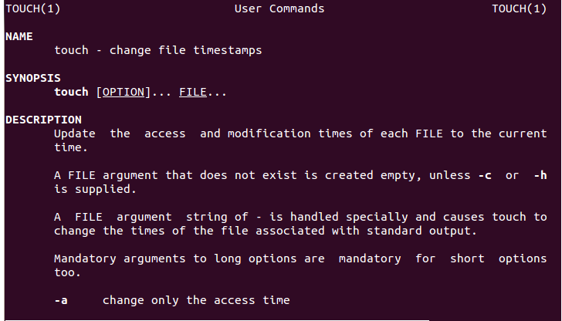

**8. cp** — Use the **cp**command to copy files through the command line. It takes two arguments: The first is the location of the file to be copied, the second is where to copy.  
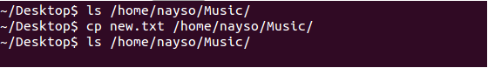

**9. mv** — Use the **mv** command to move files through the command line. We can also use the **mv** command to rename a file. For example, if we want to rename the file “**text**” to “**new**”, we can use “**mv text new**”. It takes the two arguments, just like the**cp** command.  
**10. locate** — The **locate** command is used to locate a file in a Linux system, just like the search command in Windows. This command is useful when you don't know where a file is saved or the actual name of the file. Using the -i argument with the command helps to ignore the case (it doesn't matter if it is uppercase or lowercase). So, if you want a file that has the word “hello”, it gives the list of all the files in your Linux system containing the word "hello" when you type in “**locate -i hello**”. If you remember two words, you can separate them using an asterisk (*). For example, to locate a file containing the words "hello" and "this", you can use the command “**locate -i *hello*this”.  
11. echo**— The "**echo**" command helps us move some data, usually text into a file. For example, if you want to create a new text file or add to an already made text file, you just need to type in, “**echo hello, my name is mukit>> new.txt**”. You do not need to separate the spaces by using the backward slash here, because we put in two triangular brackets when we finish what we need to write.  
**12. Cat-**Use the Cat command to display the contents of a file.

**13. nano, vi, jed — nano** and **vi** are already installed text editors in the Linux command line. The **nano** command is a good text editor that denotes keywords with color and can recognize most languages. And **vi** is simpler than **nano**. You can create a new file or modify a file using this editor. For example, if you need to make a new file named **"check.txt**", you can create it by using the command “**nano check.txt**”. You can save your files after editing by using the sequence Ctrl+X, then Y (or N for no). In my experience, using **nano**for HTML editing doesn't seem as good, because of its color, so I recommend **jed**text editor. We will come to installing packages soon.  
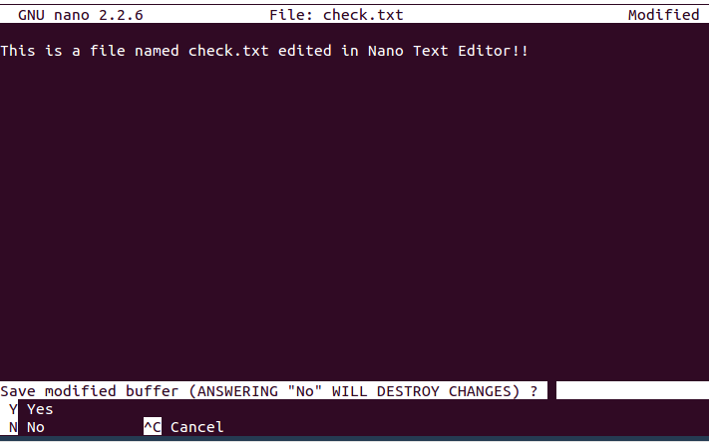

**14. sudo** — A widely used command in the Linux command line, **sudo** stands for "SuperUser Do". So, if you want any command to be done with administrative or root privileges, you can use the **sudo** command. For example, if you want to edit a file like **viz. alsa-base.conf**, which needs root permissions, you can use the command – **sudo nano alsa-base.conf**. You can enter the root command line using the command “**sudo bash**”, then type in your user password. You can also use the command “**su**” to do this, but you need to set a root password before that. For that, you can use the command “**sudo passwd**”(not misspelled, it is **passwd**). Then type in the new root password.  
**15. du** — Use **du** to know the disk usage of a file in your system. If you want to know the disk usage for a particular folder or file in Linux, you can type in the command **df** and the name of the folder or file. For example, if you want to know the disk space used by the documents folder in Linux, you can use the command “**du Documents**”. You can also use the command “**ls -lah**” to view the file sizes of all the files in a folder.  
