UNIVERSITY OF LAY ADVENTISTS OF KIGALI
Faculty of Computing and Information Sciences
DPR400210 - Database Programming with Oracle Database
Final Examination (Capstone Project) - Full Report
Project: Smart Nkunganire System (SNS)
Anti-Fraud & Soil-Specific Subsidy Allocator
Database naming convention (replace with your details):
31527_2025_mukiza_SNS_DB
Academic Year 2025-2026 | Instructor: Eric Maniraguha

Table of Contents
Table of Contents 2
0. Naming Convention Notice 3
1. Phase I - Problem Statement 3
1.1 The Rwandan Context 3
1.2 The Real-World Problem 3
1.3 Target Users 3
1.4 Project Objectives 3
1.5 Expected Benefits 3
2. Phase II - Business Process Modeling (MIS) 4
2.1 System Scope 4
2.2 Actors 4
2.3 Swimlane Process Diagram 4
2.4 One-Page Explanation 4
3. Phase III - Logical Database Design 5
3.1 Entity-Relationship Diagram 5
3.2 Entities, Keys and Relationships 5
3.3 Normalization to 3NF 6
4. Phase IV - Database Creation 6
5. Phase V - Table Implementation 7
6. Phase VI - PL/SQL Programming 7
7. Phase VII - Advanced Database Programming 7
8. Phase VIII - Documentation & Presentation 8
8.1 GitHub Repository Structure 8
8.2 Presentations Delivered 8
9. Innovation Component (8 Marks) 8
10. Marking-Scheme Self-Checklist 8

0. Naming Convention Notice

1. Phase I - Problem Statement

1.1 The Rwandan Context
The national Smart Nkunganire System (SNS), managed by the Rwanda Agriculture Board (RAB) and BK TecHouse, digitalizes the distribution of subsidized seeds and fertilizers to millions of smallholder farmers. Farmers interact with the system via USSD (*774#).

1.2 The Real-World Problem
Agro-Dealer Fraud: some corrupt local agro-dealers buy up subsidized fertilizer by falsely inputting multiple vulnerable farmers' National ID numbers into the system, creating ghost transactions. They then hoard the fertilizer and resell it on the private black market at double the price.
Soil Over-Allocation: Rwanda has integrated the Soil Information System (RwSIS) to optimize soil health. The database must dynamically enforce strict fertilizer allocation limits based on a farmer's registered land size (hectares) and the specific soil-health profile of their sector (e.g. potato norms in Musanze vs. maize norms in Nyagatare) to prevent soil degradation from over-fertilization.

1.3 Target Users
- Smallholder farmers registered in SNS via USSD
- Licensed agro-dealers who redeem subsidy allocations
- RAB officials responsible for oversight and fraud review
- BK TecHouse platform administrators

1.4 Project Objectives
- Design a normalized (3NF) Oracle database that links farmers, sectors, soil profiles, dealers, allocations and transactions.
- Compute soil-specific subsidy ceilings automatically from RwSIS norms.
- Detect and block ghost transactions and over-allocation attempts in real time.
- Score agro-dealers for hoarding behaviour using PL/SQL cursor-based analytics.
- Provide a full audit trail and a weekday/holiday DML lock on sensitive allocation edits.

1.5 Expected Benefits
- Farmers receive their full, fair entitlement instead of losing it to fraud.
- Soil health is protected through enforced, crop-specific fertilizer ceilings.
- RAB gains an automated early-warning system for corrupt dealers.
- A transparent audit trail supports accountability and policy evaluation.

2. Phase II - Business Process Modeling (MIS)

2.1 System Scope
The scope covers the subsidy redemption cycle end-to-end: a farmer requests inputs via USSD, SNS validates the request against RwSIS soil norms and creates/updates an allocation, the farmer redeems the allocation at a licensed agro-dealer, and RAB officials review any transactions flagged as suspicious.

2.2 Actors
- Farmer - initiates requests and redeems allocations
- SNS Platform (RAB / BK TecHouse) - validates, allocates, audits, enforces business rules
- Agro-Dealer - records the physical redemption transaction
- RAB Official - reviews fraud alerts and manages dealer licenses

2.3 Swimlane Process Diagram
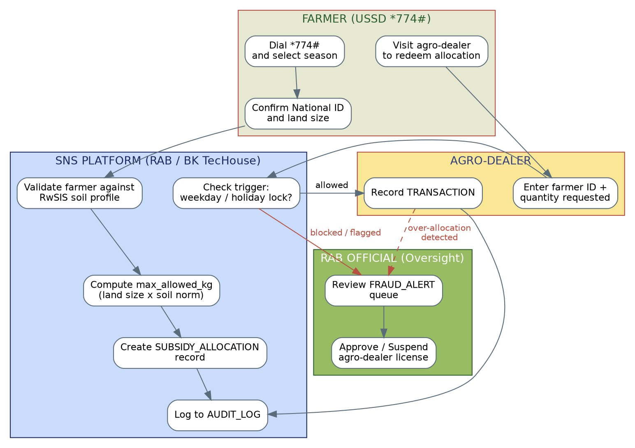

2.4 One-Page Explanation
The workflow begins when a farmer dials *774# and selects a season (F1-F2). The SNS platform validates the request against the farmer's RwSIS soil profile and computes a soil-specific ceiling (max allowed kilograms = land size x RwSIS max kg/hectare for the crop grown in that sector) before creating a SUBSIDY_ALLOCATION record (S1-S3). When the farmer later visits an agro-dealer to redeem the allocation (F3), the dealer enters the farmer's ID and the requested quantity (D1). Before any change is committed, the platform checks the weekday/public-holiday DML lock and the remaining allocation ceiling (S4); requests that pass are recorded as a TRANSACTION (D2) and logged to AUDIT_LOG (S5). Requests that fail - because a dealer is suspended, the ceiling is exceeded, or a USSD reference has already been used - are rejected, written to FRAUD_ALERT, and routed to an RAB official for review (R1), who may suspend or revoke the offending dealer's license (R2). This closed loop ensures that every redemption is both soil-aware and fraud-checked before it reaches the farmer.

3. Phase III - Logical Database Design

3.1 Entity-Relationship Diagram
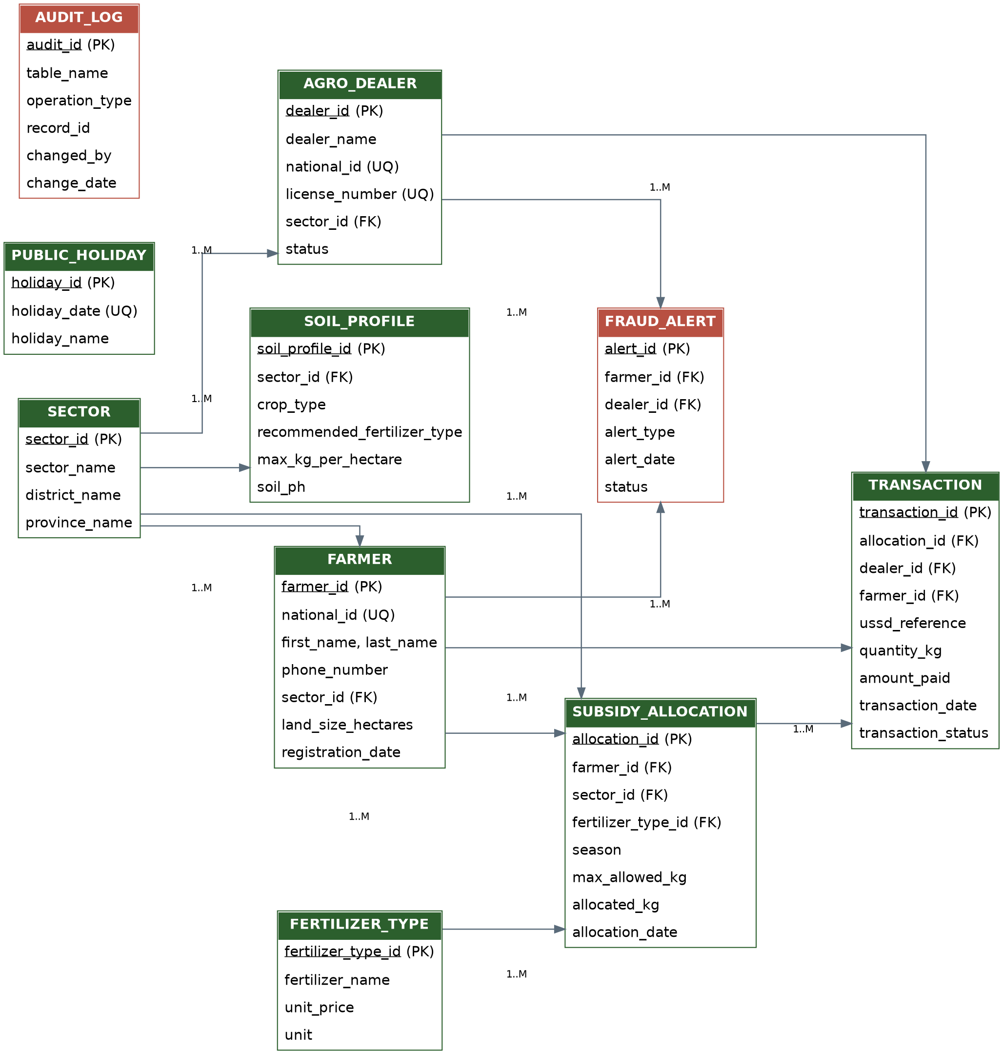

3.2 Entities, Keys and Relationships
Entity | Primary Key | Key Foreign Keys | Relationship
SECTOR | sector_id | - | 1 sector : M farmers, dealers, soil profiles
SOIL_PROFILE | soil_profile_id | sector_id | M profiles : 1 sector
FERTILIZER_TYPE | fertilizer_type_id | - | 1 type : M allocations
FARMER | farmer_id | sector_id | 1 farmer : M allocations, transactions
AGRO_DEALER | dealer_id | sector_id | 1 dealer : M transactions, alerts
PUBLIC_HOLIDAY | holiday_id | - | reference table for the DML-lock trigger
SUBSIDY_ALLOCATION | allocation_id | farmer_id, sector_id, fertilizer_type_id | 1 allocation : M transactions
SNS_TRANSACTION | transaction_id | allocation_id, dealer_id, farmer_id | M transactions : 1 allocation
FRAUD_ALERT | alert_id | farmer_id, dealer_id | raised by triggers/packages
AUDIT_LOG | audit_id | - | generic audit trail, all tables

3.3 Normalization to 3NF
1NF: every attribute holds a single atomic value (e.g. first_name and last_name are split instead of one combined name field; no repeating groups exist in any table).
2NF: all non-key attributes are fully dependent on the whole primary key. Since every table uses a single-column surrogate key (e.g. allocation_id), no partial-dependency case can arise.
3NF: transitive dependencies were removed by extracting SOIL_PROFILE, SECTOR and FERTILIZER_TYPE into their own tables rather than repeating district, province or soil-norm data inside FARMER or SUBSIDY_ALLOCATION. For example, max_kg_per_hectare depends on the sector and crop, not on any given farmer, so it lives in SOIL_PROFILE and is looked up, not duplicated.

4. Phase IV - Database Creation
Script: sql/01_schema_ddl.sql. Creates the Oracle user/schema following the StudentID_FirstName_Project_DB naming convention, grants CONNECT, RESOURCE and the DDL privileges needed to build tables, sequences, procedures and triggers, and allocates an unlimited quota on the USERS tablespace. Take an Oracle Enterprise Manager (OEM) screenshot of the created user/session for the GitHub submission where available.

5. Phase V - Table Implementation
Script: sql/01_schema_ddl.sql (tables) and sql/02_sample_data.sql (sample data). Ten tables are created in dependency order with primary keys, foreign keys, NOT NULL, UNIQUE and CHECK constraints - for example, subsidy_allocation.allocated_kg is constrained to sit between 0 and max_allowed_kg at all times, and farmer.national_id is both UNIQUE and length-checked. Sample data covers four sectors across two RwSIS soil zones (potato - Musanze, maize - Nyagatare), three fertilizer types, five farmers, two agro-dealers and a 2026 public-holiday calendar.

6. Phase VI - PL/SQL Programming
Script: sql/03_plsql_programs.sql.
- fn_calc_max_allocation - function computing the soil-specific ceiling for a farmer/fertilizer pair.
- sp_create_allocation - parameterized procedure that opens a season allocation using the function above.
- pkg_sns_subsidy - package grouping record_transaction (procedure), fn_dealer_fraud_score (function with an explicit cursor and a PL/SQL associative-array aggregation), and detect_ghost_transactions (cursor loop over all active dealers).
- Exception handling - custom exceptions (e_over_allocation, e_dealer_suspended, e_duplicate_ussd), NO_DATA_FOUND, DUP_VAL_ON_INDEX and an OTHERS handler, each translated via RAISE_APPLICATION_ERROR.
- Transaction control - explicit COMMIT after successful writes and ROLLBACK inside every exception branch so partial fraud attempts never persist.

7. Phase VII - Advanced Database Programming
Script: sql/04_triggers_audit_security.sql.
- trg_farmer_audit - simple row-level trigger logging INSERT/UPDATE/DELETE on FARMER to AUDIT_LOG.
- trg_dealer_status_check - simple trigger blocking a REVOKED dealer from silent reactivation.
- trg_transaction_compound - compound trigger (BEFORE STATEMENT, AFTER EACH ROW, AFTER STATEMENT) recording row-level detail plus one statement-level summary per batch of redemptions.
- trg_allocation_dml_lock - the required business rule: blocks INSERT, UPDATE and DELETE on SUBSIDY_ALLOCATION on weekdays (Monday-Friday) and on any date listed in PUBLIC_HOLIDAY, logging every blocked attempt to AUDIT_LOG before rejecting it.
- trg_sns_logon_audit - AFTER LOGON ON SCHEMA trigger for user activity tracking.
- sns_auditor_role - a read-only role restricted to AUDIT_LOG, FRAUD_ALERT and SNS_TRANSACTION for security control.

8. Phase VIII - Documentation & Presentation

8.1 GitHub Repository Structure
- /docs - this report, problem statement, ERD and swimlane images
- /sql - 01_schema_ddl.sql, 02_sample_data.sql
- /plsql - 03_plsql_programs.sql, 04_triggers_audit_security.sql
- /screenshots - OEM, SQL*Plus / SQL Developer execution evidence
- /slides - Phase1_Problem_Statement.pptx, Phase8_Final_Presentation.pptx

8.2 Presentations Delivered
- Phase1_Problem_Statement.pptx - 3 slides, Helvetica, per the Phase I brief.
- Phase8_Final_Presentation.pptx - 10 slides covering Introduction, Problem, Methodology, Database Design, Implementation, Results and Conclusion.

9. Innovation Component (8 Marks)
Recommended innovation: a Power BI dashboard connected to the Oracle schema via the Oracle ODBC/OLE DB driver, refreshing from AUDIT_LOG, FRAUD_ALERT and SUBSIDY_ALLOCATION. Suggested visuals:
- A map of sectors coloured by open FRAUD_ALERT count.
- A trend line of blocked DML attempts (trg_allocation_dml_lock) over time.
- A dealer leaderboard sorted by fn_dealer_fraud_score to prioritise RAB inspections.
- A soil-ceiling utilisation gauge per sector (allocated_kg / max_allowed_kg).
Oracle APEX is a viable alternative if Power BI licensing is unavailable: the same queries can back an APEX interactive report and a card-style fraud-alert dashboard.

10. Marking-Scheme Self-Checklist
Component | Marks | Where addressed
Problem definition & analysis | 3 | Section 1
Business process modeling | 3 | Section 2
ERD & normalization (3NF) | 4 | Section 3
Table creation & constraints | 6 | sql/01_schema_ddl.sql
SQL operations (DML & DDL) | 4 | sql/01, 02
PL/SQL (procedures, functions, packages) | 4 | sql/03_plsql_programs.sql
Triggers & exception handling | 3 | sql/03, sql/04
Auditing & security implementation | 2 | sql/04_triggers_audit_security.sql
Documentation & GitHub | 2 | Section 8, this report
Innovation | 8 | Section 9

