Lab Assignment – 2

***Android Application for currency converter using API***

* The application consists of two screens namely main and home screen for login and currency converter.
* For login, user will enter the information. The credentials are:

Username: arch

Password: architha

* The home screen helps to convert European Euros to Indian INR.
* When Euros are entered in the field and convert button is pressed then equivalent amount of money in Euros is expressed in Indian rupees.
* User can get out of the application using LOGOUT.

***Screenshots***

* Login Screen – After opening the app

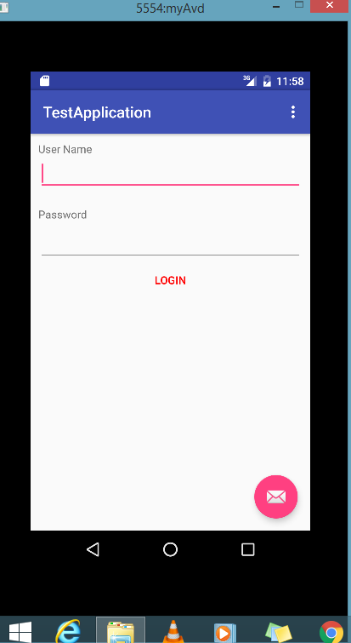

Login Screen – If the credentials are blank or invalid

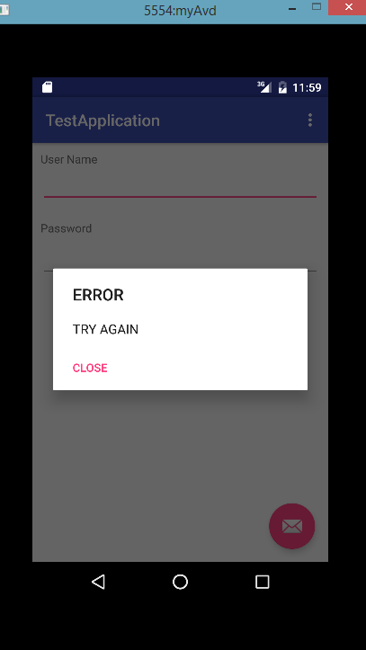

* Home Screen – After entering Euros and entering convert button.

