LIST

In the original folder:

RainfallinfiltrationTutorial, I tried add components and intimate RainfallinfiltrationTutorialFinal.

I could export files to reiverflow2D, but there are several errors.

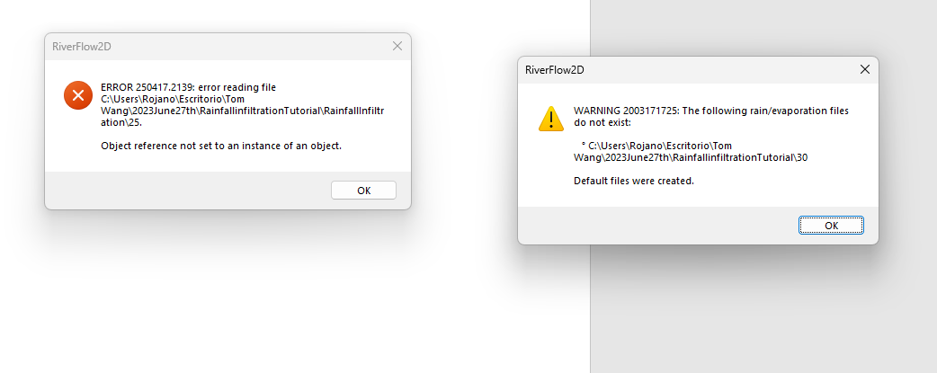

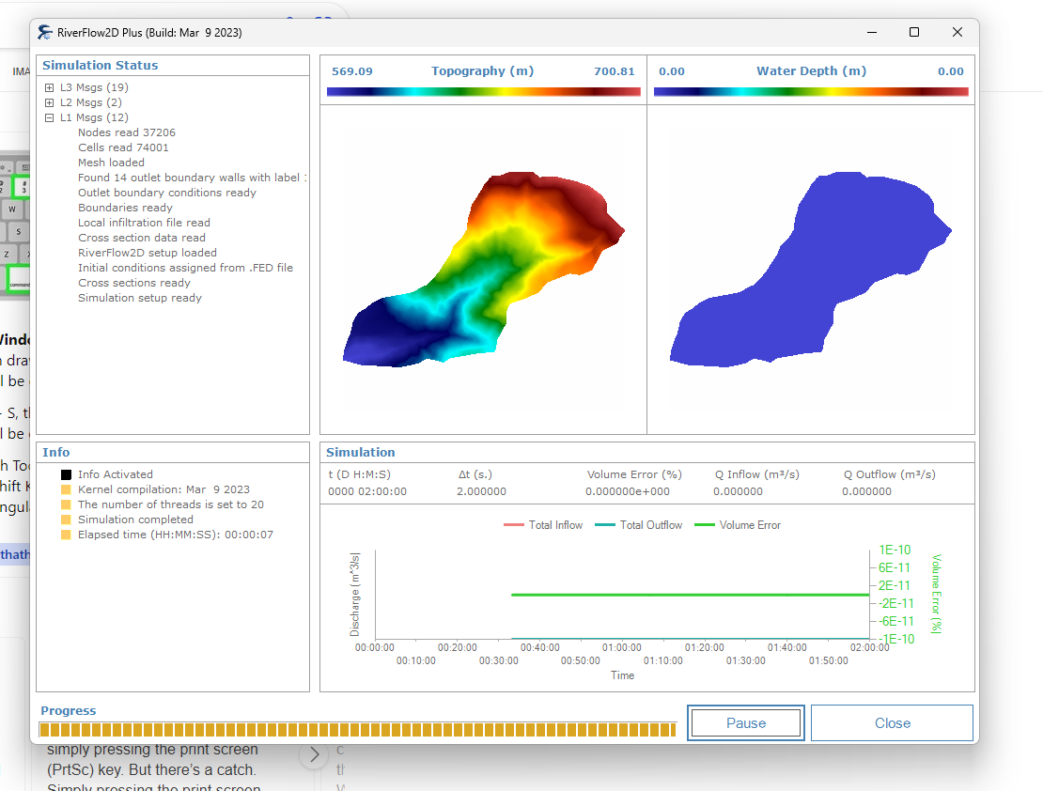

Even though I could start the simulation, I could not start get the similar good result from RainfallinfiltrationTutorialFinal.

See the screenshot for RainfallinfiltrationTutorialFinal below:

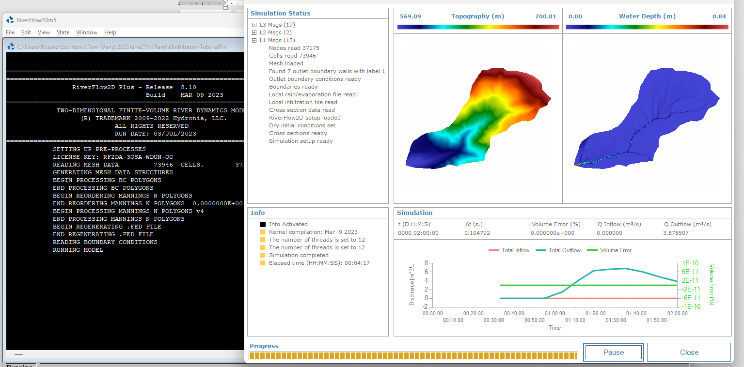

I only added COMPONENTS RainEvap and Infiltration manually. I think I missed somethings. But I failed to find them. The only thing I am doing is to try to compare differences of files between RainfallinfiltrationTutorialFinal and RainfallinfiltrationTutorial.