

**EGERTON UNIVERSITY NJORO CAMPUS**

**COMPUTER SCIENCE DEPT**

**TEAMWORK PROJECT**

**UNIT CODE: COMP 309**

**PROJECT NAME: MA3TICKET BOOKING SYSTEM**

**SYSTEM DOCUMENTATION**

**TEAM MEMBERS**

**Crescent Musyoki s13/20720/13**

**Michael Mukolwe s13/20829/12**

**Ethredah Chao**

**Mary**

**Steven Kitavi**

**TABLE OF CONTENTS**

**CHAPTER ONE**

1. 0 Introduction……………………………………………………………………………….5

1.1Purpose………………………………………………………………………………..…...5

1.2Scope……………………………………………………………………………………….5

1.3References………………………………………………………………………….……...5

**CHAPTER TWO**

2. 0 Overall description……………………………………………………………………..…6

2.1Product Perspective…………………………………………………………………..……6

2.2 Product Function……………………………………………………………………..……6

2.3 User characteristics………………………………………………………….…………….7

2.4 Constraints………………………………………………………………………………...7

2.5 Assumptions and dependencies…………………………………………………………...7

**CHAPTER THREE**

3.0 System features……………………………………………………………………………8

3.1 Database Design………………………………………………………….………………..8

3.0.1Admin…………………………………………………………………………………….8

3.0.2 Secure admin Login …………………………………………………………………… .8

3.0.3 Add administrator………………………………………………………………………..8

3.0.4 Approve/delete posts……………………………………………………………………9

3.0.5 User……………………………………………………………………………………...9

3.0.6 Report found item……………………………………………………………………….9

3.0.7 Search item……………………………………………………………………………...10

3.0.8 Functional Requirements……………………………………………………………….10

3.1 Database Design………………………………………………………………………….11

**CHAPTER FOUR**

4.0 External Interface Requirements………………………………………………………….15

4.0.1 User Interfaces………………………………………………….……………….15

4.0.1 Hardware Interfaces………………………………….………………………….18

4.0.1 Software Interfaces………..…………………………………………………….18

4.1 Communication Interfaces .……………………………………………………………….18

**CHAPTER FIVE**

5.0Requirements……………………………………………………………………………...19

5.1 Functional Requirements……………………………………………………………….…19

Table 1: Use Case- Report Item......................................................................….............19

Table 3 Use Case- search document..………………………………………………....21

Table 4: Use Case- Login……………………………………………………………..23

Table 5: Use Case- Add admin…………………………………………………….…24

Table 6: Use Case- Approve posts……………………………………………………25

Table 7: Use Case- Log out…………………………………………………………...26

5.1.1 Use case diagram……………………………………………………………………27

5.1.2Admin Activity Diagram ……………………………………………………………28

5.1.3Client Activity Diagram …………………………………………………………….29

5.1.4Add admin Sequence Diagram …………………………………………………...…30

5.1.5Approve posts Sequence Diagram ………………………………………………….31

5.1.6Delete Posts Sequence Diagram …………………………………………………….32

5.1.7Search Lost Item Sequence Diagram ……………………………………………….33

5.2 Non-functional requirements……………………………………………………………...34

5.2.1 Performance requirement……………………………………………….34

5.2.2 Software requirement…………………………………………………...34

5.2.3 Security requirement……………………………………………………34

**CHAPTER ONE**

# 1.0 INTODUCTION

## 1.1 Purpose

This document contains a detailed definition of all the requirements for the Ma3ticket booking system. It is defined after completion of the collecting process of all the necessary requirements in order to start the implementation process. The requirements are presented using textual descriptions to explain concepts, various diagrams to illustrate the complicated interactions and tables to relate relevant information.

The intended audiences of this document are the team members and the supervisor. The team members should use the document during the implementation processes, while adding the features of the system and the system should work according to this document. The requirements can change as requested by the supervisor and any changes should be reflected in the document.

## 1.2 Scope

This document describes all the requirements for the project and the constraints that the team is likely to face during the implementation process. The proposed system “Ma3ticket booking System” will be of paramount importance to all Kenyans. The clients can be able to locate and find the nearest Bus Station and schedule time of the Buses to any location they choose, also compare the prices offered by the Bus Operators. This will save the clients a great deal of time in going to the station asks for scheduled bus, when they leave and the booing process is easy and simple.

## 1.3 References

1. Individual Bus Booking system of the Operators.

2.

3.

**CHAPTER TWO**

**2.0 Overall description**

This section will give an overview of the whole system. The system will be explained in its context to show how the system interacts with other systems and introduce the basic functionality of it. It will also describe what type of stakeholders that will use the system and what functionality is available for each type. And lastly, the constraints and assumptions for the system will be presented.

**2.1 Product perspective**

The system is a web search portal where users can search for scheduled bus, by date and time and be able to choose which operator they are willing to use. System provides opportunity for all the bus operators to have a single platform where they can be easily reached. The Bus Operators will be able to create their accounts, where they can add their schedules, edit the schedules if any changes are to be made, confirm tickets booked singly or group booking.

The portal will provide a user with a page where he or she can type in their Origin and Destination and Date of Travel and system will search for the available Bus Operator meeting those criteria, where they can now select from there which Bus Operator they are willing to travel with and book a ticket with them.

Also system offers Group Booking, where organizations can book for a Bus for trips and special events. And there booking will be broadcasted to the available Bus Operators which will confirm with the Group on the prices and other details. System offers introduction of the parties.

**2.2 Product functions**

With the web portal, users will be able to do fast booking process with no hustle of going to the actual Station, plus they can make choice of which operator to use cause of price range and time the operators will be offering in their schedules.

The web portal also provides individual Bus Operators access to the wide online market that’s available and easy to tap.

**2.3 User characteristics**

There are two types of users that interact with the system: Customers / Users of the web portal, and Administrators, this case the Bus Operators. Each of these two types of users has different use of the system so each of them has their own requirements.

The web portal users can only use the application to search for scheduled Bus. Meaning that the user doesn’t have to have an account they only search, select Bus, give details required and book their ticket.

The system administrators will use the portal to manage the information about their company, enter schedules, edit the schedules, and confirm booking seats, delete bookings, and confirm group booking. So they will create an account by which they can log in to operate.

**2.4 Constraints**

The Internet connection is a constraint for the system. Since the application web based system, it is crucial that there is an Internet connection for the system to work.

**2.5 Assumptions and dependencies**

One assumption about the system is that users who are using the system to book for services are genuinely booking and they will show up to use/ travel using the Bus Operator.

**CHAPTER THREE**

**3.0. System Features**

In this subsection we will examine the features of the system in detail by categorizing them according to their functionality. For each of the feature, we will give a description and a stimulus/response sequence. Description part will give basic background information about the feature. After that, we will show flow of events in stimulus/response subsection.

**3.0.1Admin/Operator**

**3.0.2 Secure admin Login**

Each administrator must log in to the server to in order to do Edit their Company Page and do all the operations. To create account they have to enter their valid credentials, plus small something about themselves where they are located, Stations, services they provide.

There is a login page so that admin can type into their login information, and login to the system. Login information is email and password specified in registration process. Server let through the user if the given email and password are matched with the ones in database saved in registration. If specified information is not matched, an error dialog will be shown. Otherwise, admin will be redirected to manage posts interface.

*Normal Flow of Events*

1. Operator loads the login page
2. Operator Signs up, if already signed up tries to log in with their credentials.
3. System validates the specified information
4. Operator is logged in and directed to their Load page

*Alternative Event Flow*

1. User cannot logged into the system due to incorrect credentials

## 3.0.3 Add Schedule

After a successful login, the admin will add their Bus schedules as shown in the following flow of events.

*Normal Flow of Events*

1. Operator clicks add Operation.

2. Operator supplies the requested information about the schedule

3. System saves the specified information

4. New schedule operation is added.

## 3.0.4 Edit/Delete Schedule

After a successful login, the admin will be able to edit their Bus schedules as shown in the following flow of events.

Also admin can delete schedule if canceled.

*Normal Flow of Events*

1. Operator clicks view Operation.

2. All available operations displayed

3. Operator selects the operations and edit/delete, saves changes.

4. The schedules are saved in system.

## 3.0.5 Approve/delete Booking

*Normal Flow of Events*

1. Admin selects a schedule Date to view Bookings

2. Admin selects multiple bookings

3. Admin clicks approve button to approve the selected booking

*Alternative Event Flow*

4. Admin clicks delete button to delete the selected booking.

**3.0.6 User/Client**

The system User/ Client/ Customer for travel has only access to the search page which is the system homepage where they can search for the schedule bus, then from the choices given make a choice of Bus to travel with. Fill in their details that are required for the ticket and confirmation of the user when they come to alight the Bus due date.

*Normal Flow of Events*

1. User loads home page

2. User enters the search criteria details

3. User clicks the search button

4. User selects Bus Operator they want from a list.

5. User fills in their details

6. Users clicks the book button

7. System saves the data in database and sends notification to Bus Operator.

*Alternative Event Flow*

8. System display nothing on the search no available Buses

**3.0.7 Functional Requirements**

**REQ 1:** The system shall provide an admin login page

**REQ 2:** The system shall provide a registration page to add operator

**REQ 3:** The system shall provide a Bus operator home page

**REQ 4:** The system shall provide a add schedule page

**REQ 5:** The system shall provide an edit schedule page

**REQ 6:** The system shall provide search form

**REQ 7:** The system shall provide a display for schedules found details

**REQ 8:** The system shall user details input form

**3.1 Database Design**

**1. admin**

|  |  |
| --- | --- |
| Id | int |
| FirstName | Varchar(50) |
| LastName | Varchar(50) |
| Username | Varchar(50) |
| Password | Varchar(50) |
| Primary Key | id |

**2. atms**

|  |  |
| --- | --- |
| a_id | int |
| acc_name | Varchar(255) |
| acc_number | Varchar(100) |
| bank | Varchar(255) |
| status | tinyint |
| date | date |
| description | text |
| Primary key | a_id |

**3. certificate**

|  |  |
| --- | --- |
| c_id | int |
| serialNo | Varchar(50) |
| institution | Varchar(255) |
| indexNo | Varchar(50) |
| reg_number | Varchar(50) |
| exam_yr | Char(4) |
| fname | Varchar(100) |
| lname | Varchar(100) |
| otherName | Varchar(100) |
| date | Date |
| status | tinyint |
| description | text |
| Primary key | C_id |

**4. contactdet**

|  |  |
| --- | --- |
| id | int |
| name | Varchar(255) |
| phone | Varchar(50) |
| email | Varchar(100) |
| otherDetails | text |
| date | date |
| Primary key | id |

**5. driving_license**

|  |  |
| --- | --- |
| d_id | int |
| surname | Varchar(100) |
| otherName | Varchar(100) |
| address | Varchar(255) |
| number | Varchar(50) |
| status | tinyint |
| date | date |
| description | text |
| Primary key | d_id |

**6. identification**

|  |  |
| --- | --- |
| iid | int |
| number | Varchar(20) |
| serial | Varchar(50) |
| fname | Varchar(100) |
| lname | Varchar(100) |
| Other_name | Varchar(100) |
| description | text |
| status | tinyint |
| date | date |
| type | Varchar(50) |
| Primary key | Iid |
|  |  |

**7. other_item**

|  |  |
| --- | --- |
| id | int |
| type | Varchar(255) |
| date | date |
| description | text |
| status | tinyint |
| Primary key | id |

**8. title_deed**

|  |  |
| --- | --- |
| tid | int |
| plotNo | Varchar(255) |
| fname | Varchar(100) |
| lname | Varchar(100) |
| other_name | Varchar(100) |
| serialNo | Varchar(50) |
| status | tinyint |
| date | date |
| description | text |
| Primar key | tid |

**9. link**

|  |  |
| --- | --- |
| id | int |
| item_id | int |
| contact_id | int |
| table_name | Varchar(100) |
| Primary key | id |

**CHAPTER FOUR**

**4.0 External Interface Requirements**

**4.0.1 User Interfaces**

This system has quite a number of user interfaces, which include home page, interface for displaying in Bus schedules found, Operator login, Operator sign up and operator edit page for details, schedules etc... Other parts include Help, Terms & Conditions, and Contact page. Home page is the landing page where it has the search fields. Here, the search is done by entering the origin, destination and the date of travel then search.

*Figure 1: Home page*

The search results will be displayed on next page where the user can select the bus depending on their choices. Here, they can also modify the search as its provided on top and the system will search again.

*Figure 2: search results page*

After selecting they fill in there details that will be used to confirm their identity and also be displayed to the Operator to put on record who traveled. Then clicks reserve seat for successful booking.

*Figure 3: ticket details*

Admin login allows the administrator to provide their login details before being directed to manage posts interface. At this level, the system administrator can approve or delete posts before being made public. This would help very much in avoiding words posted that do not make sense from reaching the public.

*Figure 4: admin login*

Admin signup page where the admin creates account and fiils in their details to be saved in the database. This information is usefull and will be displayed to the customer when they look up the company details.

*Figure 5: admin sign-up*

Admin can add operations/ schedules by filling the details, also edit the details on changes made. On edit they can delete the schedules.

*Figure 6: admin add-schedule/ edit*

Admin can view the details of booking and here can confirm the booking or delete the booking/ reject.

*Figure 7: Manage booking interface.*

**4.0.2 Hardware Interfaces**

Since the application is web based, it does not have any direct hardware interfaces. The connection to the database server is managed by the underlying operating system on the web server.

**4.0.3 Software Interfaces**

Apache, MySQL 5.0 and above and a browser, such as Mozilla Firefox, Window 7, 8 or a Unix based operating system.

**4.1 Communications Interfaces**

The communication between the different parts of the system is important since they depend on each other. In searching for instance, the system takes in the typed word and then searches through all the fields in the database table for the given item. If a match is found, the system returns all the details of items corresponding to the searched word. Upon selecting claim, the system retrieves details of the finder and then displays them for the user. After keying in details for a found item the system stores them in the database and then prompts the finder for their contact details.

**CHAPTER FIVE**

# 5.0 Requirements

This section of the SRS describes the system’s functional and nonfunctional requirements for the Ma3ticket System. This section is intended to be used by the members of the project team that will implement and verify the correct functioning of the system. It contains all the services the system will provide to the users and all the types of the requirements the system will need in order for it to function accordingly.

**5.1 Functional Requirements**

**Use Case Tables**

*Table 1: Use Case- Search and Select schedule*

|  |  |  |
| --- | --- | --- |
| Use-case Number | 1 | |
| Use-case Name | Search Item | |
| Priority | High | |
| Actor | User/ Customer and system | |
| Description | This use case describes how a user searches for scheduled Bus | |
| Precondition | Access to the homepage | |
| Post-condition | If the use case was successful, the actor then proceeds to the next use case | |
| Basic Course of Action | **User Action** | **System Response** |
| Basic course of  Action | 1. The actor is on the home page.  3. The actor enters search criteria  5. The actor clicks search  7.User selects the bus schedule on next page. | 2. The system prompts with search fields.  4. The system then search database using the criteria as filters  6. The system loads the next page with search result displayed |
| Alternate Course of Action | If the actor does not enter any search criteria or wrong criteria entered the page will refresh with a warning. | |

*Table 2: Use Case-Enter Ticket details*

|  |  |  |
| --- | --- | --- |
| Use-case Number | 2 | |
| Use-case Name | Enter Ticket details | |
| Priority | High | |
| Actor | Client and system | |
| Description | This use case describes how the client enters their ticket details | |
| Precondition | The client has selected a scheduled Bus | |
| Post-condition | If the use case is successful, the system redirects the actor to the page confirming success | |
| Basic Course of Action | **User Action** | System Response |
| Basic course of  Action | 1.The actor fills out ticket details form | 2. The system saves the form to database  3. systems loads success page |
|  |  | |

#### Table 3: Use Case – Login Operator

|  |  |  |
| --- | --- | --- |
| Use-case Number | 3 | |
| Use-Case Name | Log in | |
| Priority | High | |
| Actor | System admin/Operator | |
| Description | This use case describes how system administrator logs into the System. | |
| Precondition | Access to the home page | |
| Post-condition | If the use case was successful, the actor is now logged into the system access the admin home page. | |
| Basic course of Action | User Action | System Response |
| 1. The actor is on the home page.   3. The actor enters email and password, Click on Login Button.  6. The actor makes appropriate changes, the actor can either add operations, edit, delete | 1. The system prompts the actor to enter username and Password. 2. The system verifies that all the filled have been filled out and valid. 3. The actor is successfully logged in the system as an administrator and can make appropriate changes.   7. Use case Exit |
| Alternate course of Action | If the user validation is unsuccessful the system prompts the administrator to try logging again | |

#### Table 7: Use Case – Log out

|  |  |  |
| --- | --- | --- |
| Use-Case Number | 4 | |
| Use-Case Name | Log out | |
| Priority | High | |
| Actor | Users and Admin | |
| Description | These use case allow manager and admin to log out from the system at a time of accomplishing their work. | |
| Precondition | Actor should be logged in | |
| Post Condition | System logs out | |
| Basic Course of Action | User Action | System Response |
| 1. The Actor wants to log out and clicks on the logout link. | 1. The system responds to the requested action.   The system displays a message that the Actor has been logged out from the system. |

**5.1.1 Use case diagram**

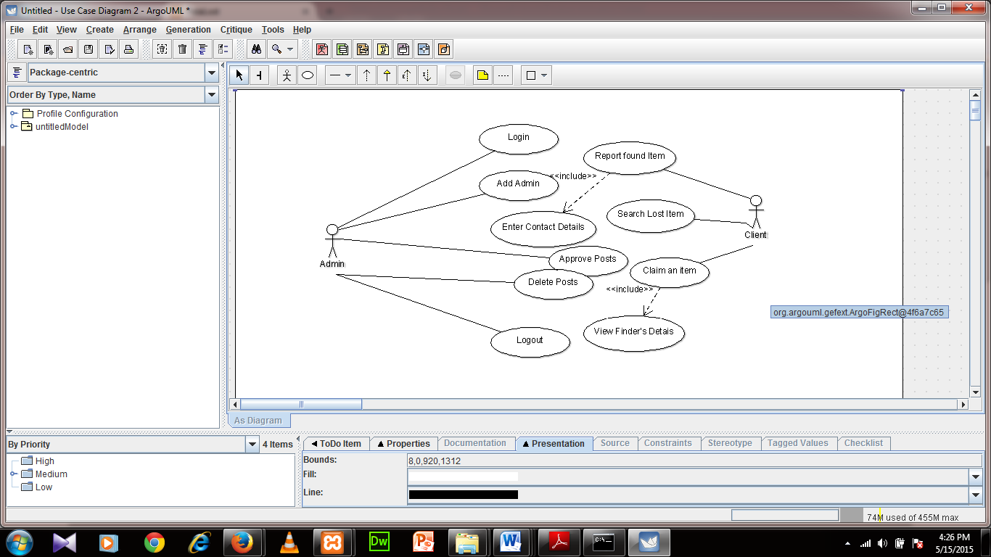

**5.1.2 Admin Activity Diagram**

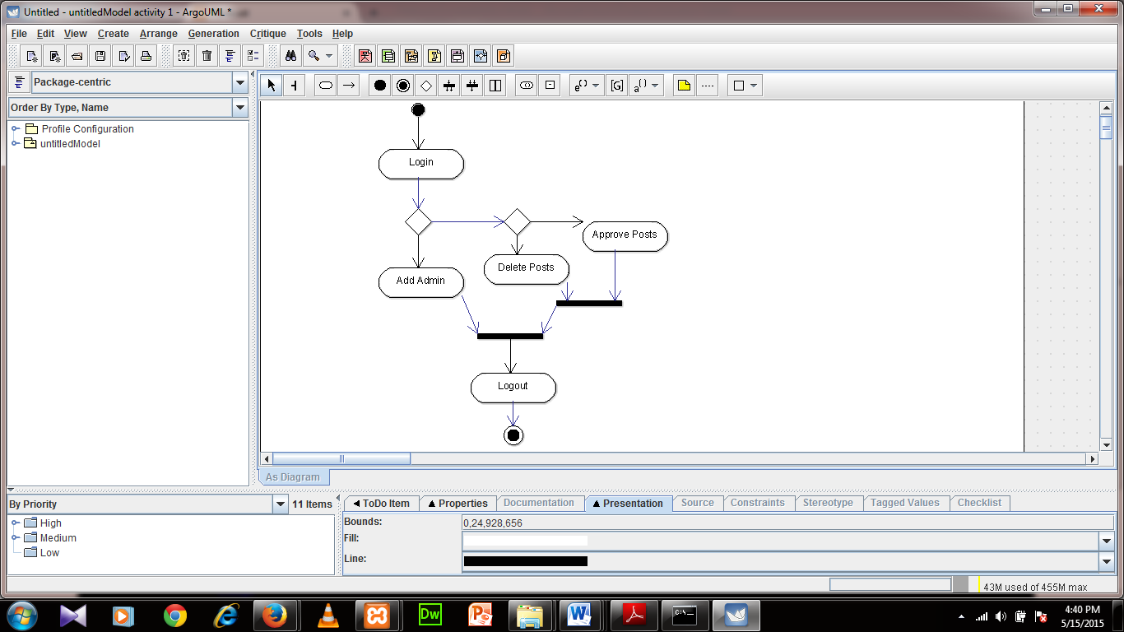

**5.1.3 Client Activity Diagram**

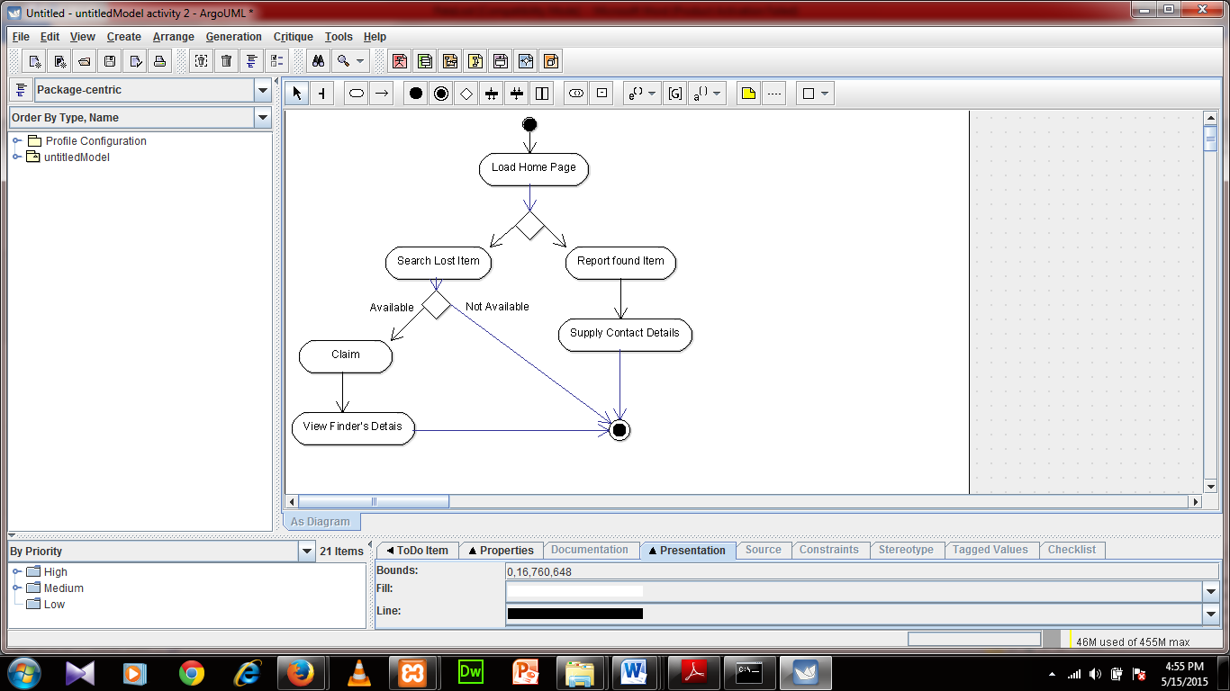

**5.1.4 Add admin Sequence Diagram**

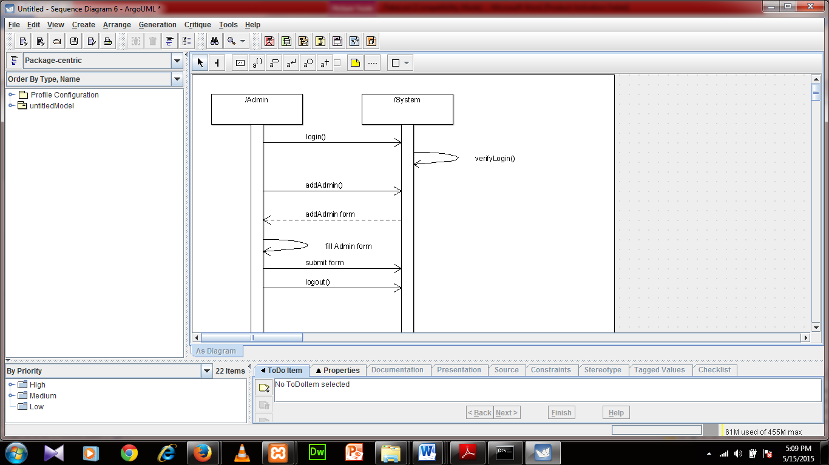

**5.1.5 Approve posts Sequence Diagram**

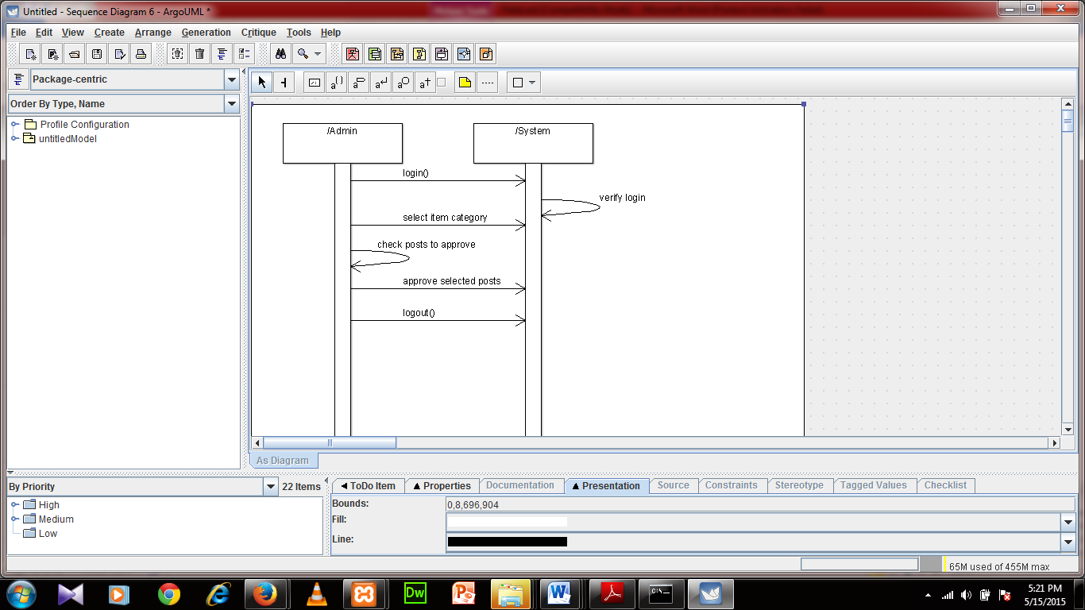

**5.1.6 Delete Posts Sequence Diagram**

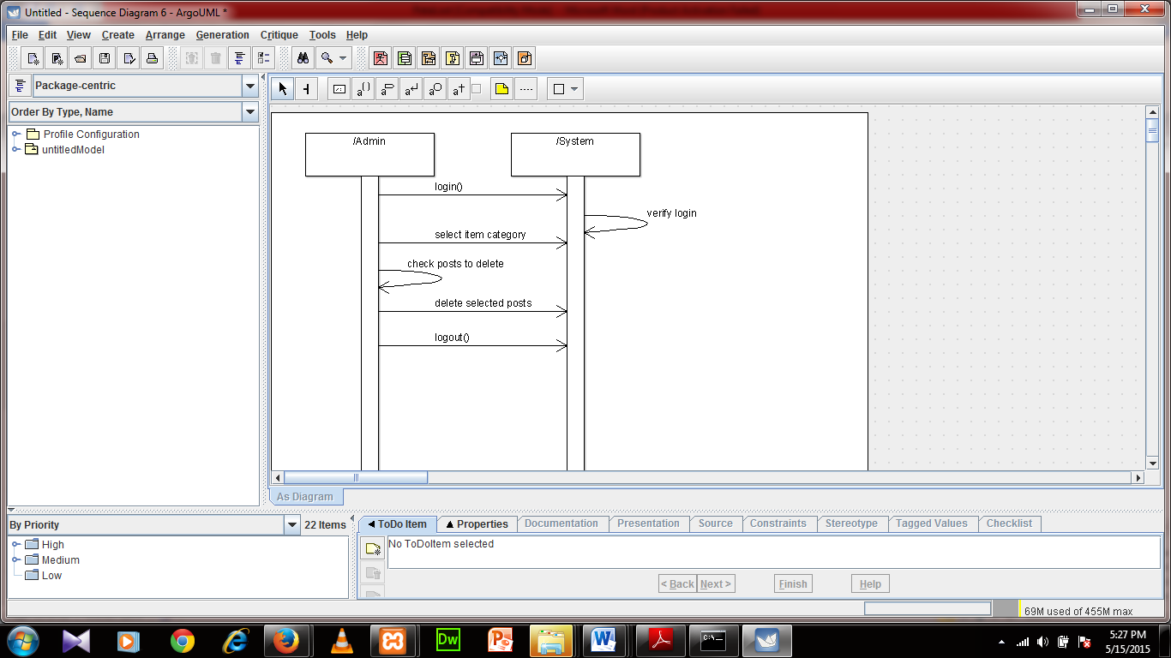

**5.1.7 Search Lost Item Sequence Diagram**

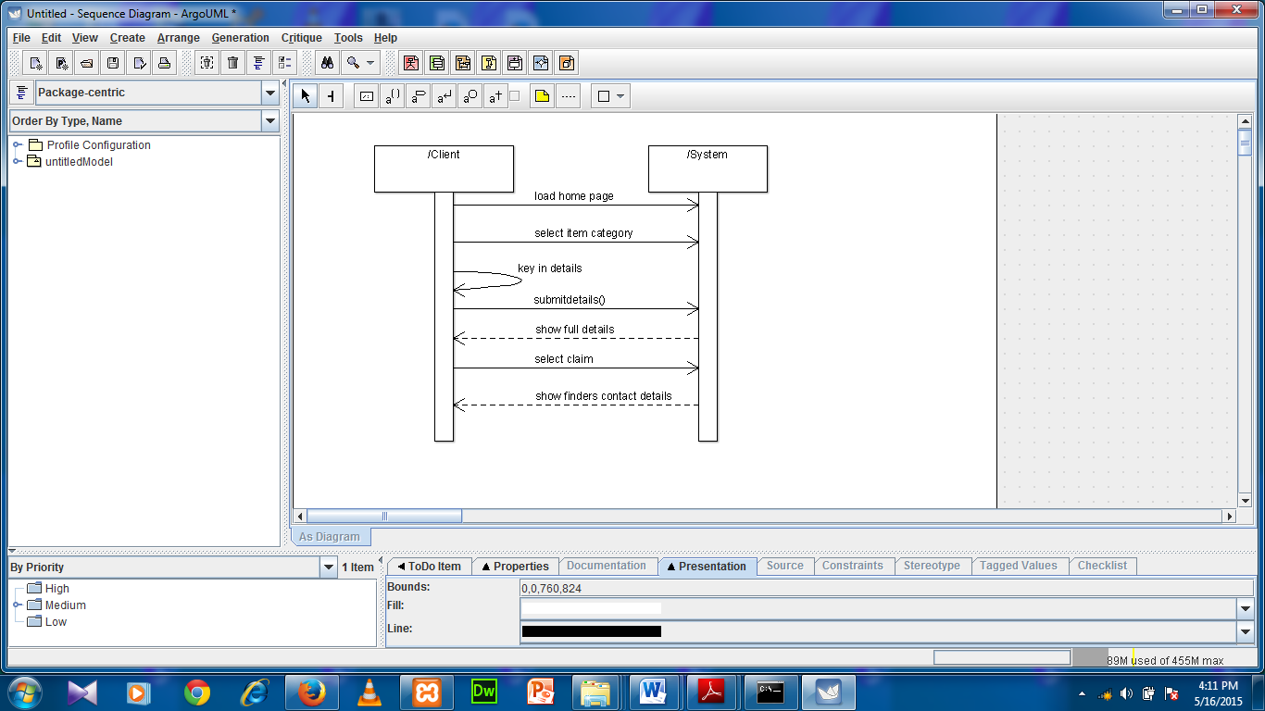

**5.2 Non-functional requirements**

**5.2.1 Performance requirements**

* The system will not take longer than 20 seconds to respond to end user requests.
* The system shall support an unlimited number of users at any given time of the day.
* The system shall display confirmationmessages not longer than 4 seconds after user inputs.
* The system shall be available at all times to the end user depending on the client’s internet connectivity.
* Scalability: the system will increase the total throughput under an increased load when resources are added.

5.2.2 Security Requirements.

* The system shall only permit admin to manage all the posts before they are made available to internet users. This will help filter out some offensive posts.
* The system allows users to view home page and search for their documents without logging in.

### 5.2.3 Software Quality Attributes

* Availability: The Ma3ticket System shall be available to users on the internet at all times enabling those who post found items to post as soon as they find them and losers of documents are able to search at any time.