Answer to the question no- 01

Reliability of Component A (Ra): 0.97
Reliability of Component B (Rb): 0.95
Reliability of Component C (Rc): 0.90
Reliability of Component D (Rd): 0.97
Reliability of Component D (Re): 0.90

R1 = 1 - [1 - Rb] * [1 - Rd] = 1 - [1 - 0.95] * [1 - 0.97] = 1 - 0.0015 = 0.9985
R2 = 1 - [1 - Rc] * [1 - Re] = 1 - [1 - 0.90] * [1 - 0.90] = 1 - 0.0100 = 0.9900

Rs = 0.97 * 0.9985 * 0.99
Rs = 0.9588
FR = 1 - Rs
FR = 1 - 0.9588
FR = 0.0412

System Reliability (Rs) = 95.88%.
Failure Rate (FR) = 4.12%.

Answer to the question no- 02
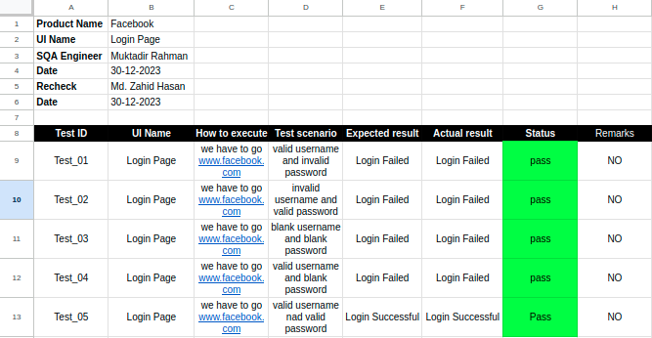

Answer to the question no- 04
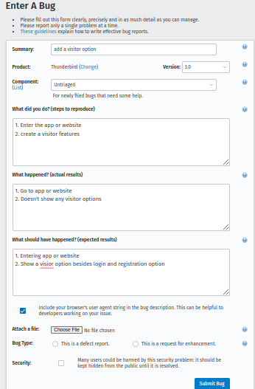

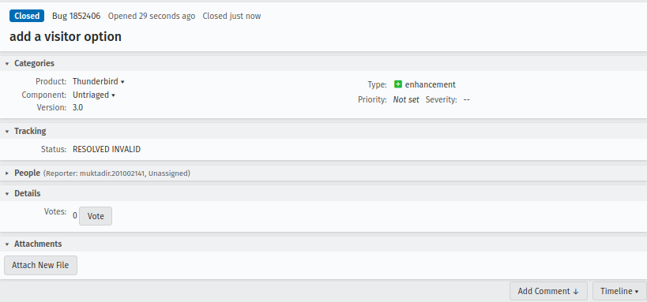
Figure 01: Create a bug

Figure 02: Resolved the bug

