ReproducibleResearchPrj1.R

mukta.mittal

Sun Aug 12 20:51:17 2018

## Load, unzip and read activity file  
setwd("~/R/Work in progress")  
url <- "https://d396qusza40orc.cloudfront.net/repdata%2Fdata%2Factivity.zip"  
destfile <- "step_data.zip"  
download.file(url, destfile)  
unzip(destfile)  
activity <- read.csv("activity.csv", sep = ",")  
  
## Structure of data taking awaya rows with NA steps  
names(activity)

## [1] "steps" "date" "interval"

str(activity)

## 'data.frame': 17568 obs. of 3 variables:  
## $ steps : int NA NA NA NA NA NA NA NA NA NA ...  
## $ date : Factor w/ 61 levels "2012-10-01","2012-10-02",..: 1 1 1 1 1 1 1 1 1 1 ...  
## $ interval: int 0 5 10 15 20 25 30 35 40 45 ...

head(activity[which(!is.na(activity$steps)), ])

## steps date interval  
## 289 0 2012-10-02 0  
## 290 0 2012-10-02 5  
## 291 0 2012-10-02 10  
## 292 0 2012-10-02 15  
## 293 0 2012-10-02 20  
## 294 0 2012-10-02 25

## Mean of "total number of steps taken" over all days  
library(reshape2)  
activity_melt <- melt(activity[which(!is.na(activity$steps)), ], id.vars = c("date", "interval"))  
head(activity_melt)

## date interval variable value  
## 1 2012-10-02 0 steps 0  
## 2 2012-10-02 5 steps 0  
## 3 2012-10-02 10 steps 0  
## 4 2012-10-02 15 steps 0  
## 5 2012-10-02 20 steps 0  
## 6 2012-10-02 25 steps 0

steps_sum <- dcast(activity_melt, date ~ variable, sum)  
head(steps_sum)

## date steps  
## 1 2012-10-02 126  
## 2 2012-10-03 11352  
## 3 2012-10-04 12116  
## 4 2012-10-05 13294  
## 5 2012-10-06 15420  
## 6 2012-10-07 11015

summary(steps_sum$steps) # Summary of data

## Min. 1st Qu. Median Mean 3rd Qu. Max.   
## 41 8841 10765 10766 13294 21194

## Histogram of total number of steps taken sans NA rows. Also, showing  
## mean and median of the data.  
hist(steps_sum$steps, main = "Histogram of total steps taken per day",   
 xlab = "Total steps per day", ylab = "Number of days",   
 breaks = 10, col = "steel blue")  
abline(v = mean(steps_sum$steps), lty = 1, lwd = 2, col = "red")  
abline(v = median(steps_sum$steps), lty = 2, lwd = 2, col = "black")  
legend(x = "topright", c("Mean", "Median"), col = c("red", "black"),   
 lty = c(1, 2), lwd = c(2, 2))

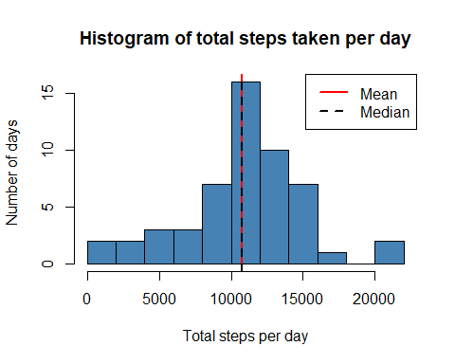

## Average daily activity pattern  
stepsmeaninterval <- dcast(activity_melt, interval ~ variable,   
 mean, na.rm = TRUE)  
head(stepsmeaninterval)

## interval steps  
## 1 0 1.7169811  
## 2 5 0.3396226  
## 3 10 0.1320755  
## 4 15 0.1509434  
## 5 20 0.0754717  
## 6 25 2.0943396

plot(stepsmeaninterval$interval, stepsmeaninterval$steps, ty = "l",  
 xlab = "time interval", ylab = "Average steps",   
 main = "Average steps taken over all days vs \n time interval")

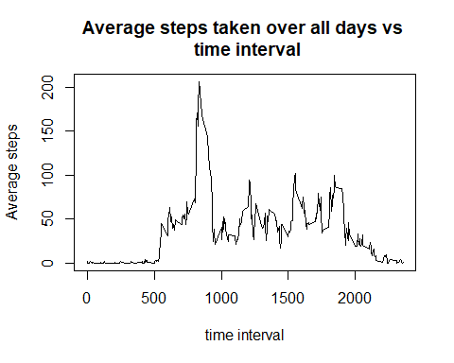

maxsteps_interval <-   
 stepsmeaninterval$interval[which.max(stepsmeaninterval$steps)]  
maxsteps_interval

## [1] 835

## Imputing missing values  
activity2 <- split(activity, activity$interval)  
activity2 <- lapply(activity2, function(x) {  
 x$steps[which(is.na(x$steps))] <- mean(x$steps, na.rm = TRUE)  
 return(x)  
})  
activity2 <- do.call("rbind", activity2)  
row.names(activity2) <- NULL  
  
activity2 <- split(activity2, activity2$date)  
df <- lapply(activity2, function(x) {  
 x$steps[which(is.na(x$steps))] <- mean(x$steps, na.rm = TRUE)  
 return(x)  
})  
activity2 <- do.call("rbind", activity2)  
row.names(activity2) <- NULL  
head(activity2)

## steps date interval  
## 1 1.7169811 2012-10-01 0  
## 2 0.3396226 2012-10-01 5  
## 3 0.1320755 2012-10-01 10  
## 4 0.1509434 2012-10-01 15  
## 5 0.0754717 2012-10-01 20  
## 6 2.0943396 2012-10-01 25

library(reshape2)  
activity_melt2 <- melt(activity2, id.vars = c("date", "interval"))  
steps_sum <- dcast(activity_melt2, date ~ variable, sum, na.rm = TRUE)  
head(steps_sum)

## date steps  
## 1 2012-10-01 10766.19  
## 2 2012-10-02 126.00  
## 3 2012-10-03 11352.00  
## 4 2012-10-04 12116.00  
## 5 2012-10-05 13294.00  
## 6 2012-10-06 15420.00

## Histogram of total number of steps taken with imputed missing values  
hist(steps_sum$steps, main = "Histogram of total steps taken per day",   
 xlab = "Total steps per day", ylab = "Number of days",   
 breaks = 10, col = "steel blue")  
abline(v = mean(steps_sum$steps), lty = 1, lwd = 2, col = "red")  
abline(v = median(steps_sum$steps), lty = 2, lwd = 2, col = "black")  
legend(x = "topright", c("Mean", "Median"), col = c("red", "black"),   
 lty = c(2, 1), lwd = c(2, 2))  
  
## Number of rows with NA values  
sum(is.na(activity$steps))

## [1] 2304

sum(is.na(activity$steps))*100/nrow(activity) # Percentage of rows

## [1] 13.11475

## Differences in activity patterns: Weekdays vs Weekends  
library(lubridate)

##   
## Attaching package: 'lubridate'

## The following object is masked from 'package:base':  
##   
## date

weekends <- which(weekdays(as.Date(activity2$date)) == "Saturday" |  
 weekdays(as.Date(activity2$date)) == "Sunday")  
weekdays <- which(weekdays(as.Date(activity2$date)) != "Saturday" &  
 weekdays(as.Date(activity2$date)) != "Sunday")  
temp <- c(rep("a", length(activity2)))  
temp[weekends] <- "weekend"  
temp[weekdays] <- "weekday"  
length(temp)

## [1] 17568

activity2 <- cbind(activity2, temp)  
head(activity2)

## steps date interval temp  
## 1 1.7169811 2012-10-01 0 weekday  
## 2 0.3396226 2012-10-01 5 weekday  
## 3 0.1320755 2012-10-01 10 weekday  
## 4 0.1509434 2012-10-01 15 weekday  
## 5 0.0754717 2012-10-01 20 weekday  
## 6 2.0943396 2012-10-01 25 weekday

names(activity2)[4] <- "day"  
  
activity2split <- split(activity2, activity2$day)  
stepsmean_interval <- lapply(activity2split, function(x) {  
 temp <- aggregate(x$steps, list(x$interval), mean)  
 names(temp) <- c("interval", "steps")  
 return(temp)  
})  
  
## Unsplit stepsmean_interval  
stepsmean_interval <- do.call("rbind", stepsmean_interval)  
weekdays <- grep("weekday" ,row.names(stepsmean_interval))  
weekends <- grep("weekend" ,row.names(stepsmean_interval))  
temp <- c(rep("a", length(stepsmean_interval$steps)))  
temp[weekdays] <- "weekdays"  
temp[weekends] <- "weekends"  
names(temp) <- "day"  
stepsmean_interval <- cbind(stepsmean_interval, temp)  
row.names(stepsmean_interval) <- NULL  
  
head(stepsmean_interval)

## interval steps temp  
## 1 0 2.25115304 weekdays  
## 2 5 0.44528302 weekdays  
## 3 10 0.17316562 weekdays  
## 4 15 0.19790356 weekdays  
## 5 20 0.09895178 weekdays  
## 6 25 1.59035639 weekdays

library(ggplot2)

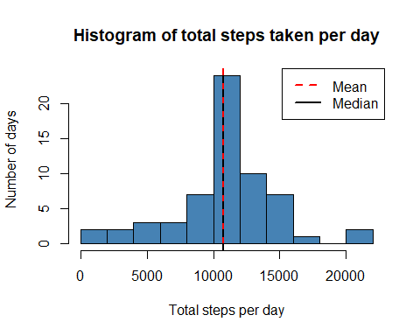

ggplot(stepsmean_interval, aes(interval, steps)) + geom_line() + facet_grid(temp ~ .)

