PENETRATION TESTING REPORT
FOOTPRINTING & RECONNAISSANCE ACTIVITIES
EDUCATIONAL CYBERSECURITY PROJECT
Trainee / Tester | Mujahid Muktar
Programme / Batch | B084
Instructor | Waqas Karim
Project date  13 November 2026 | 13 November 2026
Target supplied | google.com
Environment | Kali Linux
REPORT ISSUE DATE: 13 NOVEMBER 2026 | EVIDENCE COLLECTION: 12 NOVEMBER 2026
Prepared for educational and training documentation

1. Liability Disclaimer & Authorisation
This document records the learning activities and outputs supplied for an educational cybersecurity exercise. The evidence provided shows public-information lookups and basic HTTP/DNS observations only. It does not demonstrate exploitation, vulnerability validation, authenticated testing, or access to Google's internal systems. The materials provided do not include written authorisation from the target owner. Therefore, this report does not claim that Google authorised testing. Any further testing must only be performed within a written, explicitly approved scope and in accordance with the target owner's rules.

2. Introduction
This report documents introductory footprinting and reconnaissance activities performed in a Kali Linux terminal against the domain google.com on 12 November 2026. The exercises used WHOIS, WhatWeb, nslookup, cURL, Wafw00f, DNSRecon, and Nmap (through Zenmap) to observe publicly available registration data, DNS records, web response characteristics, generic WAF-fingerprinting results, and basic host availability. The report is limited to the commands and outputs supplied by the trainee.

2.1 Scope and Limitations
- Target entered in the commands: google.com.
- Activities documented: WHOIS lookup, WhatWeb fingerprinting, DNS resolution with nslookup, HTTP response inspection with cURL, generic WAF detection with Wafw00f, DNS record enumeration with DNSRecon, and a basic Nmap host-discovery scan.
- No exploitation, password attacks, vulnerability exploitation, authenticated testing, or modification of target data is evidenced in the supplied material. The Nmap output shows host discovery only; it does not show a port scan or service/version enumeration.
- The WHOIS and DNS queries are information lookups; the HTTP and WAF tools generated network requests. The supplied material does not establish permission from the target owner.

3. Tools Used
Tool | Purpose
WHOIS | Retrieve publicly available domain-registration and registrar information.
WhatWeb | Identify observable web technologies and response characteristics from a website.
nslookup | Query DNS to resolve a domain name to IPv4 and IPv6 addresses.
cURL (-i) | Request a URL and display the HTTP response headers together with the response body.
Wafw00f | Use generic fingerprinting requests to check whether a web application firewall can be identified.
DNSRecon | Enumerate publicly published DNS records, including SOA, NS, MX, A, AAAA, TXT, DMARC, and SRV records.
Nmap (Zenmap interface) | Perform basic host discovery and report whether the selected target host responds; this run did not enumerate ports.

4. Activities Performed

4.1 WHOIS – Domain Registration Lookup
Command: whois google.com
The WHOIS output identified GOOGLE.COM as the queried domain and MarkMonitor Inc. as the registrar. The record showed a creation date of 15 September 1997, registry expiry date of 14 September 2028, and four Google name servers (NS1.GOOGLE.COM through NS4.GOOGLE.COM). The displayed registrant contact details were redacted for privacy. The WHOIS response also listed several client/server status restrictions and reported DNSSEC as unsigned.
Security relevance: The result provides basic registration and DNS delegation context. Registration data is informational and does not, by itself, indicate a security weakness. The DNSSEC field should be interpreted as the status reported by this WHOIS response at the time of collection.

4.2 WhatWeb – Web Technology Fingerprinting
Command: whatweb google.com
WhatWeb reported HTTP 301 redirects for the bare domain and successful HTTP 200 responses for the www.google.com destinations. The output identified the web server as gws, displayed Google page titles, reported HTML5 and cookie indicators, and listed response IP addresses including 142.250.140.101, 142.250.140.113, 142.251.154.119, and 142.251.151.119.
Security relevance: The observed redirects indicate that the requested hostnames direct browsers to the www host. Technology fingerprinting can help defenders understand the externally visible application surface. The detected indicators are observations, not proof of a vulnerability.

4.3 nslookup – DNS Resolution
Command: nslookup google.com
The query used DNS server 8.8.8.8. The non-authoritative answer returned multiple IPv4 addresses (142.250.129.100, 142.250.129.139, 142.250.129.101, 142.250.129.113, 142.250.129.102, and 142.250.129.138) and IPv6 addresses (2a00:1450:4009:c15::8a, ::65, ::64, and ::8b).
Security relevance: Multiple DNS answers can be used for traffic distribution, resilience, and regional routing. DNS results can vary over time and by resolver location; they should be recorded with the query date and resolver.

4.4 cURL – HTTP Response Header Inspection
Command: curl -i google.com
The response shown was HTTP/1.1 301 Moved Permanently with a Location header pointing to http://www.google.com/. The output also displayed Content-Type, Content-Security-Policy-Report-Only, Date, Expires, Cache-Control, Server: gws, Content-Length, X-XSS-Protection, and X-Frame-Options headers, followed by a short HTML redirect body.
Security relevance: The 301 status indicates a permanent redirect from the requested URL to the Location destination. The Content-Security-Policy-Report-Only header reports policy violations rather than enforcing the policy. Header presence or absence alone is not sufficient to conclude that a site is vulnerable.

4.5 Wafw00f – Generic WAF Fingerprinting
Command: wafw00f google.com
Wafw00f v2.4.2 checked https://google.com and returned: “No WAF detected by the generic detection.” The tool reported that it made seven requests.
Security relevance: This result means that Wafw00f did not identify a WAF using its generic detection method during this run. It does not prove that no WAF, filtering layer, or other protective service exists. Detection can be limited by the tool, its signatures, and the target's configuration.

4.6 DNSRecon – DNS Record Enumeration
Command: dnsrecon -d google.com
DNSRecon completed its general enumeration and reported SOA information for ns1.google.com; four authoritative name servers (ns1 through ns4.google.com); MX records pointing to smtp.google.com; multiple IPv4 (A) and IPv6 (AAAA) addresses; TXT records including domain/service verification entries and an SPF policy; a DMARC record at _dmarc.google.com with policy p=reject; and SRV records for LDAP, CalDAVS, and CardDAVS services. The output also displayed an error stating that there was no answer for its DNSSEC query. The tool ended with “12 Records Found” and “Completed enumeration.” The full verification-token values are intentionally not reproduced in this report.
Security relevance: DNSRecon provides a broader view of publicly published DNS configuration than a basic address lookup. The discovered service records and mail-authentication policies are useful inventory information for an authorised domain owner. The DNSSEC query error is a query outcome, not proof of a DNSSEC vulnerability; it should be checked independently with the domain owner’s approved DNS tooling. Public TXT verification strings should not be treated as passwords or secrets, but need not be copied into a general report.

4.7 Nmap / Zenmap – Basic Host Discovery
Command / scan: Nmap 7.991, launched through the Zenmap graphical interface; target entered: google.com.
Observed output: Nmap reported that google.com resolved to two IP addresses and selected 142.251.208.142 for this scan. The selected host was reported as up. The output also listed the IPv6 address 2a00:1450:4006:821::200e as another address that was not scanned, and gave the reverse-DNS name ncmrsb-ao-in-f14.1e100.net. The scan completed in 0.34 seconds.
Interpretation and limitation: “Host is up” indicates that the selected address responded to Nmap's host-discovery method at the time of the test. This output does not contain an open-port list, service fingerprints, operating-system identification, or vulnerability results. The IPv6 address was not tested. Therefore, this result must not be presented as evidence that the host has no open ports or vulnerabilities.
Security relevance: Basic host discovery is useful for confirming reachability within an approved assessment scope. Any follow-on port or service testing must be explicitly covered by written permission, target-owner rules, and agreed rate limits.

5. Risk Analysis / Impact
The table below records observations from the supplied outputs. These are not confirmed vulnerabilities.
Observation | Evidence | Assessment | Interpretation
WHOIS registration and name-server data visible | Public registration metadata and DNS delegation information were returned. | Low | Expected public information; not a confirmed vulnerability.
Multiple DNS addresses returned | The resolver returned several IPv4 and IPv6 addresses. | Informational | Normal DNS behaviour; no weakness established.
HTTP redirect observed | The bare domain returned HTTP 301 and a Location header. | Informational | Redirect behaviour is not itself a vulnerability.
Security-related headers observed | The response included CSP-Report-Only, X-Frame-Options and X-XSS-Protection fields. | Informational | Header values require context and policy review; no exploitability was tested.
WAF not identified by generic detection | Wafw00f did not detect a WAF in this run. | Unconfirmed | A negative fingerprinting result is not proof that protective controls are absent.
DNS records enumerated | DNSRecon returned SOA, NS, MX, A, AAAA, TXT, DMARC, and SRV information; DNSSEC query returned no answer. | Informational | Useful DNS inventory. The DNSSEC query error alone does not establish a security weakness.
Target host responded to basic discovery | Nmap 7.991 reported host 142.251.208.142 as up; one additional IPv6 address was listed but not scanned. | Informational | Confirms reachability of the selected address at scan time only. No ports, services, or vulnerabilities were assessed.

6. Recommendations
- Keep all further testing within a documented, written authorisation scope that names the exact domains, IP ranges, methods, dates, and rate limits permitted.
- Treat WHOIS, DNS, technology-fingerprinting, and HTTP-header outputs as reconnaissance observations rather than confirmed vulnerabilities.
- For systems owned by the organisation being assessed, review DNS records and registrar security settings periodically.
- Review HTTP response headers against the organisation's intended security policy; validate configuration in an authorised test environment before making changes.
- Do not infer the absence of a WAF from a single Wafw00f result. Confirm protective controls through approved documentation and owner-authorised testing.
- Preserve timestamps, exact commands, tool versions, and unedited evidence screenshots so findings can be reproduced.

7. Conclusion
The exercise introduced core reconnaissance concepts using seven common tools. WHOIS provided registration details; WhatWeb returned visible technology and response indicators; nslookup resolved the domain to multiple IPv4 and IPv6 addresses; cURL displayed an HTTP 301 redirect and response headers; Wafw00f did not identify a WAF through its generic detection method; DNSRecon enumerated SOA, NS, MX, A, AAAA, TXT, DMARC, and SRV records; and Nmap reported that the selected IPv4 host was up. These outputs describe publicly observable behaviour and do not confirm a vulnerability. The work should be treated as an educational reconnaissance record. Any additional testing of google.com requires explicit authorisation from the system owner and compliance with the approved scope.

8. Evidence Collected
The following screenshots were supplied during the exercise. Captions identify the evidence type; the original terminal output remains the source for the exact values transcribed in this report.
WHOIS lookup – google.com
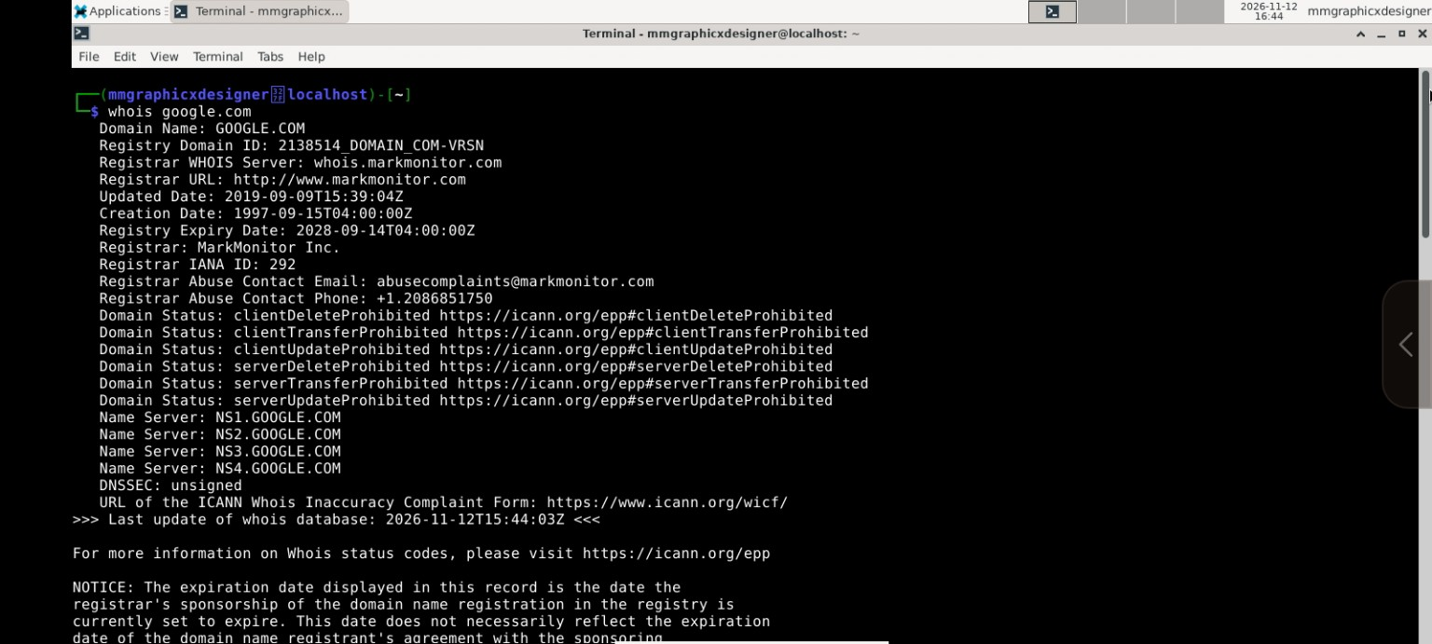

WhatWeb fingerprinting – google.com
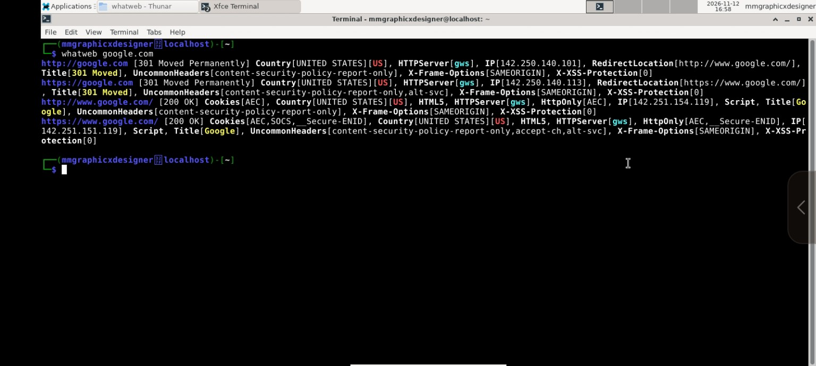

DNS lookup – nslookup google.com
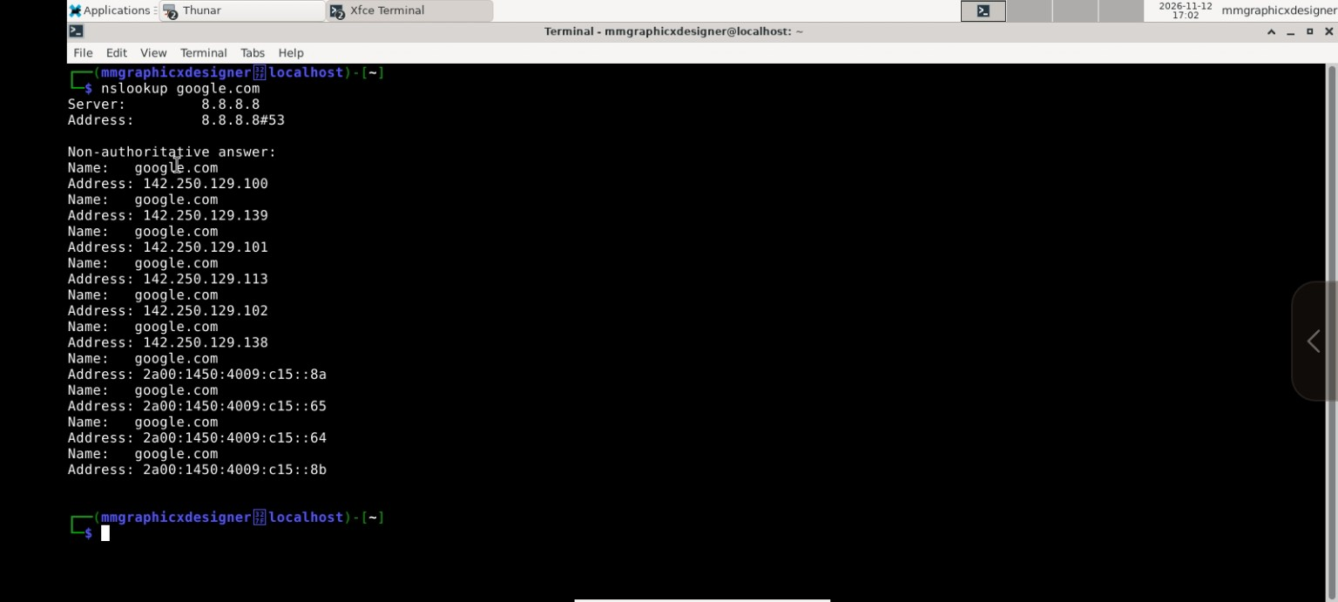

HTTP response inspection – curl -i google.com
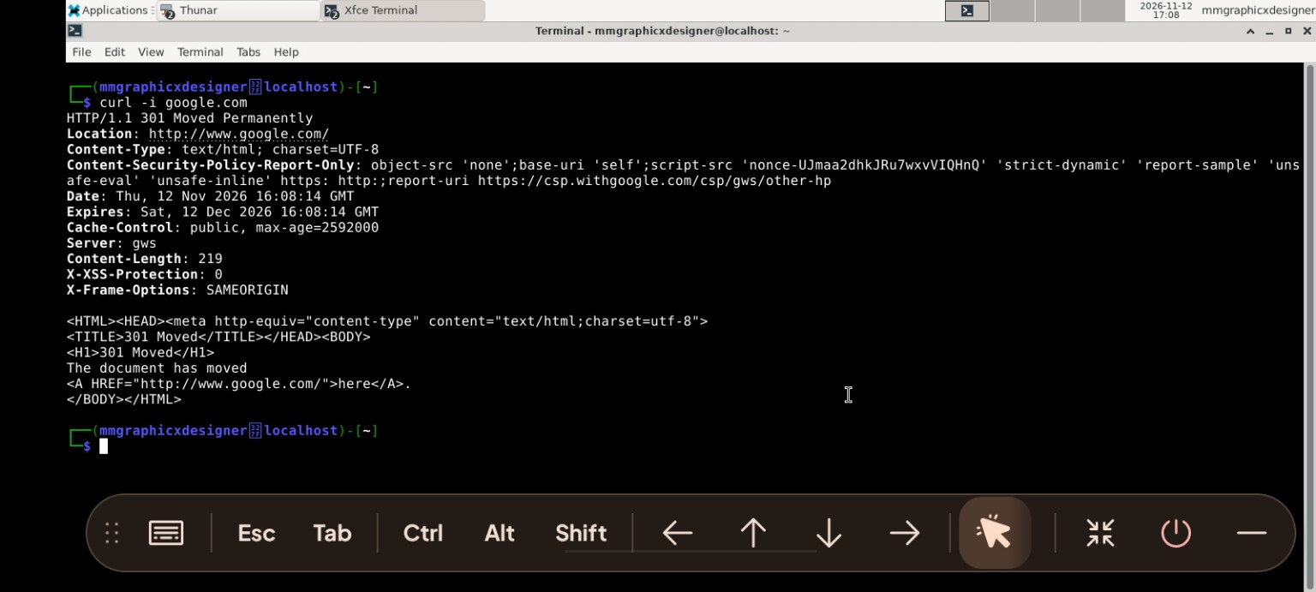

Wafw00f evidence (terminal output transcribed): Wafw00f v2.4.2 checked https://google.com; generic detection reported “No WAF detected by the generic detection”; 7 requests were made. The text output was supplied in the conversation.
DNSRecon output – command and terminal text supplied in the conversation; no separate screenshot was provided.
Nmap / Zenmap evidence (terminal output supplied in the conversation): Nmap 7.991 reported google.com host 142.251.208.142 as up, listed one additional IPv6 address as not scanned, displayed reverse-DNS name ncmrsb-ao-in-f14.1e100.net, and completed in 0.34 seconds. The supplied output is a host-discovery result only.

9. Evidence and Submission Notes
Before submitting, compare this report with the instructor's official assignment brief. The assignment requirements or marking rubric were not included in the materials received. Also attach or reference written authorisation if the instructor expects a real client penetration test. Do not describe this reconnaissance exercise as an authorised penetration test unless that permission has actually been granted.

APPENDIX A — ADDITIONAL SCREENSHOT EVIDENCE
The following original screenshots were supplied on 13 November 2026 for inclusion in this report. The displayed terminal timestamps show that the underlying reconnaissance activities were conducted on 12 November 2026. Screenshots are retained as supporting evidence; interpretation remains limited to the outputs shown and does not establish authorisation or the presence/absence of vulnerabilities.
Figure 9. Wafw00f v2.4.2 generic fingerprinting output
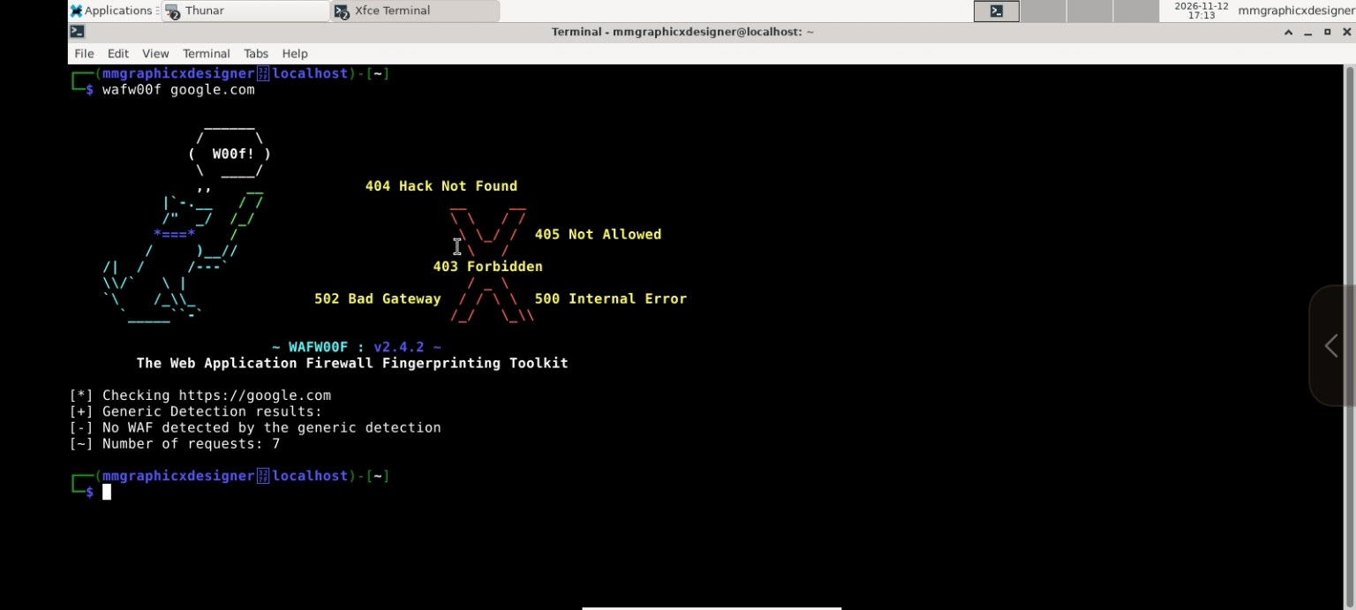
Figure 10. DNSRecon enumeration output — SOA, NS, MX, A and AAAA records
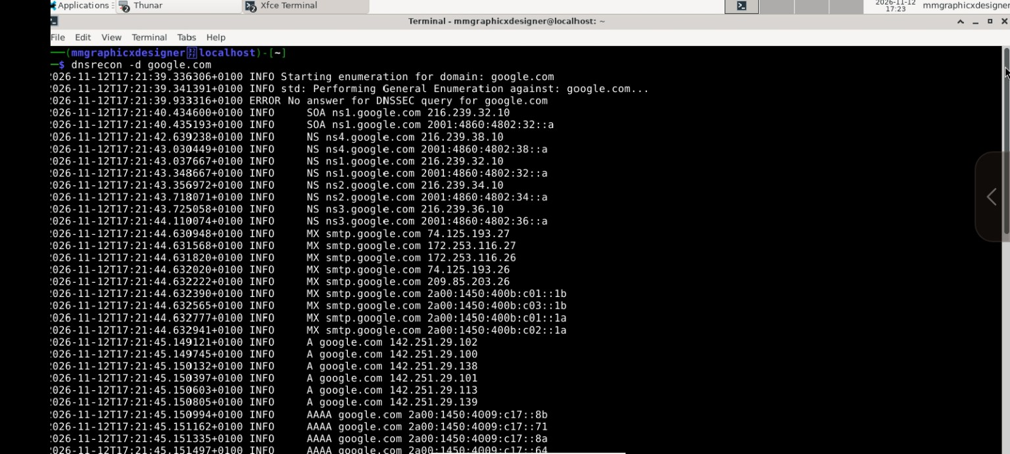
Figure 11. DNSRecon enumeration output — TXT, DMARC and SRV records
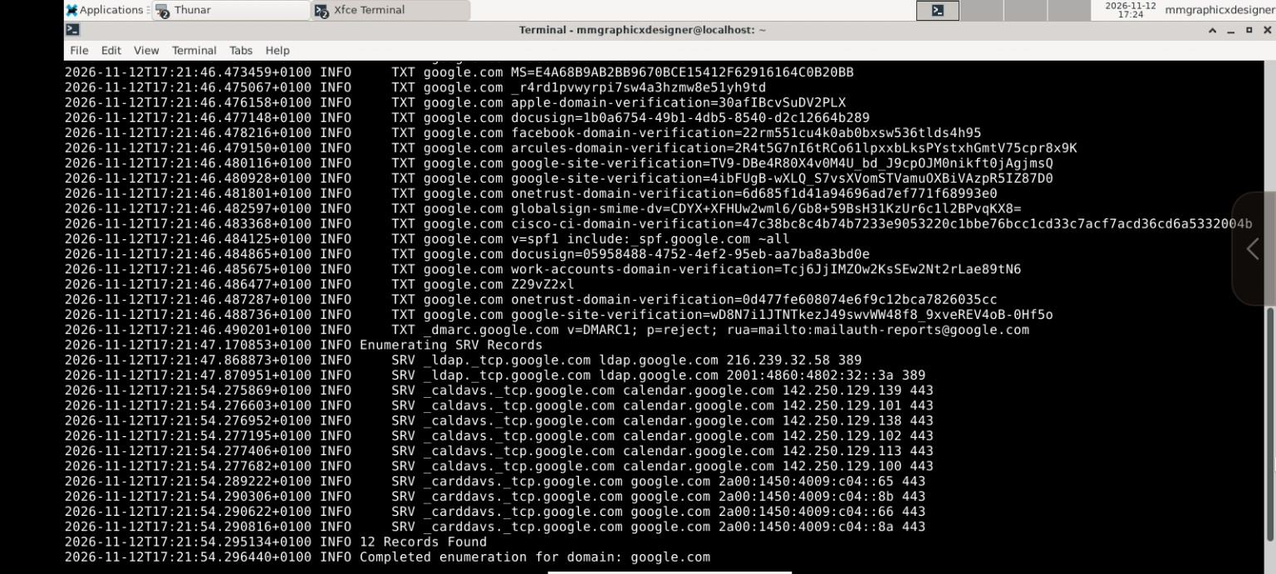
Figure 12. Zenmap topology view for the basic host-discovery scan
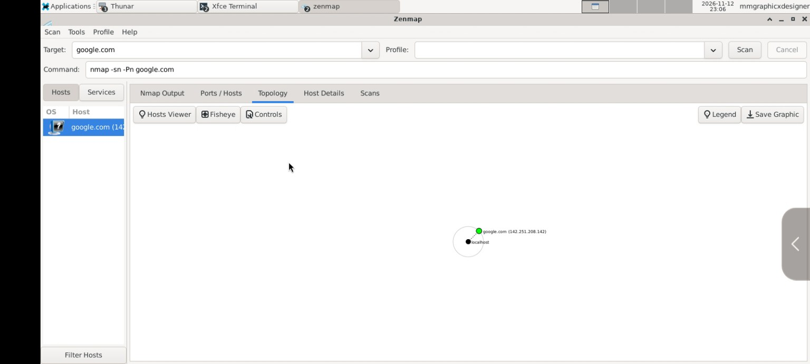
Figure 13. Zenmap/Nmap 7.991 host-discovery output


