**C PROGRAMMING ASSIGNMENT:**

**11**

DATE: 02.12.21

SUBMITTED BY: -

NAME: MUKTESH MISHRA

BRANCH: CSE

SECTION: B22

ROLL NO.: 21052258

**Program1:**

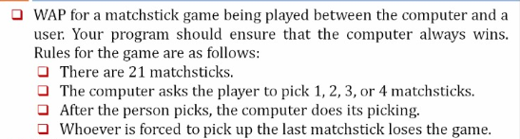

Code:

#include<stdio.h>

//matchstick game

int main()

{

    int ms = 21, uc, cc;

    while(ms>=1)

    {

        printf("Total Match Sticks: %d\n", ms);

        printf("Pick up the no of match sticks between (1 to 4): ");

        scanf("%d", &uc);

        if(uc>4)

        {

            printf("Invalid Entry");

            break;

        }

        cc = 5 - uc;

        printf("Computer picks up the %d match sticks.\n", cc);

        ms = ms-uc-cc;

        if(ms==1)

        {

            printf("\nYou have been lost via computer.");

            break;

        }

    }

    return 0;

}

Output;

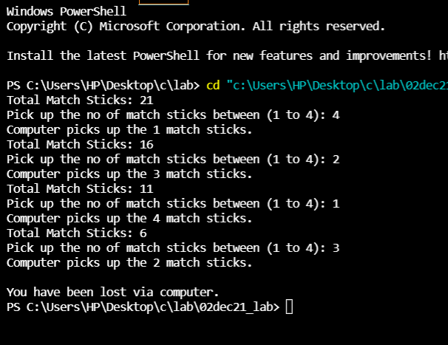

**Program 2**: 

Code:

#include <stdio.h>

//prime nos  from 1 to 300

void main()

{

    int i, num, count = 0;

    printf("The prime numbers in between the range 1 to 300:\n");

    for (num = 1; num <= 300; num++)

    {

        count = 0;

        for (i = 2; i <= num / 2; i++)

        {

            if (num % i == 0)

            {

                count++;

                break;

            }

        }

        if (count == 0 && num != 1)

            printf("%d\n", num);

    }

}

Output:

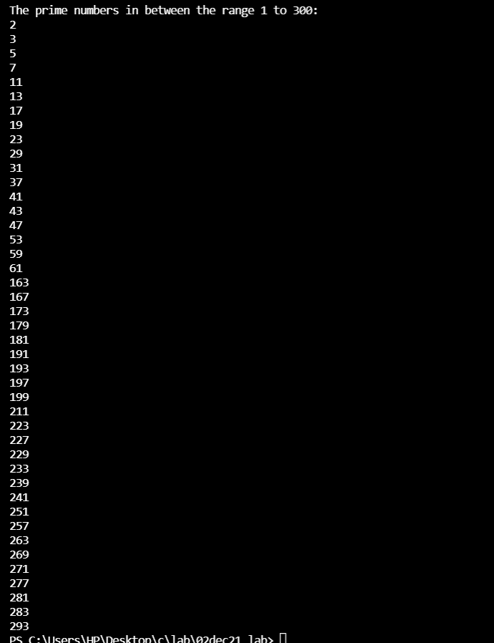

Program 3:

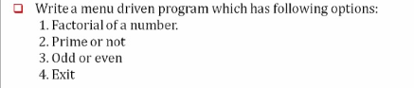

Code:

#include <stdio.h>

//menu driven

int main(int argc, char const *argv[])

{

    int c;

    int n, f = 1, count;

    printf("Enter 1 for performing factorial of a number\n");

    printf("Enter 2 for performing prime or not\n");

    printf("Enter 3 for performing Odd or even number\n");

    printf("Enter 4 for exiting the program\n");

    printf("Enter your choice\n");

    scanf("%d", &c);

    switch (c)

    {

    case 1:

        // factorial

        printf("Enter a number\n");

        scanf("%d", &n);

        for (int i = 1; i <= n; i++)

        {

            f = f * i;

        }

        printf("%d", f);

        break;

    case 2:

        // prime or not

        printf("Enter a no \n");

        scanf("%d", &n);

        count = 0;

        for (int i = 2; i <= n/2 ; i++)

        {

            if (n % i == 0)

            {

                count++;

                break;

            }

        }

        if (count == 0 && n != 1)

            printf("Prime no\n");

        else

        {

            printf("Not a prime no\n");

        }

        break;

    case 3:

        // even or odd

        printf("Enter a no \n");

        scanf("%d", &n);

        if(n%2==0){

            printf("Even no");

        }

        else{

            printf("Odd no");

        }

        break;

    case 4:

        break;

    default:

        printf("Invalid");

        break;

    }

    return 0;

}

Output:

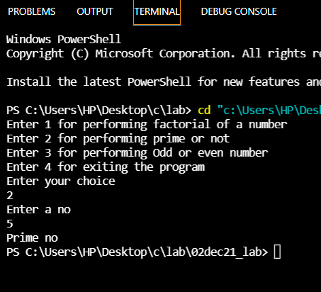

**Program 4:**

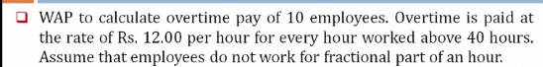

Code:

#include <stdio.h>

// overtime pay

int main(int argc, char const *argv[])

{

    int n,a;

    for (int i = 1; i <= 10; i++)

    {

        printf("Enter the no of hours worked by employee %d:\n", i);

        scanf("%d", &n);

        if (n > 40)

        {

            a = (n - 40) * 12;

            printf("The overtime amount to be payed to employee %d is: Rs.%d\n",i,a);

        }

        else{

            printf("No overtime pay\n");

        }

    }

    return 0;

}

Output:

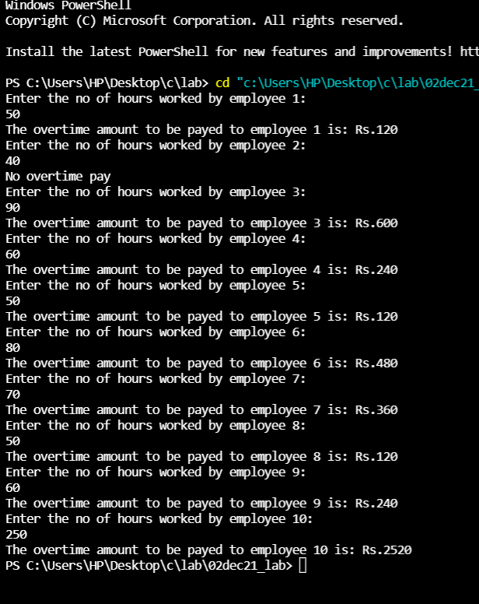

**Program 5:**



Code:

#include <stdio.h>

// One no raise to other

int main(int argc, char const *argv[])

{

    int n1,n2,r=1;

    printf("Enter 2 nos\n");

    scanf("%d %d", &n1, &n2);

    for (int i = 1; i <= n2; i++)

    {

        r=r*n1;

    }

    printf("%d\n", r);

    return 0;

}

Output:

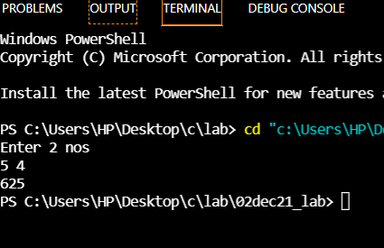

**Program 6:**



Code:

#include <stdio.h>

// factorial

int main(int argc, char const *argv[])

{

    int n, f = 1;

    printf("Enter a number\n");

    scanf("%d", &n);

    for (int i = 1; i <= n; i++)

    {

        f = f * i;

    }

    printf("factorial: %d", f);

    return 0;

}

Output:

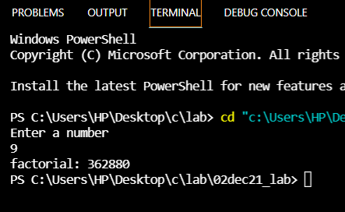

**Program 7:**



Code:

#include <stdio.h>

// ascii

int main()

{

    char ascii;

    int i;

    for (i = 0; i <= 255; i++)

    {

        printf("%c = %d\n", i, i);

    }

}

Output:

 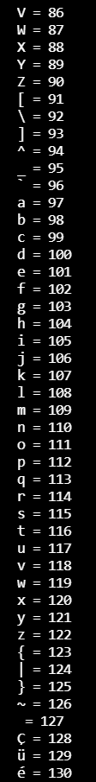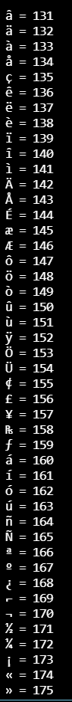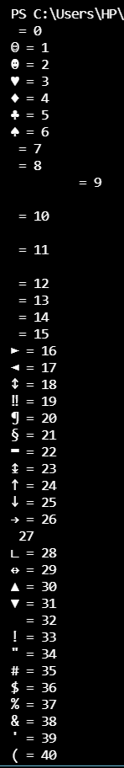 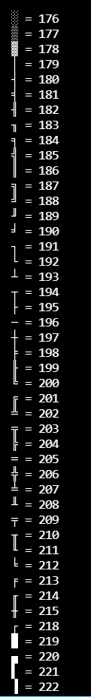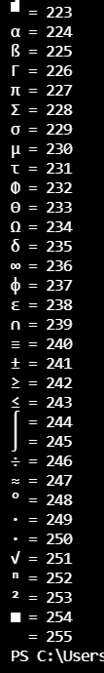

**Program 8:**



Code:

#include <stdio.h>

//octal

int main()

{

    int num, oct = 0, rem = 0, place = 1;

    printf("Enter a decimal number\n");

    scanf("%d", &num);

    printf("\nOctal Equivalent of %d is ", num);

    while (num)

    {

        rem = num % 8;

        oct = oct + rem * place;

        num = num / 8;

        place = place * 10;

    }

    printf("%d\n", oct);

    return 0;

}

Output:

