**C PROGRAMMING ASSIGNMENT:**

**6**

DATE: 11.11.21

SUBMITTED BY: -

NAME: MUKTESH MISHRA

BRANCH: CSE

SECTION: B22

ROLL NO.: 21052258

**Program 1:** write a program to find out the velocity and distance covered by a stone after time(1,2,3,4,5 sec), if it is thrown with a initial velocity from top of eiffel tower

**Code:**

#include<stdio.h>

#define g 9.8

#define h 0.5

int main(int argc, char const *argv[])

{

    int u,t=0; float v,s;

    printf("Enter the initial velocity\n");

    scanf("%d",&u);

    //t=1

    t++;

    v=u+g*t;

    s=u*t+h*g*t*t;

    printf("Velocity and distance = %f and %f respectively when t=1\n",v,s);

     //t=2

    t++;

    v=u+g*t;

    s=u*t+h*g*t*t;

    printf("Velocity and distance = %f and %f respectively when t=2\n",v,s);

     //t=3

    t++;

    v=u+g*t;

    s=u*t+h*g*t*t;

    printf("Velocity and distance = %f and %f respectively when t=3\n",v,s);

     //t=4

    t++;

    v=u+g*t;

    s=u*t+h*g*t*t;

    printf("Velocity and distance = %f and %f respectively when t=4\n",v,s);

    return 0;

     //t=5

    t++;

    v=u+g*t;

    s=u*t+h*g*t*t;

    printf("Velocity and distance = %f and %f respectively when t=5\n",v,s);

}

**Output:**

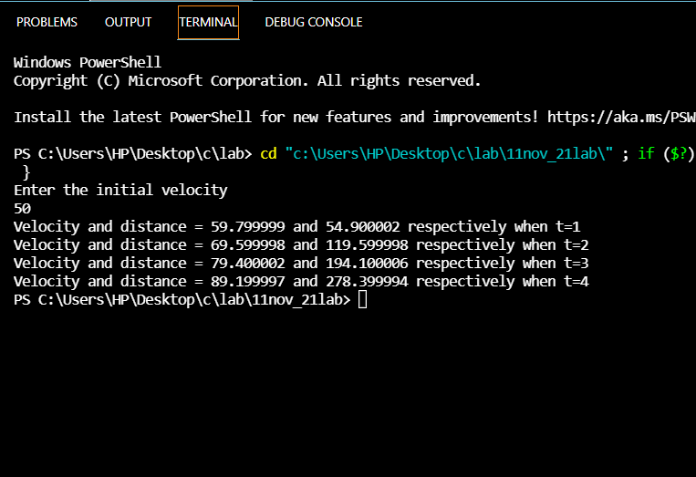

**Program 2:** Write a program to accept resistance in series and parallel and find the current

**Code:**

#include<stdio.h>

int main(int argc, char const *argv[])

{

    float r1,r2,r3,v,i1,i2,t,rs,rp;

    printf("Enter the Voltage");

    scanf("%f",&v);

    printf("Enter the 3 resistance values in ohms\n");

    scanf("%f %f %f",&r1,&r2,&r3);

    rs=r1+r2+r3;

    i1=v/rs;

    printf("The current when the given resistances are connected in series =%f\n",i1);

    rp=(1/r1)+(1/r2)+(1/r3);

    t=1/rp;

    i2=v/t;

    printf("The current when the given resistances are connected in parallel =%f\n",i2);

return 0;

}

**Output:-**

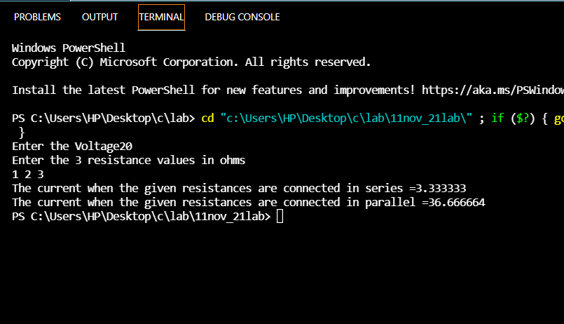

**Program 3:** Write a program to find 2D slope

**Code:**

#include<stdio.h>

int main(int argc, char const *argv[])

{

    int x1,x2,y1,y2;float m;

    printf("Enter the values for (x1,y1)\n");

    scanf("%d %d",&x1,&y1);

    printf("Enter the values for (x2,y2)\n");

    scanf("%d %d",&x2,&y2);

    m=(y2-y1)/(x2-x1);

    printf("The slope of givrn two 2D points =%f",m);

    return 0;

}

**Output:**

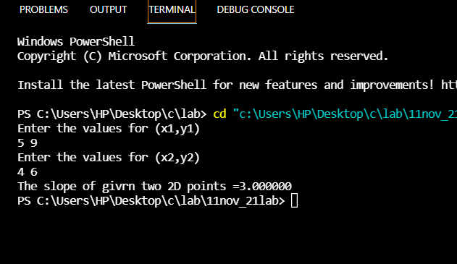

**Program 4:** write a program to find out the secondary voltage of a transformer if primary voltage, turns of primary and secondary are given.

**Code:**

#include<stdio.h>

int main(int argc, char const *argv[])

{

    int pt,st,pv,sv;

    printf("Enter the primary voltage\n");

    scanf("%d",&pv);

    printf("Enter the primary turns\n");

    scanf("%d",&pt);

    printf("Enter the secondary turns\n");

    scanf("%d",&st);

    sv=(pv*st)/pt;

    printf("Secondary voltage = %d",sv);

return 0;

}

**Output:**

