**C PROGRAMMING ASSIGNMENT:**

**20**

DATE: 14.01.2022

SUBMITTED BY: -

NAME: MUKTESH MISHRA

BRANCH: CSE

SECTION: B22

ROLL NO.: 21052258

***Question:***

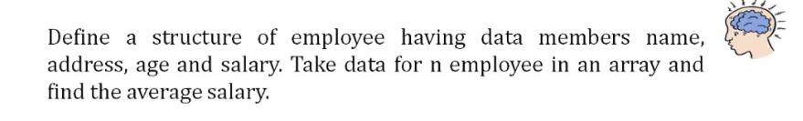

***Code:***

#include <stdio.h>

#include <string.h>

*struct* employee

{

*char* name[80];

*int* age;

*char* address[1000];

*int* salary[80];

};

*int* main(*int* *argc*, *char* const \**argv*[])

{

*char* nm[80];

*int* n, sal[100], ts = 0;

*struct* employee i;

    printf("Enter the no of employees");

    scanf("%d", &n);

    for (*int* a = 0; a < n; a++)

    {

        printf("Enter the name of employee\n");

        scanf("%s", i.name);

        printf("Enter the age\n");

        scanf("%d", &i.age);

        printf("Enter the address\n");

        scanf("%s", i.address);

        printf("Enter the salary\n");

        scanf("%d", &i.salary[a]);

        ts+=i.salary[a];

        printf("\n\nEmployee no %d:\nName:%s\nAge:%d\nAdress:%s\nsalary:%d\n\n",a+1, i.name, i.age, i.address, i.salary[a]);

    }

    printf("Average Salary=%d\n", (ts/n));

    return 0;

}

***Output:***

