**C PROGRAMMING ASSIGNMENT:**

**21**

DATE: 20.01.2022

SUBMITTED BY: -

NAME: MUKTESH MISHRA

BRANCH: CSE

SECTION: B22

ROLL NO.: 21052258

1. **WAP to show how enumerations helps in writing clear codes and simplify programming.**

***Code:***

#include <stdio.h>

*enum* week{Sunday,Monday, Tuesday, Wednesday,Thursday,Friday,Saturday};

*int* main()

{

*enum* week today;

    today = Saturday;

    printf("%d day", today + 1);

    return 0;

}

***Output:***

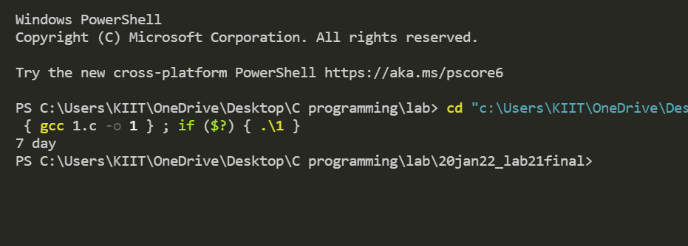

1. **WAP to show bitwise operator operations**

***Code:***

#include <stdio.h>

*int* main()

{

*unsigned* *int* a = 60; /* 60 = 0011 1100 */

*unsigned* *int* b = 13; /* 13 = 0000 1101 */

*int* c = 0;

    c = a & b; /* 12 = 0000 1100 */

    printf("Line 1 - Value of c is %d\n", c);

    c = a | b;/* 61 = 0011 1101 */

    printf("Line 2 - Value of c is %d\n", c);

    c = a ^ b;/* 49 = 0011 0001*/

    printf("Line 3 - Value of c is %d\n", c);

    c = ~a; /*-61 = 1100 0011 */

    printf("Line 4 - Value of c is %d\n", c);

    c = a << 2;/* 240 = 1111 0000 */

    printf("Line 5 - Value of c is %d\n", c);

    c = a >> 2; /* 15 = 0000 1111*/

    printf("Line 6 - Value of c is %d\n", c);

    return 0;

}

***Output:***

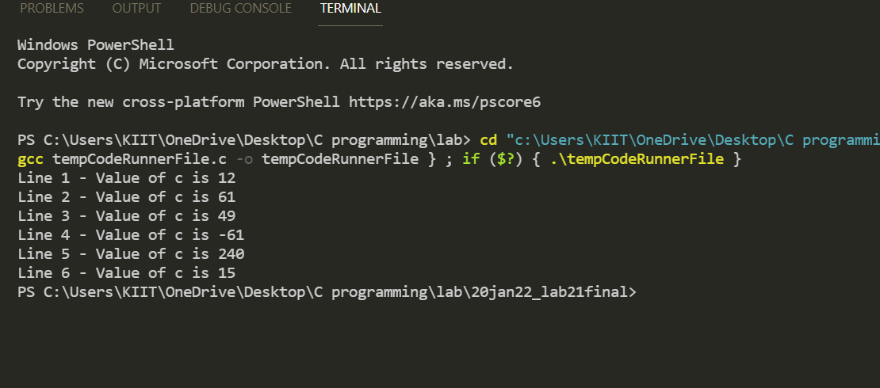

**3.WAP to print largest element stored in 0th position**

***Code:***

#include<stdio.h>

#include<stdlib.h>

*int* main()

{

*int* i = 0, n;

*float* *data;

    printf("Enter total number of elements(1 to 100): ");

    scanf("%d", &n);

    data = (*float* *)calloc(n, sizeof(*float*)); /* Allocates memory */

    for (i = 0; i < n; ++i){

        printf("\nEnter Number %d: ", i+1);

        scanf("%f", data + i);

    }

    for (i = 1; i < n; ++i)

        if (*data < *(data + i))

            *data = *(data + i);

    printf("Largest element = %.2f", *data);

    free(data);

    /* Stores number entered by user. */

    // &data[i]

    return 0;

}

***Output:***

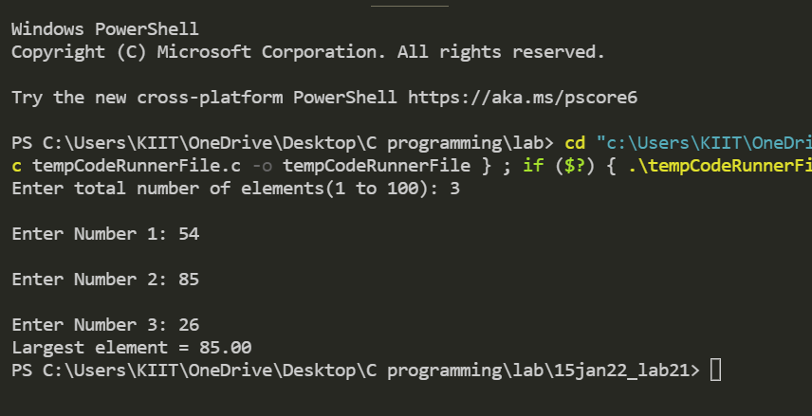

**4.WAP to  use mallloc than array of score(cricket)**

**of 10 matches of player and find the average score**

***Code:***

#include <stdio.h>

#include <stdlib.h>

*int* main()

{

*int* i;

*int* count,tot;

*int* *arr;

*int* sum = 0;

    arr = (*int* *)malloc(10 * sizeof(*int*));

    for (i = 0; i < 10; i++)

    {

        printf("Enter The Scores of Match %d : ", (i + 1));

        scanf("%d", arr + i);

        sum += *(arr + i);

    }

    tot=sum/10;

    printf("The average score is %d \n", tot);

    free(arr);

    return 0;

}

***Output:***

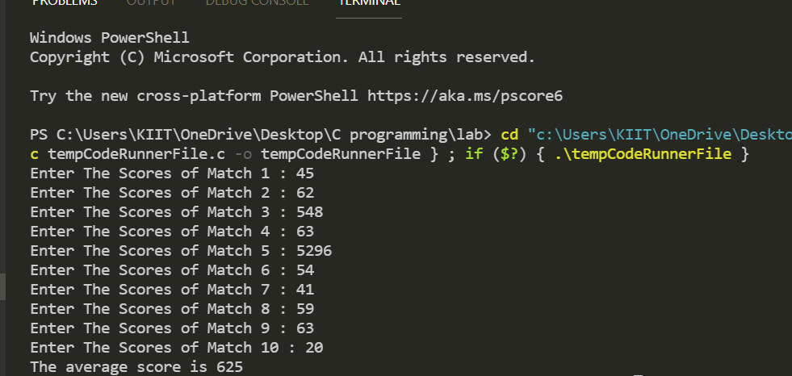

1. WAP to add arrays using dynamic memory allocation.

***Code:***

#include <stdio.h>

#include <stdlib.h>

*int* main()

{

*int* n, i, *ptr, sum = 0;

    printf("Enter number of elements: ");

    scanf("%d", &n);

    ptr = (*int* *)malloc(n * sizeof(*int*));

    printf("Enter elements of array: ");

    for (i = 0; i < n; ++i)

    {

        //memory allocated using malloc

        scanf("%d", ptr + i);

        sum += *(ptr + i); // ptr[i];

    }

    printf("Sum=%d", sum);

    free(ptr);

    return 0;

}

***Output:***

