**C PROGRAMMING ASSIGNMENT:**

**22**

DATE: 21.01.2022

SUBMITTED BY: -

NAME: MUKTESH MISHRA

BRANCH: CSE

SECTION: B22

ROLL NO.: 21052258

1. WAP for accessing array elements

***Code:***

#include<stdio.h>

*int* main()

{

    FILE *fp;

*int* i, a[10] = {2, 4, 6, 8, 1, 3, 5, 7, 9, 0};

    fp = fopen("Pr1.txt", "w");

    for (i = 0; i < 10; i++)

        fprintf(fp, "%d\n", a[i]);

    fclose(fp);

    return (0);

}

***File:***

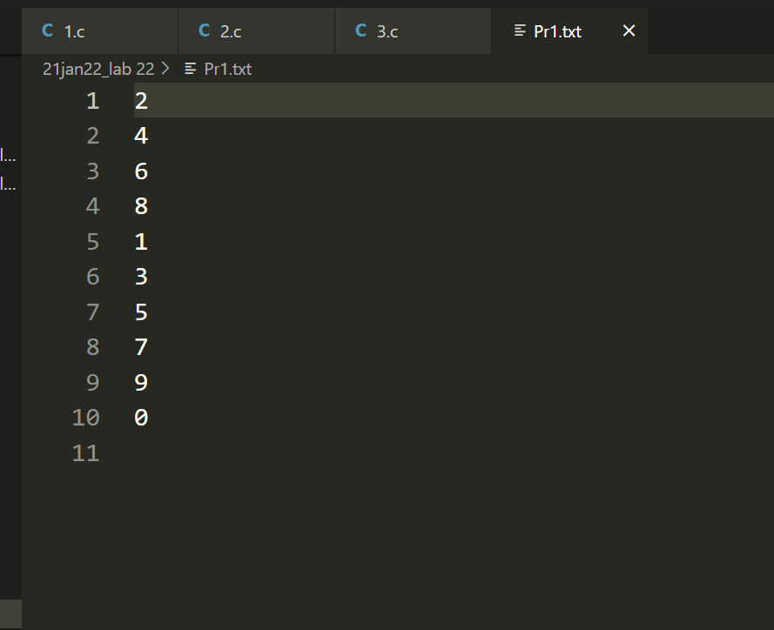

***Output:***

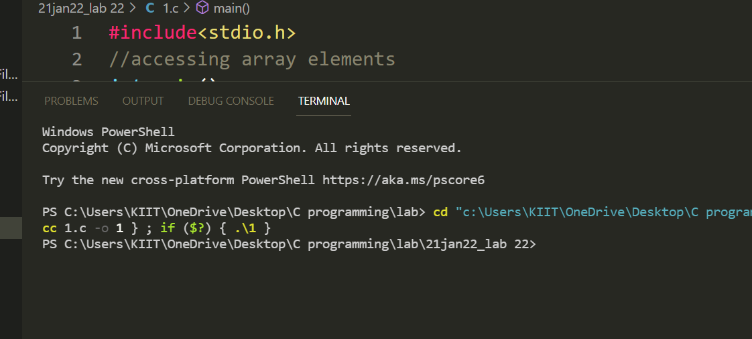

1. WAP to read contents of a file, store it onto an array and find sum of the elements

and print in reverse order.

***Code:***

#include <stdio.h>

*int* main()

{

    FILE *fp;

*int* a[10], i, sum = 0;

    fp = fopen("Pr1.txt", "r");

    for (i = 0; i < 10; i++)

    {

        fscanf(fp, "%d", &a[i]);

        sum += a[i];

    }

    printf("SUM= %d ",sum);

    for (i = 9; i >= 0; i--)

        printf("\n %d ", a[i]);

    fclose(fp);

    return (0);

}

***File:***

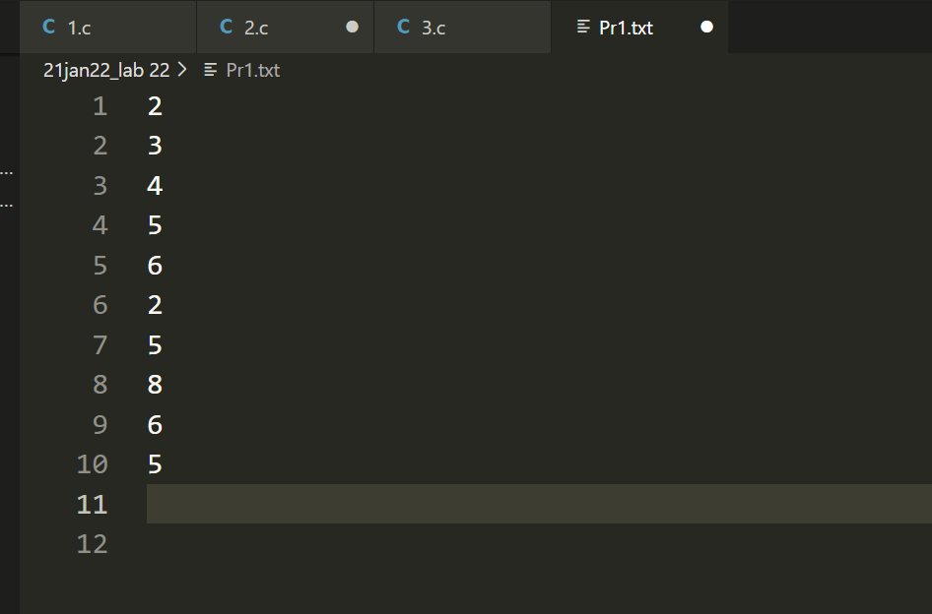

***Output:***

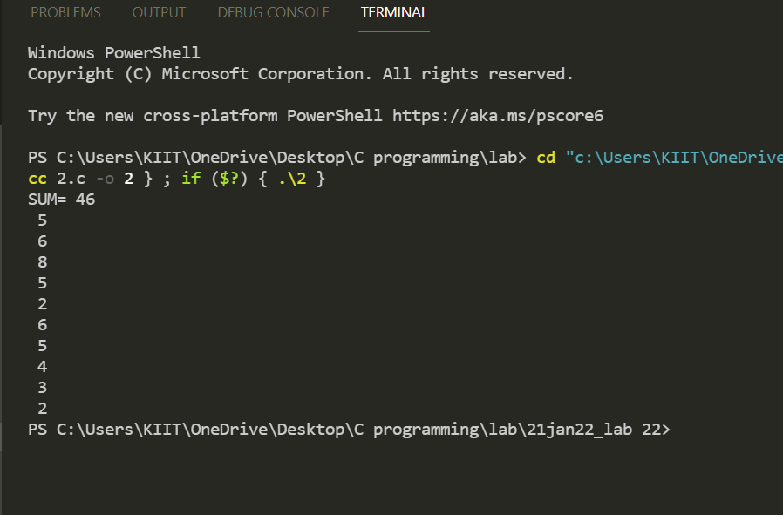

1. WAP to Count chars, blank spaces, tabs and newlines in a file.

***Code:***

#include <stdio.h>

*int* main()

{

    FILE *fp;

*char* ch;

*int* noc = 0, nob = 0, not = 0, non = 0;

    fp = fopen("Pr1.txt", "r");

    while ((ch = fgetc(fp)) != EOF)

    {

        noc++;

        if (ch == ' ')

            nob++;

        if (ch == '\t')

            not ++;

        if (ch == '\n')

            non++;

    }

    //continuation of program

    printf("\nNo. of characters = %d", noc);

    printf("\nNo. of blanks = %d", nob);

    printf("\nNo. of tabs = %d", not );

    printf("\nNo. of lines = %d", non);

    fclose(fp);

    return 0;

}

***File:***

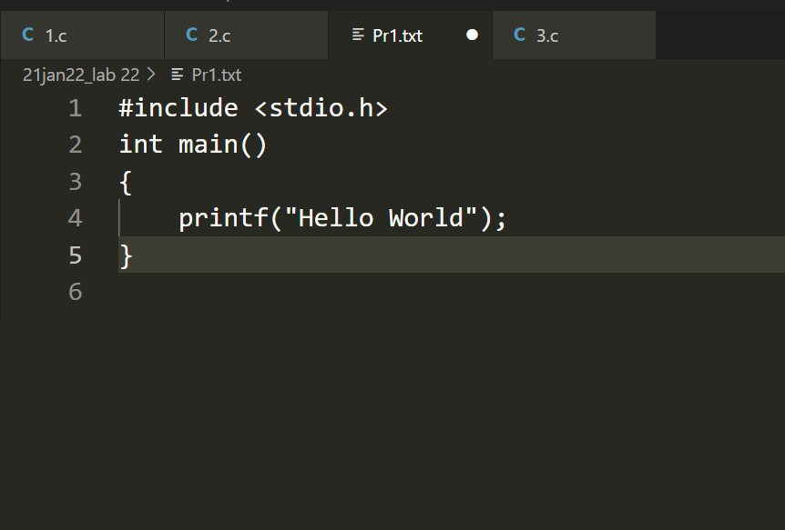

***Output:***

